FINAL REPORT: Evaluation services for the SANE pilot for people with complex mental health needs
Institute for Social Science ResearcH
30 September 2023

Title: | FINAL REPORT: Evaluation services for the SANE Australia pilot for people with complex mental health needs
Prepared for: | Department of Health and Aged Care
Prepared by: | Institute for Social Science Research
Date: | 30 September 2023
Revision: | 1.1
Project work package lead
---------------------------------------
Assoc Prof Fran Boyle
The Institute for Social Science Research at the University of Queensland (UQ) acknowledges the Traditional Owners and their custodianship of the lands on which UQ operates. We pay our respects to their Ancestors and their descendants, who continue cultural and spiritual connections to Country.
We acknowledge the lived experience and expertise of people with complex mental health issues, and we value their contributions to the development of services that are responsive to people’s needs.

Contents
Acknowledgements 6
Acronyms and abbreviations 7
Glossary 9
Executive Summary 10
1. Introduction 23
1.1. Overview of the SANE Guided Service 23
1.2. Key Evaluation Questions 25
1.3. Outline of the report 25
2. Methods and Data Sources 26
2.1. Ethics approvals and considerations 26
2.2. Quantitative component 31
2.3. Economic component 34
2.4. User experience component 35
2.5. Implementation and policy component 37
2.6. Caveats and limitations of the findings 38
3. Has implementation of the Guided Service been effective? 40
3.1. The SANE Guided Service workforce (KEQ 1.1) 40
3.2. Extent to which the Guided Service was implemented as planned (KEQ 1.4) 41
3.3. Promoting referrals to the Guided Service (KEQs 1.2, 1.3) 42
3.4. Guided Service participants (KEQs 1.5, 1.6, 1.7) 47
3.5. The digital platform (KEQ 1.8) 56
3.6. Participant satisfaction and support (KEQ1.9) 58
4. Has the Guided Service made a difference to participants? 62
4.1. Waiting times and service access (KEQs 2.3, 2.1) 63
4.2. Appropriate and timely intervention (KEQ 2.2) 72
4.3. Participant outcomes (KEQs 2.7, 2.8, 2.9, 2.10) 73
4.4. Engagement with different service modalities including self-directed resources (KEQ 2.11) 85
4.5. Primary care and other supports (KEQ 2.4) 87
5. Is the SANE Guided Service cost-effective? 89
5.1. Estimated cost to deliver the Guided Service (KEQ 3.1) 89
5.2. Use of other healthcare resources (KEQ 3.2) 90
5.3. Outcomes associated with participation in the Guided Service (KEQ 3.3) 92
5.4. Estimated overall incremental cost-effectiveness and value for money? (KEQ 3.4) 93
6. Is the Guided Service appropriate for a national roll-out? 97
6.1. Alignment with mental health care policies and priorities (KEQs 4.1, 4.2, 4.3) 97
6.2. Alignment and integration with other mental health services (KEQs 4.4, 4.5) 99
6.3. Ability to alleviate unmet service demand (KEQ 4.6) 106
6.4. Need for adjustments for a national roll-out (KEQ 4.7) 109
6.5. Estimated budgetary impact (KEQ 4.8) 110
7. Summary and recommendations 111
7.1. Recommendations 112
Tables
Table 1: Evaluation questions addressed by components of the evaluation 27
Table 2: Mental health outcome and service use measures collected from SANE Guided Service participants 32
Table 3: Sources of referrals to the Guided Service from 9 May 2022 to 2 July 2023 43
Table 4: Characteristics of people reached by the SANE Guided Service compared to PMHC MDS data 48
Table 5: Complex needs of SANE Guided Service participants compared to PMHC MDS data 51
Table 6: Discontinuation and completion of SANE registered referrals and participants through Guided Service stages 54
Table 7: Service completion and discontinuation by priority populations 55
Table 8: Average number of sessions completed, cancelled, and missed by participants who have completed portal registration* 65
Table 9: Utilisation rate of each session type by SANE Guided Service participants completing a welcome call* 71
Table 10: RAS-R outcome change from baseline to Time 2 or exit for the overall participant sample and priority sub-samples 74
Table 11: ReQoL outcome change from baseline to Time 2 or exit for the overall cohort and priority groups. 77
Table 12: : MOS-SSS-6 outcome change from baseline to Time 2 f or exit for the overall cohort* 77
Table 13: K5+/K10+ baseline scores outcomes for the overall SANE sample, PMHC MDS comparison data and priority groups 79
Table 14: K10+ scores at baseline, at Time 2 and the mean difference (p-value) for SANE Guided Service participants and matched PMHC MDS data 80
Table 15: K10+ and K5+ baseline days out of role for the SANE sample and priority groups, and PMHC MDS comparison sample 82
Table 16: K10+ days out of role at baseline, at Time 2 and the mean difference (p-value) for SANE Guided Service participants and matched PMHC MDS data 83
Table 17: Characteristics, baseline K10+ psychological distress scores, and cohort regression coefficients for K10 change scores between baseline and follow-up of the matched SANE and PMHC MDS sample* 84
Table 18: Characteristics, baseline K10+ days out of role, and cohort regression coefficients examining follow-up K10+ days out of role scores of the matched SANE and PMHC MDS sample* 85
Table 19: Itemised costing for the SANE Guided Service 2021-2023 90
Table 20: Cost of additional healthcare resource use from baseline to Time 2 91
Table 21: Cost of additional healthcare resource use by timepoint for all completed surveys 91
Table 22: Change in utility values from baseline to follow-up at Time 2 or exit for the overall cohort and priority groups. 93
Table 23: Cost of the SANE Guided Service when compared to other programs. 94
Table 25: SANE Guided Service in context of other DMH services 101
Table 26: Guided Service participants as a proportion of population and estimated NMHSPF need for individual support, 2022-23 107

Figures
Figure 1: Data sources for each component of the evaluation 31
Figure 2; Summary of responses for nine PHN representatives 45
Figure 3: Summary of responses for 33 non-PHN stakeholders 46
Figure 4: a) age distribution for SANE participants, b) age distribution for PMHC MDS comparison group 49
Figure 5: Geographical distribution of Guided Service participants across PHN regions. 50
Figure 6: Overall rating of the service by 89 YES CMO SF survey respondents 58
Figure 7: Summary of Guided Service participant responses to YES CMO SF survey items 59
Figure 8: Summary of YES CMO SF respondents’ ratings of aspects of the Guided Service 59
Figure 9: Summary of sessions ratings with quotes from participants 62
Figure 10: Average number of days that participants waited for service commencement 63
Figure 11: Total number of completed, cancelled, and no-show appointments for each type of session of the SANE Guided Service. 64
Figure 12: Distribution of total number of support sessions completed by Guided Service participants. 66
Figure 13: Distribution of total number of support sessions for participants who completed the Guided Service 67
Figure 14: Participant journey mapping across key service milestones as of 30 June 2023 for all participants, consumers, and carers/family/friends. 68
Figure 15: Participant journey mapping for priority population groups (Aboriginal and/or Torres Strait Islander participants, Autistic people, people with intellectual disability). 69
Figure 16: Participant journey mapping for priority populations including LGBTQIA+, culturally and linguistically diverse and regional/rural PHN groups. 70
Figure 17: Distribution of changes in K10+ psychological distress scores and days out of role for SANE participants and matched PMHC MDS clients between baseline and follow-up at time 2 (changes >0 indicate improvements). 83
Figure 18: Use of SANE self-guided and online services for participants who completed a baseline and follow-up survey. 87
Figure 19: Frequency of use of SANE self-guided and online services for participants who reported using these services for baseline and follow-up Time 2. 87
Figure 20: Frequency of use of SANE self-guided and online services for participants who reported using these services for baseline and follow-up Time 2. 100

Appendices
Appendix A: SANE Guided Service participant journey
Appendix B: Program Logic informing the SANE Guided Service evaluation approach
Authors

Assoc Prof Fran Boyle
Dr Sandra Diminic
Dr Mary Lou Chatterton
Assoc Prof Caroline Salom
Dr Julie Dean
Dr Yanshu Huang
Dr Yong Yi Lee
Assoc Prof Meredith Harris
Ms Noor Yousef
Dr Aditi Lohan
Dr Jennifer Juckel
Ms Shelby Marrington

Acknowledgements
This work was commissioned by the Australian Government Department of Health and Aged Care. We thank the Department of Health and Aged Care project team, including Derek James, Owen Pettit, Matt Conte, and Alison Field for their constructive feedback and helpful guidance. We also acknowledge and thank the members of the SANE team for their helpful assistance throughout the evaluation. We thank Jenni Campbell for her expert advice as a member of our Advisory Group, Dr Katie Brooker for her ongoing guidance in the design and implementation of inclusive research methodologies, Gina Nuttall for her assistance with graphic design, and Dr Maca San Martin Porter and Sophie Austerberry for assistance with online survey development.
We sincerely thank the SANE Guided Service participants and professional stakeholders who took part in the evaluation for their valuable contributions and insights.

Suggested citation
Boyle FM, Diminic SN, Chatterton ML, Salom C, Dean JH, Huang Y, Lee YY, Harris M, Yousef N, Lohan A, Juckel J, Marrington S. (2023). Evaluation services for the SANE pilot for people with complex mental health needs: Final Report. Institute for Social Science Research, The University of Queensland.

Acronyms and abbreviations
Acronym | Full name
ADHD | Attention deficit hyperactivity disorder
AOD | Alcohol and other drugs
CHIME | Connectedness, Hope & optimism, Identity, Meaning, Empowerment framework
CPSP | Commonwealth Psychosocial Support Program
GP | General practitioner
HREC | Human Research Ethics Committee
ISSR | Institute for Social Science Research
K10 / K5 | Kessler Psychological Distress Scale
LGBTQIA+ | Lesbian, gay, bisexual, transgender, queer/questioning, intersex, asexual and other sexually or gender diverse people
KEQ | Key evaluation question
MOS-SSS-6 | Medical Outcomes Study Social Support Survey 6-item
MVS | Minimum Viable Service (implemented November 2021 – April 2022)
NDIS | National Disability Insurance Scheme
NGO | Non-government organisation
NMHSPF | National Mental Health Service Planning Framework
NoMAD | Normalisation MeAsure Development survey instrument
PHN | Primary Health Network
PMHC MDS | Primary Mental Health Care Minimum Data Set
PSW | Peer support worker
PTSD | Post traumatic stress disorder
PVEQ | Peer Volunteer Experience Questionnaire
QALY | Quality-adjusted life year
QCIDD | Queensland Centre for Intellectual and Developmental Disability
QCMHR | Queensland Centre for Mental Health Research
RAS-R | Recovery Assessment Scale – revised
ReQoL | Recovering Quality of Life questionnaire
UoM | University of Melbourne
UQ | The University of Queensland
YES CMO SF | Short form version of the Your Experience of Service Community Managed Organisation survey

Glossary
Term | Definition
Carers | Family members, friends, and other informal caregivers of people with complex mental health issues, who engage as participants with SANE services.
Consumers | People with recurring or persistent complex mental health issues, who have access to the SANE Guided Service. To be eligible for the service, consumers need to be 18 years or over and be within eligible locations. Includes consumers who are Autistic, have intellectual disability or acquired brain injury.
Participants | Clients or consumers of SANE’s Guided Service, including people with complex mental health issues, as well as family members and carers of people with complex mental health issues, who have completed a welcome call.
SANE Guided Service | A personally tailored program of digital and telehealth services for around 12 weeks available to people over 18 years living with complex mental health needs as well as their family and carers. A personalised recovery plan is developed collaboratively between the participant and a SANE support team member who provides 1:1 support to help the participant engage with the program. Services include sessions with a designated counsellor and/or peer support worker; access to SANE’s online community Forums, peer-led group support and other tools and resources on a personalised online portal.
SANE Drop-in Services | SANE services that are available for self-directed access, do not require registration, and can be completed anonymously.
People use many terms when referring to autism, and each individual will have a preferred way of communicating and self-describing. There are people in the Autistic community who either prefer the terms ‘identity first language’ or ‘people first language’ or interchange between both. In this report, we have used identity first language to ensure consistency with other Australian Government and Parliamentary Committee reports and with the preferred position of the Cooperative Research Centre for Living with Autism (Autism CRC).

Executive Summary
The SANE Guided Service is a digital guided psychosocial support service for people over 18 years of age with complex mental health needs and their families and carers. This evaluation of the SANE Guided Service assessed the reach, utilisation, effectiveness and cost-effectiveness of the service from December 2021 to June 2023 to inform future decisions about service roll-out and service quality improvement.
The Guided Service aims to provide participants with a free, flexible, goal-orientated, tailored recovery plan through its online platform including regular one-on-one telephone sessions with counsellors and/or peer support workers, peer-led online group support, access to SANE’s drop-in services including online community Forums and Support Line services, connection with local social services and coordination with health professionals and other supports.
The service is designed to be inclusive of Autistic people and people with intellectual disability, acquired brain injury, substance use issues, or homelessness and aims to be inclusive and accessible to members of priority population groups, including Aboriginal and Torres Strait Islander peoples, culturally and linguistically diverse (CALD) groups and lesbian, gay, bisexual, transgender, queer/questioning, intersex, asexual and other sexually or gender diverse (LGBTQIA+) communities.

Key Evaluation Questions (KEQs)
The evaluation is framed using four key evaluation questions developed in consultation with SANE and the Department.
Key Evaluation Numbers | Key Evaluation Questions
KEQ1 | How effective has the implementation of the Guided Service been and what can we learn from it?
KEQ1 | What difference is the Guided Service making to consumers and their carers and families, compared with usual supports?
KEQ1 | How cost-effective are services provided by the Guided Service, compared with usual supports?
KEQ4 | Is the Guided Service appropriate for a national roll-out?

Data sources
The evaluation applied a mixed methods design using quantitative and qualitative data from multiple sources to answer the KEQs.
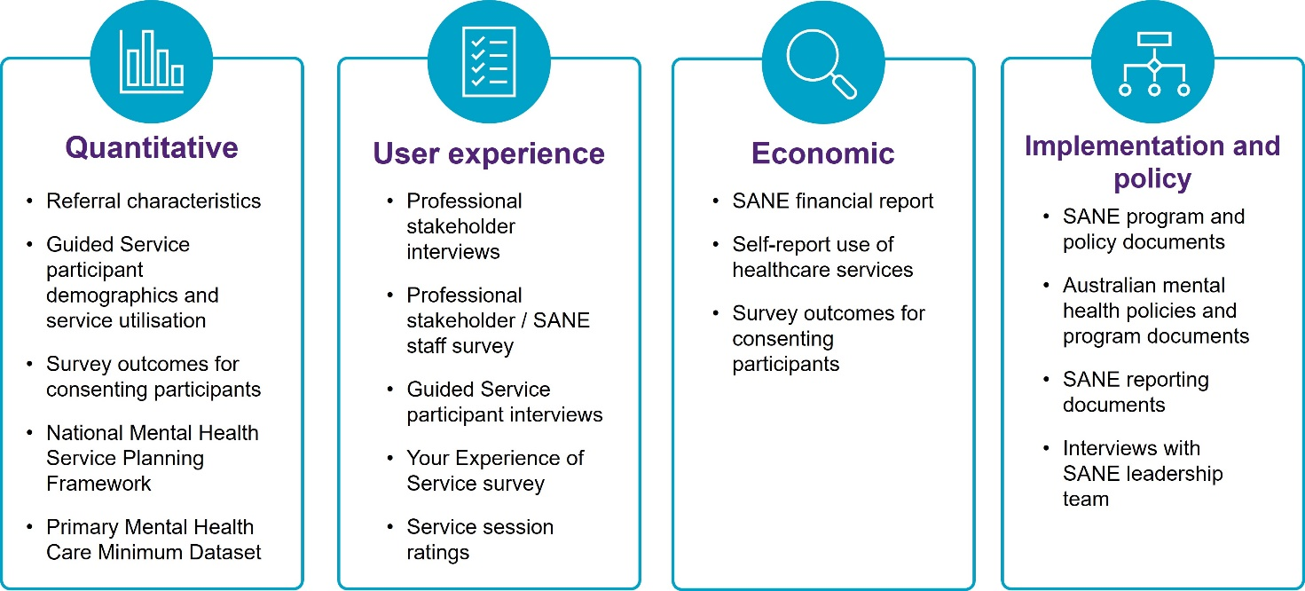

Caveats and limitations
A number of caveats and limitations apply to the evaluation findings. These include: availability and quality of data to assess outcomes of the service and for use in the economic evaluation; representativeness of service participants and other stakeholders who provided information; and insufficient opportunity to assess ongoing refinements to service design that have occurred during the evaluation period.

KEQ1: How effective has the implementation of the Guided Service been and what can we learn from it?
The Guided Service is reaching various priority subgroups, including people with complex needs, and has potential to fill an important service gap.
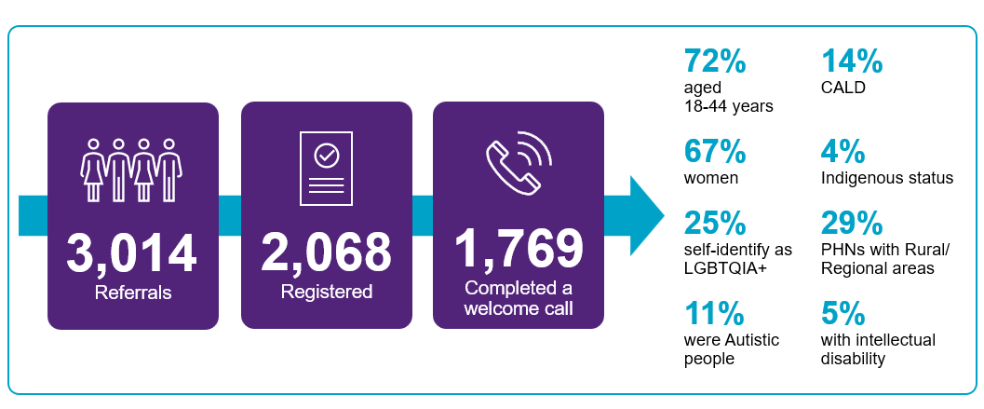
“What we really love about the service that SANE has offered is that it is targeting quite complex mental health needs, and we know that there’s a big gap in that space. So, it’s been extremely helpful for us.” (PHN Representative).
“I’m in a regional town… the population is like 10,000. So there’s literally no psychologists… there’s no complex mental health. We don’t even have doctors at the hospital… my psychologist left… so I’m counting on these sessions with SANE.” (Guided Service Participant).
After referral and acceptance into the Guided Service, participants are assigned to receive a welcome call to explain the service followed by a support planning call before commencing support sessions.
There have been significant implementation challenges including waitlists and pressure points along the service journey. A lack of communication about waiting times and service changes was a source of frustration and distress for some participants.
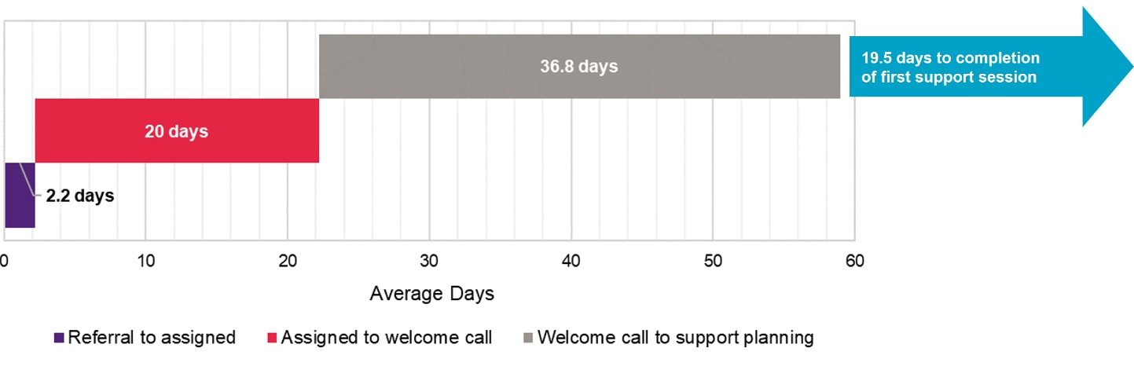
"I'm not someone that's been helped by SANE. In fact, I feel let down in that I was promised things that haven't been delivered." (Guided Service participant).
"We don't want to offer people who are already on a waitlist another waitlist". (PHN representative).
There was a high rate of discontinuation across the service journey.
Of the 1,769 participants who had completed a welcome call, 803 (45%) had exited the service by 30 June 2023 with 94 having completed the service and 93 having a planned early exit. Of the participants who commenced the Guided Service, 231 had an unplanned exit from the service.
Once Guided Service participants commenced support sessions, they had generally high levels of satisfaction. SANE counsellors and peer support workers were highly regarded and valued for their ability to listen and convey respect and understanding.

The best thing about the service was:
The compassion, empathy and understanding from the support workers.
Counsellor was excellent – felt listened to and she provided resources outside of session.
Peer support and encouragement to take small steps to get there.

KEQ2: What difference is the Guided Service making to consumers and their carers and families, compared with usual supports?
There was a statistically significant improvement in quality of life (ReQoL) scores and mental health recovery (RAS-R) scores for participants who exited the service after at least one support session.
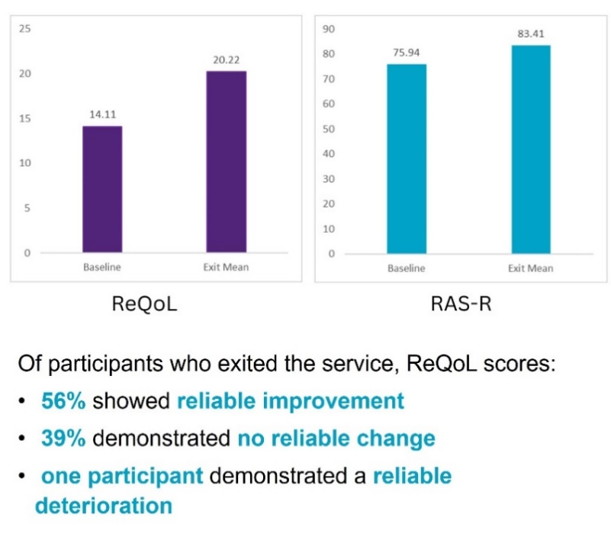
So probably keeping me going (while I don’t have) access to any other services without long wait times and everything, they’re keeping me going… They are keeping me more stable that what I would be without it.” (Guided Service participant).
The counsellor giving me strategies like how to deal with the thoughts and cope better with the rumination and the negative thoughts and how to change them. Definitely giving me tools, strategies… because otherwise you could just spiral downwards very quickly.” (Guided Service participant).
There was no statistically significant change in psychological distress (K10+) scores or in the number of days out of role due to psychological distress.
The status of participant outcomes should continue to become clearer as more participants complete the service and more data are available for evaluation, including for K10+ outcomes that can be compared with other services.
There was significant improvement in quality of life and recovery between baseline and first follow-up survey (~12 weeks) for CALD, LGBTQIA+ and rural/regional priority groups.
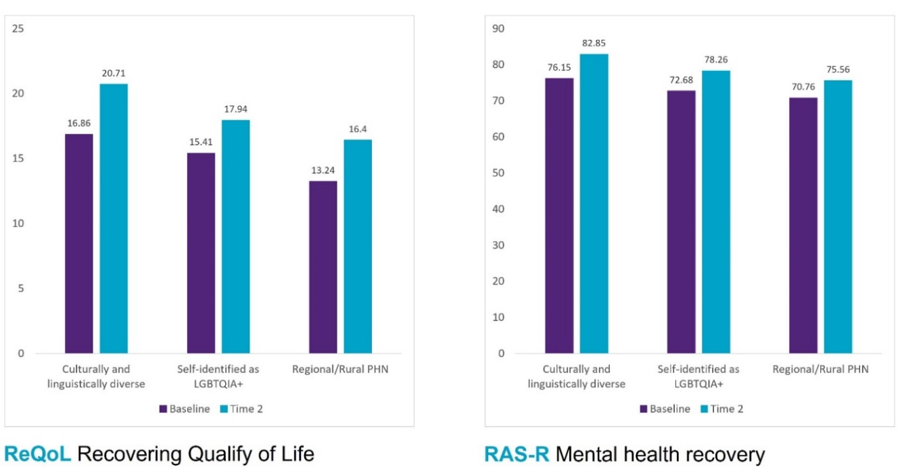

KEQ3: How cost-effective are services provided by the Guided Service, compared with usual supports?
The mean cost of acute services used by participants involving ambulances, emergency departments, hospital and residential care decreased by an average of $400 between baseline and first follow-up survey at approximately 12 weeks.
Participants who completed at least one session had an average decrease of $1,000 in acute care service costs.
These changes were not statistically significant.
There was no significant change in QALYs (quality-adjusted life years) from baseline to follow-up.
The cost per consumer who was registered by the SANE Guided Service was $2,614 (excluding program development).
The economic evaluation suggests the Guided Service is at the lower end of cost per participant for psychosocial services aimed at complex needs (although this may reflect people not receiving many support sessions).

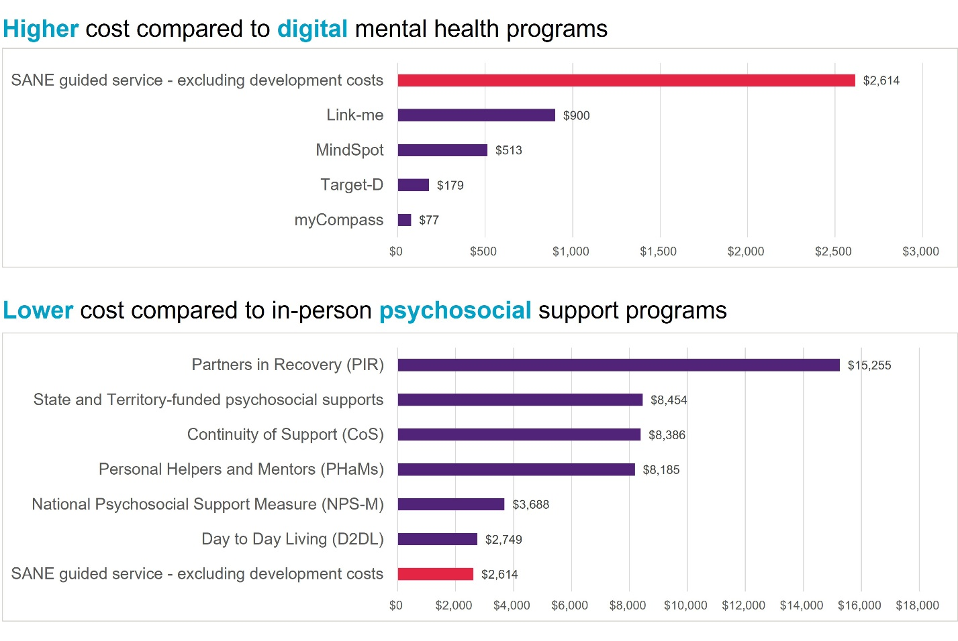

KEQ4: Is the Guided Service appropriate for a national roll-out?
The Guided Service is well-aligned with current Australian mental health policy directions and provides unique services in the digital mental health landscape. The service appears to be filling a critical system gap and providing a positive experience and outcomes for participants who receive support.
However, there have been significant implementation challenges, including wait times for the service and pressure points along the service journey, service changes that have not been well-communicated to service participants, and delays in development of a robust data collection system for participant support, service quality monitoring and evaluation purposes. These issues should be demonstrated to have been addressed before national roll-out.
SANE has been proactive in responding to implementation challenges, resulting in a service model that has evolved greatly from the initial envisaged model and that differs significantly from the service that was the substantive focus of this evaluation.
Demonstrating reach, utilisation and effectiveness of this refined service model is an immediate priority through ongoing monitoring and evaluation of service refinements and their impacts.

Recommendations

Continue to monitor participant characteristics and needs
Collect and use robust and appropriate measures to establish participant needs, plan support and assess the impact of care on participants’ mental health and wellbeing. Train and support staff to implement and document this practice. Ensure that participants understand the importance of this practice in providing best and most appropriate support to them. This will also aid in evaluating the evolving service model and ensuring that it continues to match participant needs.

Manage workforce needs
Ensure credential requirements and ongoing training and support are provided so that staff have the capabilities required to support participants with complex mental health needs, trauma, co-occurring health conditions including substance use, autism and disabilities, and to address specific considerations such as cultural and identity backgrounds. Provide ongoing review and support of practice to ensure training is effective, capabilities are implemented, and workforce capacity is sufficient to address participant needs. This may also reduce staff turnover related to burnout.

Communicate and monitor the impact of change
Ensure changes to the Guided Service model are clearly communicated to referrers and potential participants, to manage expectations and ensure appropriateness of referral. Clearly document the timing and structure of future changes, and ensure that supports, data systems and referral pathways in and out of the Service remain relevant. Evaluate the impact of change on support effectiveness using robust independent review. Continue to monitor the ability of the Service to provide timely and appropriate support to current participants before expanding referral networks and target populations. Continue to monitor the place and fit of the Service within the mental health landscape to support connected, collaborative and adaptable care for people with complex mental health needs.
SANE Guided Service improvements | Measures to improve the SANE Guided Service
Wait times for participants and service pressure points | - Carefully review SANE’s capacity to match demand and demonstrate timely flow for participants across the participant journey from initial referral to transition.  - Make available transparent information about wait times to all potential and referred participants and referring partners including PHNs.  - Implement clear policy to prioritise and triage referrals and provide services to participants according to need.  - Consolidate approaches to ensure participants are linked with broader primary health supports at transition out of the Guided Service and ensure that participants and referring organisations are aware of these from the outset.  - Establish well-articulated pathways for SANE Guided Service participants through linkages with PHNs and by introducing the SANE suite of non-directed service offerings as part of the Guided Service.  - Consider options about extending the number of services available to people without other available alternatives for psychosocial support.
Promoting service engagement through flexibility and ‘good fit’ for participants | - Improve understanding of reasons for service discontinuation at every step through the service journey and continue to develop service-level responses to support participants with complex mental health needs to engage with and complete the service.  - Prioritise service design that includes one-on-one personalised contact to engage participants in service options.  - At every stage of the service journey ensure participants are aware of the nature of the service and how they will transition to other forms of support once they have completed the Guided Service.  - Review the digital platform regularly to ensure optimal functionality and ease of use for participants including responding to feedback from participants and ensuring access for people with differing levels of experience and interest in using digital technologies.  - Give special consideration to digital inclusion for people with intellectual disability/cognitive impairment. Easy Read versions of measures are now available and can be refined even further according to best practice, with potential application for a range of different participant groups including people who are experiencing high levels of distress, people who are not proficient in English, and people with low levels of literacy.
SANE Guided Service workforce | - Continue to implement credentialling and provide appropriate ongoing training and support for the peer workforce as well as specialised training in complex mental health, mentoring and support for staff wellbeing across the SANE workforce.  - Monitor staff feedback and identify opportunities to improve the staff experience on a regular and ongoing basis.  - Provide regular staff training in support to people with intellectual disability/cognitive impairment and Autistic people who have complex mental health needs including approaches to communication, mental health support and appropriate referral pathways.
Building awareness of the service and referral processes | - Ensure regular contact with PHNs for ongoing promotion of the service. To maintain confidence in the service as a viable referral option, promotion material should provide clear information about service options, including peer support, and incorporate feedback from service participants.  - Target community agencies beyond health services with promotional activities to facilitate linkage between sectors and support a more integrated mental health system.  - Ensure that the online referral process and website design supports both self-referral and referral by health care professionals.  - Review referral information to include detail about whether self-referral was facilitated by a health care provider or through interaction with a referring organisation.
Evaluation-related recommendations | - Conduct further independent rigorous analysis of data assessing reach, outcomes and cost-effectiveness within the next 12 months. Analysis should include consideration of outcomes for priority groups and populations and K10+ outcomes. This is essential to assess significant changes to the service delivery model from that which was evaluated at this time.  - Prioritise the use of agreed measures to guide both individualised support planning and service monitoring and evaluation. Regular professional development for SANE staff about the use of these measures in helping to improve participants’ recovery, including communication to participants about how and why completing these measures is helpful in guiding support sessions and to further help in improving the service. Staff implementation of measures should be monitored to inform professional development about use of measures in counselling and peer support practice.  - Undertake careful assessment of participant perspectives of the acceptability and appropriateness of the refined service model, including to inform understanding of participant no-shows, cancellations and unplanned service exit. A key focus should be on reasons for people maintaining contact with the service after contact with drop-in services, and to understand and address barriers to continuing to engage with SANE’s provision of support.  - Update system and data fields for recording of reasons for exit to provide better clarity and granularity in terms of the different stages in which participants exit the service. Implement mechanisms for detailing and understanding reasons for exiting the program, at different stages. This could provide better insight into aspects that contribute to the discontinuation of participants. Timely updates to participant records will ensure accurate records of participant journey durations and prompt collection of routine survey data at service completion.  - Continue to embed system and data infrastructure to prevent delays in data analysis and ensure optimal levels of follow-up data from participants. The format of variables within the data have been changed across the span of the evaluation; to enable comparison in future monitoring and evaluation activities, ensure data and reporting formats are consistent.  - Conduct further analysis of self-reported healthcare resource use and associated costs between baseline and service completion within the next 12 months to provide information on changes in service use potentially attributable to the SANE Guided Service.  - Further evaluate the average cost of program delivery compared to the average quality of life and K10+ outcomes in view of the changes in the service delivery model.  - Include measures of participant engagement in the broader suite of SANE drop-in services and measures of linkages to other health supports to the evaluation framework to enable analysis of relationships between pattern and intensity of service delivery and participant outcomes, and to assess integration of support through SANE services with broader support networks.  - Ensure clear documentation of refinements to service design and implementation by SANE for ongoing learning, further service development, quality control and monitoring.
Learnings for future evaluations of complex service interventions | - Consider carrying out a formal evaluability assessment to determine the readiness of the initiative for evaluation and to ensure allocation of necessary resources for evaluation. This includes considering whether the program has been implemented long enough to allow assessment of expected outcomes and the availability of, and capacity for systems and staff to provide, necessary data for robust analyses.  - Undertake formative evaluation during the early roll-out phase of a new program or an adaptation of an existing program (e.g., MVS) to enable findings to inform modifications to the program prior to full program implementation. Ensure the time frames for the MVS are sufficient to enable the service to develop and embed program refinements. Findings from the formative evaluation can be used to inform planning for the outcome evaluation (e.g., including areas of specific interest such as reasons for discontinuation and referral pathways.)  - Implement an outcome evaluation when program modifications have been embedded, to enable evaluation evidence to apply to the service when it is fully implemented.  - Routinely use appropriate measures as part of service monitoring and evaluation to optimise co-occurring benefits for clinical care and evaluation including acceptability, likelihood of completion and reduced burden for participants and staff. Consider use of evidence-based measures that have high face and content validity — where items are regarded by service users as appropriate, relevant and covering components of importance — and where service users have been involved in their development (e.g., ReQoL, YES CMO SF). Choose outcome indicators that can be compared across data sets.  - Consider adoption of a longer-term time frame for funding models that involve development, implementation and evaluation of a new program. Longer-term funding could ameliorate potential program cost inefficiencies such as staff turnover due to possible program de-funding, increased confidence for PHNs and referring agencies to invest in promotional activities and referrals and improve the capacity to stage evaluation phases according to phases in service development.

- Introduction
This report presents the findings of the evaluation of the SANE Australia Pilot (now known as the SANE Guided Service) of specialised mental health services and interventions for people living with complex mental health needs, including Autistic people and people living with intellectual disability. The SANE Guided service is a digital psychosocial support service that aims to address some of the current barriers to accessing mental health support for members of this population.
The Department of Health and Aged Care (the Department) engaged a team led by the Institute for Social Science Research (ISSR) with partners from the Queensland Centre for Mental Health Research (QCMHR) at The University of Queensland (UQ), the Health Economics Group at Monash University, and the Queensland Centre for Intellectual and Developmental Disability (QCIDD) to undertake the evaluation.
The overall purpose of the evaluation was to inform any future potential rollout of the SANE Guided Service and/or other measures to improve how people with complex mental health needs, and their families, can be supported to achieve improved recovery outcomes. The evaluation also considered alignment with other key Australian policies and programs to contribute to the growing evidence base to support ongoing mental health system improvement.
The timeframe for this evaluation was from December 2021 to June 2023, which included ongoing development, an initial trial phase (Minimum Viable Service, MVS), and first iteration of the Guided Service.
  - Overview of the SANE Guided Service
SANE was funded by the Department over two years, from July 2021 to June 2023, to develop and trial a digital guided psychosocial support service for people with complex mental health needs and their families and carers. Service funding by the Department was extended for a further 12 months to 30 June 2024.
The service is designed to be inclusive of those experiencing intellectual disability, acquired brain injury, autism, substance use issues, or homelessness and aims to be inclusive and accessible to members of priority population groups, including Aboriginal and Torres Strait Islander peoples, culturally and linguistically diverse (CALD) groups and LGBTQIA+ communities.
The initial service model was informed by a co-design process with members of the lived experience community that was supported by the ALIVE Centre for Lived Experience Research at the University of Melbourne.

How the Guided Service works
The SANE Guided Service aims to provide participants with a free, flexible goal-orientated, tailored recovery plan through its online platform including regular one-on-one telephone counselling, online peer-led group support, access to SANE’s drop-in services including online community Forums and Support Line services, connection with local social services and coordination with health professionals and other supports.
The service model is underpinned by the CHIME Recovery Framework, which encompasses five key components associated with mental health recovery: Connectedness, Hope and Optimism, Identity, Meaning and Purpose, and Empowerment. Counsellors and peer workers follow this framework, using a strengths-based approach to promote recovery and improve participants’ quality of life by building connection, personal skills, confidence and self-knowledge.
The SANE Guided Service was intended to be, on average, a 12-week program available to people over 18 years old who reside within an eligible PHN. A referral (including via self-referral) is required. The service is personally tailored to each participant’s situation and needs, based on an individual needs assessment and support plan which is developed collaboratively between the participant and their dedicated SANE support team. Once accepted to the service, a participant portal is activated, and a profile is created by the participant. Following this registration process, participants are oriented to the program through a ‘Welcome Call’ to explain the service and a ‘Support Planning Call’ to explore individual recovery goals and develop a plan of individual support sessions with a counsellor and/or peer support worker. Participants engage in 1:1 telephone counselling and/or peer support sessions and have access to online social and psychoeducational groups.
SANE’s range of free services can also be accessed via SANE drop-in services, a range of self-directed services that are available to anyone aged 18 years or older who resides in Australia. Unlike the Guided Service, these drop-in services do not require a registration and participants can choose to be anonymous. Participants have unrestricted access to online moderated community Forums and online mental health resources through the SANE website and can access the information Support Line to talk to a mental health professional. Guided Service participants may also use the self-directed drop-in services to support transition into the Guided Service and/or as part of a step-down in level of care based on client needs.
Guided Service users are provided with a personalised participant portal through which they can track and self-manage their recovery journey. The secure online portal allows participants to access their personal support plan, scheduled one-to-one appointments and events, review progress, gain access to resources, fact sheets and blogs, and complete routine surveys that include measures to assess their mental health and wellbeing. Information collected from the surveys helps in the design of the participant’s tailored plan and is a source of information for the evaluation. Health data and user records, including referral details, demographic, mental health and Guided Service utilisation data are stored and maintained in a customised and secure client record management (CRM) system built using Salesforce Health Cloud. Key demographic and mental health-related details are collected at baseline when the participant portal is first created. Mental health outcome surveys are requested to be completed at follow-up timepoints, generally every 12 weeks and at service exit. This routinely collected information is a key data source for the current evaluation.
In summary, the service journey for SANE Guided Service participants involves:
- Referral via a webform
- Review, triage and participant acceptance of the referral, including activation of the participant portal
- Welcome Call to explain the service, get to know the participant and explore other needs for referral
- Support Planning Call to explore individual recovery goals and scheduling of support sessions
- Counselling and/or peer support calls including referral to other SANE services or broader community services
- Transition counselling or peer support final session
The service user journey is depicted in further detail in Appendix A.

Referral pathways to the Guided Service
There are multiple referral pathways to the Guided Service. Participants can self-refer or be referred by a general practitioner (GP) or other medical specialist, allied or other health care professional, other service provider, family member or friend.
The Guided Service is a limited pilot trial and is currently available to adults (18 years and older) residing in an eligible Primary Health Network (PHN) region.
National rollout of the Guided Service began with an initial trial phase (Minimum Viable Service, MVS) from November 2021-April 2022 involving two PHNs: North-Western Melbourne PHN and Central Queensland, Wide Bay, Sunshine Coast PHN.
Three additional PHNs joined for the full Guided Service roll out in May 2022: Brisbane North PHN, Central and Eastern Sydney PHN, and Capital Health Network (ACT).
In August 2022, the Guided Service reach extended to include another eight PHN regions: Western Victoria PHN, Darling Downs and West Moreton PHN, Western Sydney PHN, The Hunter, New England and Central Coast PHN, Adelaide PHN, Northern Territory PHN, Tasmania PHN, and Western Australia Primary Health Alliance (covering Perth North, Perth South, and Country Western Australia PHNs). The addition of these regions opened Guided Service eligibility to all states and territories in Australia.
To create awareness of the service, including among priority population groups, SANE reports to have worked in close partnership with PHNs, GPs, non-government organisations (NGOs), hospitals, State and Territory Governments and Aboriginal Community Controlled Health Services.
Due to increased awareness of the service, a portion of referrals have been received from people residing in at least 10 other currently non-eligible PHN regions, overcoming eligibility checks for a range of reasons including complex border/boundary arrangements between postcodes and PHNs, exceptions made based on high level of risk, and a residual proportion of SANE national Support Line service users.
  - Key Evaluation Questions
A consultation workshop was held on 8 December 2021, with representatives of the Department, SANE, and our Evaluation Team. The draft Program Logic that had been developed during the SANE co-design process was used as a starting point, with the resulting Program Logic (included in Appendix B) then incorporating contributions from the workshop. Participants were invited to offer further post-workshop contributions and amendments during the following month.
The evaluation was designed to answer four key evaluation questions (KEQs) that were developed and refined through a consultative process with stakeholder input. These high-level questions addressed the reach, utilisation, effectiveness, and cost-effectiveness of the SANE Guided Service:
  - KEQ1. How effective has the implementation of the Guided Service been and what can we learn from it?
  - KEQ2. What difference is the Guided Service making to consumers and their carers and families, compared with usual supports?
  - KEQ3. How cost-effective are services provided by the Guided Service, compared with usual supports?
  - KEQ4. Is the Guided Service appropriate for a national roll-out?
The evaluation took a values-based approach that was underpinned by a commitment to collaboration and inclusivity. Throughout the evaluation, regular meetings were held with the Department and SANE to update on progress and to address any issues as they arose.
  - Outline of the report
Section 2 presents an overview of the evaluation methods and data sources. The section concludes by acknowledging a number of caveats and limitations that are important for interpreting the evaluation findings.
Sections 3 to 6 present the findings of the evaluation. The findings are structured according to the KEQs.
The final section (Section 7) presents a summary and synthesis of the findings, concluding with recommendations.

- Methods and Data Sources
The evaluation applied a mixed methods design using quantitative and qualitative data from multiple sources to answer the KEQs. For each of the KEQs, specific sub-questions addressed aspects of the KEQ in more detail.
The matrix presented in Table 1 lists the KEQs and their corresponding sub-questions together with the evaluation component that addressed each sub-question. Minor modifications have been made to the original KEQs and sub-questions to reflect changes in terminology and scope that occurred over the course of the evaluation and to reduce duplication.
The evaluation comprised four distinct, but inter-related, component areas, each with its own set of evaluation activities.
Evaluation Component | Evaluation Component description
 | The quantitative component of the evaluation sought to obtain and analyse quantitative data from SANE and a comparison group of people using PHN-commissioned mental health services. The aim was to understand patterns of utilisation of supports offered through the SANE Guided Service and their impacts on service access and mental health outcomes.
 | The economic component of the evaluation aimed to estimate the cost-effectiveness (i.e., value for money) of the SANE Guided Service when adopting a health sector perspective. This considered: (1) costs, such as the cost to deliver the Service, and the cost of other health care services utilised by participants (e.g., emergency department visits and hospital admissions); and (2) outcomes data for participants across the Service and a relevant comparator.
 | The user experience component of the evaluation sought to capture, through survey and qualitative interview methods, a range of user experiences, including those of Guided Service participants, providers and partner organisations. The aim was to gain insights into service implementation, including the needs and barriers of users and strategies to address them.
 | The implementation and policy component of the evaluation sought to contextualise the SANE Guided Service and its implementation within the diverse and complex mental health service environment.
  - Ethics approvals and considerations
All evaluation activities were conducted in accordance with the National Statement on Ethical Conduct in Human Research. The evaluation included both routinely collected data that were made available to the evaluation team (secondary data) and data collected specifically for the evaluation by members of the evaluation team (primary data). Ethics approval relating to data that were routinely collected by SANE and shared in deidentified form with the evaluation team was obtained from the University of Melbourne HREC (Reference number: 2023-23572-42007-9). University of Melbourne HREC approvals were also ratified by UQ HREC (Project number: 2022/HE002093). Ethics approval relating to PMHC MDS data and primary data collection activities, including interviews and surveys involving Guided Service participants and other stakeholders, were approved by the UQ HREC (Project number: 2022/HE000265).
Quotes and illustrative examples are provided throughout the report. In all instances, specific details and any personally identifying information have been removed.

Table 1: Evaluation questions addressed by components of the evaluation
Symbol | Address level
♦ | Addressed directly via this component
◊ | Incidental information gathered via this component
- | Not addressed via this component
KEQS AND SUB-QUESTIONS |  |  | EVALUATION COMPONENTS
 |  |  | Quantitative | Economic | User experience | Implementation and policy
1. How effective has the implementation of the Guided Service been and what can we learn from it?
1.1 Were appropriate staff recruited, trained and supported to provide appropriate care for consumers? |  |  | - | - | ♦ | ◊
1.2 Were appropriate referral pathways developed and used to link PHNs and other support organisations to the Guided Service, both for referrals in and referrals out of the service? |  |  | ♦ | - | ♦ | -
1.3 Was the Guided Service sufficiently and effectively promoted to services and clients through these identified referral pathways? |  |  | - | - | ♦ | -
1.4 To what extent was the original design of the Guided Service implemented as planned for consumers? Were there barriers and/or facilitators of this? |  |  | ◊ | - | ♦ | ♦
1.5 To what extent did consumers engage with the Guided Service? |  |  | ♦ | - | ♦ | -
1.6 Which areas of specific need were represented by consumers who engaged with the Guided Service (e.g., people experiencing complex mental health disorders, intellectual disability, autism)? |  |  | ♦ | - | ♦ | -
1.7 To what extent did consumers using the Guided Service include priority populations, including people from remote/rural areas, people who identified as Aboriginal, Torres Strait Islander, culturally diverse or LGBTQIA+, family and carers? |  |  | ♦ | - | ◊ | -
1.8 Was the digital platform easy to navigate for staff and consumers? |  |  | - | - | ♦ | -
1.9 Were consumers satisfied with their engagement with the Guided Service? Did consumers feel supported during and after each session? |  |  | - | - | ♦ | -
2. What difference is the Guided Service making to consumers and their carers and families, compared with usual supports?
2.1 To what extent did the Guided Service improve access to services for people with complex mental health needs? |  |  | ♦ | - | ♦ | -
2.2 To what extent did the Guided Service provide appropriate and timely intervention for participants? |  |  | - | - | ♦ | -
2.3 Has the Guided Service reduced the waiting time for mental health services? |  |  | ♦ | - | ♦ | ◊
2.4 Did consumers feel their primary and mental health care became better connected? |  |  | - | - | ♦ | -
2.5 Were ‘step-up’ and ‘step-down’ protocols effectively implemented? |  |  | - | - | - | -
2.6 Did the varying-intensity packages of services provided improve recovery for consumers with varying levels of need? |  |  | ♦ | - | - | -
2.7 Have consumers and carers achieved better outcomes as a result of the Guided Service? |  |  | ♦ | - | ♦ | -
2.8 To what extent have consumers/carers achieved better outcomes in terms of functional capacity, independence, participation in education, employment and/or community? |  |  | ♦ | - | ♦ | -
2.9 Compared to the overall cohort, are there equivalent outcomes for specific target cohorts including people with autism and intellectual disability, and other priority populations (e.g., people who identify as Aboriginal or Torres Strait Islander, culturally diverse or LGBTQIA+, and socioeconomically disadvantaged or rural populations)? |  |  | ♦ | - | - | -
2.10 Do families and carers better understand and feel more able to support the needs of their loved one, and themselves? |  |  | ♦ | - | ♦ | -
2.11 How effective were self-directed resources available to maintain consumers’ social connectedness and ensuring sustained recovery? |  |  | ♦ | - | ♦ | -
2.12 Were there any changes in reliance on other government-funded services as a result of the Guided Service? |  |  | - | - | ♦ | -
3. How cost-effective are services provided by the Guided Service, compared with usual supports?
3.1 What is the estimated cost to deliver the Guided Service, per client, per episode of care, compared to usual supports? |  |  | - | ♦ | - | -
3.2 What additional healthcare resources are used by people participating in the Guided Service? Do participants in the Guided Service report using fewer other healthcare resources? |  |  | - | ♦ | ♦ | -
3.3 What outcomes are associated with participation in the Guided Service? |  |  | ♦ | - | ◊ | -
3.4 What is the overall incremental cost per quality-adjusted life year and cost per point improvement in K10 of the Guided Service compared to treatment as usual? Does the Guided Service represent value for money? |  |  | - | ♦ | - | -
4. Is the Guided Service appropriate for a national roll-out?
4.1 Does the Guided Service align with national policies and priorities for mental health care? |  |  | - | - | - | ♦
4.2 What measures were in place to ensure the Guided Service was appropriate, accessible and inclusive for people with complex mental health needs, including but not limited to those with intellectual disability, autism, homelessness issues, vulnerable population groups etc? |  |  | - | - | ♦ | -
4.3 How well does the Guided Service align with other mental health services including the Commonwealth Psychosocial Support Program (CPSP), Adult Mental Health Centres, digital mental health initiatives such as Head to Health – as well as other health services and community supports? |  |  | - | - | ♦ | ♦
4.4 How well does the Guided Service integrate with other mental health services including CPSP, Adult Mental Health Centres, Head to Health as well as other health services and community supports? |  |  | - | - | ♦ | -
4.5 Has the Guided Service reduced waiting times or alleviate unmet demand for similar services such as the CPSP? |  |  | ◊ | - | ♦ | -
4.6 Were there aspects of the Guided Service design and implementation that would need to be adjusted for a national roll-out? |  |  | ◊ | - | ♦ | ◊
4.7 What is the estimated budgetary impact of the Guided Service if rolled out nationally? |  |  | ◊ | - | - | -

The main data sources for the evaluation are summarised in Figure 1 and each data source is described further below.
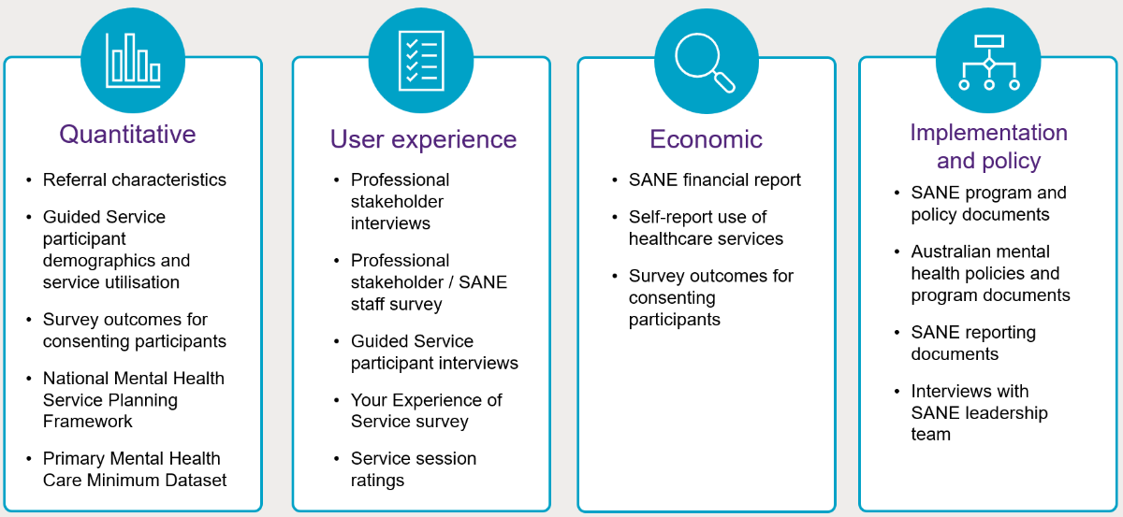
Figure 1: Data sources for each component of the evaluation
  - Quantitative component
Quantitative data from several sources were analysed to understand patterns of utilisation of supports offered through the Guided Service and how the Guided Service impacts on service access and mental health outcomes. Data sources for the quantitative analysis included:
- SANE Guided Service routine service data
- Primary Mental Health Care Minimum Dataset (PMHC MDS) comparison data
- National Mental Health Service Planning Framework (NMHSPF)
    - Routine service data collected by SANE
The routine outcome surveys, collected via the online participant portal, include measures of:
- General recovery, using the Recovery Assessment Scale (RAS-R) (for consumers only).
- Quality of life, using the Recovering Quality of Life (ReQoL) Questionnaire.
- Social connectedness, using the Medical Outcomes Study Social Support Survey 6-item scale (MOS-SSS-6). This measure was only collected until January 2023.
- Psychological distress and role functioning, using the K10+ (or K5 where indicated). The K10+ includes the first 10 psychological distress items of the K10+ (or 5 items of the K5) with additional items 11 and 12 of the K10+ to measure full and partial days out of role for mental health reasons. Note that routine collection of the K5/K10 was only introduced from January 2023.
- Use of SANE self-guided services (e.g., online forums) and other health services (e.g., inpatient and residential mental health care). These items were only introduced from January 2023.
SANE identifies participants as falling within one of five survey cohorts based on whether they are a consumer/carer, identify as being of Aboriginal and/or Torres Strait Islander origin, and/or have a cognitive impairment. Outcome measures for each survey cohort were tailored appropriately, including Easy Read versions for people with intellectual disability and/or cognitive impairment. The latter modifications were based on current evidence and with advice from the Queensland Centre for Intellectual and Developmental Disability (QCIDD). They included deletion of some items to reduce questionnaire length, and simplified response options (e.g., 3-point instead of 5-point Likert scale with graphical or simplified language). The measures collected for each cohort are shown in Table 2.
Table 2: Mental health outcome and service use measures collected from SANE Guided Service participants
Cohort | Measures
- Participants with complex mental health issues (including those with co-occurring autism) who do not identify as Indigenous | - RAS-R  - ReQoL  - MOS-SSS-6 (before January 2023)  - K-10+  - Health Service Use  - SANE Service Use
- Participants with complex mental health issues (including autism) who identify as Indigenous | - RAS-R  - ReQoL  - MOS-SSS-6 (before January 2023)  - K-5+  - Health Service Use  - SANE Service Use
- Carers who do not identify as Indigenous | - ReQoL  - MOS-SSS-6 (before January 2023)  - K-10+  - SANE Service Use
- Carers who identify as Indigenous | - ReQoL  - MOS-SSS-6 (before January 2023)  - K-5+  - SANE Service Use
- Participants with complex mental health issues and co-occurring intellectual disability (Indigenous and non-Indigenous) | - Easy Read RAS-R  - Easy Read ReQoL  - K-5+  - Easy Read Health Service Use  - SANE Service Use
For this evaluation, SANE provided their routinely collected data on the Guided Service for the period 9 May 2022 to 30 June 2023, including:
- Aggregated summary data from SANE’s monthly reports to the Department on referral sources for the Guided Service, covering to 2 July 2023 (n=3,436). This report also provided summary data on total utilisation of SANE’s separate drop-in services to 2 July 2023.
- Aggregated summary data on wait times from SANE to the Department covering from 9 May 2022 to 31 May 2023.
- Aggregated summary data on the date and key characteristics of all referrals to the service to 30 June 2023 (n=3,014).
- Deidentified unit record data on referral date, demographics and mental health-related characteristics, and Guided Service utilisation for participants who completed registration for the service through the SANE online portal to 30 June 2023 (n=2,068).
- Deidentified unit record data from mental health outcome surveys completed at baseline and follow-up timepoints to 30 June 2023, for participants consenting to share their survey data for the evaluation (n=641).
    - Comparison data from the Primary Mental Health Care Minimum Data Set (PMHC MDS)
The characteristics and outcomes of SANE Guided Service participants were compared with a group of people using PHN-funded mental health supports with likely complex needs. Logicly provided national, deidentified unit record data from the PMHC MDS on adult (aged 18 years or over) clients of PHN-funded mental health services with an episode of care commencing between 1 June 2021 and 30 September 2022 that met our inclusion criteria for potential complex needs. These criteria were: (a) having a principal focus of treatment plan relating to ‘clinical care coordination’ or ‘complex care package’ or ‘psychosocial support’ OR (b) being a National Disability Insurance Scheme (NDIS) participant OR (c) with a principal diagnosis of psychotic disorder, bipolar disorder, or personality disorder OR (d) having multiple mental disorder diagnoses recorded.
Client and service data covering up to 30 September 2022 were extracted. Any client who had at least one episode of care (i.e., a continuous period of contact between a client with a provider or clinician, concluding at discharge) during the period that met one or more of the above criteria was selected for inclusion, with the analysis focusing on their earliest eligible episode of care within the above timeframe. The general comparison of PMHC MDS clients and SANE Guided Service participants was based on this sample of 88,251 clients aged 18+ years nationally. These were the first episode of care for each client within the above timeframe, with those with missing referral dates not included in the analyses. No data were collected or available for PMHC MDS clients about whether individuals have intellectual disability, autism, or identify as LGBTQIA+.
A subset of the PMHC MDS group was selected for comparison of K10+ outcomes with the 29 SANE Guided Service participants for whom baseline and follow-up K10+ outcome data were available. The PMHC MDS clients were matched with the available 29 Guided Service participants through two-stage exact matching based on gender, age, baseline K10+ scores or days out of role, and regional/rural PHN status (matched PMHC MDS sample n=858 for K10+ psychological distress and n=790 for K10+ days out of role).
    - National Mental Health Service Planning Framework (NMHSPF)
The NMHSPF was used to estimate the total number of adult consumers needing individual psychosocial support services for more complex needs within the participating PHN areas. The NMHSPF is a needs-based tool designed to help plan, coordinate, and resource mental health services in Australia. It combines epidemiological data, services data and evaluations, and provider and lived experience consensus to estimate need and expected demand for mental health care and the level and mix of mental health services required for a given population.
The analysis focused on individuals and services likely to most closely align with the target population for the SANE Guided Service, specifically adults 18+ with severe illness (i.e., people who have a diagnosed mental illness that has a high impact on their day-to-day lives), excluding older adults with behavioural and psychological symptoms of dementia (BPSD) or living in residential aged care. Given the relatively small proportion of carers/family members among Guided Service participants, the analysis focused on overall service needs for people with mental health conditions. The estimated numbers of consumers aged 18+ with severe mental illness and needing one or both of Individual Support and Rehabilitation (counselling/psychosocial support) or Individual Consumer Peer Support services was generated from the NMHSPF Care Profiles V4.3, using established methods for estimating people requiring psychosocial support from the NMHSPF. Numbers of people were calculated separately for each in-scope PHN region using 2022-23 population estimates from the NMHSPF Planning Support Tool. A separate analysis for Aboriginal and Torres Strait Islander populations was planned but not completed due to the small numbers of these Guided Service participants at PHN level.
Results from the NMHSPF were compared with estimates of the number of NDIS participants aged 19+ with a primary psychosocial disability in each in-scope PHN region. Estimates were derived from published NDIS data for Q2 2023, with suppressed small counts replaced with mid-points and reported participant numbers by NDIS Service District mapped to their approximate PHN locations.
  - Economic component
Data on costs and outcomes were collected over the course of the project to evaluate whether the SANE Guided Service would represent value for money.
    - Cost of the SANE Guided Service
The total cost of the SANE Guided Service was estimated by obtaining access to the financial records of the SANE Guided Service for the periods comprising the 2021-22 and 2022-23 financial years. These records provided itemised cost information across a range of functions that operate within the SANE Guided Service. The average cost per consumer of the SANE Guided Service was compared to the cost per consumer for other psychosocial support services and digital mental health programs.
    - Cost of other healthcare service use
The costs associated with healthcare service use outside of the SANE Guided Service was evaluated by asking SANE Guided Service participants to periodically complete a resource use questionnaire asking respondents to provide data on the services they had used. These include questions on: ambulance use; emergency department visits; overnight hospital stays; use of other recovery services; and the use of other miscellaneous services. The quantity of other healthcare service use was valued using unit costs derived from nationally representative data sources in Australia. These included data from: the Australian Institute for Health and Welfare; the Independent Health and Aged Care Pricing Authority (IHACPA) National Hospital Cost Data Collection; and a recent Productivity Commission report on government services.
    - Analysis of outcomes
Data collected from the ReQoL questionnaire as part of the routine service data collection (see Section 2.2) were used to derive utility values at different time points. These utility values were, in turn, used to estimate quality-adjusted life years (QALYs).
The outcomes used in the quantitative analysis, namely the change in K10+ scores over time for SANE Guided Service participants and for the PMHC comparator were also evaluated.
    - Determining the value for money of the SANE Guided Service
Data on the costs and outcomes of the SANE Guided Service were analysed to provide an assessment on whether the SANE Guided Service represents value for money. The base case analysis intended to compare total costs and outcomes (i.e., K10+ and ReQoL scores) of the Guided Service to the costs and outcomes of a similar cohort from the PMHC MDS data. Additional subgroup analyses were also planned to explore variation in costs and outcomes based on geographical area and population characteristics. However, the number of participants providing data to the cost and outcome analyses from the Guided Service was much smaller than anticipated. This led to reporting summary statistics for cost and outcome components in addition to calculation of cost per consumer for comparison to in-person and digital psychosocial programs.
  - User experience component
Understanding of user experience of the Guided Service was gained by collecting information from multiple stakeholders, including PHN representatives, service providers, service participants, and members of the SANE leadership team. Our Preliminary Evaluation Report submitted to the Department on 30 June 2023 focused specifically on the user experience and detailed the data collection methods used. These data collection methods included interviews with PHN representatives, an online Professional Stakeholder Survey completed by SANE staff and other external stakeholders, including PHN representatives, and interviews with Guided Service participants. Participants’ experience of the service was also assessed using the Your Experience of Service (YES CMO SF) Survey and via sessions ratings data.
    - Professional stakeholder interviews
Interviews were conducted with 11 PHN representatives involved in developing referral pathways to the Guided Service. Eight PHNs in five Australian jurisdictions were represented. They included PHNs with a relatively high volume of referrals to the Guided Service. Four of the PHNs covered rural and remote locations. Interviews were conducted with representatives from four PHNs on two occasions, in November 2022 and then between May-August 2023, offering insights into how engagement with the SANE Guided Service had evolved or changed over time. Two interviews were undertaken with members of the SANE leadership team (June and September 2023) to provide additional contextualisation of evaluation findings.
    - Professional stakeholder survey
The online Professional Stakeholder Survey sought the views and experiences of a broad cross-section of those in the mental health support system and primary care workforce, including PHN stakeholders and SANE Guided Service staff, regarding their experiences of the implementation and effectiveness of the Guided Service.
Survey items were based on the Normalisation MeAsure Development (NoMAD) survey instrument as described below. Additional customised items and open-ended questions that invited free-text responses were also included.
The NoMAD survey items assessed the following domains that cover the different types of work that people do around implementing a new service:
- Coherence: the sense-making work that people do to understand and operationalise the service. Applied to the SANE Guided Service, this refers to stakeholders’ understanding and expectations of the service.
- Cognitive participation: the relational work that people do to build and support implementation. Applied to the SANE Guided Service, this refers to stakeholders’ views about what helps promote use of the service.
- Collective action: the operational work that people do to enact a set of practices such as a complex health service. Applied to the SANE Guided Service, this refers to how and what stakeholders do to incorporate the service into their practice.
- Reflexive monitoring: the appraisal work that people do to assess and understand the ways the service affects them and others around them. Applied to the SANE Guided Service, this refers to stakeholders’ satisfaction with the service and appraisal of its benefits.
A total of 73 respondents completed the survey: 31 SANE staff (comprising 8 counsellors, 9 PSWs, and 14 staff who held a management or corporate role), 9 PHN staff members, and 33 representatives of various community-based mental health organisations or other health care providers.
    - Participant interviews
The SANE routine service survey asked participants if they would be willing to be contacted by the evaluation team for a follow-up interview and/or to complete the online Your Experience of Service (YES CMO SF) Survey about their experience of the Guided Service.
Data collection methods were designed with guidance from an Inclusion Support Analyst to ensure best practice approaches for gaining the perspectives of people with complex mental health needs. For example, Easy Read versions of the email invitation and Participant Information and Consent Form were developed for people with intellectual disability.
Thirty semi-structured interviews, with an average length of around 31 minutes, were conducted by phone or online with 23 Guided Service participants. Interview questions consisted of a series of broad open-ended questions designed to elicit the participants’ views and experiences and identify issues that they viewed as most relevant.
All Guided Service participants who engaged in an interview received a $40 gift card. Seven participants engaged in a follow-up interview approximately six weeks after their first interview. With an average duration of 20 minutes, these interviews helped to provide a longitudinal view of the participant experience.
Each interview was conducted by an experienced interviewer and audio recorded to ensure an accurate record of the information provided by participants. Transcripts were de-identified and summarised for analysis.
Of the 23 participants, two people identified as Aboriginal or Torres Strait Islander, one was in a carer role, and one identified as having co-occurring intellectual disability. Interviews with Guided Service participants revealed that they represented a diversity of backgrounds, for example including people who had very high and diverse mental health support needs (e.g., “in and out of hospital”, “going rough”, “seasoned [in the mental health system]”). Participants were from a range of different age groups (from under 20 years to over 60 years and/or retired), family contexts (people living alone, to working mothers with carer role) and cultural backgrounds (several participants spoke English as a second language). Participants were located across all States and Territories aside from the Northern Territory, with 16 based in a metropolitan area, six from a regional area, and one from a rural area. Most participants (18 of 23) identified as female.
    - Your Experience of Service (YES CMO SF) survey
Email invitations to complete the YES CMO SF surveys were sent by the evaluation team to all users of the SANE Guided Service who consented to receive an invitation to complete the survey (March-August 2023). A follow-up reminder email was sent one week after the initial email.
Of the 285 SANE Guided Service participants who consented to receive an invitation to complete the YES CMO SF survey, 126 responded resulting in 106 completed surveys available for analysis. The majority (97 of 106) were people with complex mental health issues, with 9 from other cohorts (carers or people with intellectual disability). An Easy Read version containing a smaller number of adapted questions about experiences of the service was developed for people with intellectual disability. Since responses were received from only five participants in this cohort, these responses are not included in the quantitative analysis and are described qualitatively.
Although representing only a small proportion (approximately 7%) of the total number of participants who commenced the Guided Service, the subsample of participants completing the YES CMO SF survey was broadly comparable to the wider group of service participants in terms of demographic characteristics and PHN locations.
    - Support session ratings
As part of SANE’s routine service data collection, a total of 2,125 sessions were rated by participants immediately after their completed support session using a thumbs up/thumbs down rating system. Many participants also opted to add a brief free-text comment alongside their rating. Of the rated sessions, 1,851 had been delivered to people with complex mental health needs, 198 to carers, and 76 to people with intellectual disability or cognitive impairment.
  - Implementation and policy component
An assessment of the Guided Service was undertaken to understand its alignment with contemporary Australian mental health polices, its provision of services to otherwise un- or under-served populations, the fidelity of implementation of the original planned and funded service, and adjustments made during the evaluation period.
    - Policy alignment
The policy landscape within which the Guided Service operates was analysed, with a focus on alignment with current and emerging major Australian health policies. Existing relevant health and mental health policies were mapped and audited for key components and concerns. Core inclusions in consultation with the Department were scoped, and a systematic search strategy identified relevant policy documentation from Government Department websites and other relevant websites such as the websites of Mental Health Commissions.
The policy review included strategic priorities, intended beneficiaries (including geographic reach and conditions addressed), guiding principles, approaches to service provision and models of care, and funding models. Policies analysed included:
- Vision 2030: Blueprint for Mental Health and Suicide Prevention (Vision 2030)
- The Fifth National Mental Health and Suicide Prevention Plan
- National Mental Health and Suicide Prevention Agreement
- Public Hearing Report – Public hearing 4: Health care and services for people with cognitive disability (October 2020)
- Prevention Compassion Care National Mental Health and Suicide Prevention Plan
- National Roadmap for Improving the Health of People with Intellectual Disability
- The Guide Accessible Mental Health Services for People with an Intellectual Disability
- Productivity Commission Inquiry Report into Mental Health - Actions and findings
- Recommendations from the National Roundtable on the Mental Health of People with Intellectual Disability 2018
- Senate Select Committee on Autism Report: Services, support and life outcomes for autistic Australians (March 2022)
- Australian Government response to the Senate Select Committee on Autism Report: Services, support and life outcomes for autistic Australians (December 2022)
- National Drug Strategy 2017-2026
- Australia’s Disability Strategy 2021-2031
- NDIS Consultation Report: Interventions for children on the autism spectrum
- National Preventive Health Strategy 2021-2030
- National Medicines Policy 2022

Data from interviews with professional stakeholders were cross-referenced to supplement these analyses.
    - Program context
The ‘fit’ of the SANE Guided Service in the Australian digital mental health landscape was analysed, considering any overlap in scope and intended delivery with other Australian Government funded digital programs, including psychosocial supports, mental health initiatives and services supported through the NDIS.
This service analysis considered the following aspects of each service: its intended client demographic; the cost to access the service; the duration of available supports and the inclusion of the following specific support components of digital mental health services:
- Peer support
- Counselling
- Online groups
- Online forum
- Online webchat
- Phone helpline
- Intended capacity to address complex mental health needs

    - Program implementation
We attempted to assess the extent to which the Guided Service has been implemented according to the original plan, by reviewing documentation provided by SANE. This included a desktop review of SANE policies and protocol documents critical to service delivery, meeting minutes and records where available of development and implementation activities undertaken during the MVS and then the national rollout of the Guided Service. This included examination of promotional work, service delivery events, staff recruitment, training and support, establishment of partnerships and referral pathways, engagement with key stakeholders to promote the service, and service refinement and redevelopment activities. Where possible, we have cross-referenced findings with qualitative data collected from consumers and professional stakeholders to supplement these analyses.
  - Caveats and limitations of the findings
The findings presented in the following sections of this report need to be considered in the context of limitations in the data that were available for the evaluation.
    - Availability and quality of quantitative data
The number of Guided Service eligible PHN areas, referral and participant numbers gradually scaled up over the evaluated period of full roll-out from 9 May 2022 to 30 June 2023. During this period, ongoing refinements were also made to SANE’s data systems for the service and the processes to routinely collect referral and participant data. For example, there was a significant update to the data collection in mid-January 2023 which introduced new questions to identify CALD participants and participants’ primary and secondary mental health diagnoses. At the same time, the MOS-SSS-6 was replaced by the K10+/K5+ and questions about other health service use (e.g., inpatient care) in outcome surveys. Due to these changes, data for impacted items was available for fewer participants and only a subset of the overall cohort for analysis.
Further, a combination of significant waiting lists for the Guided Service and longer time periods than initially expected to engage and support participants meant that many participants had not exited the program as expected. This reduced the number of outcomes surveys available for people exiting the program to a small number which in most cases was not robust enough for analysis. Hence much of the outcomes analysis compared baseline surveys with a second collection timepoint (in most cases, not yet service exit).
A journey map was created to understand the service access for priority groups such as Aboriginal and Torres Strait Islander and CALD populations, Autistic people, and people with intellectual disability. For some of the priority subgroups there was limited outcomes data to conduct statistical analysis. In these cases, available information was limited to baseline values and related participant characteristics.
Given the later introduction of the K10+/K5+ and health service use routine collections in January 2023, few participants had both a baseline collection of these measures and at least one follow-up collection at around 12 weeks later. Since the K10+/K5+ was the only measure collected across both the SANE Guided Service and the PMHC MDS comparison group, the small number of participants with both baseline and follow-up K10+ data (n=29) limited the statistical power and options for comparing outcomes across the two cohorts of service users. Numbers were insufficient to conduct any similar comparative analyses for any priority subgroups.
    - Limited data for economic evaluation
As noted above, the later introduction of K10+/K5+ and health service use questions in routine collections from January 2023, limited the data available for use in the economic evaluation. The small number of participants with both baseline and follow-up K10+ data limited its use as an outcome measure for the economic evaluation. The small number of participants providing responses to the health service use questions at baseline and follow-up (n=33) limited the ability of the evaluation to provide robust results of possible cost savings in acute mental health care (i.e., hospitalisations) associated with use of the Guided Service.
    - Representativeness of participants in the user experience component
Across each data source, the views and experiences of those who provided information may differ from those who did not.
Participants who consented to an interview were self-selected, which may have created a bias towards people who were comfortable with telephone or online communication with an interviewer. Similarly, participants self-selected to complete the YES CMO SF survey. The likelihood of bias towards gaining perspectives from participants who had positive (or negative) engagement experiences with the Guided Service is unclear. However, participants provided feedback both about their positive experiences as well as mixed or less positive experiences, indicating their willingness to share open and honest reflections on the service.
Limited data for priority population groups made it difficult to assess whether the Guided Service is able to respond effectively to Autistic people or people living with intellectual disability or the carers of people with complex mental health needs.
The small number of frontline workers (PSWs and counsellors) who completed the follow-up SANE staff survey did not allow for meaningful assessment of the consequences of service implementation refinements that took place during the evaluation period.
    - Evolution of the service during the evaluation
SANE have been active in responding to implementation challenges that have arisen during the evaluation period leading to a service model that has evolved greatly from the initial envisaged model. Throughout the evaluation period a range of service changes have been implemented, with findings pertaining to the Guided Service implemented until 30 June 2023. Evidence is not available to evaluate recent refinements to the service design including the structured 14-week engagement offering six fortnightly 1:1 sessions alternating with group sessions. It is important to note that the current evaluation findings pertain to the period up to 30 June 2023 and the first iteration of the Guided Service. Further data analysis will be needed in six to 12 months to draw conclusions about the refined service.
- Has implementation of the Guided Service been effective?
Effective implementation requires actions, activities and resources at multiple levels and involves multiple stakeholders. Key requirements for effective implementation of the SANE Guided Service include:
- a workforce that is equipped to deliver the service (KEQ 1.1)
- a service that is delivered as planned and according to its original design and intent (KEQ 1.4)
- engagement with partners to promote the service and optimise referral pathways (KEQs 1.2, 1.3)
- engagement with participants across the range of groups who are the intended recipients of the service, including priority populations (KEQs 1.5, 1.6, 1.7)
- a digital platform that is easy to navigate for both service participants and providers (KEQ 1.8)
- a service that leads to high levels of satisfaction and sense of support among service participants (KEQ 1.9).
  - The SANE Guided Service workforce (KEQ 1.1)
The SANE staff who completed the survey viewed the Guided Service as worthwhile and highlighted positive aspects of their role alongside some significant challenges, including around staff training. The skill set of the SANE support staff was generally very highly regarded by SANE participants.
SANE’s model of service has a focus on the inclusion of peer support from staff with lived experience of mental health issues, which aligns strongly with current Australian policy regarding lived experience. Initial staff profiles for the Guided Service included both formally qualified counsellors and peer workers, a number of whom had worked with existing SANE phone services.
The SANE leadership team has identified workforce issues including changing expectations of staff positions, varying levels of qualification, high staff turnover (not uncommon in mental health services), productivity challenges and training gaps. In addition to the high number of staff required to attend to the referrals received, changes in role allocations, where co-support by counsellors and peer workers were offered, with more direct supervision and support by team leaders, increased the need for more highly qualified staff within the Guided Service. Following several reviews, recruitment has focussed on counsellors with at least ACA Level 2 standing as baseline, and peer workers were required to hold at minimum a Certificate IV in Peer Work, or to complete this within 6 months of commencement. Productivity analyses undertaken by SANE suggested that peer workers with “more extensive lived experience” were “more effective”, with the result that recruitment profiles were altered to reflect this. The changed leadership structure and service model, where Senior Peer Workers will deliver group sessions and mental health support workers will take some of the administrative tasks from counsellors and PSWs, mean the staffing profile will need to shift. In July 2023, staffing reports showed a shortfall of about 10 non-leadership staff of a target pool of 45. The reliance on agency staff while recruitment continues has significant budgetary implications as well as lack of consistency for clients.
Budget reports show a significant investment in staff training. All staff were required to undergo 3DN training and cultural safety training as part of their induction, along with role-specific training on use of the Salesforce platform for case management. Service reviews and staff consultation suggested that use of the platform required more extensive training; this is currently being re-developed and manualised, with a learning designer being recruited and a Learning and Development Matrix being designed to monitor and address staff training requirements.
The referral profiles of incoming participants suggests that 22% have alcohol and other drug (AOD) challenges and 74% reported experiencing complex trauma. This suggests that specific training in trauma-informed care and in addressing the specific needs of people who use AOD will be needed. A number of internal program reviews conducted by SANE have reflected input from the early co-design phase: that staff also need to receive specific training in working with Autistic people and people with intellectual disability. With 26% of participants reporting being Autistic or living with some form of disability, specialised skills for supporting these participants are crucial.
Noted by the SANE leadership team was the value in including measures such as the RAS-R in support planning, including the importance of training for SANE counsellors and PSWs. In addition to structured training, ongoing quality monitoring has commenced. Service Leads using a “listen in” function of the platform, where more experienced staff can listen in on support calls and provide input where appropriate to support optimal practice and assist counsellors and PSWs in responding to situations where challenges arise.
Across the two staff surveys, most SANE staff agreed that the service was worthwhile, valued its effects on their own work and could see the potential value of the service for people with complex mental health needs, including for Autistic people or people with intellectual disability who have complex mental health needs.
“My experience has been very positive, and I have grown and developed in my practice while having an opportunity to use my lived experience meaningfully and purposefully.” (SANE PSW)
“Counsellors and peer workers should be consulted more so on changes - and not only consulted but have their valuable insights listened to and used to influence positive changes. The workers are the best resources to improve the guided service.” (SANE counsellor)
Key areas for improvement identified by SANE staff were:
- provision of ongoing staff training, support and resourcing, including for staff to feel equipped to support Autistic people and people with intellectual disability who have complex mental health needs.
- ongoing monitoring and responsiveness to staff feedback about ways to enhance service quality.
Guided Service participants who completed the YES CMO SF survey identified many positive attributes of their counsellor or peer supporter, such as the experience and skills they brought in working with people with complex mental health issues, their non-judgmental and caring approach and feeling listened to, with these often identified as best thing about the service. Participants frequently emphasised their positive views of the support provided by SANE PSWs and counsellors, with some positively contrasting their experience with therapists they had previously worked with:
“To be honest I've probably seen about ten different [counsellors or psychologists] and the best [support] I ever had is through SANE… I honestly can't praise her enough. She's just been fantastic. Amazing.” (Participant 106)
  - Extent to which the Guided Service was implemented as planned (KEQ 1.4)
The initial service design envisaged during the codesign workshop phase, where service was wholly tailored to participant needs, remained flexible to accommodate change, and incorporated arts and social engagement group activities as well as counselling and support to directly address mental health concerns, has undergone significant evolution across the period of the evaluation.
Referrals are now allocated by a Service Lead to a mental health support worker for more stringent triage against eligibility criteria to manage service demand and reduce the wait times between referral and assessment. The earlier two-step engagement process, with a befriending call as well as a welcome call, created some confusion about roles and responsibilities. This has been addressed by assigning each welcome/engagement to a specific peer navigator who will remain part of the participant’s support team for the duration of their engagement with the Guided Service. Although the Salesforce platform is being adapted to automate session reminders, this initial stage will be person-centred, booking in by phone rather than email, to improve engagement. This team will now also include a counsellor, a mental health support worker and a senior peer worker, under guidance from a Service Lead. Support planning is now undertaken by either the PSW or the counsellor, and 1:1 sessions can similarly be with either according to the participant’s wishes, again to assist with wait times between assessment and subsequent commencement of support sessions.
High levels of appointment flexibility originally offered by the Salesforce system created inefficiencies in scheduling support sessions and have thus been curtailed to allow more prudent staff allocation. Individual session lengths have been reduced to 40 minutes to allow time for preparation and case note completion within an hour-long timeslot. Details of the service flow have also been adjusted, with the model transitioning to a more structured 14-week engagement that includes service planning but offers six fortnightly 1:1 sessions alternating with group sessions.
Several Guided Service participants reported that recent changes in the service model had left them disappointed and with reduced trust about whether they would receive support they were seeking.
“I have been waiting since Feb 2023 to access the guided support program. I finally had two sessions with a counsellor in the last month. Except that tonight I was told the program has changed and it is 6 counselling sessions and 6 x online group sessions. Really disappointed at the lack of communication and support to me as a participant. I don’t know why I have bothered to ask for help.” (YES CMO SF survey respondent)
Low uptake of group sessions resulted in pausing of this offering in February 2023 and loss of social opportunities, reflecting the move away from measures of social connectedness metrics in outcome data for the Guided Service. Subsequent redevelopment of the groups to focus more on recovery and less on social connection is expected to support ongoing engagement after an August 2023 launch, but with lower resource pressure. Activity of the drop-in lines (around three-quarters of the 6,500 individuals engaged with SANE were with the drop-in services) will continue, as an adjunct to the Guided Service, but operating hours will be restricted to allow staffing to be diverted to the Guided Service.
Discussion with members of the SANE leadership team highlighted their recognition of the need to understand and address implementation challenges and the need for ongoing service refinements along with the value in this opportunity to refine service design in response to implementation learning:
We're really delivering what's a very, very beta version of what it will be in a year's time … And we've had a wait list that's grown and blown out. So, we've done a lot of work to understand the contributing factors to that. What's really interesting is that…it's not just one problem, it's a multitude of factors that have led to that and so we've actually been doing work to understand - root cause analysis type work - the multitude of factors so that we make sure we're not just fixing the wrong problems. I think we'll end up showing a brand new entrant into psychosocial support into mental healthcare that could be scaled up if we're given the time to iron out the bugs and add features in. (SANE leadership team)
  - Promoting referrals to the Guided Service (KEQs 1.2, 1.3)
Self-referral was by far the most common pathway to the SANE Guided Service. Being able to self-refer was widely considered a positive feature by Guided Service participants and professional stakeholders. PHNs and other professional stakeholders generally regard the service model as filling a gap in the current support landscape, along with caution that a digitally based service model would not be accessible or acceptable to some client cohorts for a range of reasons.
Ongoing promotional efforts by SANE are needed to enhance understanding of the service by PHNs and other referring organisations and health care professionals. Feedback about participant experiences, waiting times, and features of the service such as peer support as well as counselling would be welcomed by these stakeholders.
Over the period from 9 May 2022 to 30 June 2023, SANE received 3,014 referrals to the Guided Service. As of 2 July 2023, 87% of referrals were accepted into the service, with around two-thirds completing portal registration through the online system (2,068 as of 30 June 2023). The main reason for referrals being assessed as ineligible was being outside the postcode catchment area of in-scope PHNs.
As shown in Table 3, most referrals to the Guided Service were self-referrals (73%), with a further 4% coming from a participant’s family or carer. Professional referral sources were spread across individual health professionals, community/NGO services, PHN staff, and other agencies such as schools, NDIS providers and community agencies. Interviews with PHN representatives suggested that some proportion of the 73% who self-referred were informed about the Guided Service through another service or may have self-completed the online referral form while attending another service.
Table 3: Sources of referrals to the Guided Service from 9 May 2022 to 2 July 2023
Referral source | Referred  (n=3,436)^ | Accepted referral (n=3,004)^ | Completed registration  (n=2,068)*
Self-referral | 2,506 (73%) | 2,167 (72%) | 1,542 (75%)
Allied health professional | 244 (7%) | 218 (7%) | 150 (7%)
Family/carer | 146 (4%) | 126 (4%) | 61 (3%)
Community/NGO professional | 100 (3%) | 88 (3%) | 63 (3%)
GP/medical specialist | 74 (2%) | 65 (2%) | 41 (2%)
PHN staff | 51 (1%) | 47 (2%) | 28 (1%)
Other~ | 315 (9%) | 293 (10%) | 183 (9%)
^ Referrals and accepted referrals as of 2 July 2023 from monthly data reports by SANE to the Department of Health and Aged Care; n=3,014 total referrals as of 30 June 2023 from aggregated referral data provided by SANE to UQ.
* As of 30 June 2023, from deidentified unit record data for participants who completed registration for the service through the SANE online portal.
~ Free text "other" referral sources were diverse and included a range of specific service provider types (e.g., care coordinators, support workers, case managers, youth workers, counsellors, nurses, peer workers) and organisations (e.g., NDIS, Head to Health, The Way Back), non-mental health agencies such as employment services, partners and friends. 21 responses identified referral by SANE staff, including from the SANE Drop-in Service.
SANE participants mentioned in interviews that they had first heard about the service from diverse sources such as internet and social media, family or friends or health care providers. Self-referral into the service was considered by most to be “pretty straightforward”. Self-referral was universally considered a positive feature of the service, especially where there is limited availability of mental health services and where people could not afford a consultation with a GP or other health professional.
Effective referral networks rely on ongoing promotional activities that build awareness and knowledge of the Guided Service. Some participants had found the service only by chance.
I found this service sheerly by luck. It's a support that I think would be very beneficial to people, but I don't think many people know that it exists. I was very, very lucky that I happened to be in a catchment that was actually offering it at the time. Especially the people that are in rural and remote areas or are otherwise blocked from accessing traditional support. Making sure that those particular groups of people know about it. (Participant 135)
PHN representatives reflected on the need to ensure that the website design and online referral process supported self-referral and referral by health care professionals. Several also voiced their hesitance about promoting the SANE Guided Service (and other services) when there was uncertainty around sustainability of a particular service.
I remember asking what was the funding wrapped around this and I think at the time they were saying they were six months into the two-year funding cycle and that there was no clarification about future funding ... so that made me have some caution about how much we endorse or promote this, is it going to be sustainable for our community? (PHN interviewee)
Often, we get criticised for a service that doesn’t stay long enough. You know, we’ve spread the word and it’s time for that service to end … you’ve done all this work to get that momentum happening and people are referring in. And then suddenly we can’t continue that, for whatever reason. And that’s one of the things that makes us very hesitant. (PHN interviewee)
A further comment made in several interviews with PHN representatives concerned the importance of clarity about where the SANE Guided Service sat in relation to the PHN’s commissioned services. which they prioritised. This included clear messaging about expectations for PHNs, differentiation between non-commissioned and commissioned services, and making sure that a gap was being filled to avoid any sense of competition with commissioned services.
Feedback from Guided Service participants suggested the importance of targeting community agencies beyond health services, and highlighting the inclusion of peer supports in the service.
The Guided Service Marketing & Communication Plan 2022-2023 was developed in 2022, with significant activity detailed in the Interim Report. SANE is developing partnerships with PHNs, the Royal Australian College of General Practitioners (RACGP) and other health providers to further promote the Guided Service. An online focus group of GPs was conducted in early 2023 to explore service refinements that may increase alignment with GP practices. Promotion has included a newsletter to the Australian Doctor, print materials sent to partners, and SANE fact sheets incorporated into the Medical Director and Best Practice GP software suites. Paid advertising through Google and Meta platforms is ongoing.

Views of PHN representatives
Figure 2 summarises responses from nine PHN representatives who completed the Professional Stakeholder online survey. Most responses reflected an understanding of the different service model provided by the SANE Guided Service and the potential value of the service for their work. PHN representatives were less certain about the value of the service to support recovery for people with complex mental health needs including Autistic people and people with intellectual disability. Other areas with less agreement with survey items related to having sufficient training or information to refer people to the service and awareness of feedback about benefits or effects of the service.
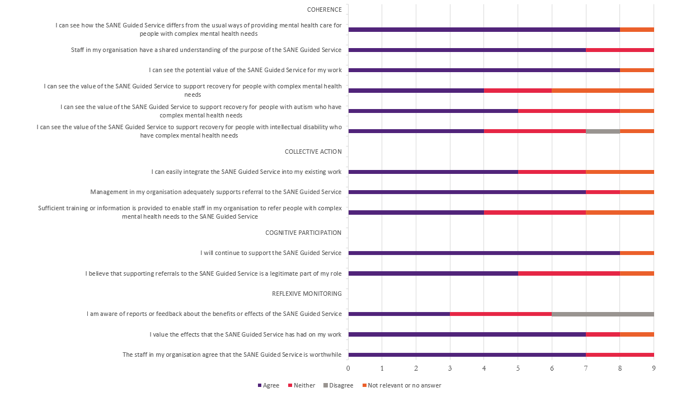
Figure 2: Summary of responses for nine PHN representatives
Promotional activities by SANE were viewed as highly beneficial by PHNs, with a key message from PHN interviewees across different timepoints that building awareness of a new service requires time and ongoing attention and effort:
“..a short sort of in-service [such as a Webinar], a quick connection with the SANE team and understanding what's happening with the program, how it's going, wait times, the opportunity to ask questions and just refresh again around the eligibility criteria … to get an understanding of how people are finding that experience, what their feedback is, what experiences around engaging with the service, what they're looking to do to improve based on that feedback” (PHN interviewee)
PHN interviewees and survey respondents expressed a desire for more feedback about benefits of the service. Most indicated that feedback about participants’ experiences of the service would be helpful in facilitating referrals:
“It would be good to read some feedback from consumers and understand outcomes - it is difficult to recommend a service without understanding the consumer experience”.
For the external stakeholders currently engaged with the service, the majority indicated that the information provided by SANE helped to increase awareness about the Guided Service and that the service filled a gap in the current supports provided for people with complex mental health needs.
Interactions between SANE staff and PHN service providers and various promotional materials were widely viewed as being beneficial. Guest presentations and meetings with individual providers had provided valuable opportunities for clinicians to ask questions and speak directly with SANE staff:
“one-on-one meetings with a lot of providers was awesome and has made a difference”.
Further opportunities for this type of engagement would assist some PHNs to raise awareness of and boost referrals to the service.
The value of making connections with local PHN teams was repeatedly emphasised. For PHNs covering rural areas, these connections and having a local presence took on even greater importance in terms of “getting the word out”.
The PHN experience varied, with some expressing a significant and ongoing uplift in the number of referrals to SANE, others indicated that without ongoing promotion it was easy for the service to “fall off the radar”.
Having a champion or ambassador within the PHN helped greatly to enhance uptake and referrals:
We have a GP who is an advocate for mental health and very passionate about the service and has promoted the service widely. (PHN interviewee)

Views of other professional stakeholders
Figure 3 presents a summary of responses from 33 non-PHN stakeholders, comprising community mental health services and other health providers, who completed the Professional Stakeholder Survey. One-third (n=11) of these stakeholders had already made, or facilitated, one or more referrals to the SANE Guided Service.
As for responses from PHN stakeholders, these pointed to the importance of efforts to enhance understanding across the sector of the value of the service. Further information and/or training to facilitate referrals, and feedback about benefits of the service may help to support wider implementation and enhance access for people with complex mental health needs.
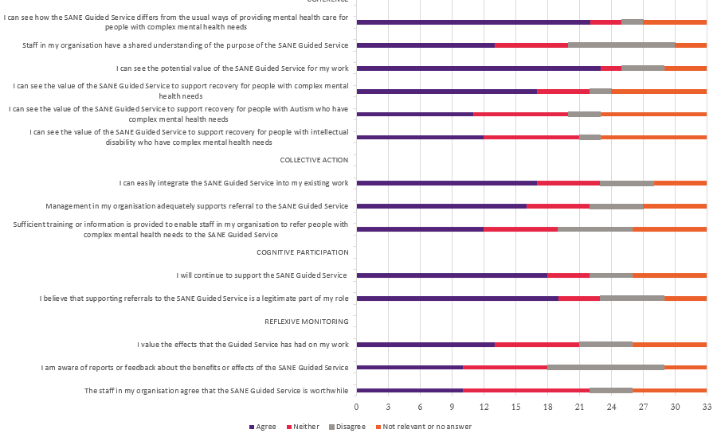
Figure 3: Summary of responses for 33 non-PHN stakeholders

  - Guided Service participants (KEQs 1.5, 1.6, 1.7)

Participant engagement with the Guided Service
There were 3,014 total referrals to 30 June 2023, 2,068 registrations through the online portal and 1,769 people completing a welcome call. The majority of Guided Service participants (92%) were people with mental health needs with the other participants being carers/family/friends of a person with mental illness (8%). A small proportion of referrals were people with self-reported intellectual disability (5%) and/or autism (11%).
The service appears to have achieved substantial engagement with non-binary and gender diverse people (10% compared with only 1% of clients in the PMHC MDS comparison sample) and LGBTQIA+ people (25% of participants). There are indications that Aboriginal and Torres Strait Islander peoples have lower access or engagement relative to other participants, including a lower proportion completing support planning, counselling and peer support sessions once engaged with the service.

Participant demographic characteristics
Of the 3,014 total referrals to 30 June 2023, 2,068 registered through the online portal and 1,769 completed a welcome call to become participants of the Guided Service. The characteristics of people referred to the program remained fairly consistent across the 59% subset who commenced the program (Table 4).
The majority of participants were people with mental health needs (92%), while the remaining 8% were carers/family/friends of a person with mental illness. Participants were mostly from younger to middle age groups, with 72% aged 18-44 years (Figure 4a). This age distribution looks similar to that of people who engage in online mental health services such as MindSpot but is slightly younger than the PMHC MDS comparison sample (Figure 4b) and adult service users of state community mental health services, PHN psychosocial programs and NDIS support for psychosocial disability. The SANE Guided Service had fewer participants aged 65+ (3%) compared to the PMHC MDS comparison group (12%).
Overall, 14% of participants were identified as CALD, consistent with the proportion seen in the PMHC MDS comparison sample. Six percent of people referred and 4% of participants identified as Aboriginal and/or Torres Strait Islander. This is higher than the proportion of the national adult population who identify as Aboriginal and/or Torres Strait Islander (3% of those aged 20 years or older), although relative levels of mental health need tend to be several times higher for Aboriginal and Torres Strait Islander populations. The proportion of participants who identified as Aboriginal and/or Torres Strait Islander is similar to that engaged by PHN psychosocial support programs generally (6%)13,15 but lower than the proportion in the PMHC MDS comparison sample (12%). However, SANE participants were recruited more from metropolitan PHN areas (71%) than the PMHC MDS comparison sample (51%).
While 67% of participants were female, a further 10% identified as non-binary, transgender, gender diverse, other or preferred not to state a gender. It is common for mental health services to have a higher proportion of female service users in this range of 60-70%13,15 and 64% of the PMHC MDS comparison sample were also female. The SANE Guided Service at 10% appears to have achieved substantial engagement with non-binary and gender diverse people, compared with only 1% of clients in the PMHC MDS comparison sample. Similarly, a relatively high proportion (25%) of Guided Service participants self-identified as LGBTQIA+.
Table 4: Characteristics of people reached by the SANE Guided Service compared to PMHC MDS data
Characteristics | Referred  (n=3,014)* | Participant completed  welcome call (n=1,769) | PMHC MDS comparison data  (n=88,251)
Participant type | - | - | -
Consumer | 93% | 92% | 100%
Carer/ Family/ Friend | 7% | 8% | –
 | - | - | -
Aboriginal and/or Torres Strait Islander | 168 (6%) | 79 (4%) | 12%
CALD | - | 247 (14%) | 14%
Self-identified | - | 237 (13%) | –
Born outside AU/NZ/GB/IE/US/CA | - | 204 (12%) | 8%
Non-English main language at home | - | 85 (5%) | 9%
Interpreter needed | - | 7 (0.4%) | 2%^
Gender | - | - | -
Male | 739 (25%) | 415 (24%) | 34%
Female | 2027 (67%) | 1185 (67%) | 64%
Other~ | 248 (8%) | 169 (10%) | 1%
Self-identified as LGBTQIA+** | - | 443 (25%) | –
Age group | - | - | -
18-24 | 596 (20%) | 333 (19%) | 23%
25-34 | 921 (31%) | 534 (30%) | 21%
35-44 | 677 (22%) | 401(23%) | 16%
45-54 | 480 (16%) | 285 (16%) | 15%
55-64 | 257 (9%) | 164 (9%) | 11%
65+ | 83 (3%) | 52 (3%) | 12%
Location | - | - | -
Metro PHN | - | 1236 (71%) | 51%
Regional/Rural PHN*** | - | 515 (29%) | 44%
* The referred data are from the aggregate referral summary report provided by SANE to UQ. Cells that are excluded in the table are data that are not collected at the referral stage.
^ Responses to Proficiency in English that are “Not at all” and “Not well”.
~ Includes individuals who identified as non-binary, transgender, gender diverse, agender, brotherboy, sistergirl, unsure/questioning, other/prefer to self-describe, or prefer not to say.
** The LGBTQIA+ indicator may be an underestimate as this is a non-mandatory field.
*** The Regional/Rural PHNs are based on the regions the PHN covers and is an approximation. PHNs classified as rural/regional cover large rural and regional areas. Regional/Rural PHN classification includes Central Queensland, Wide Bay and Sunshine Coast, Country SA, Country WA, Darling Downs and West Moreton, Gippsland, Hunter New England and Central Coast, Murray, Murrumbidgee, Nepean Blue Mountains, North Coast, Northern Queensland, Northern Territory, South Eastern NSW, Tasmania, Western NSW, Western Queensland, Western Victoria.
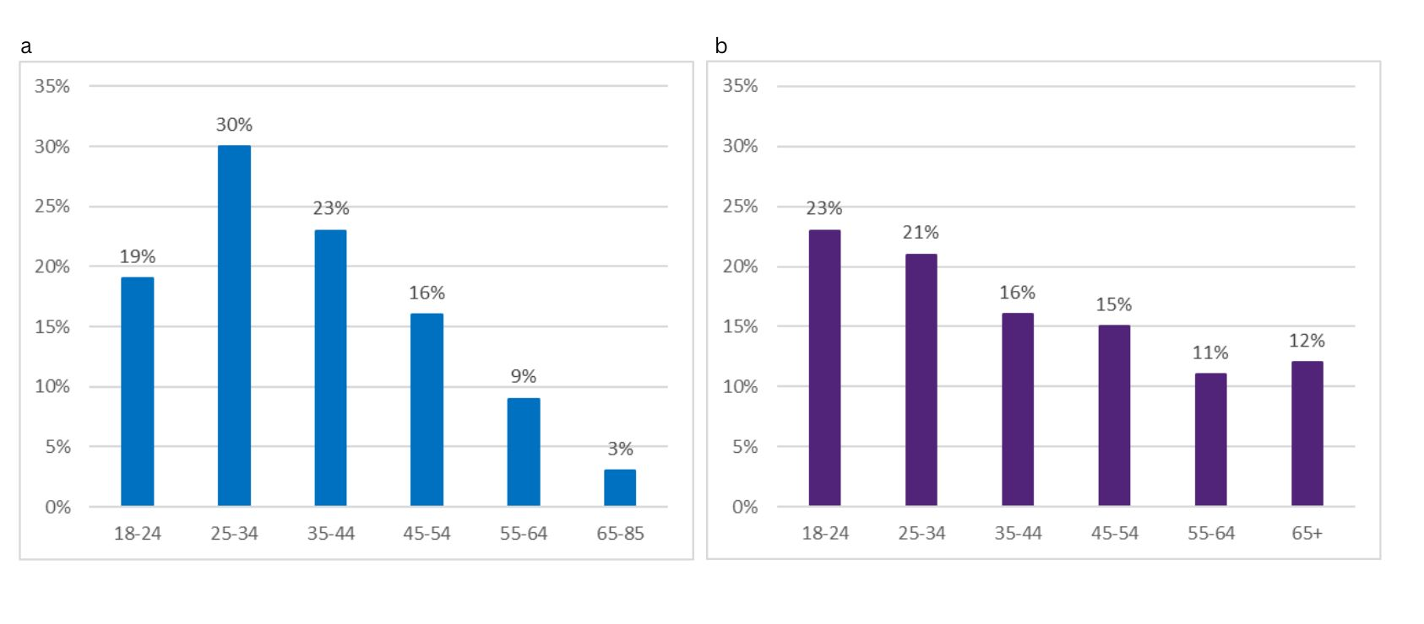Figure 4: a) age distribution for SANE participants, b) age distribution for PMHC MDS comparison group

Geographical distribution of participants
The map in Figure 5 shows the PHN regions from which the participants joined the Guided Service. A high proportion of participants were from Brisbane North PHN (16%), North Western Melbourne PHN (16%) and Central and Eastern Sydney PHN (12%) regions; these areas comprise three of the five PHNs originally participating at the start of the full service roll-out in May 2022. Thirty percent of participants came from PHNs covering rural and remote locations (including Hunter New England and Central Coast, Northern Territory, South Eastern New South Wales, Tasmania, Western Victoria, Darling Downs and West Moreton, Country Western Australia, and Central Queensland, Wide Bay and Sunshine Coast PHN regions). PHN regions that had less than 5 participants are not presented in the map below.
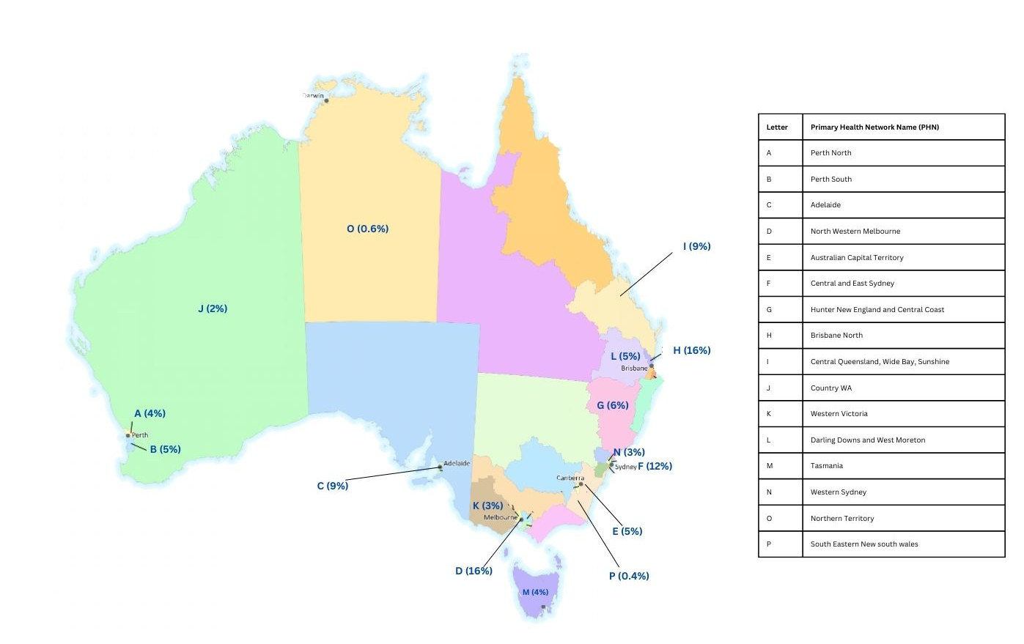
Figure 5: Geographical distribution of Guided Service participants across PHN regions.

Complex care needs of Guided Service participants
Guided Service participants self-reported high levels of complex need with 55% reporting at least one complex need including recent hospitalisation, homelessness or risk of homelessness, domestic and family violence, substance use or risk of self-harm. The SANE Guided Service appears to be filling important service access gaps; 20% of participants reported having no other support services in place and GP support was the sole source of care for a further 16% of participants.
Most SANE participants self-reported problems that were consistent with the target populations for the service, including mental health diagnoses, complex trauma, and/or one or more disabilities and other co-occurring conditions such as homelessness, domestic violence or AOD needs (Table 5).
The distribution of primary mental health diagnoses for Guided Service participants was broadly similar to that of the PMHC MDS comparison group. However, a somewhat greater proportion of SANE participants had post-traumatic stress disorder (PTSD), attention deficit hyperactivity disorder (ADHD) and personality disorder, while somewhat fewer had depressive/other affective (non-bipolar) disorders compared with the PMHC MDS cohort (Table 5). The most common primary diagnoses for Guided Service participants were PTSD (14%) and other anxiety disorders (13%). Participants also reported having a range of disabilities, including 11% with autism and 5% with intellectual disability (Table 5).
Seventy-three percent of participants self-reported complex trauma and 55% reported current concerns indicating complex needs. Participants reported a range of these other concerns, including 28% identifying risk of self-harm, 22% concerns with substance use, 12% homeless or at risk of homelessness, and 15% experiencing domestic and family violence. There was a high rate of illness severity or acuity indicated by 13% of participants reporting that they had been recently hospitalised. In the PMHC MDS comparison sample, 19% had suicide risk flagged at referral and for 5% of episodes the client was homeless in the four weeks prior to commencement. Both data sources identify the diverse complex needs of clients presenting with multiple conditions or concerns.
Despite these reported current health and social conditions, less than 5% of Guided Service participants had specific related support services in place: family violence service (2%, vs 15% reporting concern), homeless service (1%, vs 12% reporting concern), AOD service (2% vs 22% reporting concern). NDIS support plans were in place for 6% of SANE participants, slightly higher than the 4% of the PMHC MDS comparison group. Nearly half the participants had access to GP services and a similar proportion reported having a mental health care plan in place, which generally requires consultation with a GP (46%). This was similar to the 48% of PMHC MDS clients who had a mental health care plan in place. Beyond support from GPs, the most frequent other support in place for SANE participants was a psychologist (22%) or psychiatrist (17%), shown in Table 5.
The SANE Guided Service appears to be filling important service access gaps, particularly for the 20% of participants who reported having no other support services in place and the further 16% whose sole source of care was a GP. The quotes from SANE participants below highlight the role of the SANE Guided Service in providing care while transitioning between services or where there is limited availability of medical, health, and mental health services.
“And there was a gap between one phase of funding to another phase of funding, and that gap was for me, at a crucial time, when I needed support.” (Participant 140)
“All I was really hoping for was some more calls that I could use to get through until I could see a psychologist on a regular basis.” (Participant 126)
“I'm in a regional town…the population is like 10,000. So, there's literally no psychologists I can go and see. There's no complex mental health. We don't even have doctors at the hospital. At the moment I don't have a psychologist because my psychologist left [the service I was using], so I'm counting on just these sessions with SANE.” (Participant 130)
Table 5: Complex needs of SANE Guided Service participants compared to PMHC MDS data
Characteristics | Participant (completed  Welcome Call) (n=1,769) | Percentage | PMHC comparison data (n=88,251)+%
Primary mental health diagnosis* (n=902)~ | - | - | -
Post-traumatic stress disorder (PTSD) | 130 | 14% | 8%
Other anxiety disorder | 117 | 13% | 13%
Depressive/other affective disorder | 62 | 7% | 13%
Bipolar disorder/cyclothymia | 50 | 6% | 4%
Substance use disorder | 15 | 2% | 2%
Psychotic disorder | 26 | 3% | 3%
Attention deficit hyperactivity disorder (ADHD) | 49 | 5% | 1%
Personality disorder | 66 | 7% | 4%
Other disorders/symptoms | 252 | 28% | 46%
Undisclosed | 8 | <1% | –
Carer of person with complex mental health needs | 3 | <1% | –
Has other complex needs | – | – | –
Recent hospitalisation | 232 | 13% | –
Homeless or at risk of homelessness | 218 | 12% | 5%
Domestic and family violence | 270 | 15% | –
Substance use (drug alcohol) | 385 | 22% | –
Risk of self-harm (self-harm/suicidality)^ | 490 | 28% | 19%
Any complex need | 981 | 55% | –
Has Mental Health Care Plan (n=1,672) | 811 | 46% | 48%
Has support services in place# | – | – | –
GP | 863 | 49% | –
Counsellor | 130 | 7% | –
Psychiatrist | 293 | 17% | –
Psychologist | 391 | 22% | –
Social worker | 70 | 4% | –
Community-based mental health | 171 | 10% | –
Hospital-based mental health | 44 | 2% | –
NDIS support plan | 102 | 6% | 4%
Family violence service | 30 | 2% | –
Child protection agency | 16 | 1% | –
Homeless service | 25 | 1% | –
Alcohol and other drug service | 33 | 2% | –
Other telephone and online counselling | 94 | 5% | –
Others | 394 | 22% | –
Any support services in place | 1413 | 80% | –
Reported complex trauma (n=955) | 694 | 73% | –
Self-reported disability** (n=1,143) | – | – | –
Psychosocial | 743 | 42% | –
Intellectual | 82 | 5% | –
Autism | 200 | 11% | –
Developmental | 28 | 2% | –
Acquired brain injury | 52 | 3% | –
Physical or accessibility needs | 226 | 13% | –
* Primary and secondary mental health diagnoses were only routinely recorded for new SANE participants after January 2023.
~ Remaining responses were invalid values, i.e., case notes (n=102; 11%)
+ The PMHC MDS comparison dataset was restricted to participants within the ‘complex needs’ inclusion criteria, for their first episode within the inclusion timeframe and for episodes that were not missing referral date to identify the episode. Total percentages may not sum to 100% due to missing data.
^ For SANE Guided Service Participants, this includes identified concerns of “risk of harm” (if referred from May 2022 to January 2023), “self-harm" or “recent suicide attempt” (if referred after January 2023). For PMHC MDS comparison data, this includes individuals where a recent history of suicide attempt, or suicide risk, was a factor noted in the referral.
# Participants could select more than one item, meaning the total of individual item percentages may exceed 100%.
**Individuals who selected at least one of these disabilities. People were able to report more than one type of disability.

How many participants completed the Guided Service and how many discontinued?
Of the 1,769 participants who had completed a welcome call, 803 (45%) had exited the service by 30 June 2023 with 94 having completed the service and 93 having a planned early exit. Of the participants who commenced the Guided Service, 231 had an unplanned exit from the Guided Service.
In total, as shown in Table 6, 1071 people accepted into and registering for the SANE Guided Service exited the service by 30 June 2023. A minority of these individuals (268) exited the service at triage prior to becoming “participants”, either not proceeding with the service, withdrawing from the service, or unable to be contacted.
For participants who exited after completing a welcome call (803, 45% of Guided Service participants), a majority were unable to be contacted during the triage phase or had a later unplanned exit from the service (mostly also due to loss of contact, n≥104 of 231 unplanned exits), with an average episode length of approximately 178 days from referral to exit. As shown in Table 6, a further 83 participants withdrew during the triage phase and another 93 due to a planned early exit (mostly also due to participant withdrawal, n≥36 of 93 planned early exits), with an average episode length of 177 days. No information was available on the reasons for participant withdrawal.
Overall, 94 participants exited the service after completing the services in their support plan (5%), with an average episode length of just under 233 days from referral to completion. The remaining 55% of Guided Service participants had not yet exited the program as of 30 June 2023.
Table 6: Discontinuation and completion of SANE registered referrals and participants through Guided Service stages
Discontinuation Point | Number of registered individuals (n=2068) | Average episode duration in days (SD, n)^ | Range
OVERALL service discontinuation/exit | 1071* | 189.72 (72.64; n = 457) | 0–407
Triage (prior to welcome call) | 268* | – | –
Withdrew | 38 | – | –
Unable to contact participant | 157 | – | –
After completing a welcome call (participants) | 803* | – | –
Withdrew | 83 | – | –
Unable to contact participant | 168 | – | –
Planned early exit | 93 | 176.98 (79.60)# | 0–392
Unplanned exit | 231 | 178.23 (66.12)# | 43–407
Service completed | 94 | 232.98 (63.61)# | 79–360
^ Episode defined as the number of days between referral date and recorded date of service completion.
* Totals include people with missing data on the reasons for discontinuation
# Due to missing exit dates, the sample size for average episode duration is different subtotals: Planned early exit n=87, Unplanned exit n=220, and Service completed n=91

Discontinuation by participants from priority populations
Discontinuation rates were similar overall for the SANE Guided Service and PMHC MDS comparison group at around 40%. Loss of contact with participants was the main reason for discontinuation. SANE participants with acquired brain injury, developmental disability, and Autistic people had somewhat lower rates of discontinuation compared to the overall cohort.
Rates of completion and discontinuation for the SANE Guided Service and PMHC MDS comparison group, disaggregated by priority populations, have been presented in Table 7. For Guided Service participants, 17% of those who exited the service were missing data on the reason for exit and have been assumed to be unplanned or early discontinuation. Discontinuation rates were similar overall for the SANE Guided Service and PMHC MDS comparison group, at around 40%. However, PMHC MDS clients had higher rates of planned exits at service completion (27%), compared to SANE participants (5%) due to a greater proportion of SANE participants still being supported by the service.
Discontinuation rates were similar between SANE consumers and carer/family/friends, and for priority sub-groups Aboriginal and Torres Strait Islander people, LGBTQIA+ people, people with intellectual disability, and both metro and regional/rural PHN areas. As shown in Table 7, SANE participants with acquired brain injury, developmental disability, and Autistic people had somewhat lower rates of discontinuation compared to the overall cohort. For Aboriginal and Torres Strait Islander and CALD participants, the discontinuation rates were similar to the rates for these groups of clients in the PMHC MDS comparison sample. Reason for exit, when recorded, was only available at a high level (withdrew, lost contact, unplanned or planned) and no further information was provided to understand why participants discontinued the Guided Service.
Table 7: Service completion and discontinuation by priority populations
Characteristics | SANE participants (n) | SANE Service completion (n) | SANE Discontinued (n)# | SANE Discontinuation rate (%)* | PMHC MDS Service completion (%)+ | PMHC MDS Discontinuation rate (%)^
OVERALL | 1769 | 94 | 709 | 40% | 27% | 39%
Participant type
Consumer | 1634 | 78 | 652 | 40% | – | –
Carer/Family/Friend | 135 | 16 | 57 | 42% | – | –
Identified as Aboriginal and/or Torres Strait Islander | 97 | 3 | 41 | 42% | 21% | 41%
CALD | 247 | 15 | 91 | 37% | 30% | 35%
Self-identified as LGBTQIA+ | 443 | 22 | 182 | 41% | – | –
Self-reported disability
Intellectual | 82 | 6 | 35 | 43% | – | –
Autism | 205 | 9 | 68 | 33% | – | –
Developmental | 94 | 3 | 32 | 34% | – | –
Acquired brain injury | 52 | 7 | 16 | 31% | – | –
Location
Metro PHN | 1236 | 70 | 494 | 40% | 24% | 42%
Regional/Rural PHN | 515 | 17 | 207 | 40% | 32% | 34%
# Discontinued for SANE refers to unplanned exit and planned early exit or exited with missing reason.
* Discontinuation rate is found by dividing the number of individuals discontinued (excluding service completion) by the number of individuals who commenced by completing a welcome call
+ Service completed for the PMHC MDS comparison sample refers to “Episode closed - treatment concluded”.
^ Discontinued for the PMHC MDS comparison sample refers to "Episode closed administratively – client could not be contacted, declined further contact, moved out of area, referred elsewhere, other”.
Note. All remaining participants for both the SANE Guided Service and PMHC MDS comparison group have episodes that are still open.
  - The digital platform (KEQ 1.8)

Acceptability of a digital service
PHN and professional stakeholders recognised the benefits of the SANE digital service model, noting that that the digital/telehealth service modality would not be a good fit for all people with complex mental health needs. For SANE Guided Service participants who completed an interview, receiving telephone support was an acceptable alternative to face-to-face support. There were diverse views about the digital service elements, with some participants choosing to engage only in telephone support.
Professional stakeholders and Guided Service participants consistently raised both strengths and limitations of the digital service model. Potential benefits were well-recognised:
“The nature of a digital/telehealth service also provides a unique accessibility for clients who may struggle in typical mental health settings.” (SANE staff member)
In interviews with PHN representatives, technical literacy and access to technology in the home setting were identified as likely barriers for some client cohorts including people from Aboriginal and Torres Strait Islander backgrounds, people experiencing socioeconomic stress, and people in contact with the criminal justice system. For some people, including those experiencing severe social isolation, face-to-face interactions and building trust in-person may be particularly important.
Many of the interviewed PHN representatives believed there was often a high level of resistance to services that were not face-to-face, or at least person-to-person.
“Some clients report that they prefer face to face support and don't like using the phone or computer for support. Some service providers have said that their clients have cognitive impairments and will find it difficult to access the service. It would be helpful to have resources available from SANE on this topic to address these concerns.” (PHN representative – Professional Stakeholder survey)
In one PHN interview, the impact of the COVID-19 pandemic was viewed as having had a paradoxical effect on telehealth services. While digital technologies had advanced and become more widely used, at the time of the introduction of the Guided Service:
“there was a real sense after COVID at that time, for a return to face-to-face services, and there was a lot of fatigue around telehealth online” (PHN representative)
Guided Service participants, both in interviews and in the online YES CMO SF survey, also highlighted their desire for face-to-face or video-conferencing options. This was a prominent theme in responses to the question of how their experience of service might have been better. Illustrative responses are shown below.
My experience would have been better if…
“I could have face to face or zoom call support”
“I have a phone phobia! I have Autism and can’t drop my mask until see the reaction of those I’m asking for help.”
“I was given the option of video conference rather than phone counselling.”
“Would suggest audio video services for mob who can’t read or have autism”
For most Guided Service participants who completed an interview, receiving telephone support was an acceptable alternative to face-to-face support. Views expressed about the digital services were more diverse: many chose not to engage with online forums and groups, while others were highly engaged with these services.
“I’m not real good at [using digital technology]. I feel very self-conscious…I find it always challenging. I am trying not to do things that are stretching my ability with the internet because I'll end up doing something wrong and then I just collapse in myself and start the negative self talk...” (Participant 107)

Ease of use of the SANE digital platform
Participants had mixed views regarding the SANE digital platform. Some found it straightforward and helpful; others preferred to set up appointments without using the platform. All user groups mentioned challenges regarding the navigability and functionality of the digital portal.
For some SANE participants, the digital platform was “pretty self-explanatory” (Participant 130) and “easy enough to use” (Participant 105), for example to check for or reschedule appointment dates, and it "makes you feel you have control of your own services" (Participant 103). SANE staff members noted greater autonomy for participants in managing their appointments as a positive of the SANE Guided Service:
“Participants value the ability to control their appointments to cancel or reschedule by themselves. This is different to their experiences with psychologists elsewhere.” (SANE staff member)
Other participants described the platform as “overwhelming” and “much too hard” and booked their appointments directly with their SANE contact person.
All user groups noted challenges regarding the navigability and functionality of the digital platform, including participants, PHN representatives and SANE staff members.
Across the two SANE staff surveys, excluding “not relevant” responses, around half of the respondents agreed that the digital platform was easy to use “always or most of the time” for Guided Service staff (13 of 23 respondents) or participants with complex mental health needs (10 of 22 respondents).
One SANE staff member commented: “[the portal] is challenging to navigate for staff who are neurodiverse or have a mental health condition”.
“The human side is working, but the technology is what’s letting them down.” (Participant 111)
Conversely, the sophisticated analytics now available within the platform are enabling more and faster attention to service delivery challenges. This has however required the engagement by SANE of three full time IT focussed staff.
  - Participant satisfaction and support (KEQ1.9)
Guided Service participants generally had high levels of satisfaction with their support experience once they had participated in sessions with Guided Service support staff. SANE staff were highly regarded and valued for their ability to listen and convey respect and understanding.
Participant feedback about aspects that could be improved centred mainly on wait times, changes in staffing and service offerings without sufficient prior communication, and challenges with digital technologies. The finite number of support sessions available was a concern for some Guided Service participants and providers, and particularly for participants with few alternative support options.

Overall experience of the Guided Service
As shown in Figure 6, just over two-thirds of the 89 participants (69%) who responded to this question in the YES CMO SF survey, rated their experience of the service as ‘Excellent’ (46%) or ‘Very Good’ (23%). One in five survey respondents rated their service experience as ‘Poor’ (14%) or ‘Fair’ (6%).
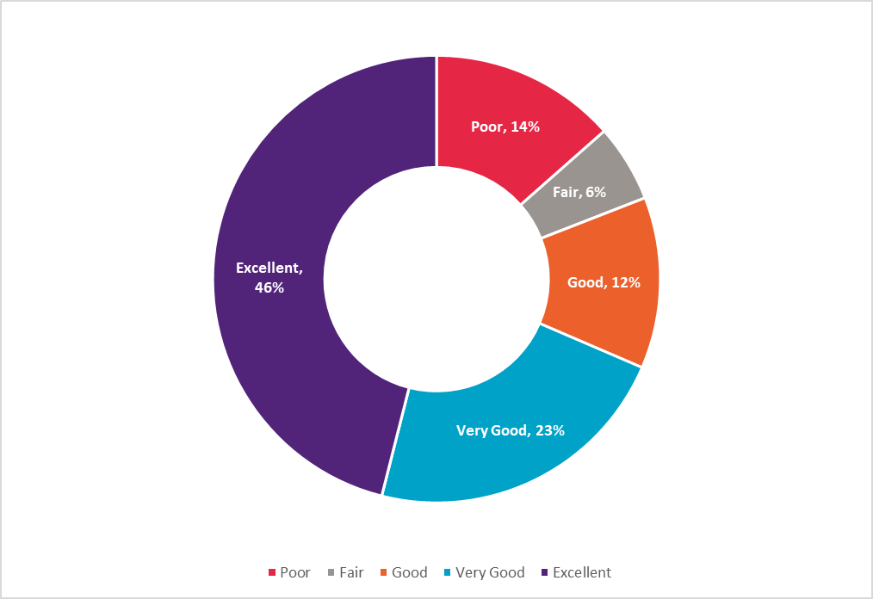
Figure 6: Overall rating of the service by 89 YES CMO SF survey respondents
Of the five participants who completed the Easy Read version of the YES CMO SF survey, all but one rated their experience of the service as ‘Very Good’.
As shown in Figure 7, most Guided Service participants who completed the YES CMO SF survey agreed that SANE staff ‘always’ or ‘usually’ showed respect towards how they were feeling (95%), and that staff were positive for their future (92%). Guided Service participants generally expressed high satisfaction with the support provided by SANE PSWs and counsellors. Participants who completed the Easy Read version of the survey rated their experience of the service as even more positive, with only one participant disagreeing with the statement about ‘support meeting your needs’. Participants always or sometimes agreed with all other items that were included in the shorter Easy Read survey.
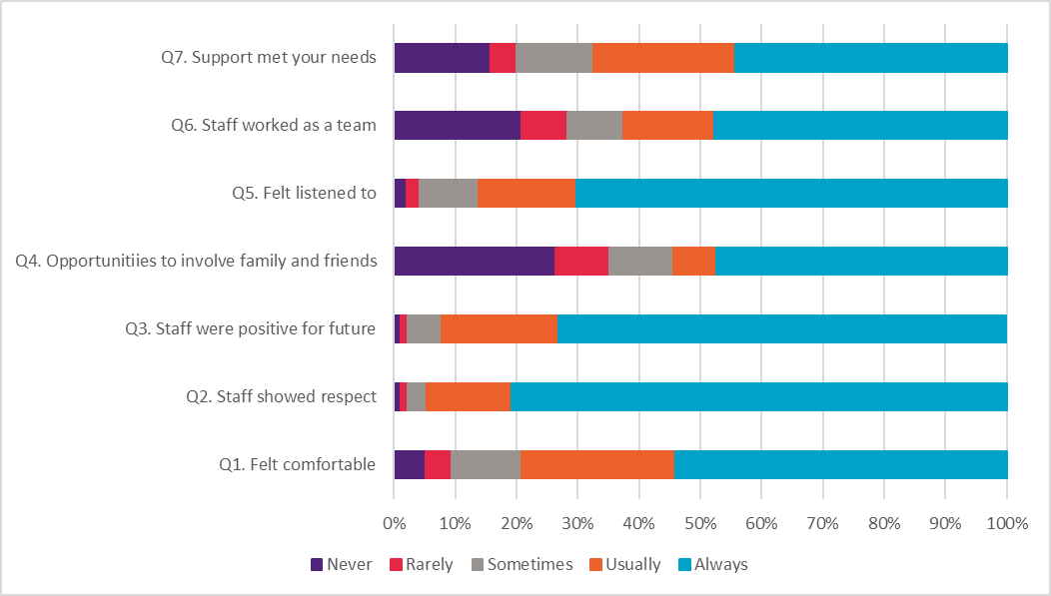
Figure 7: Summary of Guided Service participant responses to YES CMO SF survey items
As shown in Figure 7, participants completing the YES CMO SF survey rated lower satisfaction with opportunities to involve family and friends, and feeling that staff worked together as a team. However, these elements may be less relevant to the Guided Service model. Similarly, participants rated lower satisfaction regarding their involvement in the development of a care plan addressing their support needs (Figure 8).
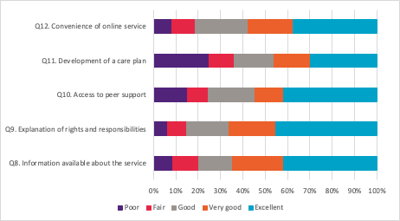
Figure 8: Summary of YES CMO SF respondents’ ratings of aspects of the Guided Service

Much of the participant feedback about aspects that could be improved centred around lengthy wait times, cancellations, and changes in staffing or service offerings without sufficient prior communication. Unmet expectations about timely support were a source of significant frustration, disappointment, and distress for some participants.
“Finding timely, relevant and targeted support, is extremely difficult and frustrating and makes one feel that's being placed in the too hard basket… And that makes you as a person feel even worse because again that makes you feel like just a number and that you're not worth anything.” (Participant 102)
“My [counsellor] just left. No warning, no nothing. And for me, what personally, that really that actually makes me worse. Like I'm a person that needs to know what's going on … if you are going to leave, I do need to know that because of one of my conditions I have like a fear of abandonment. So, I felt very, very abandoned, and nobody actually got in touch with me until weeks later to tell me.” (Participant 101)
“The worst part has been from an admin support side. It's very disjointed. It lets itself down.” (Participant 140)
Many participants reflected on the sense of worry that the limited number of sessions evoked for them and that support for people with complex mental health needs warranted more than 12 sessions.
“The worst thing is probably that looming deadline of ‘Okay, this is gonna end soon, and therefore that won't exist anymore’. That kind of sucks.” (Participant 135)
Also identified for improvement were technical challenges relating to the use of digital technologies or the digital platform (see section 3.5 digital platform).
Guided Service participants who completed the online YES CMO SF survey frequently raised these issues in responses to the question of how their experience of service might have been better. Illustrative responses are shown below.
My experience would have been better if…
“The waitlist for counselling has been really long, a couple months at least”
“I have not been receiving assistance for 3 months yet. I have not used the chat but have looked at online resources.”
“I was given updates about when I would start receiving counselling.”
“I had someone to physically show me or walk through with me how to use the website as I'm not good with technology”
“If the booking system was better, more appointments and support when in crisis besides 1-2 appointments a month, more fitted counsellor, better customer service reach/availability”
“My scheduled phone appointments worked...there was a technical problem which was not resolved”
“The calls didn't keep cutting out. Better call technology would be a better experience for both your counsellors and clients”

The best thing about the service was…
“Peer Support and encouragement to take small steps to get there.”
“A great counsellor, with skin-in-the-game experience of the difficulties involved.”
“A great match of therapist.”
“Counsellor was excellent- felt listened to and she provided resources outside of session.”
“Everyone always listens without judgement.”
“I was able to get a counsellor who rings me fortnightly to see how I am going.”
“The compassion, empathy and understanding from the support workers.”
For Guided Service participants, including carers and people with intellectual disability, the vast majority who rated a support session gave a positive (thumbs up) rating immediately after the session. Figure 9 shows that 98% of the sessions rated received a thumbs up rating. Comments that were commonly made alongside thumbs up ratings echoed many of the YES CMO SF survey responses and centred on participants feeling understood, heard and less isolated. One participant who completed the Easy Read questions about satisfaction with service commented:
“My peer worker was so unconditionally supportive and really cared about helping me meet my goals. That relationship that we developed over 12 sessions was the best part, hands down.”
Gaining a sense of hope and new skills and strategies to manage their mental health were also viewed as benefits by many participants.
“I think the counsellor giving me strategies like how to deal with the thoughts and cope better with the rumination and the negative thoughts and how to change them. Definitely giving me tools, strategies… otherwise you could just spiral downwards very quickly.” (Participant 106)
Only a small minority of sessions were rated negatively. In these instances, the concerns raised tended to relate either to technology or system issues or to a view that the counsellor or peer supporter was a poor fit for the participant’s needs. Having some flexibility around the choice of support person was important to participants.
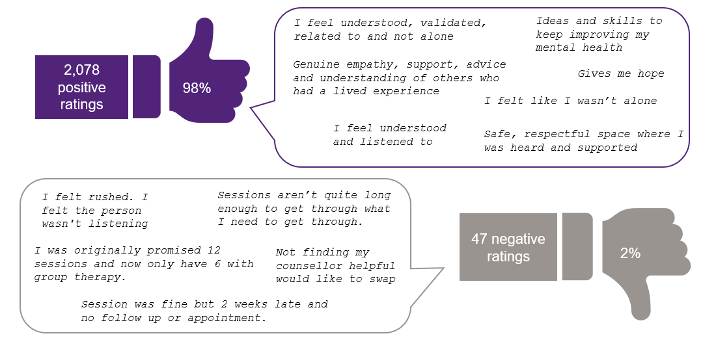
Figure 9: Summary of sessions ratings with quotes from participants
The 76 sessions that were rated by people who identified as having intellectual disability offer some insights into the experience of this group. All but three of the rated sessions received a thumbs up rating. Generated from the short open-ended responses provided alongside these ratings, the word cloud below highlights the positive experiences of support received.
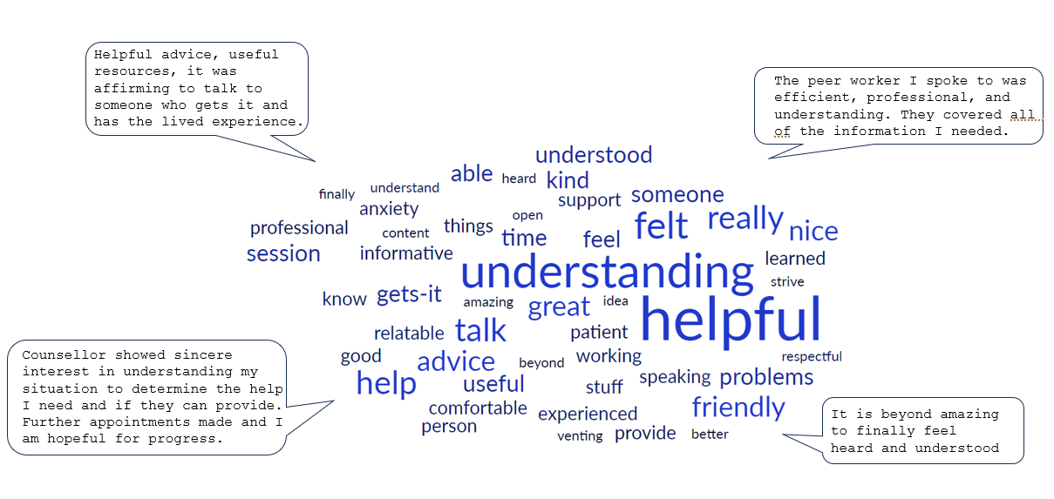
- Has the Guided Service made a difference to participants?
Achieving better outcomes for people with complex mental health needs involves multiple elements of service engagement and experience. Key requirements for the Guided Service to make a difference to participants, compared with usual supports include:
- reduced waiting times and easy access to mental health services (KEQs 2.3, 2.1)
- appropriate and timely intervention (KEQ 2.2)
- provision of different service modalities including effective self-directed resources to support recovery (KEQ 2.11)
- improved connection between primary and mental health services (KEQ 2.4)
- effective implementation of ‘step-up’ and ‘step-down’ protocols and use of other government-funded services (KEQ 2.5)
- intensity of service provision appropriate to need (KEQ 2.6)
- achieving better outcomes, including for people from specific target cohorts (KEQs 2.7, 2.8, 2.9, 2.10)
We were unable to address KEQs 2.5 and 2.6 above due to unavailability of data from the SANE Guided Service. Policy and procedure documents detailing for step-up and step-down protocols were not made available, and work done in support planning/management and transition was not recorded in the client management platform. The intensity of service provision (number and type of sessions provided) was not able to be disaggregated by level of participant need due to the small number of cases where baseline assessment data were collected.
  - Waiting times and service access (KEQs 2.3, 2.1)
Although intended as a readily accessible digital companion or alternative to traditional mental health supports, there were long average waiting times for participants to receive support from the SANE Guided Service across the evaluation period. There was a high rate of both appointment cancellations and no-shows across the services provided.
On average, SANE Guided Service participants waited approximately 2 days after being referred to then be assigned for review (Figure 10). After being assigned, participants experienced an average wait time of 20 days to complete a welcome call. The longest wait time during the service commencement stage was experienced by participants when they were transitioning from the welcome call stage to the support planning. On average participants waited 37 days before they could access the support planning and the other services in the SANE Guided Service (Figure 10). In total, the average wait time for participants from the initial referral date to support planning was therefore 59 days or nearly 2 months. Participants then experienced an additional average of 19.5 days before completing their first session (either counselling, peer support, or group-based) after support planning. This is an average delay of 78.5 days from referral to the first session. Wait times were experienced as lengthy by respondents from the YES CMO SF survey (see Section 3.6) as well as through interviews with SANE participants.
Figure 10: Average number of days that participants waited for service commencement
(Depicted are the stages between referral to assignment, assignment to welcome call and welcome call to the creation of a support plan for period covering until 31 May 2023.)
Being able to provide timely access to support in the context of high and growing demand for services and extensive waitlists was seen by PHN representatives as a key benefit of the SANE Guided Service:
“The feedback we have had from providers, and our intake team is that SANE has been a great option to refer people to that are on waiting lists – or as an additional support for other services a client might be accessing.” (PHN representative)
However, concerns were raised about SANE’s capacity to match demand and the potential impacts on waiting times for those referred to the Guided Service. One interviewee noted their reluctance to promote the Guided Service as a referral option following concerns that capacity had been reached: “we don’t want to offer people who are already on a waitlist another waitlist”. The availability of information and updates from SANE about the wait times being experienced was important for maintaining confidence in the Guided Service as a referral pathway.
Figure 11 shows the total number of Guided Service sessions booked, by whether the session was completed, cancelled, or the participant did not attend (‘no-show’). The bulk of appointments related to welcome calls, counselling and peer support services, followed by support planning sessions. Notably, there were low overall numbers of appointments completed for mid-point reviews and befriending calls, reflecting the optional nature and removal of these session types respectively from the SANE Guided Service journey. There were also relatively few group-based sessions completed; these figures reflect both low uptake by participants and the pausing of group-based sessions in February 2023 by SANE. Group sessions were relaunched in July 2023 with a redesign to focus on mutual self-help.
Figure 11 shows there was a high rate of both appointment cancellations and no-shows across the service. Approximately 21% of the planned welcome calls were cancelled while 25% were no-shows. The group-based sessions had the highest rate of no-shows at 48% of the sessions. The data also indicated higher combined numbers of group session cancellations and no-shows (n=309) compared to the completed group-based activities (n=107), reflecting the poor uptake of group-based sessions cited by SANE with these sessions paused in February 2023.
The second highest cancellation rate was for the peer support sessions, where 31% of the planned sessions were cancelled. Counselling sessions had the lowest no-shows at only 11%. In contrast, the average number of no-shows for psychosocial support sessions in the PMHC MDS comparison sample was 3.3 cancellations, representing 3% of all psychosocial sessions across the sample, a smaller percentage relative to the SANE sample. The rate of cancellation for midpoint review, support planning and group-based sessions was approximately the same, at a rate of 26% of the planned sessions. Interviews with Guided Service participants indicated that some cancellations were initiated by SANE, as well as by participants themselves. We note that participant cancellations and cancellations by the service have different implications, but data regarding the origin of cancellations were not available to the evaluation.
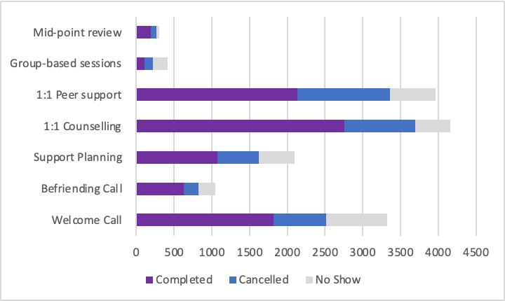
Figure 11: Total number of completed, cancelled, and no-show appointments for each type of session of the SANE Guided Service.
Table 8 shows the average number of completed, cancelled and no-show sessions per participant, by session type. These figures include participants who have completed online portal registration up to 30 June 2023 (N=2,068), including a small portion of those registered who were waiting to commence the service, including completing a welcome call. On average, participants completed one welcome call (0.9), 1.3 counselling sessions, one peer support session, and 0.5 sessions of support planning. As noted earlier, fewer befriending sessions, group-based sessions and mid-point reviews were completed overall and per participant. The largest variation in number of sessions received by participants was for the counselling sessions, where participants attended between 0 and 24 sessions of counselling each. Similarly, the number of peer support services received ranged from between 0 and 22 sessions per participant. This wide range indicates that some participants may be accessing different numbers of sessions as needed for their journey. Although only used by a small number of participants, some participants reported accessing up to 10 group-based sessions. The range of sessions provided for support planning, mid-point review, and befriending services was naturally small as participants are only expected to attend one of each of these sessions, these sessions are optional for participants.
Table 8: Average number of sessions completed, cancelled, and missed by participants who have completed portal registration*
Session type | Completed |  | Cancelled |  | No-show
 | Mean (SD), Range |  | Mean (SD), Range |  | Mean (SD), Range
Welcome Call | 0.88 (0.40) | 0–4 | 0.34 (0.65) | 0–5 | 0.39 (0.76) | 0–5
Befriending Call | 0.30 (0.48) | 0–3 | 0.09 (0.37) | 0–4 | 0.11 (0.44) | 0–5
Support Planning | 0.52 (0.52) | 0–3 | 0.27 (0.61) | 0–5 | 0.23 (0.61) | 0–5
1:1 Counselling | 1.33 (3.44) | 0–24 | 0.46 (1.23) | 0–10 | 0.22 (0.77) | 0–10
1:1 Peer support | 1.03 (2.45) | 0–22 | 0.59 (1.34) | 0–12 | 0.30 (0.80) | 0–7
Group-based sessions | 0.05 (0.44) | 0–10 | 0.05 (0.39) | 0–7 | 0.10 (0.56) | 0–9
Mid-point review | 0.09 (0.30) | 0–2 | 0.04 (0.23) | 0–4 | 0.02 (0.16) | 0–2
* Per type of session up to 30 June 2023 (N=2,068)
Figure 12 shows the total number of support sessions (counselling, Peer and Group) received by each participant. Notably, approximately half the participants had received no support sessions, and the majority had received only a small number of sessions. However, there was a small group of participants who received more than 20 sessions of support each. This pattern of few sessions per person potentially reflects the high rate of service discontinuation overall, as well as many participants who were still engaged with the service as of 30 June 2023.
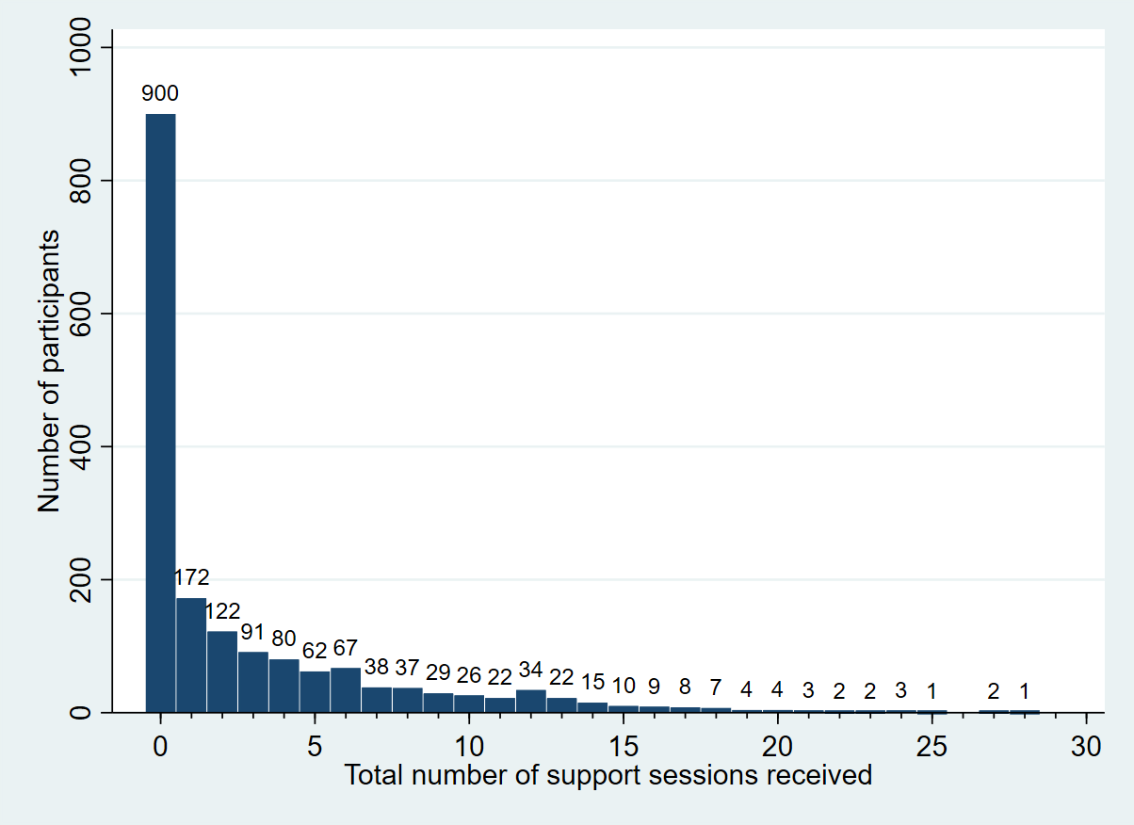
Figure 12: Distribution of total number of support sessions completed by Guided Service participants.
Focusing just on participants who had completed and exited the Guided Service, all of these participants had received at least three support sessions, with the median number being 12 sessions of support prior to service completion (Figure 13).
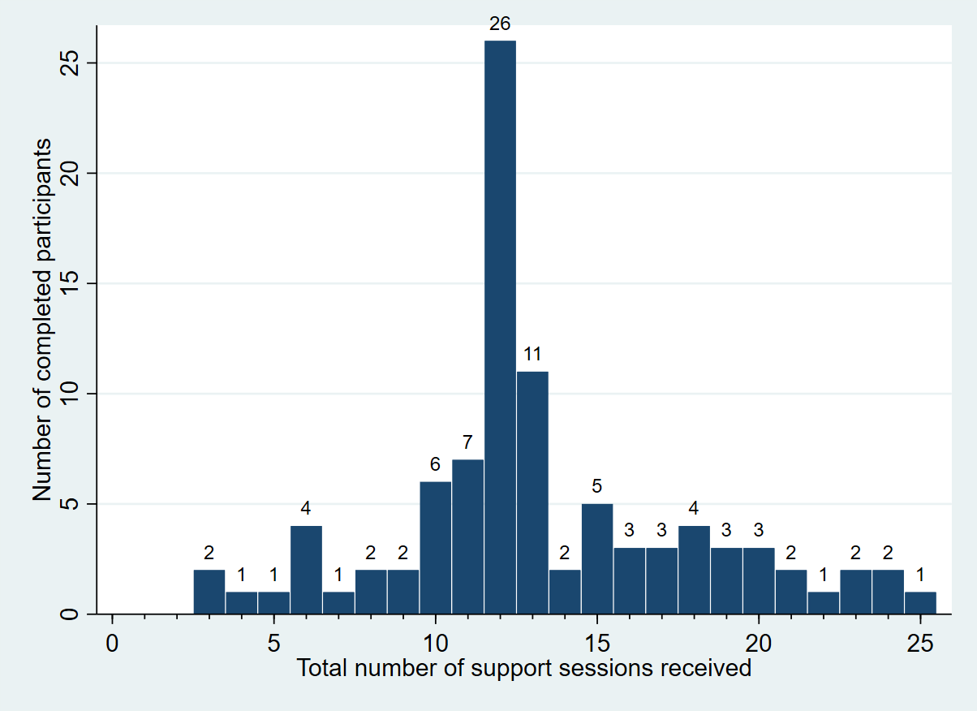
Figure 13: Distribution of total number of support sessions for participants who completed the Guided Service
The SANE leadership team highlighted additional context around the complexity of engaging some participants with complex mental health needs in the Guided Service. A recurring pattern for some participants who signed up for the Guided Service but had not yet received a welcome call was that they had multiple contacts with SANE staff via online Forums and the drop-in line (including activation of emergency response aftercare) alongside cancellations and no-shows for the Guided Service welcome call. Often this involved considerable hidden effort that was not captured in the data available for the evaluation. One of the visions for future service development presented by the SANE leadership team was “to model what these harder to engage’ participants require to be supported into the service over a longer period” and then to develop and provide a tailored model of support to enhance engagement.
“It's actually one of what I think our biggest strengths will emerge as – for people with complex needs this just might be what the pattern of engagement attempts looks like and over time we can build enough trust to eventually get someone into service.” (SANE leadership team)

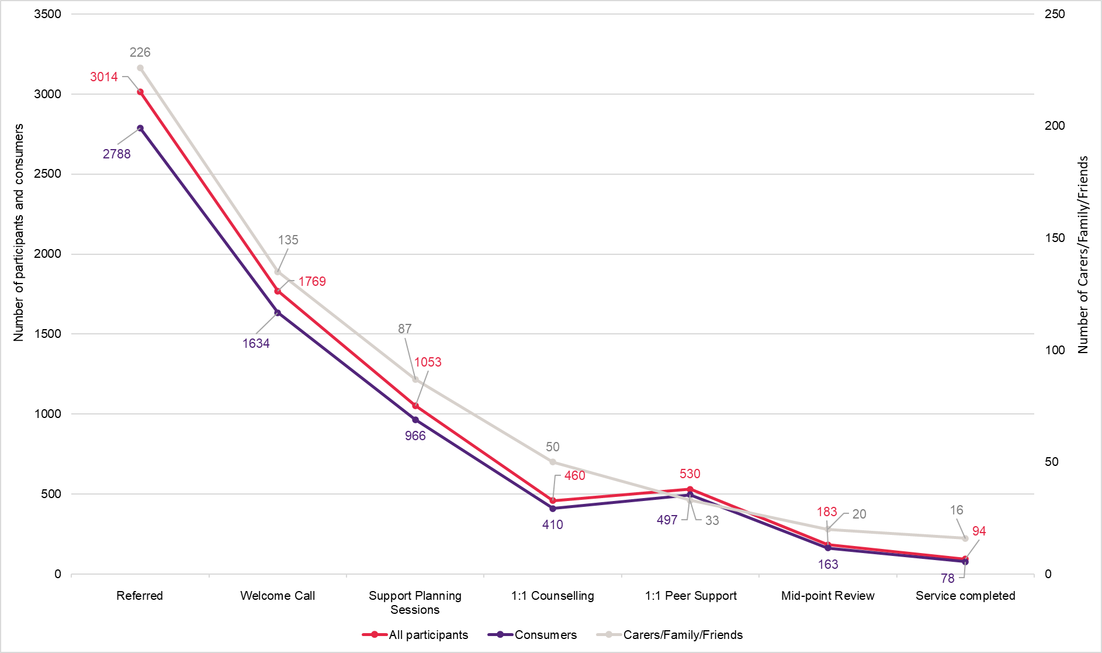
Figure 14: Participant journey mapping across key service milestones as of 30 June 2023 for all participants, consumers, and carers/family/friends.
Note. Although this figure displays a linear journey, the stages of service engagement diverges when participants begin undertaking one-to-one sessions. Participant journey progression is consistent across stages for all participants from referral up until support planning sessions. However, participant engagement with one-on-one sessions differs from person to person, with participants completing counselling, peer support, or both.
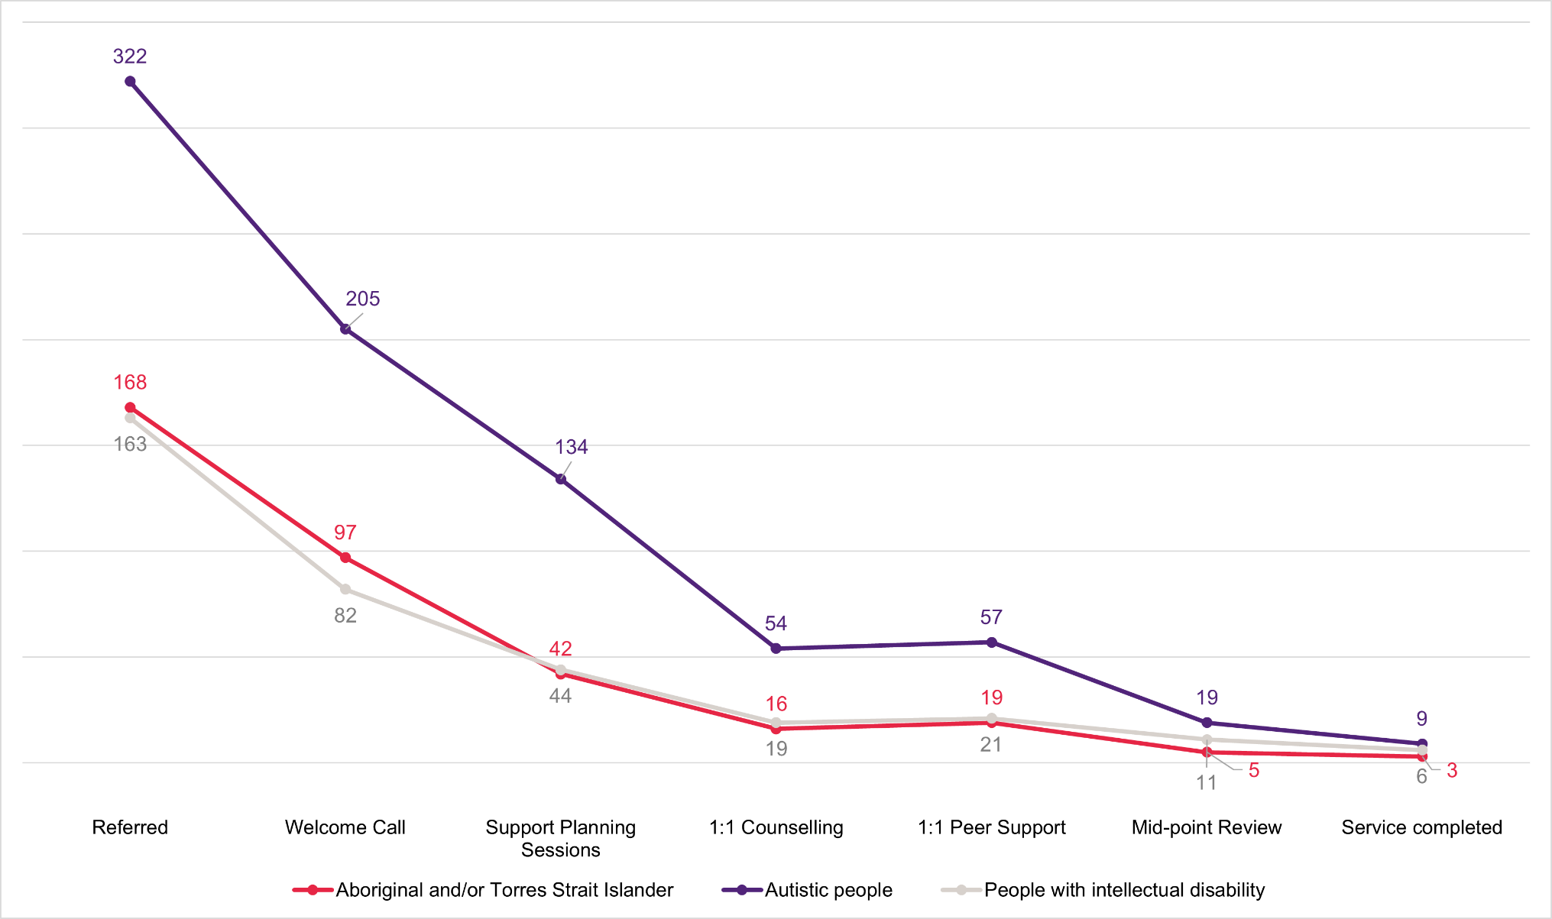
Figure 15: Participant journey mapping for priority population groups (Aboriginal and/or Torres Strait Islander participants, Autistic people, people with intellectual disability).
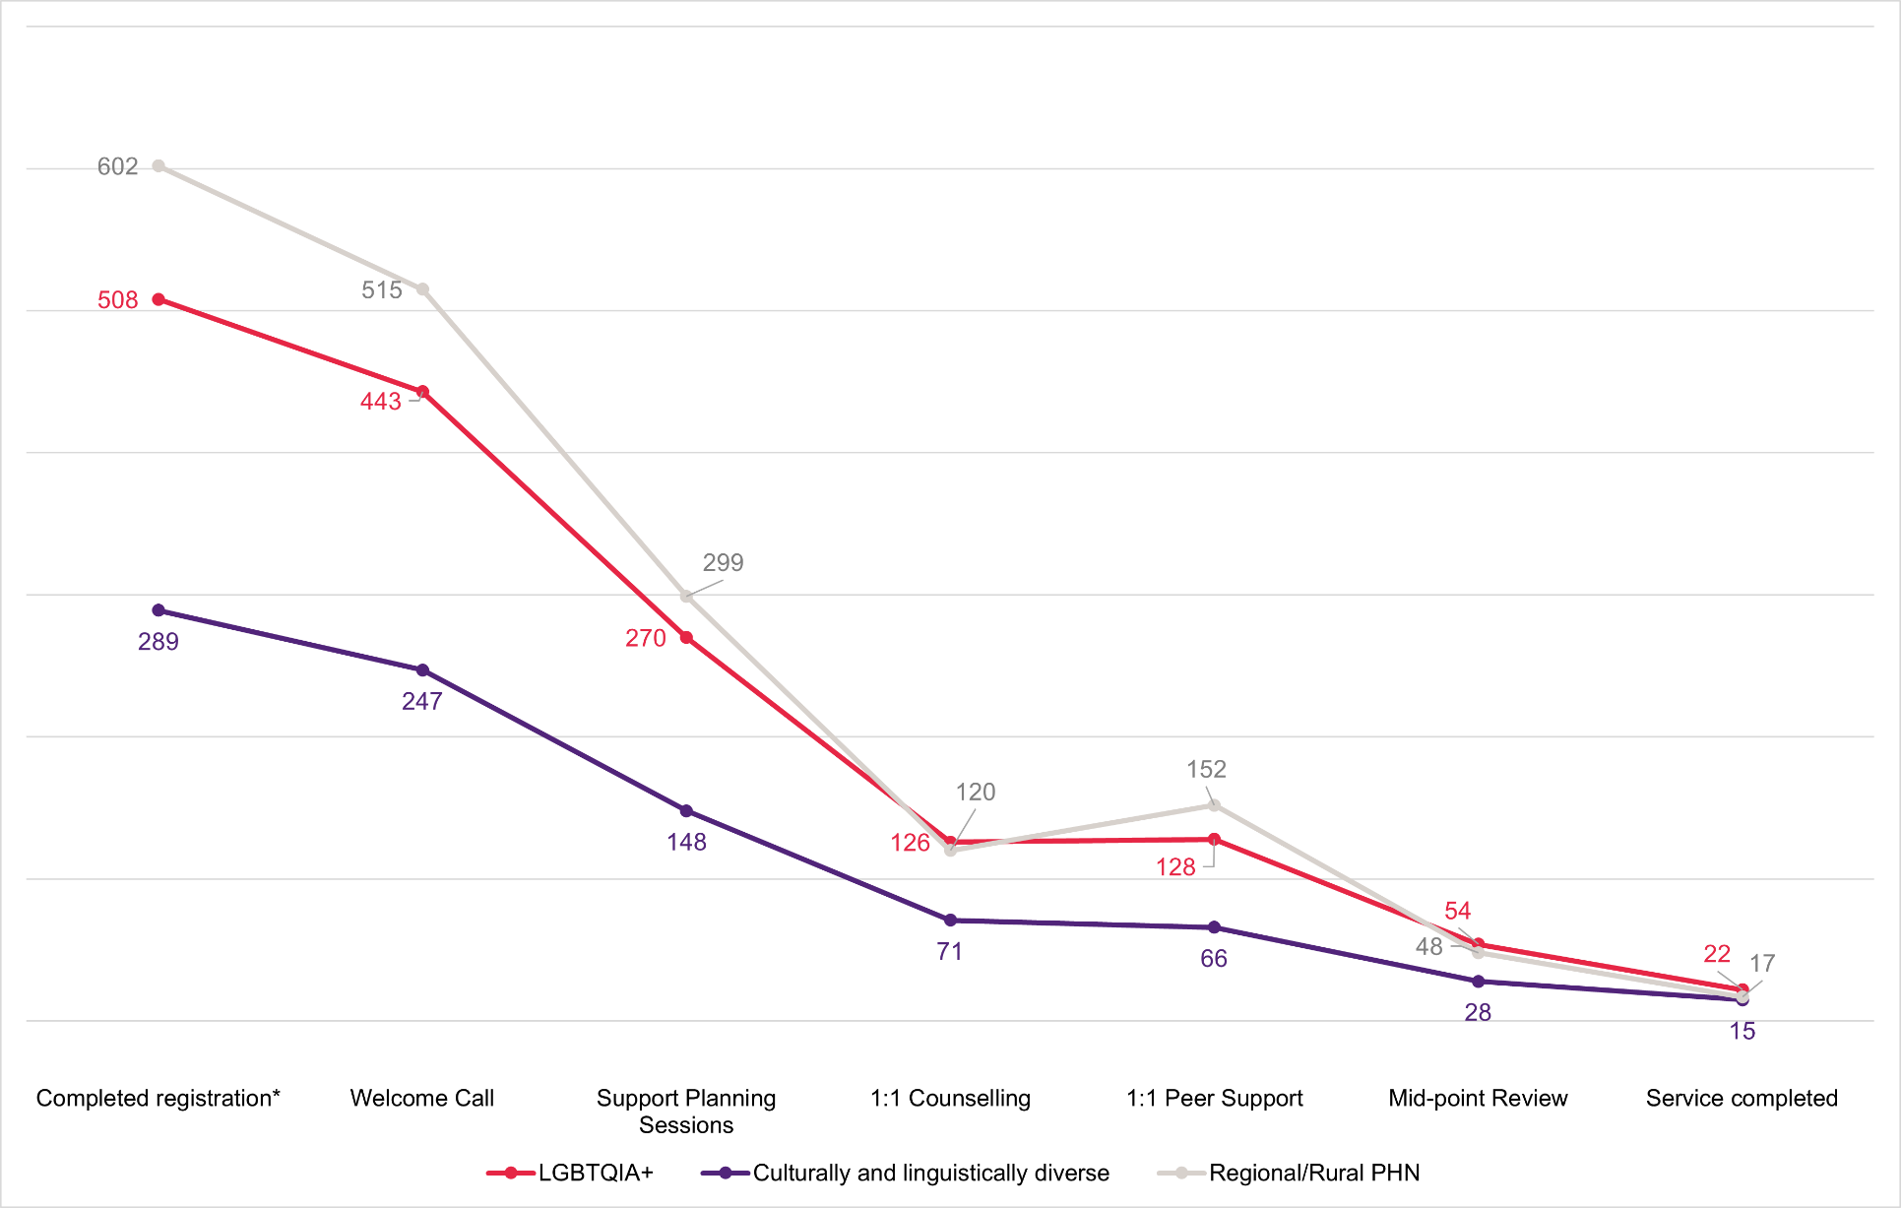
Figure 16: Participant journey mapping for priority populations including LGBTQIA+, culturally and linguistically diverse and regional/rural PHN groups.
*LGBTQIA+, CALD, and PHNs are collected after completing portal registration.

Sessions received and service pathways from referral for priority groups
Figures 14 to 16 show the pathways through the Guided Service from referral to completion for participants overall (Figure 14), for consumers versus carers/family/friends, and for priority populations including those with intellectual disability, Autistic people and Aboriginal and/or Torres Strait Islander populations (Figure 15), and participants who identify as LGBTQIA+, CALD, or live in regional/rural PHN areas (Figure 16). The journey for each priority group appears to be generally similar to the overall participant cohort shown in Figure 14, showing an initially steep decline in numbers of people being referred versus completing welcome calls and support planning sessions, and then smaller numbers of people going on to complete various one-on-one support sessions and the Guided Service overall. After completing a welcome call, 60% of all participants completed support planning, 26% completed counselling sessions, 30% completed peer support sessions, and 5% had exited after completing the Guided Service (Table 9). As noted previously, patterns of participant engagement with one-on-one sessions differ from person to person, with some participants completing both types of sessions. In contrast, others engage exclusively with one kind of session.
Table 9: Utilisation rate of each session type by SANE Guided Service participants completing a welcome call*
Participant type | Support Planning | 1:1 Counselling | 1:1 Peer Support | Service Completed
OVERALL | 60% | 26% | 30% | 5%
Consumer | 59% | 25% | 30% | 5%
Carer/Family/Friend | 64% | 37% | 24% | 12%
Aboriginal and/or Torres Strait Islander | 43% | 16% | 20% | 3%
Autism | 65% | 26% | 28% | 4%
Intellectual disability | 54% | 23% | 26% | 7%
Self-identified as LGBTQIA+ | 61% | 28% | 29% | 5%
Culturally and linguistically diverse | 60% | 29% | 27% | 6%
Regional/Rural PHN | 58% | 23% | 30% | 3%
*In the table above green text indicates the high proportion of participants completing the specific session type, while red text indicates the low proportion who completed the specific session type.
As shown in Table 9, participants with complex mental health needs (consumers), those who self-identified as LGBTQIA+, CALD or living in regional/rural PHNs had a similar rate of service engagement after their welcome call to the total participant cohort. One area of difference was that only 3% of participants from regional/rural PHNs had completed the Guided Service; it is possible this could reflect a lack of alternative mental health supports in these areas for SANE participants to step down to after the Guided Service.
Relative to all participants and consumers, a higher proportion of carer participants had progressed to support planning (64%), counselling (37%) and service completion (12%) while a lower proportion completed peer support sessions (24%). Autistic people also had a higher completion of support planning than other groups (65%), but subsequently similar proportions accessed other supports and completed the service. In contrast, for participants with intellectual disability a lower proportion completed support planning (54%), but a higher proportion completed the Guided Service overall (7%).
Concerningly, Aboriginal and or Torres Strait Islander participants appeared to have lower service access or engagement across the board, with only 43% of those who completed a welcome call progressing to complete a support plan, 16% completing counselling sessions, 20% completing peer support sessions, and 3% exiting after completing the Guided Service. This suggests that Aboriginal and Torres Strait Islander people may experience more personal or service-level barriers to engaging in the SANE Guided Service and may require more targeted approaches to improve engagement relative to other participant groups. One PHN representative noted that they, and possibly other PHNs, had commissioned free mental health care services developed and led by First Nations people and that these commissioned services were likely to be prioritised for this population.
The graphs above (Figures 14 to 16) do not include two service types, the befriending call and the group-based sessions. The befriending call service is discontinued from the SANE Guided Service and is no longer offered to participants. In February 2023 the group-based services were paused, to be re-designed to focus on mutual self-help and re-launched in July 2023. The participation in the Midpoint review is not compulsory; this is reflected in the low participation rates in Figures 14 to 16.
  - Appropriate and timely intervention (KEQ 2.2)
All stakeholder groups affirmed that the Guided Service model included enhancements to the current mental health service landscape. SANE participants identified a range of service design features they found helpful, including the focus on support for people with complex mental health issues, the choice to link with a counsellor or PSW, and continuity of support via a block of planned telephone support sessions. Highly valued was that the service was free of charge to participants.
Provision of support for Autistic people was considered one of several points of difference between the SANE Guided Service and other existing services by PHN interviewees. Also considered enhancements to the current service landscape was the focus on complex mental health needs, a range of digital services that go beyond lower intensity services to address higher levels of mental health needs, and an emphasis on peer support and the lived experience workforce.
SANE participants appreciated the service specialisation in support for people with complex mental health needs: “The beauty of SANE is that it targets complex mental health. And they have that understanding of that more complex side” (Participant 111).
“I found the quality of the services from SANE to be better, more helpful, I guess. SANE is more like a [support for people with] complex needs. That's why I felt understood…I felt it was a better match. Like they understood me.” (Participant 104)
Also valued by participants was having the choice of PSW, counsellor, or a mix. The “compatibility” between the participant and their support staff was regarded as very important to participants along with the flexibility to change their choice of support person. Participants who accessed peer support remarked on the benefits they experienced from speaking with someone with lived experience, including feeling “that empathy and understanding”, “knowing that you are not the only one” and the complementarity of peer support with other conventional clinical support they may be receiving.
The continuity of having a block of planned telephone support sessions by a specific support person was a foundational aspect of the support. Valued also was the opportunity to have some flexibility and control over the structure of the support they received during sessions: “I enjoyed being able to have that flexibility of what was best for me” (Participant 101).
“The reliability would be the best [thing about the service]. That is dependable.…It’s good to know that it's coming up when challenges arise so that you think, “OK, that's alright. I can deal with that because I know that I'm speaking to so and so in next week and I can work through that with her.” (Participant 108)
Being available after hours was also considered an important access enabler by some PHN representatives and also by participants.
“I work full time, so it's really important I [have the opportunity to access support] outside of work hours. (Participant 130)
Most participants highlighted that having no charge for the SANE Guided Service assisted with its accessibility, commenting on the high cost of accessing psychological therapies and affordability of everyday living costs at this time. This was echoed by PHN representatives: “Another great benefit of the service is that it comes at no cost to the consumer/participant.”
“The best [thing about the Service] would be the fact that it's free. You know how rare it is to find something that's free for your mental health. It costs so much money, but people don't have that money at the moment.” (Participant 130)

Michelle’s Experience
Michelle is a primary carer for a family member with complex mental health needs. She self-referred to SANE at the suggestion of another community-based service. When first contacted by the evaluation team, she had not received any contact from SANE several weeks after registering for the Guided Service and was unsure why. She remained on the waiting list for several months before being able to access the Guided Service.
When offered the opportunity to use the service she chose to link with a peer supporter. Michelle had felt “very down” about her caring role and not able to speak openly with her family about her concern. She found the support from the Guided Service “very helpful”, saying that she had a sense of feeling valued in her carer role, and more confident and motivated to continue in that role.
  - Participant outcomes (KEQs 2.7, 2.8, 2.9, 2.10)
Guided Service participants self-reported poor recovery/quality of life and very high psychological distress levels at service entry. There was a statistically significant improvement in recovery scores (RAS-R) and quality of life scores (ReQoL) for the subset of participants who consented for data to be used and had completed a baseline and second measurement of these outcomes data at approximately 12 weeks. Similar improvements were seen for CALD, LGBTQIA+ and regional/rural sub-populations. Participants who had completed at least one session and exited the service had larger improvements in recovery and quality of life.
There was no statistically significant change in K10+ psychological distress scores or days out of role between baseline and time 2 follow-up at approximately 12 weeks. The analyses and conclusions about this finding are limited by the small number of participants who completed baseline and follow-up K10+ measures due to changes in the SANE data collection processes.
It is difficult to assess whether the Guided Service is able to respond effectively to Autistic people or people with intellectual disability due to limited data on relatively small numbers of participants in these cohorts. Similarly, outcomes for carers of people with complex mental health needs who have participated in the Guided Service are uncertain.
The SANE Guided Service and data collection systems underwent continuous updates during the development of the Guided Service, including updates to the measures and procedures surrounding their routine outcomes data collection. Of the participants who consented for their data to be used for the evaluation (N = 641), a subset had completed a baseline and second measurement of outcomes data. The size of the sub-sample of repeated measures differs depending on the measure, with more available participants for recovery (RAS-R) and quality of life (ReQoL) than K10+/ K5+ measures which were only implemented in January 2023. Furthermore, due to small sub-sample sizes for some priority groups, follow-up analyses could only be conducted for some priority groups, namely people who identify as CALD, self-identify as LGBTQIA+, and who live in a regional/rural PHN.
    - Recovery
The average baseline RAS-R recovery score for consumer participants at service entry was 72 out of a possible 120, where higher scores indicate better recovery status. Baseline scores were similar across priority subgroups in the Guided Service (Table 10). Population norms or comparison data from other mental health service users are not readily available for RAS-R (24 item) measure, and total scores differ from other versions of the RAS and cannot be directly compared. However, the average RAS-R score for SANE participants was broadly similar to, albeit lower than, samples of mental health service users with serious mental illness (average scores 84–88).,, This reflects that SANE participants had similar or slightly poorer recovery status than other mental health service users at baseline.
Due to limitations in available baseline and follow-up survey responses for consumers who completed the Easy Read survey versions, changes in recovery could not be analysed for these groups. At baseline, the mean RAS-R for Easy read participants (n=23) was 16.70 out of a possible 30 on a reduced scale (SD=4.18; range=10-30).
Based on paired t-tests analysis, there was a statistically significant difference in the mean overall RAS-R score from baseline to time 2 follow up, with around a 4-point increase from service entry and approximately six to twelve weeks since service entry (Table 10). For participants who completed at least one therapeutic session, they had an average of 5 points of recovery. There were statistically significant increases in most of the sub-dimensions of RAS-R, with the exception of willingness to ask for help and goal and success orientation. There were statistically significant increases in recovery for consumers who identified as culturally and linguistically diverse, LGBTQIA+, and were from a regional/rural PHN.
Table 10: RAS-R outcome change from baseline to Time 2 or exit for the overall participant sample and priority sub-samples
Cohort | N | Baseline Mean (SD) | Time 2 Mean (SD) | Mean Difference (p-value)
OVERALL | 103 | 71.83 (12.83) | 76.13 (15.55) | 4.30 (p < 0.001)
Personal confidence and hope^ | 103 | 25.41 (5.81) | 26.61 (6.84) | 1.20 (p=0.014)
Willingness to ask for help^ | 103 | 13.80 (3.07) | 14.19 (3.26) | 0.40 (p=0.088)
Goal and success orientation^ | 103 | 16.30 (3.44) | 16.72 (3.63) | 0.42 (p=0.184)
Reliance on others^ | 103 | 9.90 (2.39) | 10.74 (2.18) | 0.83 (p<.001)
Not dominated by symptoms^ | 103 | 6.42 (2.29) | 7.86 (2.96) | 1.45 (p<0.001)
At least one session completed | 87 | 72.07 (12.69) | 77.09 (14.91) | 5.02 (p<0.001)
Identified as Aboriginal and/or Torres Strait Islander* | 32 | 70.13 (15.36) | – | –
CALD | 13 | 76.15 (9.93) | 82.85 (13.76) | 6.69 (p=0.028)
Self-identified as LGBTQIA+ | 31 | 72.68 (14.64) | 78.26 (13.41) | 5.58 (p=0.003)
Regional/Rural PHN | 25 | 70.76 (11.00) | 75.56 (15.85) | 4.80 (p=0.030)
 | N | Baseline Mean (SD) | Exit Mean (SD) | Mean Difference (p-value)
Participants who exited the service and completed at least one session | 17 | 75.94 (12.24) | 83.41 (12.32) | 7.47 (p=0.002)
* Due to limitations in available baseline and follow-up survey responses for participants who identified as Aboriginal and/or Torres Strait Islander, changes in recovery could not be analysed for this sub-group.
^ Personal confidence and hope subscale comprises 9 items (scores can range 9–45), willingness to ask for help comprises 3 items (scores can range 3–15), goal and success orientation comprises 5 items (scores can range 5–25), reliance on others comprises 4 items (4–20), not being dominated by symptoms comprises 3 items (3–15).
Of the participants who exited the Guided Service and completed a baseline and an exit survey as well as completed at least one session (n=17), there was approximately a 7 point statistically significant increase in recovery (p=0.002) from baseline to exit. This improvement in recovery was echoed in Guided Service participant interviews:
“That support was like a bridge to the other side where I could cope better on my own. [SANE Guided Service] helped with that mindset and helped me change that, whether I knew that at the time or not. I wouldn’t have coped very well without it.” (Participant 110)
“It has switched off my endless negative self chatter… An absolute godsend because I'm not feeling wretched every day because of self chatter. I'm realising a lot when I do start down that track to nip it in the bud and that allows me to get through my day much lighter in myself.” (Participant 107)
“I feel like I’m not alone and I could maybe pass my course and not withdraw again. My self-esteem is low, but with SANE they help make me feel better and try hard and they help provide strategies. And with the peer support, workers they just helped me provide the confidence, the ability to keep pushing through.” (Participant 104)
As shown in Table 10 the quantitative analyses indicated no statistically significant change in willingness to ask for help nor goal and success orientation, SANE participants specifically noted that these areas in their life were influenced by their engagement with the service. When asked during the interview about the most significant change (if any) that had resulted for them following their engagement with the SANE Guided Service, participants identified a broad range of outcomes from “being more willing to look for help”, “keeping me stable”, to “getting back on-track”.
SANE staff and Guided Service participants reported benefits for service participants including enhanced experience of support especially during times of transition or lack of access to services, increased confidence to manage mental health needs, experiencing greater control over their lives and personal recovery, and linking with other community-based support options. These were further expressed by the quotes below:
“So probably keeping me going [while I don’t have] access to any other services without long wait times and everything, they're keeping me going... They are keeping me more stable than what I would be without it. It's somebody I can talk to about what I'm thinking and what's rational and what's not rational. What's my mental illness and what's not my mental illness.” (Participant 130)
“I needed someone who was going to be able to meet me where I'm at and hopefully work with me there. I found it great because the first few weeks I sort of needed to vent. But then [the counsellor] sort of pulled me up and said “Look, we're going to do more than this. You know this isn't enough”. And I'm so thankful to him for that. And so, over the next 7-8 weeks we just sort of pulled apart a few of my sort of thinking patterns and how I might address them differently. I feel like I've got a few more tools in my bag.” (Participant 136)
    - Quality of life
The ReQoL measures recovering quality of life and covers seven themes: activity, hope, belonging and relationships, self-perception, well-being, autonomy, and physical health. Unweighted total ReQoL scores can range from 0 to 40, with a score of 24 or lower identified as a cut-off to identify people with clinical indicators of depression or anxiety. People with scores of 25 to 40 are considered as falling within the range of the general (non-clinical) population. A higher ReQoL score indicates better quality of life.
Overall, the low quality of life scores at service commencement for Guided Service participants reflect their complex mental health needs. Average ReQOL scores overall and for each subgroup, including carers, fell below the clinical threshold of 24 (out of a possible 40; see Table 11) and indicate reduced quality of life compared to the general population., ,
Due to limitations in available baseline and follow-up survey responses for consumers who completed the Easy Read survey versions, changes in quality of life could not be analysed for these groups. At baseline, the mean ReQoL for Easy Read responses (n=23) was 8.91 out of a possible 12 on a reduced scale, where lower scores also indicate poorer quality of life (SD=2.11, range from 4 to 12).
Based on paired t-test analyses, the overall sample had a statistically significant increase in ReQoL scores from baseline to the time 2 follow-up survey of almost 3 points, indicating an improvement in quality of life (Table 11). For carers, there was no statistically significant difference in ReQoL scores from baseline to time 2 follow-up, but this could be attributed to the small sample size (n=10) reducing the statistical power to find a significant effect, as the magnitude of improvement was similar to other groups. Nonetheless, an interview with a SANE participant who was a family member and carer of a person with complex mental health needs expressed that SANE was able to help them persevere, as shown in the quote below.
“Sometimes you feel when you care for someone, and you feel like you can't do it anymore and you feel like you want to be free. But when I speak to [SANE support person] I feel like, yeah, I can’t give up on my son. I know he needs…some help like to do something in his life… I want to push him for a better life, you know.” (Participant 125)
Participants from CALD groups, people who identify as LGBTQIA+, and those from a regional/rural PHN all had statistically significant mean improvements in quality of life from baseline to follow-up, ranging between 2 and almost 4 points of recovery in quality of life (Table 11). Based on the ReQoL developers’ information on interpretation of scores, these mean differences would not be considered clinically significant, as they fall below the reliable change score of 5 points. However, the sub-sample of participants who exited the service and completed at least one session increased on average 6 points in quality of life, suggesting clinically significant improvement in quality of life on average. The majority of participants had a score below the clinical threshold (≤24) on the ReQoL at both baseline and time 2 follow-up (80%), indicating that the sample falls within the clinical range.
Using the ‘reliable change’ definition for ReQoL scores, we classified participants with an increase of 5 points or more as showing ‘reliable improvement’. This improvement is considered clinically important. A decrease of 5 points or more as showing ‘reliable deterioration’, and those with a score difference between -4 and 4 show ‘no change’ (i.e., not clinically significant). We found that 35% of the sub-sample showed a reliable improvement in their ReQoL measure from baseline to time 2 follow-up. Just over half (59%) did not demonstrate reliable change, and 6% of participants showed a ‘reliable deterioration’.
Of participants who exited the service, 56% showed ‘reliable improvement’ in their ReQoL measures from baseline to exit, 39% demonstrated ‘no change’, and one participant demonstrated a ‘reliable deterioration’. It is also possible that a participant may better understand their mental health diagnosis after initial contact with a service and hence rate their quality of life more poorly once engaged but still early in service delivery.
Table 11: ReQoL outcome change from baseline to Time 2 or exit for the overall cohort and priority groups.
Cohort | N | Baseline Mean (SD) | Time 2 Mean (SD) | Mean Difference (p-value)
OVERALL | 111 | 14.99 (6.85) | 17.93 (7.85) | 2.94 (p < 0.001)
At least one session completed | 94 | 14.98 (6.41) | 18.37 (7.52) | 3.39 (p < 0.001)
Participant type
Consumer | 100 | 14.57 (6.83) | 17.50 (8.09) | 2.93 (p<0.001)
Carer/Family/Friend | 10 | 19.90 (5.09) | 22.50 (2.72) | 2.60 (p=0.125)
Identified as Aboriginal and/or Torres Strait Islander* | 33 | 14.33 (7.30) | - | -
CALD | 14 | 16.86 (5.74) | 20.71 (7.52) | 3.86 (p=0.040)
Self-identified as LGBTQIA+ | 32 | 15.41 (7.88) | 17.94 (8.41) | 2.53 (p=0.013)
Regional/Rural PHN | 25 | 13.24 (6.05) | 16.40 (7.98) | 3.16 (p=0.020)

Cohort | N | Baseline Mean (SD) | Time 2 Mean (SD) | Mean Difference (p-value)
Participants who exited the service and completed at least one session | 18 | 14.11 (6.17) | 20.22 (7.46) | 6.11 (p<0.001)
* Due to limitations in available baseline and follow-up survey responses for participants who identified as Aboriginal and/or Torres Strait Islander, changes in quality of life could not be analysed for this group.
    - Social support
The social support measure MOS-SSS-6 was removed from the routine survey in January 2023. No statistically significant difference was found in the mean MOS-SSS-6 scores between baseline and follow-up (Table 12 below) and further information is not presented in this report following the move away from social support as a key outcome for the SANE Guided Service.
Table 12: MOS-SSS-6 outcome change from baseline to Time 2 f or exit for the overall cohort*
Cohort | N | Baseline Mean (SD) | Time 2 Mean (SD) | Mean Difference (p-value)
OVERALL | 44 | 17.50 (5.41) | 17.75 (5.96) | 0.25 (p=0.629)
* Scores range from 6-30 with higher scores indicating that social support is available more of the time.
    - Psychological distress
In January 2023, the SANE Guided Service began collecting K10+ and K5+ measures for participants. Due to the survey being rolled out for a short period, there are limited numbers of participants for whom there are both baseline and follow-up measures of the K10+ and K5+ outcomes. Baseline K10+ and K5+ outcomes are presented in Table 13. Higher K10+/K5+ scores indicate higher psychological distress.
Overall, the baseline K10+ mean psychological distress score for SANE consumers was higher than that for SANE carer/family/friends, but comparable to the PMHC MDS comparison group of PHN service users. The average baseline score of 34 for SANE consumers fell within the ‘very high’ psychological distress range (scores of 30-50), while the average baseline score of 26 for SANE carer participants fell within the ‘high’ psychological distress range (22-29). Similarly, the baseline mean K10+ scores for CALD SANE participants and PHN service users are comparable. SANE participants who self-identify as LGBTQIA+, Autistic people, or people from a regional/rural PHN have similar baseline mean scores to the overall sample.
Aboriginal and Torres Strait Islander SANE participants appear to have slightly higher K5+ scores than PHN service users who are Aboriginal and/or Torres Strait Islander. Average baseline K5+ scores for both groups fell within the ‘high/very high’ psychological distress range (12-25). SANE participants who completed the Easy Read K5+ appear to have higher baseline mean psychological distress scores than other groups, also falling within the K5+ ‘high/very high’ distress range.

Table 13: K5+/K10+ baseline scores outcomes for the overall SANE sample, PMHC MDS comparison data and priority groups
Cohort | N | Baseline Mean (SD)
OVERALL | 217 | 33.31 (7.25)
Participant type
SANE consumers | 203 | 33.80 (7.05)
SANE carer/family/friend | 14 | 26.21 (6.70)
PHN service users | 38137 | 31.96 (8.89)
CALD
SANE participants | 27 | 32.30 (8.28)
PHN service users | 5206 | 31.46 (8.91)
Self-identified as LGBTQIA+ (SANE) | 55 | 32.89 (7.42)
Autistic people (SANE) | 34 | 34.38 (6.97)
Regional/Rural PHN
SANE participants | 77 | 34.38 (6.97)
PHN service users | 16880 | 32.43 (8.68)
Aboriginal and/or Torres Strait Islander (K5+)^
SANE participants | 10 | 17.6 (2.46)
PHN service users | 5487 | 15.37 (4.73)
Easy read (cognitive impairment; SANE) (K5+)^ | 23 | 20.22 (4.44)
^ K5 psychological distress scores can range from 5-25, whereas K10 scores range from 10-50.
As noted previously, due to changes in the SANE routine survey, baseline and follow-up K10+ measures were not available for all participants. The following analyses focus on participants with a baseline K10+ measure upon commencing the Guided Service and a subsequent time 2 follow-up K10+ collection. Table 14 below shows no statistically significant change in K10+ psychological distress scores between baseline and time 2 follow-up for these participants (p=1.000). Of participants who also completed at least one Guided Service session, there was no statistically significant difference in mean K10+ score (p=0.659). This contrasts with the matched sample of PHN service users who saw an almost 6 point statistically significant average decrease in K10+ scores from baseline and their first follow-up measure (p<0.001), indicating a significant decrease in psychological distress.
Importantly, the small sample size (n= 29) limits the analyses and conclusions in terms of the lack of statistically significant change in K10+ distress for SANE participants. Furthermore, the analyses only examine changes in K10+ from baseline to 12 weeks being in the SANE Guided Service rather than changes in psychological distress from baseline to program completion. Notably, only 66% (n=19) out of the 29 participants in these analyses had completed at least one session but did not see a significant change in K10+ scores from baseline to follow-up (Table 14). As baseline and follow-up data are limited, further exploration of these results cannot cover a longer duration of service engagement nor explore differences in how the number of sessions completed by participants could influence changes in psychological distress. Another important factor to note is that psychological distress is not the main target of the SANE Guided Service, which is focused on psychosocial support and recovery, and this might help to explain why there was apparently no change in psychological distress between baseline and follow-up.
Table 14: K10+ scores at baseline, at Time 2 and the mean difference (p-value) for SANE Guided Service participants and matched PMHC MDS data
Cohort | N | Baseline Mean (SD) | Time 2 Mean (SD) | Mean Difference  (p-value)
OVERALL (SANE) | 29 | 32.17 (7.46) | 32.17 (7.38) | 0.00 (p=1.000)
At least one session completed (SANE) | 19 | 33.42 (5.86) | 32.89 (6.61) | 0.53 (p=0.659)
Participant type
SANE consumers | 26 | 32.85 (7.13) | 32.92 (7.35) | 0.08 (p=0.934)
PHN service users | 858 | 34.39 (6.16) | 28.52 (8.68) | –5.89 (p<0.001)
Of these participants who were SANE consumers, 92% (n=24) had high or very high psychological distress at baseline. One of these participants reported low or moderate levels of psychological distress at time 2 follow-up. Of the 8% (n=2) of participants who reported low or moderate levels of psychological distress at baseline, all reported high or very high levels of psychological distress at time 2 follow-up. It is possible that upon commencing the service, these participants may have gained better understanding of their mental health diagnoses and reported higher psychological distress at the early stages of engaging with the Guided Service, or that potential placement on waiting lists may have increased distress levels.
    - Days out of role due to psychological distress
SANE and PHN service users were asked as part of the K10+/K5+ how many days in the past four weeks they were totally or partially unable to work, study or manage their day-to-day activities due to their psychological distress. Partial days have been included in totals here as 50% of a day, with possible total scores for days out of role ranging from 0 to 28 days.
Table15, reports the baseline days out of role for the overall SANE participant sample and priority sub-groups. SANE participants reported on average just over 16 days out of role while carer/family/friend users reported an average of almost 11 days out of role. Participants who identified as Aboriginal and/or Torres Strait Islander and Autistic people reported an average of around 17 days out of role in the last four weeks. CALD participants, participants from regional/rural PHNs, and participants who completed the Easy read survey all reported on average of between 14 to just under 15 days out of role on average at baseline. These figures indicate significant impacts of mental health on daily life.
PHN service users in the PMHC MDS comparison group reported on average of almost 10 days out of role at baseline, fewer days compared to the average of 16 days reported by the overall SANE sample. The higher number of days out of role for SANE participants, relative to PHN service users, might reflect the high complex needs of the overall SANE sample. PHN service users who were culturally and linguistically diverse or were from a regional/rural PHN both reported on average around 11 days out of role, lower than the equivalent SANE participants.

Table 15: K10+ and K5+ baseline days out of role for the SANE sample and priority groups, and PMHC MDS comparison sample
Cohort | N | Baseline Mean (SD)
OVERALL (SANE) | 217 | 15.74 (8.53)
Participant type
SANE consumers | 203 | 16.09 (8.51)
SANE carer/family/friend | 14 | 10.68 (7.47)
PHN service users | 29191 | 9.85 (10.00)
Aboriginal and/or Torres Strait Islander (SANE) | 10 | 17.40 (6.50)
Easy Read (SANE) | 23 | 14.89 (7.64)
CALD
SANE consumers | 27 | 14.41 (9.41)
PHN service users | 3311 | 10.66 (9.87)
Self-identified as LGBTQIA+ (SANE) | 55 | 16.05 (7.97)
Autistic people (SANE) | 34 | 17.29 (8.35)
Regional/Rural PHN
SANE consumers | 77 | 14.28 (8.70)
PHN service users | 11252 | 11.07 (10.04)
Note. Higher scores indicate greater impacts of psychological distress on daily functioning.
In terms of change in K10+ days out of role, of the participants with both baseline and time 2 follow-up K10+ measures, there were small decreases but no statistically significant change in days out of role for the overall SANE participant sample nor the sub-sample of SANE participants who completed at least one session (see Table 16 below). In contrast, the matched PHN service users reported a significant decrease of an average of 4 days out of role from baseline to time 2 follow-up.

Table 16: K10+ days out of role at baseline, at Time 2 and the mean difference (p-value) for SANE Guided Service participants and matched PMHC MDS data
Cohort | N | Baseline Mean (SD) | Time 2 Mean (SD) | Mean Difference  (p-value)
OVERALL (SANE) | 29 | 15.59 (9.53) | 14.48 (9.11) | –1.10 (p=0.370)
At least one session completed (SANE) | 19 | 17.37 (8.88) | 15.97 (8.89) | –1.39 (p=0.432)
Participant type
SANE consumers | 26 | 16.17 (9.74) | 14.94 (9.33) | –1.23 (p=0.370)
PHN service users | 790 | 14.48 (12.56) | 9.74 (10.59) | –4.74 (p<0.001)
Figure 17 below shows the distribution in change scores in K10+ psychological distress scores and days out of role from baseline to follow-up Time 2 for the SANE participant sample and matched PHN service users from the PMHC MDS. Change scores indicate the difference in K10+ scores from baseline to follow-up. Scores above 0 indicate improvements in psychological distress (i.e., lower K10+ scores) or fewer days out of role. As shown in the figure, there is a wider spread of change in K10+ scores for the PHN sample in comparison to the SANE sample. Similarly, most SANE and PHN users did not change in average days out of role from baseline to follow-up.
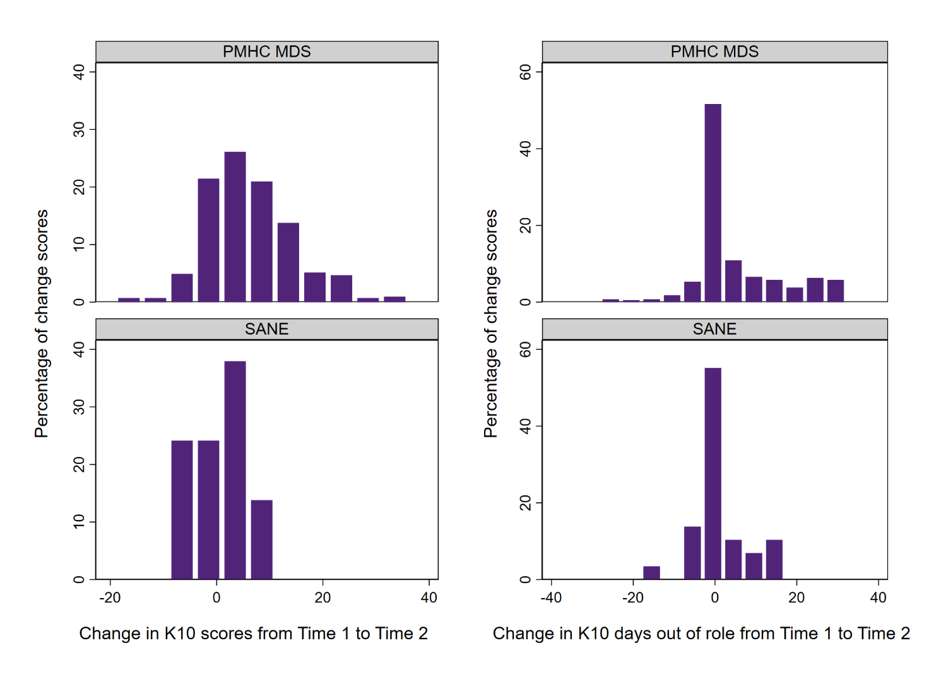
Figure 17: Distribution of changes in K10+ psychological distress scores and days out of role for SANE participants and matched PMHC MDS clients between baseline and follow-up at time 2 (changes >0 indicate improvements).
It is important to note that these scores do not reflect levels of psychological distress upon completing an episode of service, particularly for the SANE sample of whom many have not completed an episode of care (only 2 participants had exited the Guided Service out of this sub-sample at the time of these analyses). Of these participants, between both K10+ measurements, the SANE sample completed an average of 2 sessions (median = 1; range = 0–11). The PHN sample completed more sessions relative to the SANE sample on average, with a mean of 7 sessions (median = 4; range = 0–106). All of the SANE participants in this sample completed the follow-up survey between 84 to 91 days from baseline. In contrast, the matched PHN sample completed their follow-up between 0 to 399 days (although, the average time between measurements was 73 days), indicating a potentially wider timeframe between change scores for this sample. It is important to note when interpreting results that the small sample size of SANE participants limits the conclusions that can be made about the efficacy of the service at changing levels of psychological distress as many of these participants are early on in their journey.
To examine differences in K10+ psychological distress change scores between SANE participants and matched PHN service users, a regression was run to examine changes in K10+ distress scores from baseline to follow-up (see Table 17 below). When adjusting for gender, age, baseline K10+ scores, and regional/rural PHN status variables, SANE participants had a smaller decrease in K10+ psychological distress scores relative to the matched PHN service user sample. This result is consistent with the paired t-tests, which indicated no statistically significant mean change in K10+ scores for the SANE sample.
Since the baseline and time 2 K10+ psychological distress scores for the SANE cohort were the same, the lack of a significant improvement is not due to lack of statistical power caused by the small sample size. However, as noted above only two of these participants had exited the Guided Service, meaning most were still needing support and are likely to not have received many sessions yet. Further, the service may not specifically target psychological distress as a primary outcome. However, a larger sample of participants with two K10+ scores who have completed the Guided Service will need to be analysed in future to understand how the service impacts or does not impact psychological distress.
Table 17: Characteristics, baseline K10+ psychological distress scores, and cohort regression coefficients for K10 change scores between baseline and follow-up of the matched SANE and PMHC MDS sample*
Cohort | B | Robust SE | P-value | 95% CI
Gender (Ref: Female)
Male | 1.22 | 1.28 | 0.341 | [–1.29, 3.72]
Other | 1.43 | 2.43 | 0.557 | [–3.35, 6.20]
Age (Ref: 18-24)
25-34 | 1.89 | 2.36 | 0.423 | [–2.75, 6.53]
35-44 | 2.64 | 2.57 | 0.305 | [–2.41, 7.69]
45-54 | 2.15 | 2.53 | 0.396 | [–2.82, 7.13]
55-64 | 3.56 | 2.72 | 0.191 | [–1.78, 8.89]
65+ | 8.75 | 2.44 | <0.001 | [3.97, 13.53]
Baseline K10+ | 0.24 | 0.07 | 0.001 | [0.10, 0.38]
Cohort (Ref: PHN users)
SANE | –5.20 | 0.99 | <0.001 | [–7.15, –3.25]
PHN (Ref: Metro)
Regional/Rural PHN | –0.15 | 1.11 | 0.895 | [–2.32, 2.02]
*(N=887; SANE n = 29; PHN n = 858)
Next, changes in K10+ days out of role were examined. Change scores indicate the difference in days out of role from baseline to follow-up time 2. As shown in Table 18, when adjusting for gender, age, and baseline days out of role, the SANE cohort had a statistically significant smaller change in days out of role between baseline and follow-up compared to the matched PHN service users. Similar to the previous results regarding K10+ psychological distress change scores, this result is consistent with the finding from the paired t-test of no statistically significant mean change in SANE participants’ days out of role. A small average decrease of one day out of role was seen for the SANE participants, so it is possible that a statistically significant decrease for this group might be found in future with a larger sample size. However, the magnitude of change was also less than the average five days out of role improvement seen for the PHN comparison group, so the SANE participants experienced less improvement than the comparison group on average.
Table 18: Characteristics, baseline K10+ days out of role, and cohort regression coefficients examining follow-up K10+ days out of role scores of the matched SANE and PMHC MDS sample*
Cohort | B | Robust SE | P-value | 95% CI
Gender (Ref: Women)
Men | 1.41 | 1.77 | 0.427 | [–2.07, 4.89]
Other | –0.68 | 3.87 | 0.860 | [–8.27, 6.91]
Age (Ref: 18-24)
25-34 | –1.18 | 3.84 | 0.760 | [–8.72, 6.37]
35-44 | 0.14 | 4.27 | 0.974 | [–8.25, 8.53]
45-54 | –2.70 | 4.13 | 0.514 | [–10.80, 5.41]
55-64 | –3.52 | 4.19 | 0.401 | [–11.75, 4.71]
65+ | 2.07 | 4.02 | 0.607 | [–5.82, 9.96]
Baseline days out of role | 0.41 | 0.08 | <0.001 | [0.25, 0.56]
Cohort (Ref: PHN users)
SANE | –3.38 | 1.22 | 0.006 | [–5.79, –0.99]
PHN (Ref: Metro)
Regional/Rural PHN | –2.60 | 1.77 | 0.144 | [–6.08, 0.89]
* (N = 819; SANE n = 29; PHN n = 790)
  - Engagement with different service modalities including self-directed resources (KEQ 2.11)
A minority of participants accessed the self-directed digital services, although after engagement in the Guided Service more participants reported that they used at least one of the self-guided or online resources (27%) compared to program entry (15%). The most popular resource both at baseline and follow-up was the SANE website. While many participants had not engaged with the digital services such as online forums or groups, some were deeply engaged with, and highly valued these services.

Drop-in service – SANE Support Line
A total of 12,819 phone calls and 1,946 email/chat interactions were made from 9 May 2022 to 2 July 2023 as part of the SANE Drop-in service, which reached a total of 4,751 and 988 individuals respectively (5,529 individuals across both services). On average, 2.7 phone calls or 2.0 email/chat interactions were used by clients accessing each of the services respectively, with 3.8% of drop-in clients using both types of drop-in services. These drop-in services have reached a larger pool of individuals compared to those engaged in the SANE Guided Service. They were also offered to and used by some SANE Guided Service participants as outreach or extra support where needed.
A key theme was around feeling less alone: “that you are not the only one” (Participant 120) and the sensitive, respectful mutual support. Participants valued the information and suggestions from a wider network of people with lived experience:
“there's people from different parts [of the Forum] that I haven't ever met before. Everyone says what they think they mean and how it works for them, and you get lots of suggestions from people you don't know.” (Participant 112)
“It’s [online forum] fantastic. I like the fact that ‘people get it’. Like, we're all going to obviously different mental health battles. We sorta get each other, like we understand when there's no motivation and energy. Or you are depressed. So we all sort of understand. And the peer workers, the peer workers are fantastic in support, and we all support each other.” (Participant 112)
Participants who used the digital services made suggestions about potential enhancements. Several commented that that it would be helpful to have SANE staff moderate the online forum after 10pm or over weekends:
“There’s times where you write that sort of stuff [about difficult thoughts and feelings]. And it just goes off into the void” (Participant 112).
For those who had accessed the telephone or webchats, these services were highly regarded, including participants feeling "validated and respected…I feel safe talking to them” (Participant 110).
Participants appreciated various aspects of these drop-in support services including the understanding of support staff around complex mental health, having options around speaking over the phone or chatting online, being able to access drop-in services between SANE support sessions, knowing that the drop-in services are available including after exit from the Guided Service and to receive recommendations about other support options.
Differences in reported SANE service use was also examined using the SANE routine survey data. Figure 18 shows proportions of self-guided service and online resource use, amongst participants who completed a baseline and follow-up survey at time 2. Just under 15% of these participants used at least one of the self-guided or online resources at baseline and over a quarter (27.4%) indicated that they used at least one of these resources at follow-up. The most popular resource both at baseline and follow-up was the SANE website. The support line and online forums were used by more participants at follow-up from baseline. However, webchat use did not change for these participants.
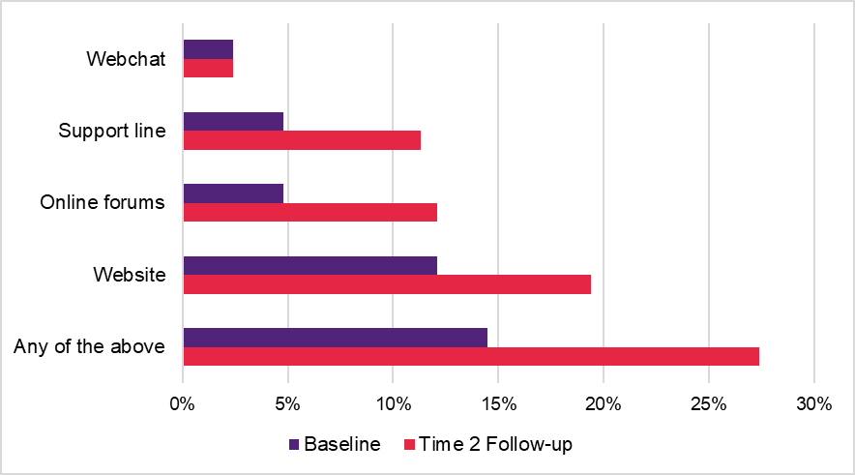
Figure 18: Use of SANE self-guided and online services for participants who completed a baseline and follow-up survey.
In terms of frequency of self-guided and online resource use for participants who completed a baseline and follow-up survey, more participants reported using the SANE website, support line, and online forums more than once at follow-up (see Figure 19 below). In contrast, webchat use frequencies were not different from baseline to follow-up.
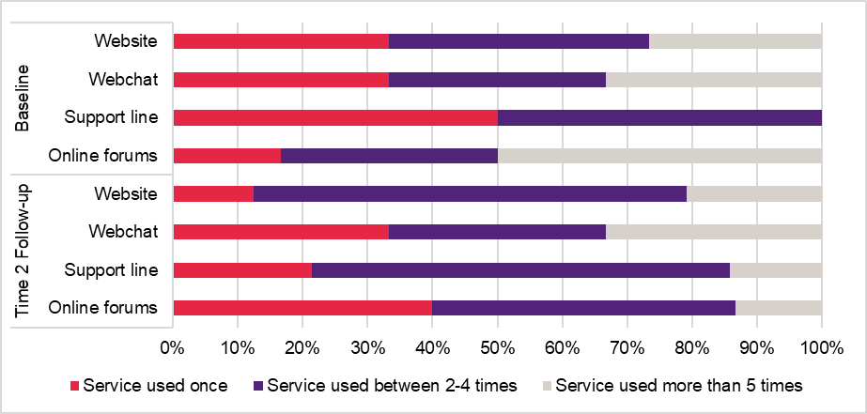
Figure 19: Frequency of use of SANE self-guided and online services for participants who reported using these services for baseline and follow-up Time 2.
  - Primary care and other supports (KEQ 2.4)
Quantitative data were not available on participants' use or connection with other mental health services or primary care services.
Interviews with Guided Service participants sought to explore this issue. Almost universally SANE participants reported no major changes in their access to their GP. A number of participants spoke of their links with new support services or resources as a result of connecting with the SANE Guided Service, such as the Crisis Assessment and Treatment Team, NDIS, online support groups, local mental health support groups, online courses, worksheets and other resources and links to other relevant services.
“It’s actually helped me link up to - It's not face to face, but still a video support group for my diagnosis. So that's ongoing. Like that's going to keep going beyond the Guided Service. And I find that really helpful.” (Participant 111)

Remy’s Experience
Remy is a young person living in a regional area who self-referred to the Guided Service in a time of crisis during a difficult period of transition. After receiving information about their options for support, they mane an informed decision to alternate support from a peer supporter and counsellor. Remy said they “felt really supported” by the Service, because the staff helped them gain useful insights into their situation as well as link with other services and supports that are now ongoing.
Upon exiting the service, Remy has run the drop-in line once, as well as having their browser tab open to the online moderated Forum page. Remy reflected that it is helpful to know the SANE support is available if they need it: “sometimes just knowing that you have the option of doing something is enough to give you a little bit of light”.

- Is the SANE Guided Service cost-effective?
Economic evaluation is defined as the comparative analysis of alternative courses of action in terms of both their costs and outcomes. Analysis of cost-effectiveness of services provided by the SANE Guided Service, compared with usual supports, includes:
- estimation of cost to deliver the Guided Service, per client, per episode of care, compared to usual supports (KEQ3.1)
- consideration of use of other health care resources (KEQ3.2)
- consideration of outcomes associated with participation in the Guided Service (KEQ3.3)
- estimation of overall incremental cost-effectiveness and value for money (KEQ3.4)
We had set out to compare the total costs (i.e., program delivery and cost-offsets) and outcomes (i.e., K10+ and ReQoL scores) of the Guided Service to the costs and outcomes of a similar cohort from the PMHC MDS data set. However, the limited number of participants providing data on cost-offsets and outcomes from the Guided Service led us to report summary statistics for these components separately. Calculating a cost-effectiveness ratio with the limited data would have produced biased results with limited interpretability. Instead, we calculated the cost per consumer and compared this to the cost of comparable in-person and digital psychosocial programs.
The cost of the SANE Guided Service in Financial Year 2022/2023 was estimated to be $5,406,085. Five percent of the total budget ($281,291) was spent to address issues with staff turnover.
Despite the lack of an incremental cost-effectiveness ratio due to data limitations, there is promising evidence to suggest that the Guided Service has the potential to represent value for money.
  - Estimated cost to deliver the Guided Service (KEQ 3.1)
The cost of the SANE Guided Service in Year 2 (Financial Year [FY] 2022-23) was estimated to be $5,406,085 based on financial data provided by SANE (Table 19). The 2022-23 expenses were largely operational costs that reflect the ongoing costs that are likely to be expected in the future. We have also noted that there were development costs of $1,164,939 incurred in Year 1 which can be viewed as sunk costs - i.e., costs that have been previously incurred, cannot be recovered and are not typically considered when making future funding decisions. Even so, these costs could be viewed as part of the opportunity cost of investing in the Guided Service and have been noted here for completeness. The sunk costs have also been included in the cost per consumer calculations.

Table 19: Itemised costing for the SANE Guided Service 2021-2023
 | FY 2021-22 Actual | FY 2022-23 Actual
Salaries / Wages & On-Costs | $1,148,369 | -
Co-design | $16,570 | -
subtotal development costs | $1,164,939 | -
Salaries / Wages & On-Costs | $1,380,717 | $3,732,369
Technology | $153,058 | $360,904
Agency Contractors | $118,395 | $158,455
Advertising | $35,082 | $219,048
Travel | $23,113 | $14,326
Training | $66,630 | $43,199
Audit fees | $1,500 | -
Administration | $203,180 | $810,913
HR compliance, staff certification, recruitment | - | $8,211
External Clinical Supervision | - | $58,660
subtotal client services/operational costs | $1,981,675 | $5,406,085
Total | $3,146,614 | $5,406,085
The 2022-23 financial year cost reports showed that 3% of the salary/wages and on-costs was attributable to a temporary contractor due to loss of IT staff. This combined with the cost of agency contractors led to 5% of the total budget ($281,291) spent on external staff to address issues with staff turnover.
  - Use of other healthcare resources (KEQ 3.2)
The ability to answer this research question was hindered by the ubiquity of missing responses among participating consumers. Reductions in healthcare resource use were observed based on 33 participants with complete data from baseline to Time 2. The mean cost of acute services involving ambulances, emergency departments, hospitals and residential care decreased by an average of $400 from baseline to Time 2. The median time between baseline and Time 2 was 12 weeks (84 days) for participants with survey responses at both timepoints. Participants who completed at least one session had an average decrease of $1,000 in acute care services. However, these differences were not statistically significant based on a paired t-tests analysis, (possibly due to the paucity of participants providing data at both timepoints). Overall, potential cost savings from the decreased use of healthcare resources outside of the Guided Service were not significant (see Table 20).
Table 20: Cost of additional healthcare resource use from baseline to Time 2
Cohort | N | Baseline Mean (SD) | Time 2 Mean (SD) | Mean Difference  (p-value)
OVERALL | 33 | $1,453 ($4,790) | $1,025 ($3,000) | -$428 (p=0.675)
At least one session completed | 20 | $2,341 ($6040) | $1,264 ($757) | -$1,076 (p=0.762)
Participant type
Consumer | 30 | $1,598 ($5,008) | $1,128 ($3,132) | -$471 (p=0.674)
Carer/Family/Friend | 3 | $0 | $0 | -
The cost of additional healthcare resource use outside of the SANE guided service is shown in Table 21 for all completed surveys. Overall, the average cost increased at subsequent time points (e.g., Times 3 and 4). However, it is unclear whether these increased costs were: (1) attributable to SANE participants using additional healthcare resources as a direct result of participating in the SANE service; or (2) if SANE participants who did not drop out had complex health needs that required the use of additional healthcare services.
Table 21: Cost of additional healthcare resource use by timepoint for all completed surveys
Cohort | Baseline Mean (SD) | Time 2 Mean (SD) | Time 3 Mean (SD) | Time 4 Mean (SD)
N | 250 | 72 | 17 | 2
OVERALL | $2,667 ($11,229) | $2,436 ($9,088) | $3,944 ($15,120) | $16,674 ($23,580)
Participant type
N | 235 | 66 | 17 | 2
Consumer | $2,833 ($11,563) | $2,657 ($9,466) | $3,944 ($15,120) | $16,674 ($25,580)
N | 15 | 6 | 0 | 0
Carer/Family/Friend | $ 75 ($291) | $0 ($0) | - | -
  - Outcomes associated with participation in the Guided Service (KEQ 3.3)
As outlined in Section 4.3, there were no statistically significant change in K10+ psychological distress scores or K10+ days out of role between baseline and time 2 follow-up. Responses from the ReQoL measure were used to obtain utility values that incorporate consumer preferences for living with different health states. These utility values, in turn, form the basis for calculating the change in QALYs over time. Table 22 presents a comparison of utility values from baseline to Time 2 (or Exit) for the overall sample and priority sub-samples. Small marginal decrements in utility values were observed over time. However, the paired t-tests analysis found that these differences were statistically insignificant and likely to not be clinically meaningful. This is in contrast to the analysis of raw ReQoL scores (see Section 4.3) which found significant and/or clinically meaningful improvements over time (particularly when analysing participants who exited the SANE service after completing at least one session). Differences between raw ReQoL scores and utility values can be explained by the fact that the ReQoL utility algorithm only uses 7 out of a total 11 items from the ReQoL measure to estimate the corresponding utility value.

Table 22: Change in utility values from baseline to follow-up at Time 2 or exit for the overall cohort and priority groups.
Cohort | N | Baseline Mean (SD) | Time 2 Mean (SD) | Mean Difference  (p-value)
OVERALL | 111 | 0.775 (0.148) | 0.751 (0.144) | -0.024 (p=0.093)
At least one session completed | 94 | 0.781 (0.144) | 0.762 (0.144) | -0.018 (p=0.209)
Participant type
Consumer | 100 | 0.769 (0.154) | 0.750 (0.148) | -0.020 (p=0.201)
Carer/Family/Friend | 10 | 0.813 (0.075) | 0.778 (0.081) | -0.035 (p=0.119)
CALD | 14 | 0.821 (0.137) | 0.782 (0.100) | -0.036 (p=0.290)
Self-identified as LGBTQIA+ | 32 | 0.779 (0.150) | 0.767 (0.144) | -0.012 (p=0.649)
Regional/Rural PHN | 25 | 0.834 (0.124) | 0.800 (0.151) | -0.033 (p=0.176)
 | N | Baseline Mean (SD) | Exit Mean (SD) | Difference (p-value)
Participants who exited the service and completed at least one session | 18 | 0.787 (0.138) | 0.747 (0.122) | -0.040 (p=0.145)
Based on the change in utility values over time, it was estimated that the overall participant sample accrued 0.220 QALYs (N=111, SD=0.106) from Baseline to Time 2. Similarly, participants who exited the service and completed at least one session accrued 0.385 QALYs (N=18, SD=0.149) from Baseline to Exit. A matching control population with utility values measured using a comparable quality-of-life measure could not be identified. As such, it was not possible to compare utility values and QALYs for the SANE participant group against a matching comparator group receiving treatment as usual.
  - Estimated overall incremental cost-effectiveness and value for money? (KEQ 3.4)
Due to the absence of a matching comparator, it was not possible to estimate an incremental cost-effectiveness ratio that compared the costs and QALYs arising from the SANE guided service to the costs and QALYs produced by treatment as usual. Similarly, the lack of statistically significant changes in K10+ and ReQoL scores observed among consumers of the SANE guided service over time, hindered the estimation of an informative cost-effectiveness ratio.
The available data was used to estimate the cost per consumer of the SANE Guided Service in order to make comparisons to other psychosocial support and digital mental health programs with similar available information (shown in Table 23). The cost per consumer was calculated by dividing the total FY 2022-23 program delivery cost ($5.4 million) by the number of consumers completing registration (2,068). The cost of the SANE guided service was at the low end of the range when compared to other psychosocial support programs. This may be due to the service being predominantly delivered through a digital platform, as opposed to conventional psychosocial support programs which are typically delivered face-to-face. By comparison, the cost of the SANE Guided Service was at the high end of the range when compared to other digital mental health programs. This may be explained by the SANE Guided Service comprising the provision of multi-faceted and highly individualised care to meet the needs of people with complex needs when compared to the service models delivered to consumers of the other digital mental health programs listed in Table 23.
Table 23: Cost of the SANE Guided Service when compared to other programs.
Program type | Program name | Program description | Cost per consumer (2023 AUD)*
SANE guided service | SANE guided service - excluding development costs | Digital psychosocial support program includes all in-house services SANE provides (excluding program development costs). | $2,614
 | SANE guided service - including development costs | Digital psychosocial support program includes all in-house services SANE provides (including program development costs). | $3,177
Psychosocial support | Day to Day Living (D2DL) | A face-to-face psychosocial support program that ran from 2011 to 2019. It sought to improve the quality of life for people living with severe and persistent mental illness by creating 60 locations nationally where consumers could access 100 hours of low or medium level support. | $2,749
 | National Psychosocial Support Measure (NPS-M) | A face-to-face psychosocial support program enacted from January 2019 to provide time-limited, recovery-based support. It sought to support people whose psychosocial support needs were not being met by the existing Commonwealth programs, the NDIS, or state and territory psychosocial support programs. | $3,688
 | Personal Helpers and Mentors (PHaMs) | A face-to-face psychosocial support program that ran from 2007 to 2019. It sought to help people with severe mental illness to live independently through an Individual Recovery Plan and personal helper/mentor. | $8,185
 | Continuity of Support (CoS) | A face-to-face psychosocial support program enacted on July 2019 to allow consumers of the Australian Government’s former psychosocial support programs (i.e., PHaMs, PIR and D2DL) who were not eligible for NDIS services to continue accessing ongoing psychosocial support. | $8,386
 | State and Territory-funded psychosocial supports | A total of 35 miscellaneous, face-to-face psychosocial support programs provided by State and Territory governments during the 2019-20 financial year. | $8,454
 | Partners in Recovery (PIR) | A face-to-face psychosocial support program that ran from 2012 to 2019. It sought to improve the coordination of care and provide wrap-around support for people with complex needs (as well as their friends, families and other support people). PIR was initially commissioned through Medicare Locals and then PHNs when these were established. | $15,255
Digital mental health | myCompass | Self-guided, online psychotherapy program for people with mild-to-moderate depression. | $77
 | Target-D | Digital support tool to match consumers who have depression to an appropriate treatment pathway in the GP clinic setting. | $179
 | MindSpot | Clinician-guided, online psychotherapy for people with depression and/or anxiety. | $513
 | Link-me | Digital support tool to match consumers who have depression and/or anxiety to an appropriate treatment pathway in the GP clinic setting. | $900
* AUD is the abbreviation for Australian dollars
Despite the lack of an incremental cost-effectiveness ratio, promising evidence suggests that the SANE Guided Service can potentially represent value for money. For example, the program’s cost per consumer is low when compared to other conventional psychosocial support programs. However, caution should be applied when interpreting these comparative cost data since the cost per consumer may reflect the intensity of service provision (with higher intensity services involving higher costs). Ultimately, value for money should be determined based on a comparison of the additional costs associated with the Guided Service against the additional outcomes achieved. However, the limited outcome data available for consumers receiving the Guided Service prevented us from undertaking these planned comparisons.
Moreover, positive quality-of-life changes were observed when analysing changes in raw ReQoL scores over time, particularly among those who exited the program after receiving at least one session. The cost of the SANE service could be reduced if changes were made to improve program efficiencies. Further consideration should be given to whether adoption of a funding model comprising longer timeframes (as opposed to short-term, year-to-year funding) can help ameliorate the cost inefficiencies observed during the implementation period, for example, by reducing the elevated level of staff turnover observed over the implementation period, along with less direct inefficiencies such as abovementioned PHN hesitancy to promote mental health services that may not continue beyond short-term time frames .

- Is the Guided Service appropriate for a national roll-out?
Service elements important in considerations about whether the SANE Guided Service is appropriate for a national roll-out include:
- alignment of the service with national mental health care policies and priorities, including measures to ensure the service is appropriate, accessible and inclusive for people with complex mental health needs across diverse populations and groups (KEQs 4.1, 4.2)
- alignment and integration with other mental health services and community supports (KEQs 4.3, 4.4)
- ability to reduce waiting times and alleviate unmet service demand (KEQ 4.5)
- need for adjustments in service design and implementation (KEQ 4.6)
- estimated budgetary impact (KEQ 4.7)
  - Alignment with mental health care policies and priorities (KEQs 4.1, 4.2, 4.3)
The SANE Guided Service aligns with policies that prioritise continuity, inclusivity, equality, and connection. Digital access is a priority for most mental health policies looking to the future, to enable further inclusivity, especially for those in Australia’s regional and remote areas. However, as stated by some in the qualitative professional stakeholder interviews (see Table 24), there are currently some barriers to digital access. For example, the SANE Guided Service caters to those with complex mental health needs, and interview data suggested this cohort may have issues with digital access.
Few policies specifically address the ‘missing middle’, who have needs that cannot be met by primary care alone but may not meet the criteria for specialist mental health services, and this is a topic and cohort SANE seeks to address. Similarly, the need for stepped care to address varying needs of a person across their recovery is not well addressed in most policies but is intended as a feature of the Guided Service. In an area of emerging emphasis in the mental health field, policies that include peer-based services with lived experience workers align with SANE’s Guided Service. However, little is stated about the specific ongoing training and support that is needed for peer workers. Most policies examined did not mention carer support, an area to which the SANE Guided Service is committed.
Importantly, Australian policies note the requirement for adherence of mental health care to quality standards and regulatory frameworks. Activity reports show that the SANE Guided Service achieved accreditation against the National Standards for Mental Health Services in November 2022, and against the National Safety and Quality Digital Mental Health Standards in March 2023.

Table 24: Alignment of SANE Guided Service with significant Australian policies.
Policy area | Findings and alignments | Comments
Strategic priorities | Continuity, inclusivity, equality, connection, and stigma-reduction are all recurring themes across policies that align with SANE Guided Service. Also of mention were systemic change, social support, and equitable digital access. | It’s really difficult to access services for those in regional and remote areas. SANE provides something as an interim.
Guiding principles | Connection, inclusivity, recovery-oriented, and empowerment (person-centred approach) are points commonly cited as a means to achieving participant goals, aligning with SANE Guided Service’s principles. | -
Priority populations/targets | SANE Guided Service is inclusive of those with severe and complex mental health issues and people with disability, including family members and carers, which not all policies offer. SANE Guided Service aligns with policies that prioritise Aboriginal and Torres Strait Islander, CALD, and LGBTQIA+ communities. | Being a digital service may not meet the needs of all groups, but not every service will.
Mental health issues/intellectual disability and/or autism | SANE Guided Service is unique in supporting people who experience complex mental health issues, trauma and supporting the mental health of those who are Autistic and people with intellectual disability, as well as their families and carers. | It really is making steps in the right direction to fill gap
Non-clinical, non-inpatient 'missing middle'/stepped care | Few policies specifically mention stepped care and the missing middle. | -
Peer-based services | SANE Guided Service aligns with policies offering the services of lived experience workers to combat stigma; however, little is said about training and support for peer workers themselves.  The Fifth National Mental Health and Suicide Prevention Plan has certified training for peer workers, while the Productivity Commission Inquiry Report into Mental Health contains a suggestion for a professional association for peer workers. | Digital is accessible for anyone with internet, however, some clients simply do not have access to, or knowledge of how to use
Digital mental health | SANE Guided Service aligns with policies that do promote equitable access and a proliferation of digital mental health services, but this is not a focus of all policies. | -
Carers | SANE Guided Service supports the wellbeing of carers, which aligns with a few policies. The majority of policies do not mention support of carers. | -
*Quotes from interviews with professional stakeholders
  - Alignment and integration with other mental health services (KEQs 4.4, 4.5)
PHN representatives who were interviewed agreed that the Guided Service was a good fit with existing services within their PHNs and that it filled a gap and provided an additional option – “an extra tool in the toolkit”– for clients and service providers, rather than replication or duplication of existing services.
“From talking to the people in SANE, they’re really not trying to replicate or duplicate existing services and it’s to fill that gap and from what I’ve seen they’re doing that”. (PHN representative)
Similarly, most professional survey respondents also agreed that the Guided Service was a good fit with other existing resources.
“Having a pathway where there is currently no other service has been immensely beneficial … We recommend this referral pathway to the providers we commission and to GPs consistently. We are interested to know how we can further promote it.” (PHN representative – open-ended survey response)
Participants who were concurrently receiving support from other mental health service providers commented that the support from the Guided Service was complementary to that provided by other services.
“I got the community support at the same time. It was already set up. They [SANE staff] do at times contact my case manager or contact my counsellor if I've said something is of concern. They do encourage you to get in contact with your team. I got the team at the same time as I got SANE ... [SANE staff] never contradict what your team has said.” (Participant 112)
PHN interviewees readily identified positive attributes of the SANE Guided Service model of care, including the underpinning CHIME model: “at the click of a button you’ve got that support there and the choice as well with different services, such as drop-in and chats, counsellors and peer support workers, different approaches, mindfulness ...”
Highlighted by PHN interviewees also was the potential for SANE to respond to the needs of “the missing middle”, whose psychosocial support needs cannot be met by primary care alone but may not meet the criteria for specialist mental health services: “Most helplines and other sorts of services seem to work in the lower intensity space, when there’s more complexity there’s more of a challenge. I think that’s what’s really good about the service”.

Program Context
The Department provides funding for a range of services under the Digital Mental Health (DMH) program. As shown in Figure 20 below, these range from crisis services (e.g., Lifeline, Kids HelpLine) to specialist counselling and educations services such as CanTeen and the Butterfly Helpline and services to support clinicians (e.g., eMHPrac). There are significant areas of overlap between service types, modalities and the range of intended beneficiaries.
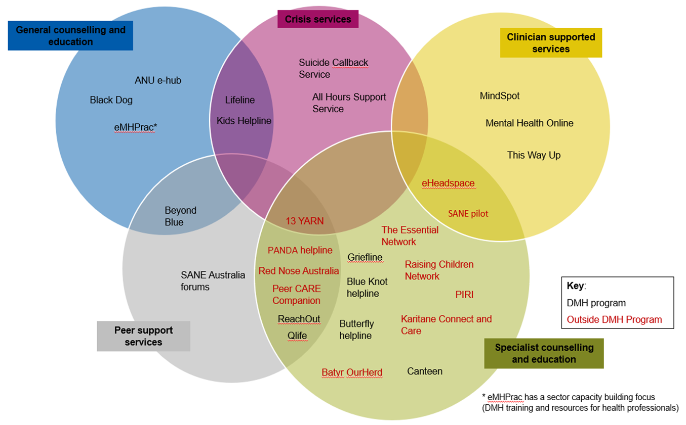
Figure 20: Frequency of use of SANE self-guided and online services for participants who reported using these services for baseline and follow-up Time 2.
Source: Department of Health and Aged Care (15 May 2023)
As can be seen in Figure 20, within the landscape of mental health programs, SANE Guided Service sits at the intersection between clinician supported services, crisis services, and specialist counselling and education services.
An examination of nationally available programs funded by the Department (Table 25) revealed that while most programs are free of charge, the majority of programs do not provide peer support; counselling; or online groups, forums, or webchat. In addition, while many programs are aimed at a specific client demographic, SANE Guided Service is designed to reach populations not covered by other services, including those with complex mental health needs. Of the most broadly available services (e.g., Beyond Blue, Black Dog, Head to Health, Healthdirect and Lifeline), only the Guided Service offers individual counselling. The service that comes closest to the SANE Guided Service offerings is headspace, which specifically supports young people (and their family/friends).

Table 25: SANE Guided Service in context of other DMH services
Service | Funder | Client Demographic | Free | Duration | Peer support | Online info | Counselling | Online group | Online forum | Online webchat | Phone helpline | Complex MH Needs
SANE | DHAC | 18+ complex MH | Y | 12w | Y | Y | Y | Y | Y | Y | Y | Y
13 Yarn | DHAC | Aboriginal & Torres Strait Islander | Y | - | Y | N | N | N | N | N | Y | N
Batyr - OurHerd | DHAC | Young people | Y | - | Y | Y | N | N | Y | N | N | Y
Beyond Blue | DHAC | Anyone | Y | - | Y | Y | N | N | Y | Y | Y | -
Black Dog Institute | DHAC | Anyone | Y | - | N | Y | N | N | N | N | N | N
Blueknot | DHAC | Complex trauma | Y | - | N | Y | N | N | N | N | Y | Y
Butterfly | DHAC | Eating disorder, body image issues | Y | - | Y | Y | Y | Y | N | Y | Y | -
Canteen | DHAC | Young people affected by cancer | Y | - | Y | Y | Y | Y | N | Y | N | N
Canteen Cancer Hub | DHAC | Affected by cancer | Y | - | Y | N | Y | N | N | N | Y | -
eheadspace | DHAC | Young people, families | Y | - | N | N | N | N | N | Y | Y | N
Griefline | DHAC | Grief | Y | - | Y | Y | N | N | Y | N | Y | -
Head to Health | DHAC | Anyone | Y | - | N | Y | N | N | N | Y | N | Y
Headspace | DHAC | 12-25, family, friends | Y | - | Y | Y | Y | Y | Y | Y | Y | -
Healthdirect | DHAC | Anyone | Y | - | N | Y | N | N | N | N | Y | -
Karitane | DHAC | Parents | Y | - | Y | Y | Y | N | N | N | Y | -
Kids Helpline | Yourtown, DHAC | 5-25 | Y | - | N | Y | Y | N | N | Y | Y | *
Lifeline | DOH | Anyone | Y | - | N | Y | N | N | N | Y | Y | *
Mental Health Online | SUT, DHAC | Anyone | Y | 12w | N | Y | N | N | N | Y | N | *
Mindspot | MU, DHAC | Anyone | Y | 4 sess | N | Y | Y | N | N | N | N | N
Moodgym | DHAC | 16+ | Y | 5 sess | N | Y | N | N | N | N | N | N
On the Line Australia | DHAC | Remote areas | Y | - | N | Y | Y | N | N | N | Y | *
Panda | DHAC | New parents, families | Y | - | Y | Y | Y | N | N | N | Y | Y
Peer Care Companions | DHAC | Peers | Y | 3 days | Y | N | N | N | N | N | N | Y
PIRI | DHAC | Parents | Y | - | N | Y | N | N | N | N | N | N
Qlife | DHAC | LGBTQIA+ friends, fam, health workers | Y | - | Y | Y | N | N | N | Y | Y | N
Raising Children | DHAC | Parents, health workers | Y | - | N | Y | N | N | N | N | N | N
Reach Out | DHAC | 18-25 | Y | - | Y | Y | N | N | Y | Y | N | *
Red Nose | DHAC | Parents following death of child | Y | - | N | Y | Y | N | N | Y | Y | Y
TEN | DHAC | Health workers | Y | - | Y | Y | Y | N | N | N | N | *
This Way Up | DHAC | Anyone | N | 90 days | N | Y | N | N | N | N | N | N

  - Ability to alleviate unmet service demand (KEQ 4.6)
Table 26 shows that the SANE Guided Service is intended to reach populations not covered by other services, and to offer support modalities not available through other means or as a digital adjunct to existing services. This is intended to contribute to alleviating unmet service demands.
Being able to provide timely access to support in the context of high and growing demand for services and extensive waitlists was seen as a key benefit of the SANE Guided Service. PHN representatives noted that, for some clients, it could be months before reaching a service and having an option to support people while on a waitlist, or where additional care options were needed, was welcomed:
“The feedback we have had from providers, and our intake team is that SANE has been a great option to refer people to that are on waiting lists – or as an additional support for other services a client might be accessing.” (PHN representative)
This was also echoed in professional stakeholder responses to the survey where the Guided Service was considered:
“helpful for people to use when they need help immediately with chats etc and groups and can't get help elsewhere”.
Similarly, some SANE Guided Service participants spoke of timely linkages with SANE staff:
“It was really, really fast and really good” (Participant 120).
However, as shown in an earlier section, service demand and staff shortages were reflected in the experience of some participants who remained on waiting lists to see SANE staff, months after initial contact:
“I’m not someone that’s been helped by SANE. In fact, I feel let down in that I was promised things that haven’t been delivered.” (Participant 121)
Table 26 shows the number of participants with complex mental health needs within each in-scope PHN area accessing the SANE Guided Service in the 2022-23 financial year (excluding carers and those exiting the service prior to 30 June 2022), compared with estimated population needs. Overall, the Guided Service reached 13.2 participants per 100,000 adult population in the participating PHNs. This rate varied across areas, with the highest rates of access in Brisbane North (30.0 per 100,000) and ACT (22.0 per 100,000), and the lowest rates in Northern Territory (4.6 per 100,000), Western Sydney (5.3 per 100,000) and Country WA (6.1 per 100,000). This variation may somewhat reflect the timepoints at which different PHNs joined and started referring into the Guided Service.
Based on analysis of the NMHSPF for 2022-23, it is estimated that approximately 147,000 adults with severe mental illness needed individual support services such as those provided by the Guided Service within the in-scope PHN geographic areas. Therefore, the SANE service reached approximately 1% of this overall need, with the relative rates across PHNs mirroring the overall population rates described above.
NDIS packages for adults with psychosocial disability and PHN psychosocial support services for our identified adult complex needs cohort reached an estimated further 33,500 and 9,352 people respectively. There will be some overlap in individuals accessing more than one of these types of support. However, assuming for simplicity that they are all separate populations, the Guided Service, PHN psychosocial supports for complex needs and NDIS psychosocial disability supports may have reached approximately 30% of the adults in the in-scope areas estimated to need individual support by the NMHSPF. This demonstrates that there are still likely significant unmet needs for supports across these regions, and potential for further scale-up of the SANE Guided Service or other programs to help meet this need.
The current in-scope PHN areas represent roughly half the adult population of Australia. Based on per capita utilisation of the SANE Guided Service in 2022-23, at the current access rate the service might reach a total of 2,781 participants if rolled out to all PHNs nationally.

Table 26: Guided Service participants as a proportion of population and estimated NMHSPF need for individual support, 2022-23
Participating PHN area | Total population 18+, 2022-23 (NMHSPF) (n) | SANE Guided Service consumer participants 2022-23 (n) | Guided Service rate per 100,000 adult population | Estimated consumers 18+ needing individual support 2022-23 (NMHSPF) (n) | Guided Service as % of NMHSPF need | PHN complex clients 18+ with psychosocial support contacts 2021-22 (n)* | Estimated NDIS participants 19+ with primary psychosocial disability, Q2 2023 (n) | Estimated SANE+PHN+NDIS as % of NMHSPF need^
Total for in-scope PHNs | 11,705,672 | 1,544 | 13.2 | 147,208 | 1.0% | 9,352 | 33,555 | 30.2%
Adelaide | 1,011,873 | 151 | 14.9 | 12,322 | 1.2% | 713 | 2,939 | 30.9%
Australian Capital Territory | 359,426 | 79 | 22.0 | 4,466 | 1.8% | 288 | 1,155 | 34.1%
Brisbane North | 870,858 | 264 | 30.3 | 10,905 | 2.4% | 866 | 2,393 | 32.3%
Central and Eastern Sydney | 1,450,048 | 165 | 11.4 | 17,569 | 0.9% | 735 | 3,012 | 22.3%
Central Queensland, Wide Bay, Sunshine Coast | 729,282 | 136 | 18.6 | 9,056 | 1.5% | 1,512 | 2,349 | 44.1%
Country Western Australia | 424,836 | 26 | 6.1 | 6,145 | 0.4% | 264 | 1,065 | 22.1%
Darling Downs and West Moreton | 470,084 | 80 | 17.0 | 6,085 | 1.3% | 293 | 1,542 | 31.5%
Hunter New England and Central Coast | 1,066,951 | 92 | 8.6 | 13,989 | 0.7% | 1,197 | 3,778 | 36.2%
North Western Melbourne | 1,606,999 | 242 | 15.1 | 19,460 | 1.2% | 761 | 5,041 | 31.1%
Northern Territory | 195,727 | 9 | 4.6 | 4,002 | 0.2% | 177 | 608 | 19.8%
Perth North | 879,672 | 63 | 7.2 | 10,708 | 0.6% | 335 | 2,307 | 25.3%
Perth South | 819,487 | 75 | 9.2 | 10,148 | 0.7% | 345 | 1,895 | 22.8%
Tasmania | 431,370 | 73 | 16.9 | 5,568 | 1.3% | 366 | 1,093 | 27.5%
Western Sydney | 827,327 | 44 | 5.3 | 10,112 | 0.4% | 856 | 2,112 | 29.8%
Western Victoria | 561,732 | 45 | 8.0 | 6,674 | 0.7% | 644 | 2,266 | 44.3%
* Adult PHN mental health service users meeting our complex needs definition who had at least one service contact for psychosocial support in 2021-22. Note this may be an underestimate of all adults receiving psychosocial support from PHN services due to focus on the complex needs cohort and comparison with 2022-23 estimates of need.
^ Estimated percentages here assume no overlap between recipients of SANE, PHN and NDIS supports. Variation across regions may reflect local population characteristics as well as differences in service delivery.

  - Need for adjustments for a national roll-out (KEQ 4.7)
This section brings together and summarises the main issues identified throughout the course of the evaluation.
    - Building awareness of the services
Professional stakeholder survey respondents indicated that there was room to enhance access to the service. For example, fewer respondents agreed that people with complex mental health needs received the right information to help them in linking to the service or that the SANE Guided Service increased access to the services needed by people with complex mental health needs.
Interviews with PHN representative and SANE participants revealed that there is much opportunity to continue building awareness about SANE Guided Service offerings among external stakeholders and potential participants, and to strengthen referral pathways both into and out of the Guided Service.
Further activity is needed to enhance the information available to potential service participants, including clear details about the changed model of support as this is implemented. Raising awareness of peer support and complementary service offerings such as SANE’s self-directed resources, and the potential for access to these as they transition into and out of the Guided Service, may help manage expectations of the Service among both referrers and participants, as well as enhancing the support provided in a step up/step down model.
    - Addressing waiting lists
Concerns about SANE’s capacity to match demand and the potential impacts on waiting times for those who were referred to the SANE Guided Service have featured prominently in this evaluation. It is essential that the service is able to demonstrate its ability to manage current demand before expanding its reach geographically, or extending its intended beneficiaries into new areas, such as people experiencing crisis or requiring more specialised supports (such as veterans).
    - Limited number of sessions
PHN representatives and participants highlighted that the constraints on the number of sessions available as part of the Guided Service was a concern, especially for participants living in areas with limited availability of mental health services. It will be essential for the SANE Guided Service to effectively communicate, to stakeholders and participants, this change from the fully flexible and wholly tailored model that was deemed important during the initial co-design phase, including the reasons for this change, and then to demonstrate the acceptability and effectiveness of this new model of service prior to further expansion.
    - Digital platform
Acceptability and usability of the digital platform will need continued monitoring. Maintenance of a human-human communication mode within the digital environment has been highlighted as important for both engagement and ongoing support of participants. A need for video conferencing options as well as improved communication with participants regarding staffing changes and, service offerings have both been noted.
    - Workforce management
Workforce management remains a crucial issue. Recruitment and retention of appropriate and skilled staff remains a challenge in the mental health sector. Recruitment profiles and ongoing training and clinical/practice support systems will need to match the profiles and needs of participants, requiring ongoing monitoring of these needs as the Guided Service continues to evolve. Capabilities such as use of clinical tools to plan mental health support and assist recovery, working with complex trauma, co-occurring conditions such as substance use, addressing specific needs of Autistic people and people with intellectual disability, and a range of cultural competencies will need to be addressed in both training and ongoing practice support. The effectiveness of training and support systems should be monitored.
  - Estimated budgetary impact (KEQ 4.8)
Based on the 13 PHNs participating in the current evaluation of the Guided Service, we estimate that the 2022-23 financial year cost as reported in the financial statement provided by SANE ($5.4 million), represents the likely cost to provide the service to these PHNs in future years. Adjusting for an estimated 6% rate of inflation leads to an estimate of $5.724 million in 2023/24. Efficiencies in program delivery and decreases in staff turnover may decrease the operational costs by a minimum of 5% ($286,200).

- Summary and recommendations
There are significant mental health support gaps nationally for people with complex needs, including for the ‘missing middle’ whose psychosocial support needs cannot be met by primary care alone but who may not meet the criteria for specialist mental health services. State and Commonwealth governments have committed under the National Agreement to reviewing unmet needs for psychosocial support outside the NDIS, where the Productivity Commission Inquiry Report into Mental Health identified large numbers of people needing but not receiving psychosocial support.
High referral numbers and participant and other stakeholder feedback all demonstrate high demand for SANE’s services. Referrers spoke positively about the service model addressing needs for low-cost, timely access to mental health support for people with complex needs. Subject to sorting out the implementation issues, staffing and waitlists, the service does seem to be filling a critical system gap and providing a positive experience and outcomes for participants who receive support.
The Guided Service is a unique offering in providing free digital services including 1:1 counselling and peer support services for people with complex mental health needs. There are indications that the service is reaching people who would otherwise be less likely to access services. While there are some issues with access and the technology, digital services also have potential to provide equitable service access for regional, rural and remote populations who otherwise may have few support options on the ground (especially MBS and private/NGO services) and people who find it difficult to attend in-person appointments. Maintenance of human-human contact within the digital environment will be important for engagement and support of participants.
The service has recruited participants with significant and complex mental health needs and participants seem to particularly value the expertise of SANE’s Guided Service staff in working with complex populations.
External stakeholders, SANE staff, and Guided Service participants alike highlighted the value of the service model targeting the needs of people with complex mental health conditions and those who may face barriers to accessing mental health services. Once people receive support from a peer supporter and/or counsellor their experience is generally positive. Repeatedly emphasised and greatly appreciated by participants, as well as professional stakeholders, was that there was no financial cost to access the service.
Participants overall are showing significant improvements in recovery and quality of life, and this is seen across priority subpopulations (that could be assessed). This outcomes picture should continue to become clearer as more participants complete the service and more data become available for evaluation.
The economic evaluation suggests the SANE Guided Service is at the lower end of cost per participant for psychosocial services aimed at complex needs (although this may reflect people not getting many sessions on average).
Most digital services are not targeted at people with complex needs. As part of this, there is probably value and efficiencies in having such a service funded and run nationally, rather than piecemeal in specific regions.

  - Recommendations
There have been significant challenges in the early implementation phase of the SANE Guided Service. This is not completely unexpected for any complex health service intervention. It is imperative that these challenges are addressed before the service is considered ready for national roll-out. In addition to affecting implementation, some of these challenges have had consequences for the evaluation of the Guided Service, making it difficult to draw definitive conclusions at this stage. With the advent of significant changes in the Guided Service model from a fully flexible, individually tailored support model to a more defined approach, the following recommendations address both findings from the current evaluation and expectations for the immediate future of the service.
In summary, the following are crucial as the SANE Guided Service progresses in its new iteration:
Continue to monitor participant characteristics and needs. Collect and use robust and appropriate measures to establish participant needs, plan support and assess the impact of care on their mental health and wellbeing. Train and support staff to implement and document this practice. Ensure that participants understand the importance of this practice in providing best and most appropriate support to them. This will also aid in evaluating the evolving service model and ensuring that it continues to match participant needs.
Manage workforce needs. Ensure credentialling is required and ongoing training and support are provided so that staff have the capabilities required to support participants with complex mental health needs, trauma, co-occurring health conditions including substance use, autism and disabilities, and to address specific considerations such as cultural and identity backgrounds. Provide ongoing review and support of practice to ensure training is effective, capabilities are implemented, and workforce capacity is sufficient to address participant needs. This may also reduce staff turnover related to burnout.
Communicate and monitor the impact of change. Ensure changes to the Guided Service model are clearly communicated to referrers and potential participants, to manage expectations and ensure appropriateness of referral. Clearly document the timing and structure of future changes, and ensure that supports, data systems and referral pathways in and out of the service remain relevant. Evaluate the impact of change on support effectiveness using robust independent review. Continue to monitor the ability of the service to provide timely and appropriate support to current participants before expanding referral networks and target populations. Continue to monitor the place and fit of the service within the mental health landscape to support connected, collaborative and adaptable care for people with complex mental health needs.
The following specific recommendations are offered to support this.
Wait times for participants and service pressure points have featured prominently in this evaluation. These are evident across all phases of the participant journey from referral to transition to other supports. There is the potential to do harm to participants and erode confidence among referral partners if expectations are not met, particularly when the Guided Service is viewed as a way of providing support while on waitlists for other mental health support options. There are also concerns about the time-limited nature of the service for people with complex mental health needs, particularly considering recent changes that include a reduced number of services.
RECOMMENDATION: Carefully review SANE’s capacity to match demand and demonstrate timely flow for participants across the participant journey from initial referral to transition.
RECOMMENDATION: Make available transparent information about wait times to all potential and referred participants and referring partners including PHNs.
RECOMMENDATION: Implement clear policy to prioritise and triage referrals and service participants according to need.
RECOMMENDATION: Consolidate approaches to ensure participants are linked with broader primary health supports at transition out of the Guided Service and ensure that participants and referring organisations are aware of these from the outset.
RECOMMENDATION: Establish well-articulated pathways for SANE Guided Service participants through linkages with PHNs and by introducing the SANE suite of non-directed service offerings as part of the Guided Service.
RECOMMENDATION: Consider options about extending the number of services available to people without other available alternatives for psychosocial support.
Promoting service engagement through flexibility and ‘good fit’ for participants – the flexibility of the service model, including being able to access either or both counselling and peer support was widely regarded as a powerful component of the SANE Guided Service as was the ease for participants of changing their support person for a better ‘fit’ if required. More detailed understanding of the service journey is needed to identify reasons for participants discontinuing their engagement with the service at different points.
RECOMMENDATION: Improve understanding of reasons for service discontinuation at every step through the service journey and continue to develop service-level responses to support participants with complex mental health needs to engage with and complete the service.
RECOMMENDATION: Prioritise service design that includes one-on-one personalised contact to engage participants in service options.
RECOMMENDATION: At every stage of the service journey ensure participants are aware of the nature of the service and how they will transition to other forms of support once they have completed the Guided Service.
RECOMMENDATION: Review the digital platform regularly to ensure optimal functionality and ease of use for participants including responding to feedback from participants and ensuring access for people with differing levels of experience and interest in using digital technologies.
RECOMMENDATION: Give special consideration to digital inclusion for people with intellectual disability/cognitive impairment. Easy Read versions of measures are now available and can be refined even further according to best practice, with potential application for a range of different participant groups including people who are experiencing high levels of distress, people who are not proficient in English, and people with low levels of literacy.
SANE Guided Service workforce Retaining a workforce that has capacity and capability to respond to complex mental health needs is critical for participants, and for referral partners who want to be assured about service quality and appropriateness.
RECOMMENDATION: Continue to implement credentialling and provide appropriate ongoing training and support for the peer workforce as well as specialised training in complex mental health, mentoring and support for staff wellbeing across the SANE workforce.
RECOMMENDATION: Monitor staff feedback and identify opportunities to improve the staff experience on a regular and ongoing basis.
RECOMMENDATION: Provide regular staff training in support to people with intellectual disability/cognitive impairment and Autistic people who have complex mental health needs including approaches to communication, mental health support and appropriate referral pathways.
Building awareness of the service and referral processes – requires ongoing communication and local promotional activities with PHNs and referring organisations. The SANE communications team has an important role here. Sharing feedback on participants’ experiences would allow participants to know more of the service and help to clarify expectations. Self-referral was the main pathway to the service but further information about what prompted self-referral is needed to understand the current and potential role of referring organisations.
RECOMMENDATION: Ensure regular contact with PHNs for ongoing promotion of the service. To maintain confidence in the service as a viable referral option, promotion material should provide clear information about service options, including peer support, and incorporate feedback from service participants.
RECOMMENDATION: Target community agencies beyond health services with promotional activities to facilitate linkage between sectors and support a more integrated mental health system.
RECOMMENDATION: Ensure that the online referral process and website design supports both self-referral and referral by health care professionals.
RECOMMENDATION: Review referral information to include detail about whether self-referral was facilitated by a health care provider or through interaction with a referring organisation.

Evaluation-related recommendations
This evaluation was designed to assess the potential of the Guided Service to be effective in helping to improve recovery and quality of life for people with complex mental health needs. An evidence-based and fit for purpose framework for ongoing monitoring and evaluation was developed, which can and should be used for further evaluation of the SANE Guided Service. The outcomes of the Guided Service should continue to become clearer as more participants complete the service and more data is available for evaluation, including for K10+ outcomes that can be compared with other services, for example via the Primary Mental Health Care Minimum Data Set. It is not known at this stage whether the Guided Service is able to respond effectively to Autistic people or people with intellectual disability. Outcomes for these groups, as well as for carers, are uncertain due to the limited representation of this cohort in the data that have contributed to the evaluation.
The following recommendations are specifically directed towards the ongoing evaluation required for the SANE Guided Service, but also offer learnings for future evaluation of complex interventions.
RECOMMENDATION: Conduct further independent rigorous analysis of data assessing reach, outcomes and cost-effectiveness within the next 12 months. Analysis should include consideration of outcomes for priority groups and populations and K10+ outcomes. This is essential to assess significant changes to the service delivery model from that which was evaluated at this time.
RECOMMENDATION: Prioritise the use of agreed measures to guide both individualised support planning and service monitoring and evaluation. Regular professional development for SANE staff about the use of these measures in helping to improve participants’ recovery, including communication to participants about how and why completing these measures is helpful in guiding support sessions and to further help in improving the service. Staff implementation of measures should be monitored to inform professional development about use of measures in counselling and peer support practice.
RECOMMENDATION: Undertake careful assessment of participant perspectives of the acceptability and appropriateness of the refined service model, including to inform understanding of participant no-shows, cancellations and unplanned service exit. A key focus should be on reasons for people maintaining contact with the service after contact with drop-in services, and to understand and address barriers to continuing to SANE’s provision of support.
RECOMMENDATION: Update system and data fields for recording of reasons for exit to provide better clarity and granularity in terms of the different stages in which participants exit the service. Implement mechanisms for detailing and understanding reasons for exiting the program, at different stages. This could provide better insight into aspects that contribute to the discontinuation of participants. Timely updates to participant records will ensure accurate records of participant journey durations and prompt collection of routine survey data at service completion.
RECOMMENDATION: Continue to embed system and data infrastructure to prevent delays in data analysis and ensure optimal levels of follow-up data from participants. The format of variables within the data have been changed across the span of the evaluation; to enable comparison in future monitoring and evaluation activities, ensure data and reporting formats are consistent.
RECOMMENDATION: Conduct further analysis of self-reported healthcare resource use and associated costs between baseline and service completion within the next 12 months to provide information on changes in service use potentially attributable to the SANE Guided Service.
RECOMMENDATION: Further evaluate the average cost of program delivery compared to the average quality of life and K10+ outcomes in view of the changes in the service delivery model.
RECOMMENDATION: Include measures of participant engagement in the broader suite of SANE drop-in services and measures of linkages to other health supports to the evaluation framework to enable analysis of relationships between pattern and intensity of service delivery and participant outcomes, and to assess integration of support through SANE services with broader support networks.
RECOMMENDATION: Ensure clear documentation of refinements to service design and implementation by SANE for ongoing learning, further service development, quality control and monitoring.
Learnings for future evaluations of complex service interventions – careful consideration of what is achievable in a time-constrained evaluation to minimise time and effort directed to evaluating elements of the program that are not feasible as well as optimise the opportunity for evaluation findings to inform service evolution and quality service provision.
RECOMMENDATION: Consider carrying out a formal evaluability assessment to determine the readiness of the initiative for evaluation and to ensure allocation of necessary resources for evaluation. This includes considering whether the program has been implemented long enough to allow assessment of expected outcomes and the availability of, and capacity for systems and staff to provide, necessary data for robust analyses.
RECOMMENDATION: Undertake formative evaluation during the early roll-out phase of a new program or an adaptation of an existing program (e.g., MVS) to enable findings to inform modifications to the program prior to full program implementation. Ensure the time frames for the MVS are sufficient to enable the service to develop and embed program refinements. Findings from the formative evaluation can be used to inform planning for the outcome evaluation (e.g., including areas of specific interest such as reasons for discontinuation and referral pathways.)
RECOMMENDATION: Implement an outcome evaluation when program modifications have been embedded, to enable evaluation evidence to apply to the service when it is fully implemented.
RECOMMENDATION: Routinely use appropriate measures as part of service monitoring and evaluation to optimise co-occurring benefits for clinical care and evaluation including acceptability, likelihood of completion and reduced burden for participants and staff. Consider use of evidence-based measures that have high face and content validity — where items are regarded by service users as appropriate, relevant and covering components of importance — and where service users have been involved in their development (e.g., ReQoL, YES CMO SF). Choose outcome indicators that can be compared across data sets.
RECOMMENDATION: Consider adoption of a longer-term time frame for funding models that involve development, implementation and evaluation of a new program. Longer-term funding could ameliorate potential program cost inefficiencies such as staff turnover due to possible program de-funding, increased confidence for PHNs and referring agencies to invest in promotional activities and referrals and improve the capacity to stage evaluation phases according to phases in service development.

CRICOS Provider Number 00025B
Contact details
Assoc Prof Fran Boyle
T 07 3346 7471
E f.boyle@uq.edu.au
W uq.edu.au

National Statement on Ethical Conduct in Human Research 2007 (updated 2018)
Nicolaidis C, Raymaker D, Kapp SK et al., (2019). The AASPIRE practice-based guidelines for the inclusion of autistic adults in research as co-researchers and study participants. Autism, 23(8), 2007-2019.
The K-5 comprises a reduced subset of items from the K-10/K-6 scales, with some small wording adjustments (see https://www.abs.gov.au/ausstats/abs@.nsf/Lookup/84330C2EDC3DB940CA2579D50015D74E?opendocument). Although the K-5 questionnaire was specifically designed for use with Aboriginal and Torres Strait Islander populations, the questions are not culturally specific and provide a shorter set of items similar to the K-6 that can be used to measure psychological distress. This measure was therefore chosen as the best short-form version for all participants with co-occurring intellectual disability.
Diminic S, Gossip K, Page I, & Comben C. (2023). Introduction to the National Mental Health Service Planning Framework. Commissioned by the Australian Government Department of Health and Aged Care. Version AUS V4.3. The University of Queensland, Brisbane. Available at: https://www.aihw.gov.au/nmhspf/overview/documentation
Diminic S, Comben C, Pagliaro C, & Wright E. (2023). Methods for analysis of estimated numbers of people needing psychosocial supports from the NMHSPF V4.3. Brisbane: The University of Queensland.
National Disability Insurance Agency (2023). Participant numbers and plan budgets data June 2023. Retrieved from: https://data.ndis.gov.au/datasets/participant-datasets
Boyle FM, Dean JH, Salom C, Harris M, Yousef N, Huang Y, Diminic S, Chatterton ML, Lee YY, & Marrington S. (2023). Evaluation services for the SANE Australia pilot for people with complex mental health needs: Preliminary evaluation report. Institute for Social Science Research, The University of Queensland.
www.amhocn.org/__data/assets/pdf_file/0012/696846/yes_cmo_final_report_with_appendices.pdf
www.amhocn.org/__data/assets/pdf_file/0012/696846/yes_cmo_final_report_with_appendices.pdf
Department of Developmental Disability Neuropsychiatry (3DN) training to address intellectual disability mental health
PHNs do not generally provide health services directly. However, referrals from these other community and health providers may have been encouraged or facilitated by PHNs (including through PHN central intake/triage teams where these exist, either directly referring or encouraging self-referral).
Bassilios B, Ftanou M, Machlin A, Mangelsdorf S, Tan A, Scurrah K, Morgan A, Roberts L, Le L, Banfield M, Spittal M, Mihalopoulos C, & Pirkis J. (2022). Independent evaluation of supported digital mental health services: Phase 2 final report. The University of Melbourne. https://www.aihw.gov.au/reports/mental-health-services/mental-health-services-in-australia/report-content/community-mental-health-care-services
Australian Institute of Health and Welfare (2022). Table CMCH.9: Community mental health care service patients, by demographic characteristics, states and territories. 2019-20. Mental health: Community Services. Australian Government, AIHW. https://www.aihw.gov.au/reports/mental-health-services/mental-health-services-in-australia/report-content/community-mental-health-care-services
Nous Group (2021). Evaluation of National Psychosocial Support Programs: Final Report. https://www.health.gov.au/resources/publications/evaluation-of-national-psychosocial-support-programs-final-report
NDIA (2023). Age distribution of NDIS participants with psychosocial disability as of June 2022. NDIS: Explore data. https://data.ndis.gov.au/explore-data
Australian Bureau of Statistics (2021). Aboriginal and Torres Strait Islander people: Census. ABS. https://www.abs.gov.au/statistics/people/aboriginal-and-torres-strait-islander-peoples/aboriginal-and-torres-strait-islander-people-census/2021
Page IS, Ferrari AJ, Slade T, Anderson M, Santomauro D, & Diminic S. (2022). Estimating the difference in prevalence of common mental disorder diagnoses for Aboriginal and Torres Strait Islander peoples compared to the general Australian population. Epidemiology and Psychiatric Sciences, 31, e44, 1-8. https://doi.org/10.1017/S2045796022000233
While presented a ‘risk of harm’ in the referral form, this was intended as risk of harm to self, as the questions are about clients’ mental health concerns.
Cook JA et al. (2012). A randomized controlled trial of effects of Wellness Recovery Action Planning on depression, anxiety, and recovery. Psychiatric Services, 63(6), 541-547.
Palmer VJ et al. (2015). The CORE study protocol: a stepped wedge cluster randomised controlled trial to test a co-design technique to optimise psychosocial recovery outcomes for people affected by mental illness in the community mental health setting. BMJ Open, 5(3), e006688.
Palmer VJ. et al. (2021). The CORE study—An adapted mental health experience codesign intervention to improve psychosocial recovery for people with severe mental illness: A stepped wedge cluster randomized‐controlled trial. Health Expectations, 24(6),1948-1961.
Barkham M, Bewick B, Mullin T, Gilbody S, Connell J, Cahill J, Mellor-Clark J, Richards D, Unsworth G, & Evans C. (2013). The CORE-10: A short measure of psychological distress for routine use in the psychological therapies. Counselling and Psychotherapy Research, 13. doi: 10.1080/14733145.2012.729069.
Keetharuth A, Brazier J, Connell J, Bjorner J, Carlton J, Taylor Buck E., . . . Barkham, M. (2018). Recovering Quality of Life (ReQoL): A new generic self-reported outcome measure for use with people experiencing mental health difficulties. The British Journal of Psychiatry, 212(1), 42-49. doi:10.1192/bjp.2017.10
Kroenke K, Spitzer RL & Williams JB. (2001). The PHQ-9: validity of a brief depression severity measure. J Gen Intern Med, 16(9):606-13. doi: 10.1046/j.1525-1497.2001.016009606.x.
University of Sheffield (2017). How to interpret-ReQoL-10 scores. https://innovation.ox.ac.uk/wp-content/uploads/2016/08/How-to-interpret-ReQoL-scores-Clinicians-v1.0-130917.pdf
Skivington K et al. (2021). A new framework for developing and evaluating complex interventions: update of Medical Research Council guidance. BMJ 374.
Online arts, social and psycho-educational support sessions, and other tools and resources
After-hours access
Peer-led online group sessions
Multi-session counselling
Survivors, supporters and professionals
Complex trauma including abuse, neglect or violence
Via virtual support groups
Via national helpline
Virtual support groups
Webchat support groups
Through events and programs (PEER)
Alternatives to F2F and in person events
Canteen Connect app
Online training and workshops; ebook for supporting grieving friends
Search engine for digital mental health resources from trusted service providers
Chatbot/virtual assistant
Refers to other service providers
Online and telephone
Up to 4 teletherapy sessions
Online treatment course
Telephone
Modules based on CBT
(North, central, and western Melbourne; Hunter New England and Central Coast; and regional South Australia), and men’s health (MensLine Australia)
Men’s health and suicide
Resources for patients, health professionals, and clinics
Perinatal mental health
Assist people with lived experience of suicide to become peer supporters
Training people with lived experiences of suicide to be valuable contributors to suicide prevention
Suicide prevention
Resources for peer support
Negative pregnancy outcomes, SID
Counselling
Early pregnancy loss, stillbirth, neonatal death, SIDS, and sleeping accidents, and any other sudden death of a child up to 18 years
Bereavement following early pregnancy loss or death of a child during pregnancy, birth, infancy or childhood
The Essential Network for Health Professionals
Helping healthcare professionals find resources and support to navigate burnout and maintain good mental health
5 free telehealth sessions with a clinical psychologist or psychiatrist through TEN Clinic
$59 for 90 days, or free for 90 days via prescription/referral
Online treatment course * Explicit information not available

