Submission to the United Nations Committee on the Rights of Persons with Disabilities
on
autistic Australians
and our actual Rights

from Autism Aspergers Advocacy Australia

July 2019

Summary
- Australia’s laws and its legal system:
  - do not protect the rights of persons with disabilities
  - protect, and possibly promote, disability discrimination against autistic citizen in disability services.
- ASD is now a major disability type especially among younger Australians.
- Australia’s NDIS is designed without appropriate input from autistic people, their representatives and ASD-specific clinicians. The result is a scheme that discriminates adversely against many autistic Australian.
- Health and education systems in Australia do not meet the needs of many autistic Australians.
- Employment rates, social and economic participation of autistic Australians are a national disgrace.

Introduction
Thank you for the opportunity to write to your committee about autistic Australians, people whose disability is or includes autism spectrum disorder (ASD). Autism Aspergers Advocacy Australia appreciates enormously the Committee’s efforts in reviewing Australia’s responses to the Convention on the Rights of Persons with Disabilities (CPRD).

About ASD
The Diagnostic and Statistical Manual of Mental Disorder, 5th edition (2013) known as the DSM-5, describes diagnostic criteria and additional information for a neurological disorder called Autism Spectrum Disorder (ASD). The WHO’s ICD-11 describes similar diagnostic criteria for autism spectrum disorders.
The diagnostic criteria require observed needs for support related to:
- Persistent deficits in social communication and social interaction
- Restricted, repetitive patterns of behaviour, interests, or activities
Most adults who have an ASD diagnosis prefer to be call “autistic” … rather than being called “a person with ASD” or “with autism”.
Until recently, “autism” was described as relatively rare but since the 1990s, the number of diagnoses has increased substantially.
The DSM-5, under the heading “development and course”, says:
A small proportion of individuals deteriorate behaviorally during adolescence, whereas most others improve. Only a minority of individuals with autism spectrum disorder live and work independently in adulthood; those who do tend to have superior language and intellectual abilities and are able to find a niche that matches their special interests and skills. In general, individuals with lower levels of impairment may be better able to function independently. However, even these individuals may remain socially naive and vulnerable, have difficulties organizing practical demands without aid, and are prone to anxiety and depression. Many adults report using compensation strategies and coping mechanisms to mask their difficulties in public but suffer from the stress and effort of maintaining a socially acceptable facade. Scarcely anything is known about old age in autism spectrum disorder.

Autistic Australians
The number of autistic Australians, that is Australians diagnosed with ASD, is increasing significantly. The Australian Bureau of Statistics (ABS) in 2015 found via its Survey of Disability Ageing and Carers that 2.8% of Australian children aged 5 to 14 years are autistic but fewer than 0.3% of Australian adults having an ASD diagnosis. The ABS estimates there were 164,000 autistic Australians in 2015. This is a 42% increase from the previous survey in 2012 which, at 12% increase each year, is an alarming rate of growth in ASD diagnoses.
The ABS survey found abysmal outcomes for autistic Australians in education, employment and independent living; outcome as bad or worse than the appalling outcome for Australia’s indigenous people.
National data collection showed that prior to the NDIS just 34,000 or 20.7% of autistic Australians got any disability support.
In 2013, Australia started its National Disability Insurance Scheme (NDIS), a scheme to support Australians with disability up to 65 years of age. The Committee previous commended Australia for its “national scheme of self-directed disability support, which includes persons in need of intensive support”.
Sadly, the implementation of the NDIS has been less than ideal for many autistic Australians; for example, NDIS administrators told A4 that they regard the overwhelming body of scientific evidence about early intervention as “contested”. They choose to make access to essential supports for autistic Australians dependent on extended litigation through Australia’s challenging and highly adversarial legal system: families have to take legal action to get funding for evidence-based early intervention.
The NDIS replaces previous state-funded disability services. The NDIS is meant to provide individual support plans for 460,000 Australians. The NDIS expects 20% of NDIS participant, that is 92,000, at full scheme roll-out will be autistic. So far, the actual rate has risen to 29.5%. A very high percentage of autistic applicants are eligible for the NDIS which indicates that mostly autistic people only apply if they really need the support.
NDIS roll-out is close to complete in most parts of Australia but so far there are only 260,000 Australians deemed eligible, just 57% of the number expected. We estimate that there are around 240,000 autistic Australians in 2019 but just 86,500 were NDIS participants by March 2019. Many autistic Australian do not get the services and supports that they have a right to.

About Autism Aspergers Advocacy Australia
Autism Aspergers Advocacy Australia, known as A4, represents autistic Australians, their carers, families and service providers. A4’s Management Group has 8 members from around the country: 3 members are autistic adults; 7 members have autistic children and all members have experience providing services in the ASD service sector.
A4 represents ASD interests in the Australian Federation of Disability Organisations (AFDO). The Government regards A4 as a national disability representative organisation.

Article 1-4 – general obligation
Many issues arise from the Committee’s initial review of Australia’s response to the Convention on the Rights of Persons with Disability (CRPD).
- Para. 9 – the Committee asked the Australia Government to incorporate rights into Australian laws. The Australian Government has not protected the rights of autistic Australians.
- Para. 11 – the Australian Government has not engaged with autistic DPOs or peak bodies to develop legislation to implement the CRPD.
- Para. 13 – Government funding advocacy for autistic children is inadequate.
Australia has yet to align its legislation with the CRPD and the other UN Conventions describing universal human rights. In this regard, Australia is a serial offender. There is no sign this deplorable situation will be remedied.
Note that children and persons with disability cannot appeal to international legal processes to protect their rights so the rights of Australian children and persons with disability are largely unprotected.
Australian citizens need a bill of right or an equivalent legal construct to protect their rights. This is especially pertinent for Australian citizens with disability who are among the most vulnerable, hence most needing protection.
The Australian Government said it has a National Disability Strategy 2010-20 to address the needs of autistic Australians but the Australian government developed its strategy without:
- consulting the ASD community.
- recognising the needs of the growing number of autistic Australians – the strategy says there are 8 Autism Specific Early Learning and Childcare Centres when there are actually just six. If the government can’t count to numbers fewer than ten, then its strategy has no credibility. These centres are largely inaccessible; they could only ever serve a tiny fraction of young autistic children in Australia.
- ensuring these centres provide evidence-based early intervention.
The Australian Government is now developing Australia’s National Disability Strategy 2020- This time it intends to consult ASD service providers but not autistic people and ASD representatives.

Article 5 - Equality and non-discrimination
Autistic Australians are not treated equally. Discussion below shows that they do not have equal access to appropriate and effective:
- early intervention
- Education
- Health services
- Employment
- Accommodation and supported accommodation
- Equal treatment in Australia’s legal system
Australia’s Disability Discrimination Act (DDA) 1992 is often ineffective. Section 45 Special measures of the act provides exemptions that protect disability services, such as the NDIS, from discrimination complaints. The Section is meant to ensure services like guide dogs for the blind are safe from legal action asking them to service people with other disability types, to allow the service to focus on people with vision impairment. Unfortunately, DDA 1992 Section 45 also protects schemes like the NDIS from complaints that they discriminate against autistic Australians.
Instead of protecting Australians with disability from discrimination, Australia’s legal system protects disability discrimination in disability programs like Australia’s NDIS from any disability discrimination complaint.
The Australian Human Right Commission has taken no discernible action to protect autistic citizens from this (or other) disability discrimination, nor did it raise for review unacceptable outcomes for autistic Australians in the AHRC’s “Issue Prior to Reporting” document (June 2017).
Increasingly, Australia’s NDIS is the sole source of essential disability services and supports for Australians with disability. Figure 1 below shows average NDIS funding for early intervention for autistic children is inadequate; less than $20,000 included in committed cost for children under 7 years of age is far too little to provide evidence-based early intervention for an autistic child. The consequence of underfunding early intervention (and support in school-age years) is substantially higher support costs for adults.
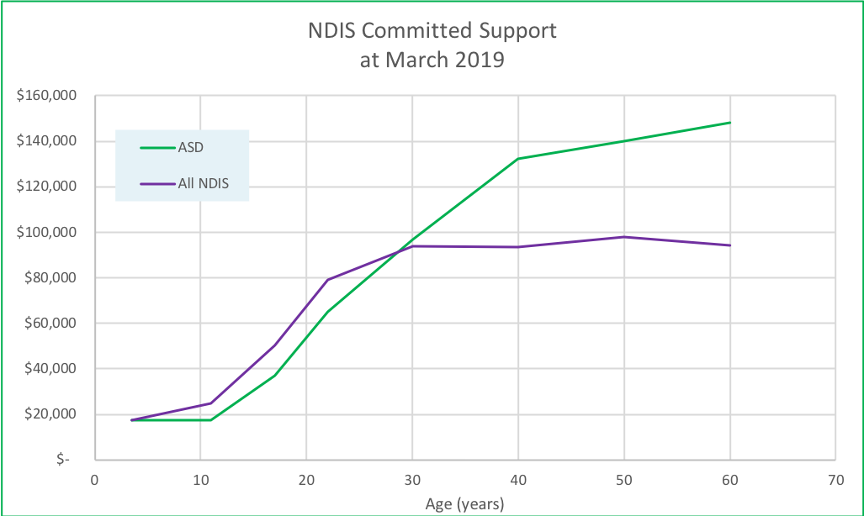
Figure 1. Committed Supports
Australians who feel the NDIS is not meeting their needs can request that the AAT review NDIS decisions. This is a legal process; it is slow and adversarial. Few families are able to engage the NDIS is a legal battle. For those who do, the biggest issue is that the delay involved is a detriment for young autistic children who need extensive intensive ASD-specific early intervention. The delay involved denies the child the early intervention they need even when the AAT decides in their favour.
Many people with disability, their family and carers are unable to protect themselves legally. They are chronically conflict-averse and simply cannot approach Australia’s adversarial legal system.
Section 45 of Australia’s DDA 1992 protects the NDIS from discrimination complaints that the NDIS under-funds autistic children, especially in relation to funding for evidence-based or best practice early intervention.

Article 6 – women with disability
There is insufficient research and data collection relating to autistic women in Australia. It appears that autistic women have similar experiences to those seen in other developed countries.
- Experience higher than average unwanted sexual encounters
- Diminished access to women’s’ health supports
- Sex and pregnancy education are absent or ineffective
- Particularly poor health outcomes including higher rates of ante- & post-natal depression, difficulty breast-feeding, …
- Use of forced sterilisation
- Separation of children from parents with disability, in particular from autistic mothers
ASD diagnosis has been less reliable for women and girls. Typically, ASD is said to have a 4:1 ration male-to-female. Australian data (Figure 2 below) from two independent sources suggests that diagnosis rates for women and girls may be improving slowly. The gender ratio is moving towards 3:1 (25% females).
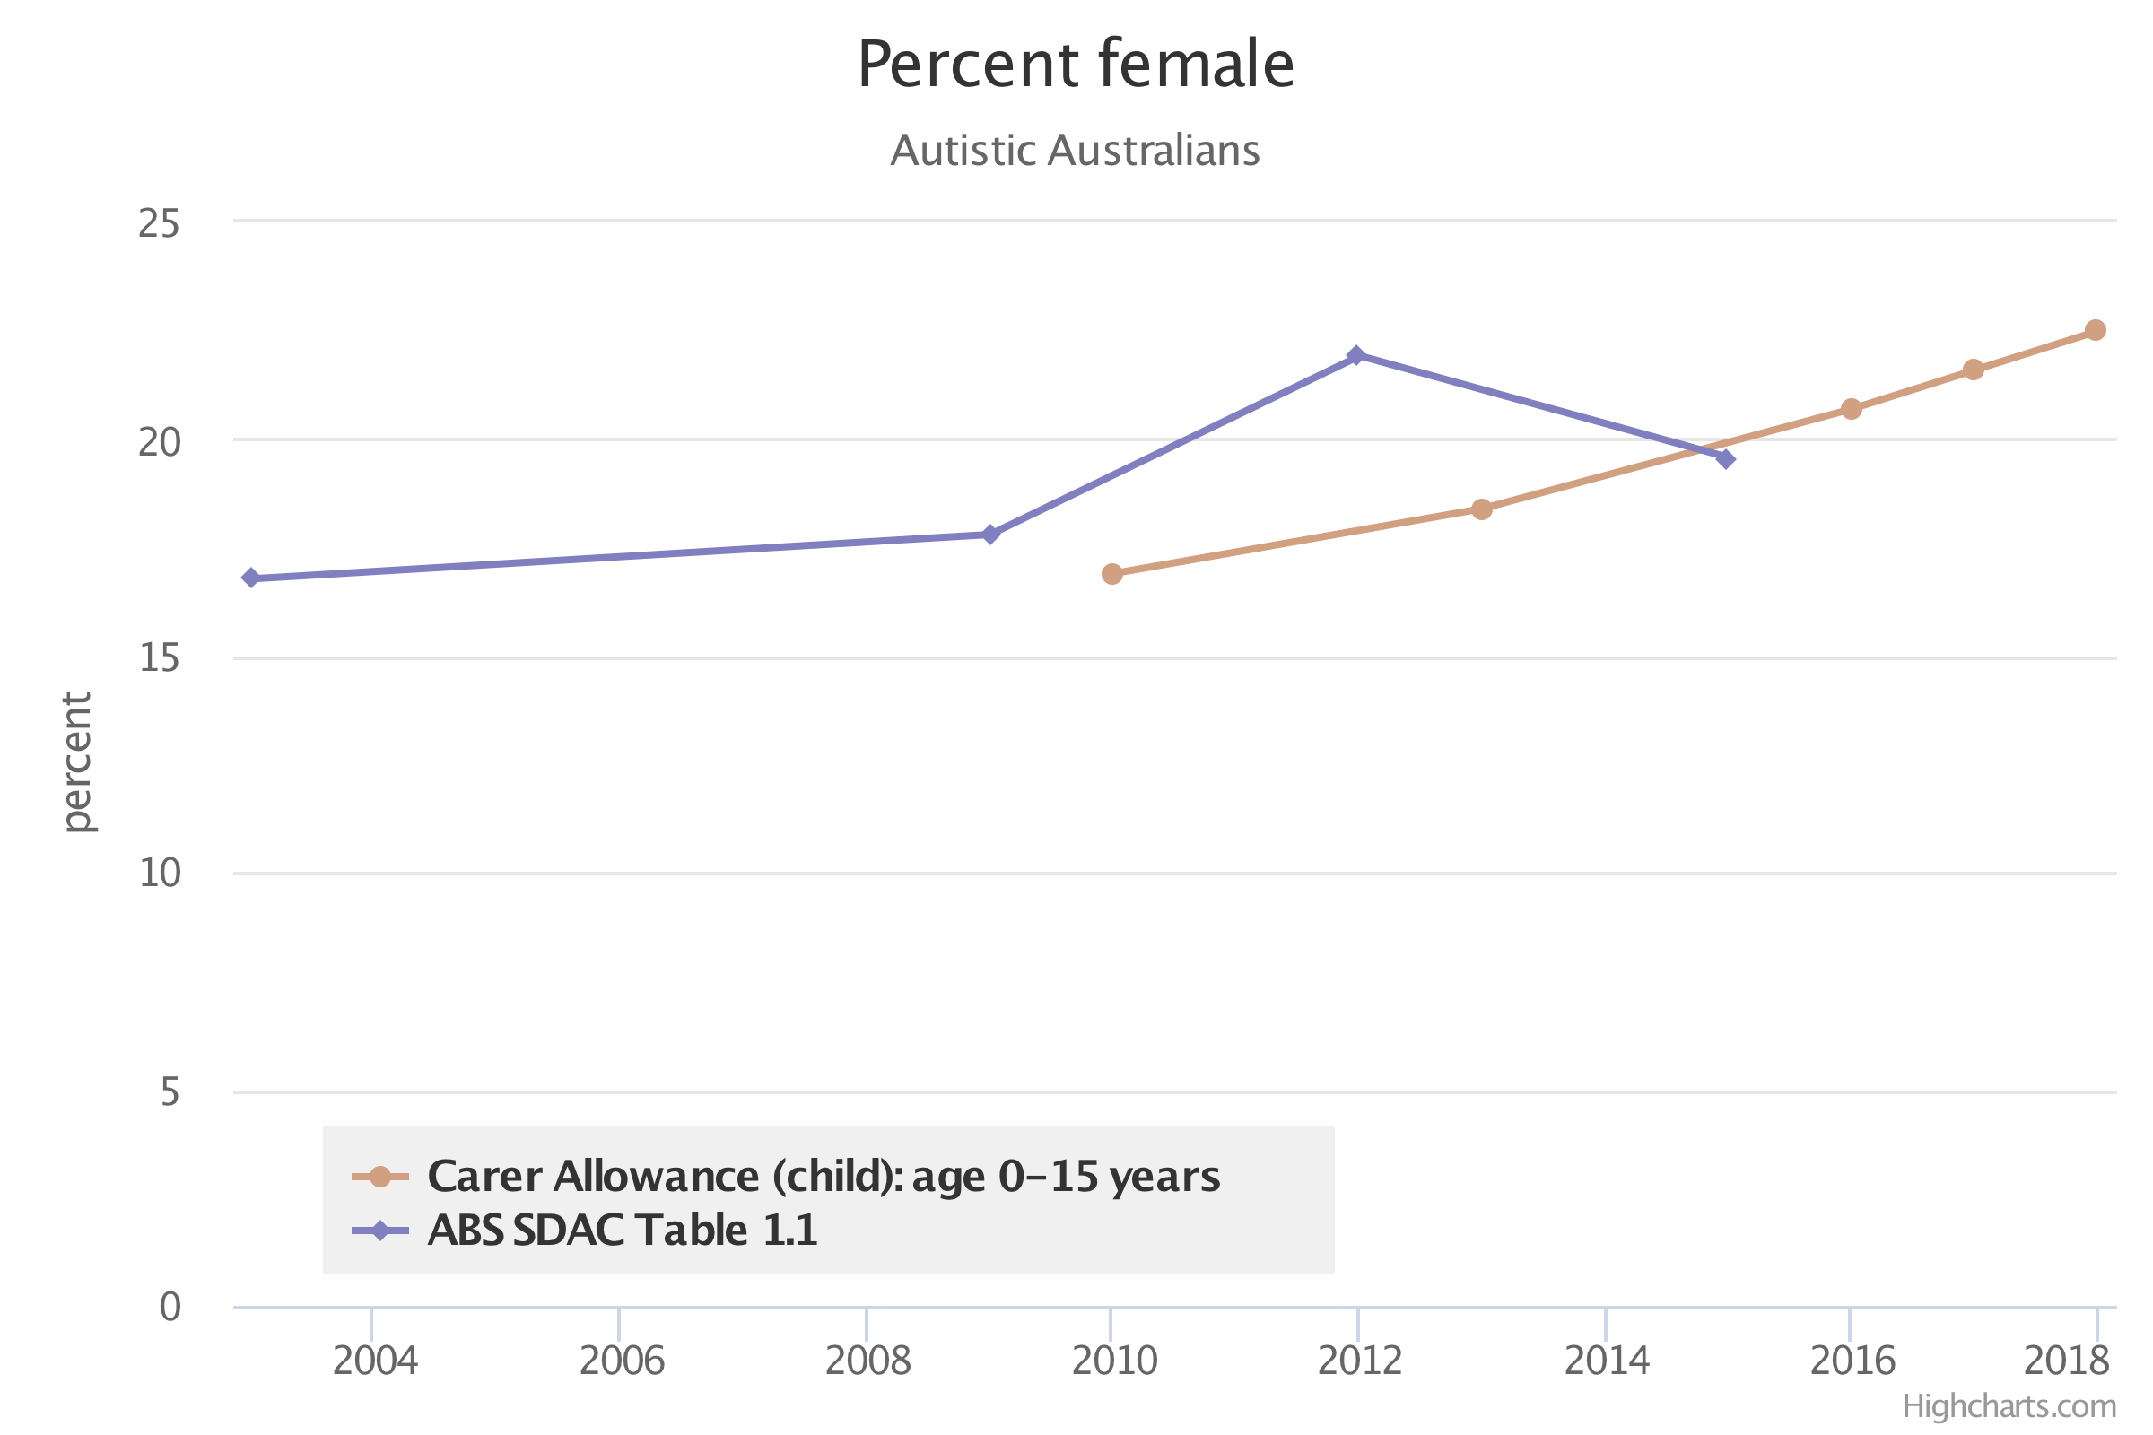
Figure 2. ASD diagnosis rates for women and girls
Non-binary gender identity is expected to be higher in the autistic population. Support for this group is inadequate in Australia.

Article 7 – Children with disability
The Figure 2 below shows few (about 35% of) autistic children in Australia are diagnosed by age 4 or 5 years of age, in time to access best practice early intervention (for at least 2 years) before their access to this essential disability support is cut off (by the NDIS) when the child enters school (aged 6 or 7 years).
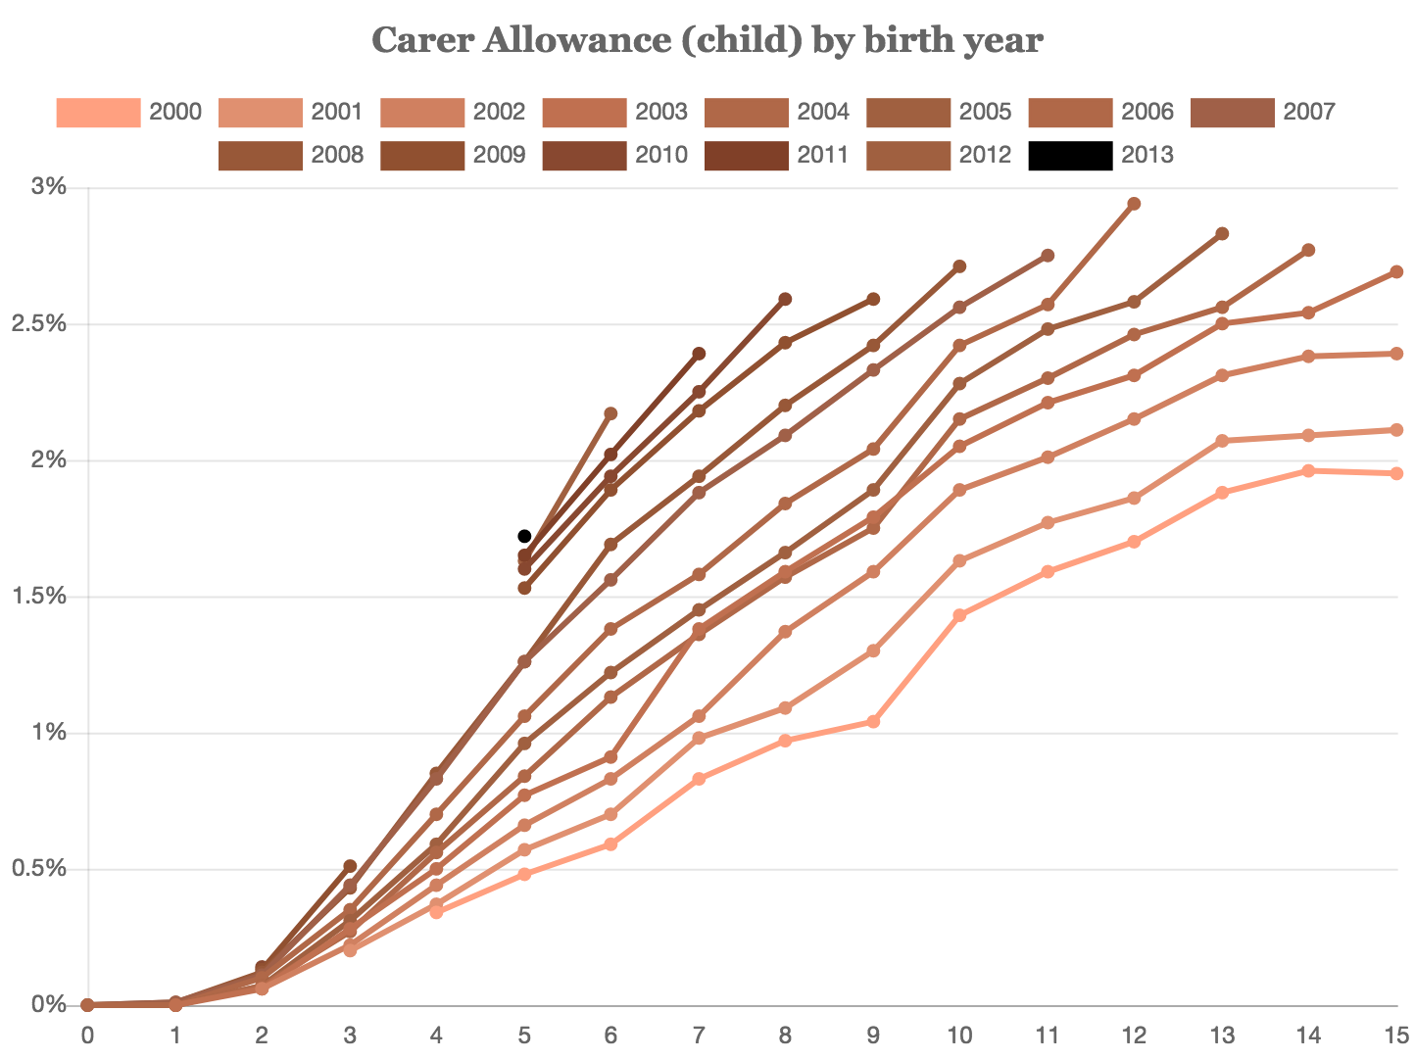
Figure 3. ASD Diagnosis rate by age (years)
In Australia, ASD diagnosis is expensive or very slow. Mostly, families have to fund their child’s diagnosis. Private health insurance does not cover the cost of ASD diagnosis.
So most autistic children in Australia miss out on essential early intervention for their ASD because they are diagnosed too late. Australia needs to improve ASD diagnosis for young children so young autistic children can access essential early intervention.
ASD diagnosis is just the first barrier for autistic children.
The NDIS denies most autistic children access to evidence-based early intervention. The Government commissioned a series of reports about evidence-based or good/best practice early intervention for autistic children. The 2016 report answered the question about whether the outcomes for a particular child can be predicted (to be used for support funding allocation). The answer was basically “no”. None-the-less, the NDIS expects families and clinicians to predict outcomes for each child, contrary to the expert advice they received.
Further, the NDIS says evidence-based practice for autistic children is “contested”. The NDIS won’t discuss this with representatives of autistic people, clinicians or service providers.
Evidence-based early intervention for autistic children aims to prepare autistic children for education and for independent living. Challenges for autistic children trying to access appropriate and effective education are discussed in Article 24 – Education below.

Article 8 – Awareness-raising
Autistic Australians are subject to substantial misinformation, ignorance and prejudice. Most disability support is now provided by the NDIS but the NDIS disputes or rejects evidence that:
- ASD diagnoses are increasing
- Evidence-based early intervention is essential to achieve equitable outcomes
- Needs of autistic Australians are often not met, especially in health, education, employment, accommodation and community participation.
Australia’s National Disability Strategy largely ignores its autistic citizens. Government excludes autistic representatives from policy development.

Article 9 – equal recognition before the law
Autistic people are treated differently before the law because autistic people are different, and they often respond differently from how people who enforce and administer the law require them to respond.
For example, autistic people often need more time to answer a question or respond to an instruction/command. Autistic people are often very literal; they obey the instruction given rather than the intent. This behaviour often annoys officials – who respond by mistreating autistic people.
Law enforcement officers often exacerbate conflict with autistic people. Police may bark instructions/commands loudly. They repeat commands quickly; too often, they do not give autistic people enough time to process and respond to commands. Sometimes, autistic people, many of whom have communication difficulty by definition, simply don’t understand the instructions they are given. Then the autistic person is seen as non-compliant when they are just slower to respond. They are described this way to the courts.
As advocates for autistic people, we have not been able to obtain data showing incarceration rates for autistic Australians. We are concerned that legal system in Australia’s states and territories usually fails to recognise or make reasonable adjustments for autistic detainees and prisoners.
For young children, delays in Australia’s legal processes deny children timely access to essential evidence-based disability supports. Autistic children need effective early intervention while they are young and for an extended period but extended delays in legal processes mean their window of opportunity is passed before their matter is heard by the legal system.
The NDIS rarely funds evidence-based early intervention in an autistic child’s support plan. The average level of NDIS funding provided in NDIS plans for autistic children is insufficient for evidence-based early intervention. A child’s family has to seek a legal remedy via the Administrative Appeals Tribunal (AAT) review process. The AAT review process is slow and often challenging for families.
- AAT processes often take so long that the child’s support funding runs out so families have to take what little is offered or endure an extended period without any funds for early intervention while they endure the added stress of an adversarial legal dispute.
- Rather than review the NDIS’s planning decision as described by the law, the AAT conducts a prolonged conciliation process designed to give the NDIS ongoing opportunities to revise the support plan it offers to the Applicant.
- If the matter reaches a hearing, the AAT officer considers the NDIS’s best offer rather than the NDIS’s decision that was the subject of the Applicant’s complaint – the AAT considers material from the Respondent that is outside the jurisdiction of the complaint taken to the AAT.
This AAT’s legal review process in these matters does not provide equal recognition before the law. Government agencies do not act as model litigants.
Few people with disability can pay for legal representation. Sometimes the state provides legal representation for an Applicant but the legal representation is minimally (often inadequately) funded – and focusses more on managing the case load rather than getting just outcomes. The legal aid provided has little or no understanding of crucial technical matters and typically shows strong disinterest in presenting supporting evidence. The NDIS’s legal representation is well funded.
For example, the matter of LJJY vs NDIA shows that government funded legal aid was inadequate representation for an autistic student. The legal representation for the person with disability failed to prepare evidence properly resulting in the AAT having to make an unfavourable decision due to the lack of evidence.
Both the AAT and then Attorney-General promised A4 that they would review the AAT’s processes. Neither did it.

Article 15 - Freedom from torture and cruel, inhuman or degrading treatment or punishment
A4 has received numerous reports of autistic people experiencing cruel, inhuman and degrading treatment or punishment.
Encounters with police are problematic. When police see and autistic person engaged in “abnormal behaviour”, which is part of the definition of ASD, they are inclined to demand immediate compliance. Some autistic people cannot comply because they simply don’t understand the instructions the police are giving. Sometimes police simply don’t allow an autistic person enough time to comprehend and respond to a command. Other autistic people regard the instructions as illogical and refuse to comply. Police then escalate the situation rapidly. Then police apply cruel, inhuman and degrading restraint to the autistic person.
Police in Australia are not trained to interact recognise ASD and to respect autistic people’s rights.
A4 is aware of several young men who were traumatised by their treatment at the hands of the police. In the worst cases, law enforcement agents kill autistic people – see http://a4.org.au/node/941.
Even though schools have psychologist among their staff, some schools in Australia subject autistic children to cruel, inhuman or degrading treatment and punishment as the infamous reports of cages and locked closets in schools have shown.
- http://a4.org.au/node/1181
- http://a4.org.au/node/1072
- http://a4.org.au/node/1841
- http://a4.org.au/node/1887
- http://a4.org.au/node/2022
There is no discernible intent from government towards preventing similar actions in future.
Autistic Australian need real behaviour support services.
Bad treatment of autistic people is not limited to schools; hospitals and other parts of the health system either restrain autistic people or discharge them without treatment. One example is the story of a young autistic man who was admitted to hospital. The hospital held him for over 200 days locked in a room subject to degrading treatment.
As the young man was the subject of an NDIS plan, A4 reported the situation to the NDIS Quality & Safeguard Commission. Rather than investigate, the Commission’s responses said:
The NDIS Commission was given an assurance that XX is being cared for and his welfare and needs accommodated at the Hospital
This is an extremely disappointing response because:
- the Commission did not investigate his NDIS behaviour supports but instead simply accepted the word of the service provider that it’s all good, nothing to see here;
- regarded the whole thing as outside the NDIS Q&S Commission’s jurisdiction even though his needs, especially his behaviour support needs, should be met through his NDIS plan; and
- did not work with other relevant bodies such as the NSW Health Care Complaints Commission since the NDIS Q&S Commission told advocates when the Commission was launched that those agencies would work closely together in matters like this.

Article 16 - Freedom from exploitation, violence and abuse
Here is some good news! After years of staunch resistance, the Australia Government is now planning a Royal Commission into Violence, Abuse, Neglect and Exploitation of People with Disability.
The bad news is that everyone expects that the Royal Commission will hear a lot of evidence.
The disability sector objects to the choice of some commissioners. The Government is ignoring objections.
Unfortunately, the Australian Government has an extremely poor record when it comes to learning from its Royal Commissions.

Article 19 - Living independently and being included in the community
The DSM-5 sets low expectations in relation to autistic adults. The poor expectations are realised in Australia.
Some autistic people have distressed behaviour that limits their inclusion in the community. Australia is starting to address the needs of autistic people with distressed behaviour though the new NDIS Quality and Safeguards Commission but this does not address support needs in other major settings such as education, incarceration (corrections or prison?), etc..

Article 24 – Education
Education outcomes for autistic Australians are abysmal. The ABS SDAC 2015 found that …
almost all children on the autism spectrum had some form of educational restriction (96.7%), including a small number who were unable to attend school because of their disability.
…
People with other disability were 2.3 times more likely to have a bachelor degree or higher than people with autism, while people with no disability were 4.4 times more likely to have one.
Another recent report says …
The Monash University research found that between 2009 and 2015, the inclusion of autistic students in mainstream classes dropped from 18.8 per cent to just 3.3 per cent.
The number of autistic students increased substantially in the period. But with greater increases in mild and moderate ASD, inclusion rates for autistic students in mainstream education settings should improve, not decline.

Article 25 – Health
It is hard to describe just how dysfunctional Australia’s health sector is for autistic people.
Just for starters, we estimate that just one in 10 autistic adults has a diagnosis. Australia’s health system does not fund autism diagnosis for people over 13 years of age so teenagers and adults have to fund their own diagnoses … with require a considerable effort, so they are expensive. As a result, ASD diagnosis and subsequent supports in Australia are not accessible for poor adults.
Australia’s health system does not support autistic citizens.
Caleb’s experience with the main hospital in that nation’s capital is blatant disability discrimination against an autistic person. The media reports …
A Canberra teenager with one failing kidney is facing a death sentence without dialysis and an eventual transplant but according to his mother, doctors at Canberra Hospital have told him he can’t be treated because of his autism.
Autistic Australians have high rates of undiagnosed and untreated health conditions. For autistic Australians, health professionals:
- are often hard to access,
- are not trained to diagnose and treat autistic patients,
- often fail to diagnose serious health problems for these patients, and
- even when they diagnose a condition they fail to provide effective treatment.
In Australia, each of the eight states and territories has its own health system. Sometimes these health systems meet the needs of autistic patients but too often they fail to provide adequate health services for autistic people. Clinical and administrative staff are not prepared or trained for autistic patients. Health workers are unprepared for autistic responses and behaviour.
- Many families report that health staff typically ignore advice from carers and escalate challenging behaviour resulting in failure to diagnoses and/or treat health conditions.
- Autistic patients are often discharged prematurely which leads to deaths, for example as for Stephen Moon. And subsequent inquiry/inquest just covers up health-care failure.
- Sometimes, autistic people are denied treatment for other health conditions because they are autistic: as well as Caleb’s story above, see http://a4.org.au/node/911, http://a4.org.au/node/1410 and http://a4.org.au/node/1425. This is disability discrimination.
- Mental health staff typically refuse admission for autistic patients – in the 1990s, Australia recognised the need for and then developed specialist services for people with a dual diagnosis of intellectual disability and mental illness but most of these services are now subject to bureaucratic annihilation. Governments strongly resist calls to recognise similar needs for autistic people with mental illness.
As an example, an A4 member reports an experience of their autistic and hyposensitive child in an hospital Accident & Emergency department. When they arrived, they told the triage staff that the child was in pain, is autistic and hyposensitive. After hours of waiting, the hospital staff said they’d been watching the child and not seen the normal signs of pain. Clearly, the hospital staff disregarded the carer’s advice that the child was hyposensitive … as a result, they’ve denied the child timely treatment and subjected the child to hours of pain. Often the families leave without treatment because the child cannot tolerate the noisy and stressful Accident & Emergency environment.
Another young autistic man has been traumatised through his encounters with police. He says “if the police come, I’ll kill himself”. The police insist on attending because “he threatened to kill himself”. They physically and chemically restrain him severely … and take him to hospital. They keep him at the hospital for many hours, until he is calmer and the chemical restraints wear off. He asks constantly to be allowed to go home, but he isn’t allowed until he is “treated”. When the hospital staff eventual decide to “treat” him, they decide immediately that they can’t treat him because he is autistic (which they knew when he arrived at the hospital) so he is then sent home without treatment. This is an ongoing assault on this young man’s mental health.
These are just a few example experiences of autistic Australians in the health system.
A4 believes that the health sector needs to embrace Inclusion: health services should cater for people with all disability types, as is the goal in the education sector. An approach that relies on specialist services for particular subgroups, like intellectual disability as recommended in the Australian Civil Society’s submission, will always leave some people with different disability types who miss out on crucial services because the specialist service for their disabilities simply does not exist.
A4 disagrees with this aspect of the submission from Australia’s Civil Society.

Article 26 - Habilitation and rehabilitation
Issues of habilitation and rehabilitation in the forms of early intervention for autistic children and behaviour intervention for autistic adolescents and adults divides the ASD community deeply.
Some autistic adults claim that autistic children and autistics generally just need acceptance; that they don’t need rehabilitation, arguing that reasonable environmental accommodations meet all their needs.
Others argue that all children need to learn to function in their community; and that autistic children, maybe more so for those most affected by ASD, need more help learning skills for life so they can live as independently as possible and participate in their community.
While NDIS legislation provides for funding early intervention, senior officials in the NDIS decided that the science associated with evidence-based early intervention for ASD is “contested” so the NDIS resists/refuses funding evidence-based early intervention for autistic children.
A few families are able to get evidence-based early intervention for through the challenging legal system described above.
The NDIS cuts off access to early intervention for autistic children when the child enters school. Cutting early intervention when a child enters school is not evidence-based.
Australian children who need behaviour support have difficulty accessing the support they need because Australia still lacks a proper registration scheme for behavioural clinicians … and Australian universities train very few behavioural clinicians.
The new NDIS Quality & Safeguards Commission has created a registration scheme for behaviour specialists without properly consulting relevant representatives of the ASD community of representatives of behavioural clinicians with international clinical registration.

Article 27 - Work and employment
Most autistic people are physically and mentally able to work. Most of them want to work, and can work well in jobs that suit them. So it is very disappointing that the Australian Bureau of Statistic reported in 2015 …
The labour force participation rate was 40.8% among the 75,200 people of working age (15-64 years), living with autism spectrum disorders. This is compared with 53.4% of working age people with disability and 83.2% of people without disability.
The unemployment rate for people with autism spectrum disorders was 31.6%, more than three times the rate for people with disability (10.0%) and almost six times the rate of people without disability (5.3%).
These unacceptable employment outcomes are due in part to Australia’s education systems failing autistic people. Without effective education, autistic Australians are not properly prepared for employment.
Politicians and bureaucrats blame autistic people for being unemployed; they call people with disability “leaners”. They don’t recognise that employers are reluctant/unwilling to employ autistic people and that Australia needs evidence-based approaches to employment for autistic people.

Article 29 - Participation in political and public life
Successive Ministers for Social Security, who were responsible for disability support, in the previous three terms of government refused to meet representative of autistic people and their community. The current Minister for NDIS is also refusing to meet. The relevant Ministers exclude representatives from the political debate and policy development.

Article 30 - Participation in cultural life, recreation, leisure and sport
Internationally, the Paralympics do not have categories for autistic people; autistic people are unable to compete in the Paralympics.
Mainstream recreation, leisure and sport provide little support for autistic Australians. The Special Olympics movement is a notable exception.
A few autistic people make notable contributions to cultural life in Australia, but most autistic people are largely excluded.
Autistic people who are eligible for an NDIS plan, a fraction of Australia’s autistic citizens, may get some support for these activities.

Article 31 - Statistics and data collection
Overall, data relating to autistic Australians is very limited.
The ABS SDAC is the most comprehensive publication. The ABS nation census does not collect disability type so it provides no analysis relating to ASD.
Australia need much better data collection to inform policy and program development to meet the needs of autistic Australians.
Data and statistics only help if their analysis is recognised and respected. Recently, the NDIS Actuary compared 2019 NDIS numbers of autistic participants to autism rates observed in 2015 ABS SDAC data. When asked how the NDIS adjusted 2015 ABS SDAC figures for 2019, the Actuary said there was no reason to expect the number of Australians diagnosed with ASD had increased since 2015.
This is despite the ABS SDAC 2015 report pointing out an increase of 42% from 2012 to 2015 which is a consistent pattern across this data series. Other Australian and overseas datasets consistently show significantly increasing ASD diagnosis rates.
From the outset, the NDIS expect that autism would be the primary disability for 20% of NDIS participants. At last report, NDIS participants listing autism as their primary disability make up 29.5% of all participants.
The NDIS’s refusal to recognise increasing diagnosis rates for ASD prevents it from planning properly to meet the needs of autistic Australian. Expecting 20% when there are 29.5% results in a 1/3 reduction in support on an individual basis.

see https://www.aihw.gov.au/reports/disability-services/disability-services-data-cubes/contents/data-cubes/2017-18-ds-nmds-service-user-data
Para. 6, http://docstore.ohchr.org/SelfServices/FilesHandler.ashx?enc=6QkG1d%2fPPRiCAqhKb7yhsnzSGolKOaUX8SsM2PfxU7tjZ6g%2fxLBVYsYEv6iDyTXyNk%2bsAB%2fHgrVpAKHcEYTB%2b1t%2fH3HX1F%2f%2bo%2bk3O4KhxfhPoTQZ3LeS75n8PHidYHE3
Where 10,000 of these listed intellectual disability as their primary disability and ASD as secondary – they often do this because they fare better in the NDIS’s inequitable funding model.
The Australian Bureau of Statistics estimated there were 164,000 autistic Australians is 2015. A4’s estimate is based on 10% increase per year from then.
Australia has a legal system. Australia’s lack of an enforceable Bill of Rights or equivalent legal instruments to ensure internationally defined rights, including right described in treaties sign by the Australian Government, and systemic failure/inability/refusal to make reasonable adjustments for persons with disability (and other vulnerable people) mean Australia does not have a justice system (meaning a system that delivers justice).
Most government funded diagnostic services have long waiting lists; some are notoriously averse to giving ASD diagnoses.
Clinicians and researchers tend to use the terms “challenging behaviour” or “behaviours of concern”.
Note: “hyposensitive” is not really the right term; the autistic child does feel pain but has not yet learned (been taught?) how to show/communicate pain “convincingly” to others. The child may never have a “normal” response to pain, so their assessment approach that hospital staff use is inappropriate … and completely disrespects carers.

