April 2010 - Volume 8, Number 3

Software testing and Asperger's Syndrome
Infoxchange Australia is planning to develop a software testing social enterprise that employs people who have Asperger’s Syndrome with support from Social Firms Australia (SoFA) and Alpha Autism.
The enterprise will be seeking people who have the ability to concentrate with intensity for lengthy periods of time, excellent memory recall and extraordinary attention to detail, which is often present in people who have Asperger’s and high-functioning autism.
Evidence has shown that people with these particular qualities have a strong ability to pick up glitches in computer systems and “bugs,” which have the potential to cause catastrophic failures. The model has been proven by Danish company, Specialisterne, which was started by entrepreneur, Thorkil Sonne. Specialisterne have a 90 per cent rate of workers who have autism and work with clients that include Oracle Corporation and Microsoft.
The Australian enterprise will be employing people with Asperger’s and high-functioning autism. They will have their unique skills applied and used to their full potential and paid commercial salaries in the process.
Infoxchange is planning to launch this enterprise in the second half of 2010. If you would like to provide support for this initiative, please contact info@infoxchange.net.au.

Contents
Software testing and Asperger's Syndrome 1
Contents 1
Convenor’s message 2
National Disability Insurance Scheme 4
Helping A4 4
AABASD position on appropriate education 5
Oxytocin and Autism research 6
Tasmanian election 7
The Cage 8
Increase Autism Funding 9
What Happens Next? – A unique opportunity 10
Where do you want the government to spend $$$ next? 10
USA: Health-care Reform Bill Passes Both Houses 11
Autism rates soaring among Queensland school children 12
Letters 13

NSW: Mainstream high school not an option 13
Qld: Supported Housing for person with disability 14
Research paper 15

Convenor’s message
Dear A4 member
I am pressed for time … but there are things already in this Update that should be shared with you, so I am sending this out as soon as I can.
The proposal for a National Disability Insurance Scheme (NDIS) will be a substantial issue for A4 in the coming years. An NDIS potentially could improve the lives and outcomes for people with autism spectrum disorders and their families. Or it could essentially exclude people with ASD. In my view, the ASD community should be as clear as possible about what it needs from such a scheme and do what it can to ensure that ASD needs are met if/when a scheme is introduced.
A4 exists to represent its members. A4 needs help from members in deciding what the ASD community needs and expressing those needs to Government. Please think about this issue and tell us what you think. Perhaps A4 should survey members and the ASD community on this issue.
The previous A4 Update highlighted the rapid increase in ASD diagnosis both here in Australia and overseas. In recent times, the observed prevalence of ASD has more than doubled every five years.
One piece of recent research …
“found that children living near a child who has been previously diagnosed with autism have a much higher chance of being diagnosed themselves in the following year. The increased likelihood of being diagnosed is not due to environmental factors or contagious agents, the study found. Rather, it is due mainly to parents learning about autism from other parents who have a child diagnosed with the disorder.”
…
The researchers stress that the results do not mean that autism is not real or that it is overdiagnosed. "Our study doesn't address the underlying cause of autism," Dr. Bearman said. "We are describing the mechanism by which the number of diagnoses is increasing. It could be that the real incidence of the disorder is only now being uncovered. …
Note that this may be “a mechanism” rather than “the mechanism by which the number of diagnoses is increasing” (my emphasis).
Recent data on the number of students is Queensland with ASD are consistent with (and offers some confirmation of) the prevalence of ASD described at APAC ’09 (which was based on data from Centrelink’s Carer Allowance clients). These data shows that the rate of ASD diagnoses among Queensland students now exceeds the national average for people with an intellectual disability.
Most people I spoke with find they cannot accept the scientific principle, that the past predicts the future, in relation to autism/ASD prevalence. Many professionals, politician and bureaucrats are reluctant or even refuse to consider as a possibility that the prevalence of ASD could continue its pattern of growth: that is, doubling every 5 years. Most people now accept that data from Centrelink showed 1 in 160 children were diagnosed with Autistic or Asperger’s Disorder in 2005. But some people are unwilling to acknowledge that the same data shows diagnoses doubled over the 5 years to 2009.
As a scientist I depend on the principles of science but I confess that I am keen to see new research get started. Hopefully, it will find that disability due to ASD will not continue to increase like the growing number of ASD diagnoses has in the recent past.
Some politicians and bureaucrats dismiss evidence of increasing ASD prevalence. People like this often cite their perceptions of weaker scientific support for autism/ASD interventions to excuse their inaction. This selective use of scientific principle exposes how politicians and bureaucrats use science not as a tool in decision making but instead as a convenient excuse in avoiding responsibility.
Evidence that the prognosis for people diagnosed with autism spectrum disorders can be improved is relatively good news. Evidence supporting behavioural approaches continues to emerge: for example, a recent study showed intensive ABA for toddlers with autism is highly effective.
We also have a lesson in interpreting the portrayal of research science in the media. A media item is headed “New study of autism reveals a 'DNA Tag' (Methylation) amenable to treatment”. My very limited knowledge of epigenetics tells me that “aberrant methylation” has been implicated in cancers and disorders such as Angelman and Prader-Willi syndromes. While this knowledge will improve diagnosis, phrases in the literature like “ultimately leading to treatment” makes me doubt treatment methods that normalise methylation in vitro will be available in the near future.
Since the last A4 Update, I was able to meet Parliamentary Secretary Bill Shorten. I gave him a briefing paper that included the Shorten Curlies published in previous editions.
Also, President Obama managed to get some of his health reforms adopted. Apparently these reforms include some significant changes for people with autism/ASD.
Families of people with ASD should push hard for similar reforms in Australia. With a federal election due this year, now is the time for all of us to ask our local representatives how they will represent our interests in Parliament after the next election.
Regards
Bob Buckley
A4 Convenor

National Disability Insurance Scheme
The Productivity Commission is inquiring into a national disability long-term care and support scheme. (see http://www.pc.gov.au/projects/inquiry/disability-support). The terms of reference are at http://www.pc.gov.au/projects/inquiry/disability-support/terms-of-reference.
Amongst other things, this inquiry will examine:
- how a scheme should be designed and funded to better meet the long-term needs of people with disability, their families and carers
- how to determine the people most in need of support, the services that should be available to them, and service delivery arrangements
- the costs, benefits, feasibility and funding options of alternative schemes
- how the scheme will interact with the health, aged care, informal care, income support and injury insurance systems
- its impacts on the workforce
- how any scheme should be introduced and governed
- what protections and safeguards should be part of the scheme.
This is a major matter for people with Autism Spectrum Disorders. A4 encourages members to think about such a scheme. Please tell us (and the Government) about your views.
There is other information about a national disability insurance scheme (see http://www.ndis.org.au/). Other links include http://www.nds.org.au/sphider/search.php?query=ndis&search=1 http://www.yooralla.com.au/NDIS.php, http://www.endeavour.com.au/latest_news/latest_news_ndis.html, etc.
There are opposing views. For example, see http://www.onlineopinion.com.au/view.asp?article=9539 and http://www.civilsociety.org.au/National_Update1109.htm#Erik_Leipoldt. Also, some lawyers feel there are better alternatives, see http://www.murdoch.edu.au/elaw/issues/v9n4/menyawi94.html.
The Productivity Commission would like to receive submissions before the end of June 2010. Just write them a letter or an email.
Please help A4 develop its submission. Please think about a national disability insurance scheme. Please tell us what you think (email to cnvnr@a4.org.au). Will it work for you? What are the risks?

Helping A4
A4 needs a few volunteers to help produce A4 Updates. A number of announcements were omitted from this edition because we did not have the capacity to reformat material for inclusion or to negotiate with the people who sent the material to get it into the right format.
A4 needs help from someone skilled with Microsoft Word and who can spend a few hours each month formatting the A4 Update. If you would like to help, please email cnvnr@a4.org.au.

AABASD position on appropriate education
In April 2010, Australia's Autism Month, the Australian Advisory Board on Autism Spectrum Disorders (AAB ASD) launched its position paper on Education and Autism Spectrum Disorders in Australia: The provision of appropriate educational services for school-age students with Autism Spectrum Disorders in Australia.
The Australian Advisory Board on Autism Spectrum Disorders calls for educational services for school-aged Australian children and adolescents with an Autism Spectrum Disorder (ASD) that are governed by the following principles:
- Every child and adolescent with an ASD should have access to an educational service appropriate to his her/needs
- All government and non-government educational sectors should provide educational services that cater to the needs of children and adolescents with an ASD
- Educational services must be responsive to all children and adolescents across the autism spectrum
- There should be a range of educational services for children and adolescents with an ASD
- Educational services must address the students’ needs in communication, social skills, learning, sensory issues and behaviour and include family involvement
- Increased provision of teacher education and training to improve the capacity of educational services to provide for students with an ASD
- Educational services are based on sound evidence and quality indicators
- Following an application for service, enrolments should proceed in a timely manner to ensure students with ASD access appropriate educational services as soon as possible.
The AAB ASD paper calls for the provision of appropriate educational services for school-age students with Autism Spectrum Disorders in Australia. The complete paper presents in detail 8 key principles aimed at achieving an increase in appropriately allocated resources, collaboration between key stake holder groups and improving the capacity of the educational services and service providers.
Jon Martin stated: “Across Australia, the development of appropriate educational services is a critical priority. Demographic data tells us that most people with an ASD diagnosis in Australia are of school age – and this number is growing. ASD prevalence more than doubles every 5 years. As such, there is a significant increase in the number of students diagnosed with ASD that will require specialised support. Currently, there are high rates of suspensions, exclusions and part time schooling that impacts on ensuring the best opportunities and educational outcomes for students with an ASD”.
Links to download the position paper … http://autismaspergeract.com.au/sites/default/files/Education%20Position%20Paper%20Final%202010%20V2.pdf or http://www.autismaus.com.au/uploads/pdfs/Education_Position_Paper_2010.pdf.

Oxytocin and Autism research
Recent publication of Australian research into oxytocin and autism spectrum disorders sparked some interest in overseas media. Oxytocin is a mammalian hormone that acts primarily as a neurotransmitter in the brain
The research reports say oxytocin, administered as a nasal spray, improved subjects’ performance in a facial emotion recognition task. The article warns …
Since this was a relatively small study, additional research is still needed to confirm these promising findings and further evaluate oxytocin as a potential treatment. Until then, the authors advise against the use of oxytocin outside of supervised clinical trial research.
A second study shows Oxytocin “significantly improved the abilities of autistic patients to interact with other individuals”.
Wikipedia (see http://en.wikipedia.org/wiki/Oxytocin) describes Oxytocin’s action within the brain in relation to autism:
Oxytocin may play a role in autism and may be an effective treatment for autism's repetitive and affiliative behaviors.^{[20]} Oxytocin treatments also resulted in an increased retention of affective speech in adults with autism.^{[21]} Two related studies in adults, in 2003 and 2007, found that oxytocin decreased repetitive behaviors and improved interpretation of emotions, but these preliminary results do not necessarily apply to children.^{[22]} Oxytocin has also been implicated in the etiology of autism with one report suggesting that autism is correlated with genomic deletion of the gene containing the oxytocin receptor gene (OXTR). Studies involving Caucasian and Finnish samples and Chinese Han families provide support for the relationship of OXTR with autism.^{[21][23]} Autism may also be associated by an aberrant methylation of OXTR, as reported by Gregory and colleagues.^{[21]} After treatment with inhaled oxytocin, autistic patients exhibit more appropriate social behavior.^{[24]}
Related articles on the internet include …
- http://www.sciencecentric.com/news/article.php?q=10040937-new-treatment-social-problems-autism-oxytocin-improves-emotion-recognition
- http://www.sciencedaily.com/releases/2010/02/100216221350.htm and http://www.sciencedaily.com/releases/2010/04/100408105200.htm
- http://www.physorg.com/news189946895.html
- http://www.autismresearchcentre.com/research/project.asp?id=12

Tasmanian election
Shortly before the Tasmanian election ATAC placed the following political advertisement in several local papers.
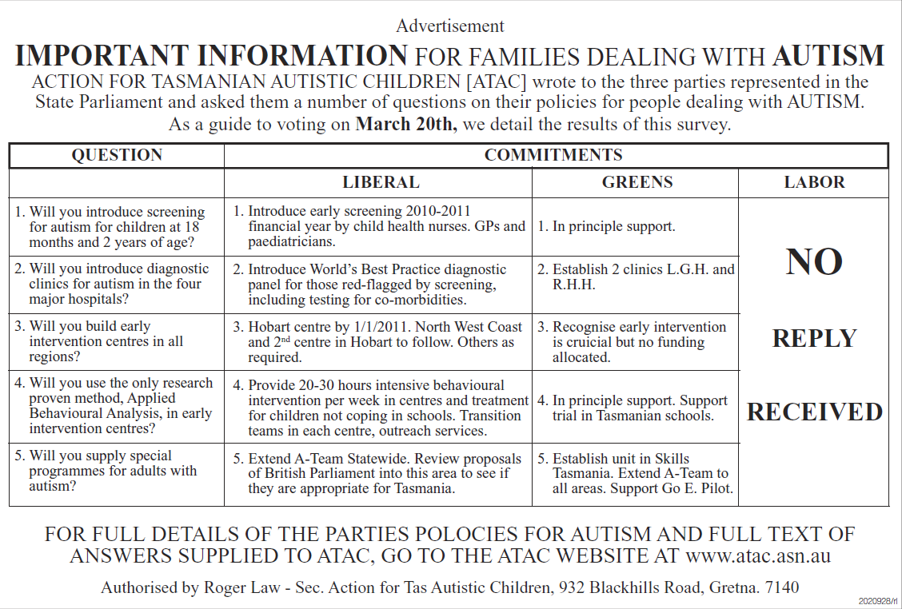
Tasmanian Labor responded quickly after the advertisement was published. However, their response was largely spin. In addition to being too late, it sought to avoid the questions that were asked. I expect Labor’s response would disappoint most people who are concerned about outcomes for people with autism spectrum disorders and their families. A bit of commentary is available at http://a4.org.au/a4/node/224.
The result of the Tasmanian election has yet to be seen. Even when a government is decided, we do not know how well the resulting Tasmanian Parliament will function.
In coming state elections, let’s ask politicians and their parties specific questions about their ASD policies, then publish their responses or lack thereof. The ASD community can show politicians that it expects clear and simple answers on matters relating to ASD. The politicians and their parties should answer the questions they are asked: they must not be allowed to change the question or answer a different question. If they respond to questions with spin, diversion and misinformation, the community can interpret their response as negative and unsympathetic.
Few state autism associations will do this; this is not their role and autism associations do not vote in elections. Family members will need to make this happen: they are the people who vote. Contact A4 if you need help.
The goal is to get the politicians to present policies that we want to vote for. We should help them all create great ASD policies by telling them what a great policy contains.
A4 can do this at the federal level. Please send the questions you would like us to ask the politicians to cnvnr@a4.org.au.

The Cage
The Cage at Seven Hills West Public School (see http://a4.org.au/a4/node/212) attracted some media interest.
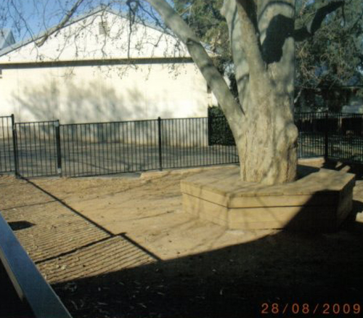
Opinions vary on this practice of restraint. Back in the late-1990s, when the ACT Education Department introduced autism-specific Learning Support Units into mainstream ACT schools, the ACT Autism Association and the Education Department agreed/insisted that every primary school with an autism-specific Learning Support Unit have its own “cage”, a small lockable area to restrain students with an autism spectrum disorder.
Not everyone agreed; there were a few dissenters. Parents of children at my son’s autism-specific learning support unit agreed that the school/unit would not have such a restraint for our children. These parents insisted on a more general solution to our children’s behaviour. We needed our children to learn safety in the community, not just when they could be contained in a small fenced area at school. We insisted our child’s education goals include safety. Note: safety was usually part of the pre-NAPLAN curriculum for primary school students.
Now, my son and I are glad that we can move safely through the community without his dashing off when he is startled or attracted to something. Now, he can get out and about with a carer; he does not need to be restrained or incarcerated. While our approach to our son’s behaviour required more effort and expertise, we felt our approach achieved a better overall outcome for my son, for us, for his education, etc.
Needless to say, as soon as my son left that school, the ACT Education Department immediately built a small compound for the students with ASD who followed. The school claims to be inclusive, but it does not “include” non-ASD students in its “cage”.
Different people have different priorities; for example, some families regard inclusion in the school playground or in school excursions as having a relatively low priority.
A school may argue that it needs to fall-back to using The Cage when a child’s absconding is a challenge that is embarrassingly beyond the ability of the limited expertise available. Parents may want to look carefully to see which goals of inclusive education such a school can deliver to any significant degree.
I suggest people think long and hard about allowing restraints such as “The Cage” for children with autism spectrum disorders. The use of restraint should be the last resort. The state (and the school) show through their choosing to use restraint that they decided to not meet the education needs of the student.
Bob Buckley, 14/3/2010

Increase Autism Funding
VOTE NOW!
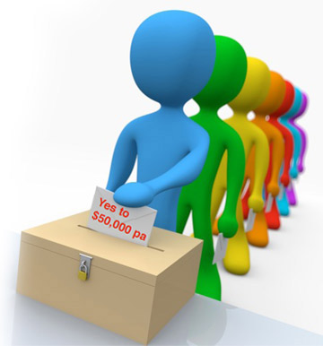
Join one of our 1000 hours dads, Scott Reading, and support his proposal to the Australian Liberal Party to "Increase Autism Funding to $50,000pa per child for 2 years."
Vote now and have your say. It's an election year so let’s make it count!
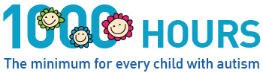
http://www.liberal.org.au/Issues/Community/Disabilities/Ideas/2010/03/18/Increase-Autism-Funding-to-50000pa-per-child-for-2-years.aspx

Response from Senator Mitch Fifield, Shadow Parliamentary Secretary for Disabilities, Carers and the Voluntary Sector:
Research shows early intervention is incredibly important to ensure the best outcome for children with autism and also results in savings down the track. It was in recognition of this that in October 2007 the Coalition Government announced a $190.7 million program to provide greater support for children with autism under the Helping Children with Autism package. This program provides much needed additional support to access a range of education, support and early intervention services and was a huge step forward in meeting an important need that affects many Australian families. The Coalition was able to initiate this package on the back of good economic policy. A strong economy is the necessary underpinning for a good social policy.
Obviously more needs to be done to support Australians with disability. It’s important to understand that the level of support a person with a disability in Australia receives can depend on a number of factors. What state they live in, whether the disability is congenital or was acquired and, if acquired, whether it was in the workplace, a motor vehicle accident or some other context. The result is that many people with a disability, particularly those born with disability, don’t always get the assistance they need.
Australia needs to move to a system of support for people with disability that is based on need rather than how a disability was acquired. One proposal to address this situation is the concept of a national disability insurance scheme. The Coalition believes this is an idea worth looking at and supports the referral of the concept to the Productivity Commission for further examination.

Media Release | 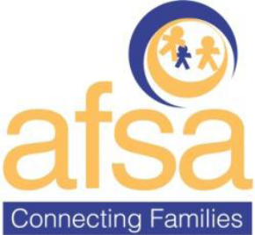

What Happens Next? – A unique opportunity
25th March 2010
The Autistic Family Support Association Inc is offering a unique opportunity for the Victorian public to help prioritize areas the Victorian State Government should focus on for the next round of investment. The Autism State Plan Stakeholder Group will be making their investment priority decision at its next meeting scheduled for 21st April 2010.
“We want to know the opinion of anyone with any kind of interest in Autism Spectrum Disorders. It’s important that as many people as possible complete the survey.” Meredith Ward, President Autistic Family Support Association Inc said.
AFSA have developed a survey to collect information about the priority areas for the next round of investment. The data will be presented at the April 21 meeting in conjunction with the large body of anecdotal evidence collected over the past ten years.
“As active statewide advocates for the autism community for about ten years, we’ve gathered a large body of anecdotal evidence about the difficult daily life issues from preschool years to adulthood” she said.
The development of the Autism State Plan included extensive statewide consultation. The findings of the consultation were made public and formed the basis for the Autism State Plan which was launched 21st May 2009.
“The consultation findings supported the anecdotal evidence we’d gathered. Now it’s time to fund the plan in a way which will address those issues. The Autism State Plan is aspirational, but implementation must close the gap between ‘what is’ and ‘what should be’” she said.
The survey is currently available on the AFSA website http://www.afsaconnect.org.au and closes 18th April 2010. The results will be published to coincide with Autism Awareness Month on AFSA website at the end of April.
Media Enquiries: Meredith Ward 0400 226 408
Autistic Family Support Association Inc. E: info@afsaconnect.org.au www.afsaconnect.org.au C/-PO Box 3328 Wheelers Hill Vic 3150

Where do you want the government to spend $$$ next?
The Victorian State Government determined that the Autism State Plan is the mechanism by which ALL new investment in ASD services will come.
We want to know your opinion.
The survey is open until 18th April.
Our next Autism State Plan meeting is 21st April at which time the Stakeholder group will decide on the areas to attract funding for the next round of investment.
Click on the link to go to survey http://www.surveymonkey.com/s/5Q557NQ
Please share this email with as many people as possible – anyone who has an interest in ASD can tell us their opinion.
Thanks and regards
Meredith Ward
President
www.afsaconnect.org.au

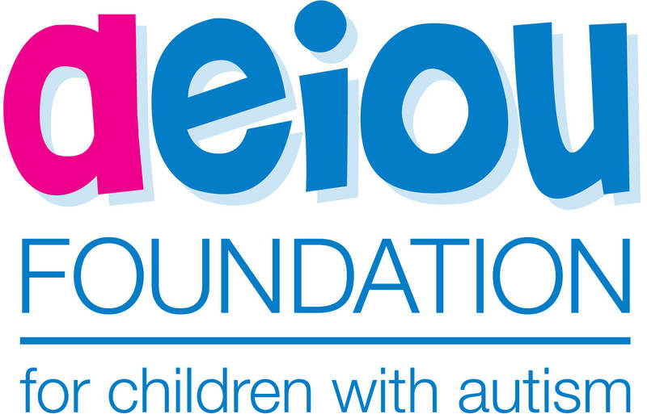 | The AEIOU Foundation for children with autism is now on Facebook so you can stay up to date with the latest events and news.
Become a fan and spread the word to your friends and Facebook contacts. Simply click on the Facebook link below and then sign in using your Facebook login (if you have an existing one) and become a fan of our page.
Follow this link
http://www.facebook.com/pages/AEIOU-Foundation-for-Children-with-Autism/351589415589
The AEIOU Foundation is one of the supporting organisations of the 1000 Hours campaign

USA: Health-care Reform Bill Passes Both Houses
Monday, March 22, 2010 By: Hannah Cary
On Sunday, March 21, the U.S. House of Representatives passed the Senate version of health-care reform. "The Autism Society is pleased that Congress took a step in the right direction late last night," said Lee Grossman, President and CEO of the Autism Society, "but we have much more work to do to ensure that families affected by autism have access to appropriate services and supports."
After more than a year of debate, the bill passed 219 to 212 and was signed into law Tuesday, March 23. This bill, which passed the Senate in late December, includes the following provisions for people with autism:
- Insurers would be prohibited from excluding coverage based on pre-existing conditions;
- Insurers would be prevented from selectively refusing to renew coverage;
- Insurers would no longer be able to charge people different premiums based on their health status, gender or occupation;
- A standardized annual out-of-pocket spending limit would be established so that no family would face bankruptcy due to medical expenses;
- Annual and lifetime benefit caps would be prohibited;
- Mental health would be covered;
- “Habilitative” and “maintenance services” would be covered; and
- Coverage of “behavioral health treatments,” such as ABA therapy, would be required.
See more at http://www.autism-society.org/site/News2?page=NewsArticle&id=15849&news_iv_ctrl=2182

Autism rates soaring among Queensland school children
AUTISM rates are at an all-time high in Queensland schoolchildren, with concerns over higher levels in mining and farming communities.
More than 2 per cent of state school students – nearly 10,000 – were classified last year as having autism spectrum disorder. Education Queensland believes it is the highest number ever to have been diagnosed with ASD in state schools.
It follows concerns the disorder is being overdiagnosed to gain funding for students whose real disability does not attract money under departmental guidelines.
Full coverage of the ASD spectrum, suburb by suburb in Saturday's Courier-Mail print edition
One pediatrician said some doctors felt forced to make an ASD diagnosis by parents and teachers desperate to gain more learning support for a child.
The official ASD rates range from one in 64 to one in 160 children, with one in 160 the most widely accepted figure in Australia. In state schools the rate is about one in 50.
For the first time, The Courier-Mail print edition can provide a breakdown of how many state school students have been diagnosed with ASD per postcode. The figures, released on Education Queensland's website for ASD approvals from January 1, 2007, to December 4, 2009, show Toowoomba, Bundaberg and Maryborough have the highest numbers.
But unusually high rates appear in Brisbane's southern outskirts and in regional areas on the Darling Downs.
Meanwhile, researchers have made potential links between mining and farming areas and higher levels of ASD.
International ASD authority and Brisbane-based psychologist Tony Attwood said it was acknowledged there was a higher incidence of ASD in the children of engineers.
"The mines employ engineers," he said.
"We would expect a higher level (in mining areas) because of the high levels of engineers in that area."
Dr Attwood said a higher level of ASD would be found among information technology workers and farmers.
John Wray, the Australian expert who co-wrote the report The Prevalence of Autism in Australia, said researchers had found early links with farming, and it was long believed there was a cluster in Silicon Valley in California.
"There is a lot of ongoing work around ongoing possible environmental explanations," Dr Wray said. But over-diagnosis was "frankly the main matter under contention".
Brisbane pediatrician Catherine Skellern, who raised concerns about over-diagnosis in Queensland schools in a report in 2005, agreed with Dr Wray that Queensland's student statistics required investigation.
Dr Skellern said teachers and parents sometimes confused behavioural problems with ASD and pushed doctors for a diagnosis so their children could get funding.
"It really highlights that we need to revisit the issue of how students are supported within schools, and to question the validity of a medical model that is the sole basis to access special education support," she said.
A ministerial briefing by the Education Department acknowledges 1.8 per cent of students – or 8656 – were diagnosed with ASD as at December 22, 2009.
But the number did not include Year 12 because it was the end of a year.
The November figure released by the department shows 9978, or 2.05 per cent of last year's 484,615 students, had a verified ASD impairment.
EQ students services executive director Dr Graham Foster said the department was "not in the business of diagnosis".
Tanya Chilcott, Janelle Miles and Peta Fuller
The Courier-Mail, April 09, 2010
From http://www.couriermail.com.au/news/queensland/autism-rates-soaring-among-queensland-school-children/story-e6freoof-1225852008088

Letters

NSW: Mainstream high school not an option
Hi There,
My name is Marcelle Buxton and I am the parent of a five year old with HFA in Sydney.
I have been disturbed by the amount of parents I am meeting with HFA & Aspergers primary school kids of various ages, who are saying that mainstream high school will not be an option for their kids and that they plan to home school for high school.
I have also been shocked to hear from parents of HFA and Aspergers kids who have already finished high school, saying how traumatised their kids are after finishing school, having withstood years and years of relentless bullying.
I am interested to find out if you are aware of any proposals to get high schools set up in Australia specifically for students with HFA or Aspergers (at the higher end of the spectrum)? At the moment in Australia there seems to be no other social schooling options other than mainstream for the kids at the higher end of the spectrum.
I am of the thinking that it is discriminatory, now that there is hard evidence that these kids brains are wired differently and they have a different learning style to their neurotypical peers. I also think it is unfair that they have to put up with high school bullying (as I think the statistics are that 90% of kids with ASD's get bullied at mainstream high schools). I know that many high schools have special ed units in them but the playground is where they main problems are and these kids are being permanently mentally damaged by being made to withstand our system and ‘fit the mould’.
I am considering starting a lobbying group to try to open high schools for these kids so if you can let me know if you have heard of any plans for any I would really appreciate it. I am of the view that this could really benefit these kids and if large ASD friendly companies (such as banks, engineering, IT type firms) got on board with sponsoring kids for on the job work experience programs as part of the curriculum, it could lead to these kids having a real chance at succeeding at life and being less traumatised by not having to put up with neurotypical bullies.
Other countries such as the US and UK already have these types of high schools available as an option. I find it incredible that this has not occurred here yet.
I have sent emails regarding this matter to Tony Attwood and Sue Larkey to try and get their views as well. I have also posted queries about it on global autism on line forums to start collating peoples’ thoughts.
Thanks in anticipation of your response.
Regards,
Marcelle

Qld: Supported Housing for person with disability
Hello [advocacy group]
Back in 1995 when things were so grim for our family a person high up in DSQ gave me the advice to leave [my child] at respite and walk away. I could not do it. What then happened was a group of services concerned for our welfare and that of [our child] combined, and issued the Minister of the day, with a Ministerial as they called it, an ultimatum, demanding supported accommodation for [our child] and that was how we eventually got it in 1997. Why it is suggested to leave your son or daughter and walk away is because the Department is forced to react in the crisis, and if the region has no money allocated for supporting the child at that point in time, the government is forced to find the necessary funding.
What I did for another group was set up an organisation that specifically fought just for accommodation. I wrote the submission for 5 people to enter housing. They were not autism but Downs Syndrome. From the time the group first started pushing for housing until they achieved it took 20 years--last year. I was disappointed, however, in the group as they moved away from the original idea of setting up as a housing company which would get one group into housing and follow on with other people or groups specifically needing supported accommodation. Once they achieved housing for their children any one coming after them had to virtually start from the beginning again.
I think you may have more of a chance now to get better housing through DSQ. After battling for years and stating what kind of housing is required for [my child] with high support needs and challenging behaviour, the department has at last listened and has specially designed a purpose built house for her which is about to be built and will be finished early next year. Much work has gone into it from an OT, psychologist, [my child]'s workers, and other interested parties including family. People have flown in from Brisbane to discuss what needs to go into it and how to make the place look like a home taking into account that she can wreck things. Right now she has furniture that can be tipped and cannot do damage to her or it. It seems we are breaking new ground. I would not mind you using my name if you begin asking for purpose built housing and let them know there is a precedent being set in [XX]. I know both the Department of Disability and Dept of Housing have learnt a lot through this exercise. The psychologist who put so much time into the planning for me is [YY]. She is a gem and extremely knowledgeable. I also think this is the right time to begin advocating strongly for more supported accommodation as an election is on the horizon. Even though supported accommodation is a State issue there is a Commonwealth State agreement, as I understand, for housing similar to disability funding, so it would be in order to advocate for housing in a federal election. I am trying to get information right now on respite and supported accommodation to use in advocacy. Supported accommodation has been sadly neglected but a crisis is looming as an ageing population is finding it cannot keep doing the caring.
There are some non- government organisations that have been given funding specifically for supported accommodation for adult children of ageing parents. However, some parents needing this kind of accommodation for their children do not fit the criteria of ageing. What one must also be careful of is if a parent does decide to give up their child before the age of 18 then Child Safety can be called in and the parent is expected to relinquish their rights. Also some non-government organisations do not have the appropriate training to deal with the behaviours of ASD and this is when the Adult Guardian is often called into the picture by the service provider who does not want to admit their incompetency, want the parent out of the way, and see the answer in strong drugs. There is yet another case I know of involving a person with Aspergers about to go to the Tribunal on Monday where it seems the parent could lose all rights because her son is in supported accommodation. This is a Brisbane case but I have been involved through the sister of the boy's mother who lives in [XX] and will take part in the hearing by tele-link.
[A Queensland Mother]

Research paper
Dear Friends of SABRI,
This email is to inform you that a new SABRI paper has just been published in 'Autism Insights' titled, "Reconceptualizing Autism: Moving Beyond the Behavioural to Address Cause, Cure and Prevention".
For online access, please go to; http://www.la-press.com/autism-insights-journal-j155.
The paper presents some historical context behind the lack of meaningful progress in terms of research into autism's cause and cure, and proposes a reconceptualisation of autism whereby biomedical variables known to be associated with autism are acknowledged within formal diagnostic systems. We argue that such a development would facilitate a more diverse, medically-relevant and successful international research effort than we have seen to date.
I trust you find the paper informative and thought-provoking: This was certainly our goal, especially in the context of the proposed changes to the diagnostic criteria for autism (due in 2013) which, in draft form at present, continue to omit all references to biological variables known to be associated with autism.
Best wishes,
Assoc. Prof. David Austin.
Director, Swinburne Autism Bio-Research Initiative (SABRI)
Faculty of Life and Social Sciences
Swinburne University of Technology
Mail 29, PO Box 218
Cnr Wakefield & Alfred St Hawthorn 3122

Disclaimer
While we have made every effort to ensure that information is free from error, A4 does not warrant the accuracy, adequacy or completeness of the information, graphics and materials in the A4 Update. A4 does not guarantee that A4 Updates will be free from viruses.
A4 is not responsible for the results of any action taken or not taken on the basis of any information in the A4 Update, nor for any error or omission in that information. A4 expressly disclaims all and any liability and responsibility in respect of anything done consequent on the whole or any part of the information in the A4 Update. A4 shall not be liable for any loss, damage, liability, expense, cost or personal injury, whether direct or indirect, consequential or incidental, which you suffer, incur or are liable for, howsoever caused (whether due to A4's negligence or otherwise), arising from or in connection with your use of A4 Updates.
A4 Contacts
A4 is a grassroots organisation. All A4 activity, such as publishing the Updates (newsletters), is done by volunteers. Please understand that A4 volunteers may have no training or qualifications for their various roles. They do the best they can for people with ASD, their families and associates. A4 welcomes assistance and constructive criticism.
Anti-spam: change -at- to @ in email addresses.
Update team: editor-at-a4.org.au
Editing: Bob Buckley edited this edition
Production: Helen Curtin (Qld) – proof-reading, Bob Buckley (ACT) – distribution.A4 Management
Convenor: Bob Buckley (ACT)
cnvnr-at-a4.org.au
Committee: Peter Hill (NSW), Mary Gebert (Vic), Myrna Dominguez (NSW), Helen Steinhardt (Qld), Mauraid Clayton (Vic), Colleen DeVeyrac (Qld).
Treasurer (donations): Cathy Ryan (Vic.)
treasurer-at-a4.org.au

Buckley B (Feb 2010), Warning over growing ASD numbers, A4 Update Vol. 8, No. 2, pp2–3. See http://a4.org.au/a4/sites/default/files/A4-2010-Update02_0.pdf
Buckley B (Aug 2009) Relating autism spectrum prevalence and government policy, APAC ’09, Sydney, Australia.
Ka Yuet Liu, Marissa King, and Peter S. Bearman. Social Influence and the Autism Epidemic. American Journal of Sociology, 2010; 115 (5): 1387-434 DOI: 10.1086/651448
See http://a4.org.au/a4/node/225 or http://www.couriermail.com.au/news/queensland/autism-rates-soaring-among-queensland-school-children/story-e6freoof-1225852008088
Williams K, MacDermott S, Ridley G, Glasson EJ, Wray JA (Sep 2008) The prevalence of autism in Australia. Can it be established from existing data? J Paediatr Child Health; 44(9):504-10.
See http://www.eurekalert.org/pub_releases/2009-11/as-eif112409.php
see http://www.sciencedaily.com/releases/2010/04/100408123245.htm or http://www.eurekalert.org/pub_releases/2010-04/foas-nso040810.php
Adam J. Guastella, Stewart L. Einfeld, Kylie M. Gray, Nicole J. Rinehart, Bruce J. Tonge, Timothy J. Lambert, Ian B. Hickie. Intranasal Oxytocin Improves Emotion Recognition for Youth with Autism Spectrum Disorders. Biological Psychiatry, 2010; 67 (7): 692 DOI: 10.1016/j.biopsych.2009.09.020
Elissar Andari, Jean-René Duhamel, Tiziana Zalla, Evelyn Herbrecht, Marion Leboyer, and Angela Sirigu. Promoting social behavior with oxytocin in high-functioning autism spectrum disorders. Proceedings of the National Academy of Sciences, 2010; DOI: 10.1073/pnas.0910249107

