SUMMARY

Human Rights Violations of Disabled Children in Australian Education settings

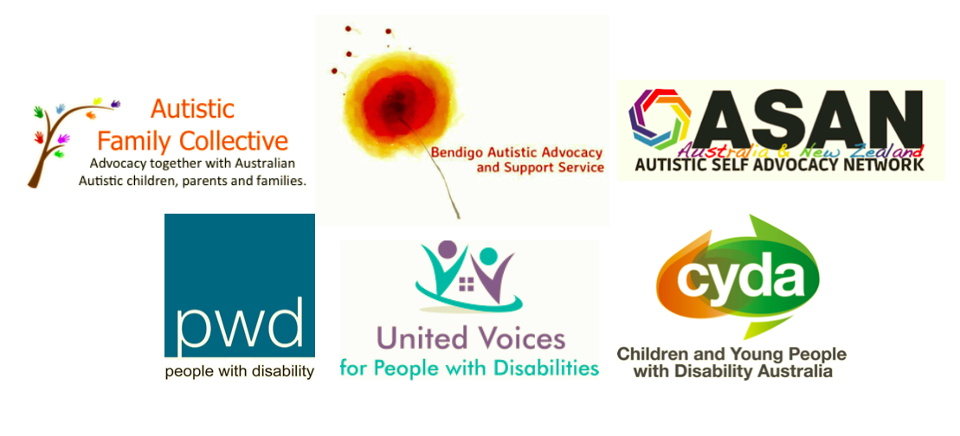

Prepared by Autistic Family Collective
June 2016
In June 2016, six advocacy organisations (Autistic Family Collective, Autistic Self Advocacy Network Australia and New Zealand, People with Disability Australia, Children and Young People with Disability Australia, Bendigo Autistic Advocacy and Support Service, United Voices for People with Disabilities) and one Disability Advocate (Ms. Julie Phillips) came together to gather information on human rights violations of disabled children in Australian educational settings in the last five years.

The purpose of gathering these cases was to send them to the United Nations Special Rapporteur on the Rights of Persons with a disability. Children's guardians were supported by participating advocacy groups to send information in the format most accessible and least traumatising to their family. Case information was received through an online survey, phone interviews and emails with children's guardians and advocates (with legal guardian's consent).

An information sheet and online survey were created and promoted through participating organisations’ websites and social media platforms.

A total of 55 cases were reported from around Australia, with the breakdown of States/Territories where the abuse was reported as follows:

Figure 1: States/Territories where abuse reported
Australian Capital Territory 2%, Tasmania 0%, South Australia 9%, Western Australia 7%, Northern Territory 0%, Queensland 22%, New South Wales 16%, Victoria 44%

Of the cases reported, 78.1% (n=43) were boys, 20% (n=11) were girls and 1.9% (n=1) were transgender. All of the children were Australian citizens and 5% (n=9) of the children were identified as Aboriginal and Torres Strait Islander. Children were aged between 5 – 19 years old at the time of incident/s, with 7.5 years old the mean age. 36.3% (n=20) of children experienced multiple incidents over multiple ages. 79.6% (n=43) of incidents occurred in a public educational setting and 20.4% (n=11) in a private educational setting.

Disabilities

Figure 2: Disability
OCD 5%, ID 14%, SPD 14%, ODD 16%, Language 16%, Anxiety 29%, ADHD 29%, Autism 93%

Wide ranges of disabilities were represented, including physical, developmental and neurological. 69% (n=38) of children had multiple disabilities. The top eight disabilities represented were Autism (93%), Attention Deficit Hyperactivity Disorder (ADHD), Anxiety, Language delays or impairments, Oppositional Defiance Disorder (ODD), Sensory Processing Disorder (SPD), Intellectual Disability (ID) and Obsessive Compulsive Disorder (OCD).

Contexts

Exploring the context and circumstances of abuse, parents reported that schools were unequipped to work with their disabled child. Of particular note is the common belief amongst parents that teaching staff did not understand autism, did not permit the use of accommodations for autistic students (such as ear phones and other items to reduce sensory overload), and instead frequently referred to their autistic children as ‘just naughty’.

Violations

Each child experienced multiple violations, with categories illustrated below:

Figure3: Type of abuse reported
Cruel, inhuman or degrading treatment 62%, Torture 16%, Detainment- by supervision 51%, Detainment-physical structure 35%, Restraint- physical 58%, Restraint- mechanical 11%, Assault 36%, Neglect or maltreatment 35%

34.5% (n=19) of children experienced neglect or maltreatment, including having no educational plan developed for them, being left unattended for entire school terms with no schoolwork to complete and being placed on reduced school attendance hours.

36.3% (n=20) of parents reported that staff physically assaulted their children, including being punched, pulled and kicked. Many children who were assaulted required medical treatment for their injuries, some for lengthy periods of time.

Children in this study were frequently restrained both mechanically, such as being held down with belts or chairs (10.9%, n=6) and physically, by being sat on or held (58.1%, n=32).

50.9% (n=28) of children were detained in unsuitable and unsafe structures and were prevented from leaving. Schools had various names for these structures including ‘calm rooms’, ‘time out spaces’ and ‘playgrounds’. In reality, parents reported that these spaces were storerooms, cupboards and unused buildings with windows blacked out and lights shut off. A range of serious physical injuries resulted from this practice, including extensive bruising, cuts to the body and vomiting. Emotional injuries resulting from these practices were reported as extensive, and included severe anxiety, school refusal, sleep disorders, Post Traumatic Stress Disorder (PTSD) and suicide attempts.

Alarmingly, 16.3% (n=9) of parents reported that their disabled child had been tortured at school. Abuses in this category included being kicked in the head and being left locked up for long periods of time in extreme temperatures without access to water.

The largest category of violation was that of cruel, inhuman or degrading treatment, with 61.8% (n=34) of parents reporting a range of practices in this category. Examples include being made to stand in front of the class while being degraded for lack of knowledge, being dragged across school grounds in front of peers and not attending to a child’s personal care needs.

Actions Taken and Responses

Parents took a range of actions as a result of discovering the abuses, with 95% (n=52) contacting school staff. Parents reported that responses from the school to their complaints were insufficient, including denial of the incident/s, lack of transparency during complaint procedures and negative treatment of the child and parents as a result of complaining, including suspension and expulsion of the child from school.

58.1% (n=32) of parents made a formal complaint through Education Departments, Ombudsmen, Local, State and Federal members of Parliament, the Police, the Human Rights and Equal Opportunities Commission and Solicitors. Those parents who did not make a formal complaint cited reasons including not being aware that they could make a complaint, fear of reprisal to the child by school staff and lack of funds to pursue legal action.

Overwhelmingly, parents were not satisfied with the results of their complaints. A theme emerged that internal inquiries conducted by Departments of Education protected teachers and schools. A disturbing trend was the many cases that reported that Police, although sometimes sympathetic, stated that further action could not be taken as the child involved was a ‘special needs’ child. In Queensland, several parents report that Police informed them that no action could be taken due to section 280 of the Criminal Code (Queensland Consolidated Acts 1899, s280), which states that ‘It is lawful for a parent or a person in the place of a parent, or for a schoolteacher or master, to use, by way of correction, discipline, management or control, towards a child or pupil, under the person's care such force as is reasonable under the circumstances’.

Reference
Queensland Consolidated Acts, Queensland Statutes s280 (1899).

