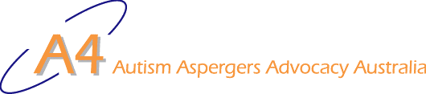
-
UPDATE

May 2008
Vol. 6, No. 4

Inside this Issue | Disclaimer  While we have made every effort to ensure that information is free from error, A4 does not warrant the accuracy, adequacy or completeness of the information, graphics and materials in the A4 Update. A4 does not guarantee that A4 Updates will be free from viruses.  A4 is not responsible for the results of any action taken or not taken on the basis of any information in the A4 Update, nor for any error or omission in that information. A4 expressly disclaims all and any liability and responsibility in respect of anything done consequent on the whole or any part of the information in the A4 Update. A4 shall not be liable for any loss, damage, liability, expense, cost or personal injury, whether direct or indirect, consequential or incidental, which you suffer, incur or are liable for, howsoever caused (whether due to A4's negligence or otherwise), arising from or in connection with your use of A4 Updates.
Family Violence 1
On violent and aggressive behaviour 2
School Bullying Leads To Substantial Damages Award. 3
Convenor’s message 5
Parliamentary breakfast about autism issues 8
A Report on the Parliamentary Breakfast for ASD 8
Release: Victorian State Plan Consultation Summary 10
call on UN - open every door for children with autism 10
Households with autism likely to earn less 10
Australian ASD research a tasteless joke 11
Book Review: Australian Autism Handbook 11
Press Release: Rotary autism research grant 12
Investigating the Gender Profile of Autism 12
Autism in federal politics 14
employment of people with a disability 14
2020 Summit 14
Bookkeeper jailed 15
The question has not been answered 15
Movie: Ben X 15
Senate Inquiry into Special Disability Trusts 15
Letters: 16
POSITIVE BEHAVIOURAL INTERVENTIONS 20
Making Sense of Autism and Strategies that Succeed 21
Sydney Seminar Series 2008 22
A4 Contacts 22

Family Violence
I often meet or see families who are devastated by the level of violence shown by an autistic child or adolescent. Many of the readers will know about homes that are destroyed, siblings and friends who are assaulted. While there is help available, behaviour modification support is hard to find and it is far beyond the budgets of most families. Unfortunately, short of calling the police or involving mental health services, there is little support in Australia.
Why does it happen? Violence is not an intrinsic part of autism. Many of you will have children who are so gentle and timid that they are victims of unmerciful bullying and intimidation. Others, particularly girls, are almost invisible children, unlikely to be diagnosed because they do not bother anyone.
We do know that if we help children when they are small, we can prevent many problems later. The problem is that while many parents have excellent parenting skills when raising their non-autistic children, they may not have had the opportunity to understand the needs of an autistic child.
A few days ago I saw a violent family in training. When he is frustrated, the little three year old grabs his mother’s curly hair and pulls hard knotting his fingers into the curls so that it is hard to get release without considerable pain. This mum knows that her child does not understand how she feels, so in an effort to teach him the perspective of others, she grabs his curly hair and does the same. He lets go very fast and the strategy appears to be effective. However we need to look beneath the interaction to understand the learning that is taking place. He may or may not be associating his hair pulling with her pain, but he is definitely learning that big people can hurt little people to get them to do things. He is also learning that it is OK to hurt people when you are cross or hurt.
When he is bigger he is going to pull harder or hurt his mum in other ways. She won’t associate her behaviour management strategies of a three year old with her black eye when he is twelve.
We all know what this family needs. The family needs to learn how to teach the child to communicate either verbally, through text and picture systems or through signing. They need proactive intervention in order to learn effective management strategies now, while the child is young and behaviour is easily changed. They need in home support if possible because this is a family matter. While I do not intend to explore the various teaching methods for autistic children, I do suggest that until the promised government services become available, that parents be proactive and join parent groups. Between you, you have knowledge and experience that can help others. Some of you will have access to autistic adults who have professional knowledge and interest in this area and they may be willing to help too. I keep thinking about the African proverb that says “It takes a village to raise a child.” Too often, families are left alone to raise an autistic child with disastrous results.

On violent and aggressive behaviour
Many families find they are suddenly addressing violent behaviour before preparing themselves for it. Understandably, we avoid the issue of violent behaviour until it confronts us directly. Then we are seriously challenged when a person with ASD behaves with violence and/or aggression.
Often we seek advice in a rush but rarely are we satisfied with the advice we get.
In my experience, advice about violent behaviour in people with ASD is relatively uninformed — it is rushed and not based sufficiently on the individual and their circumstances. It does not address the needs of the person and their family/carers. Approaches we are offered to violence, aggression and challenging behaviour lack satisfactory evidence either generally or about the individual. So in the absence of evidence we rely on limited experience, preferences, (alleged) application of logic and our feelings about what we regard as acceptable and might work in our individual situations.
Typically, we need an immediate response to an existing situation. We find
- an “ideal” strategy is impractical in the circumstances, while
- more practical strategies are either immediate or long-term, rarely both — and fall well short of ideal.
For example, it may be ideal to avoid a particular setting where a person with ASD reacts violently … but once the person is already in a situation it is too late. Practically, it may be necessary to use restraint and remove a person … a much-less-than-ideal response. Often it is more effective to get everyone else away as this does not aggravate the person and it may remove or reduce the reason behind a person’s violent behaviour.
Families can prepare for the onset of violent behaviour. Recognising the possibility and discussing strategies can prepare families and carers mentally giving them greater resilience when it happens.
As parents we need fabulous foresight — we need to try to see this aspect of the future. Families need to recognise behaviour in young children that will become inappropriate once the child is grown. It is best to establish solutions early to avoid or mitigate unacceptable behaviour. And for us to develop and practice the skill we will need to help our children when they are older.
Sometimes, a person can practice their awareness of and response to lower levels of frustration and anxiety. This can help them avoid some outbursts or recover their composure quicker on the occasions when they are pushed beyond their limits.
In my family, we practice strategies for avoiding and mitigating frustration and anxiety: the strategies are a planned part of our individual program. Mostly, we use an incidental learning mode and try to use every teachable moment to advantage.
Violent and aggressive behaviour is a very serious issue. People should obtain professional assistance if they possibly can. You can discuss it with your GP … just make sure he/she treats it very seriously.
In dealing with professionals, it may be wise to prepare yourself for the types of approaches they are likely to consider or advise. Some background showing the views of various groups can be found here.
Royal Australian College of General Practitioners has an article at … http://www.racgp.org.au/Content/NavigationMenu/Publications/AustralianFamilyPhys/2004Issues/afp200408/20040803davis.pdf
The Australian Medical Association provides a position statement relating to “aggressive and/or challenging behaviour particularly associated with a recent change in behaviour or function” (primarily in relation older people) … http://www.ama.com.au/web.nsf/doc/WEEN-5PJ373/$file/posstat_restraints.pdf
The Royal College of Psychiatrists (UK) website shows its position on “the aetiology and management of challenging behaviour” see http://apt.rcpsych.org/cgi/content/full/7/2/109. I was not able to find anything relevant on the Royal Australian and New Zealand College of Psychiatrists (RANZCP) website (see http://www.ranzcp.org/).
NSW Guardianship Tribunal has the following … http://www.gt.nsw.gov.au/information/doc_109_position_statement_behav_int_supp_behav_mgment_march06.pdf
The links are provided above for your convenience. A4 does not endorse or recommend the information provided at those links.
Bob Buckley, 10 May 2008

School Bullying Leads To Substantial Damages Award
Benjamin Cox who is now 18 years of age will receive substantial damages from the State of NSW as a result of an alleged breach of duty of care owed by the Woodberry Public School where he was exposed to an older school boy and over a number of months subjected to repeated harassment with various incidents of bullying. On at least two occasions these incidents included physical assaults of a relatively serious nature. The events were reported to the school authorities but the harassment and bullying continued.
Benjamin brought a claim alleging that the Woodberry School authorities had failed to take any reasonable steps to protect him from the repeated harassment and bullying.
One problem which confronted Benjamin in the claim was that he had no recollection of the events in question. He was young at the time and the only evidence available to him was the evidence of his mother who recounted what she had been told by her son.
Usually, a Court will not accept evidence from a person about what someone else has said. The rule which precludes the admission of such evidence is known as the Hearsay Rule.
Nevertheless the Evidence Act has provisions which allow for exceptions to the Hearsay Rule where a person is “unavailable” or “incompetent to give evidence”.
In this case, as Benjamin had no recollection of the bullying incidents, it was concluded that he was not capable of giving a rational reply to the questions about those facts and therefore was not competent to give evidence about the facts. Accordingly, as Benjamin could not give competent evidence, the evidence of his mother was accepted as an exception to the Hearsay Rule. Of course, the credibility and reliability of the mother’s testimony was still an issue for the Court, though her evidence was admissible.
A teacher is not required to prevent an injury to students but rather must take reasonable steps to protect students against risks of injury which should be reasonably foreseen.
A child of immature age may require protection against the conduct of others or indeed himself.
As the Court noted, “Children stand in need of care and supervision and this their parents cannot effectively provide when their children are attending school; instead it is those then in charge of them, their teachers, who must provide it.”
The Court also noted that a “school master was bound to take such care of his boys as a careful father would take of his boys, and there could not be a better definition of the duty of a school master.”
At the end of the day the Court concluded the school authorities responded inadequately to an escalating problem and failed to take steps to protect Benjamin from the conduct of a plainly behaviourally disturbed older pupil.
Benjamin suffered an anxiety disorder and a separation anxiety disorder.
Nevertheless, Benjamin was genetically vulnerable. The medical evidence suggested that Benjamin was a person who at the time of the assault upon him was very vulnerable to contracting some type of illness. The medical evidence suggested that he had a variant of borderline personality disorder. Notwithstanding, the Court confirmed that the negligence was a necessary condition for the occurrence of his psychiatric harm.
The Court accepted that Benjamin will not earn income in the future.
Benjamin was awarded damages of $213,500.00 for his pain and suffering and awarded compensation for past and future wage loss for the balance of his life based on the average weekly earnings of employees in NSW. The loss of earnings, however, was reduced by 25%. The reduction was applied for the vicissitudes of life. Usually a reduction of 15% is applied, however, where other factors impact on the claimant, the deduction for vicissitudes may increase. In this case the predisposition of Benjamin to psychiatric injury was sufficient to increase the reduction to 25%.
Substantial damages were awarded to an individual who could not recall the events that led to his harm. Nevertheless, this did not prevent the Court from determining that Benjamin was subject to bullying, the school authorities had failed to respond to a foreseeable risk of injury and that the State of NSW should pay for the loss that was caused.
From http://www.gdlaw.com.au/Services/July07.pdf
Please note that the school referred to above is Woodberry Public School (see http://www.woodberry-p.schools.nsw.edu.au/ ). It is not connected with (Woodbury Autism Education and Research). Woodberry was spelt wrongly in the source article.
See also …
http://www.smh.com.au/articles/2007/05/14/1178995042035.html
http://www.news.com.au/dailytelegraph/story/0,22049,21726587-5001028,00.html
http://www.abc.net.au/news/newsitems/200705/s1922707.htm
http://www.theaustralian.news.com.au/story/0,20867,21738068-7583,00.html

Convenor’s message
Dear A4 member
Thank you for your support for the 1000 Hours campaign. As I write the website has exceeded 21,500 registrations and it keeps ticking over. This support is the basis for a strong message to Governments around the country.
The ACT Budget was a big disappointment to me this year. Searching for "autism" finds http://www.treasury.act.gov.au/budget/budget_2008/files/paper5/08explai.pdf and on page 57 it says ...
Special Purpose Facility for Disability ACT Clients - Feasibility Study | 2008-09  $’000 | 2009-10  $’000 | 2010-11  $’000 | 2011-12  $’000
Expenses | 94 | 0 | 0 | 0
The feasibility study will investigate and provide advice on the accommodation needs of people with highly challenging/violent behaviours related to disability, autism and life trauma, young people with chronic progressive neurological disabilities and people with long term chronic disabilities.
This is extremely poor … but pretty much what I expected. It continues a history of ACT Government refusal to address the needs of people with ASD. It indicates their plan is to wait until people with autism are too difficult to manage and then "accommodate" them on the basis of the "highly challenging/violent behaviours" that the ACT Government expects them to develop. The ACT Government ignored Prior and Roberts expert advice (yes, we gave them this information repeatedly). There is no increase in the ACT Budget for services to keep pace with the growing number of children diagnosed with ASD.
As for feasibility studies, the ACT Government has an established record of ignoring advice related to people with autism.
The theme of this A4 Update is violent behaviour. Unfortunately, some people with autism/ASD are sometimes violent. I have not seen evidence that people with autism are any more likely to be violent than members of the population generally.
It seems to me that people feel they do not understand a person with autism when they are violent. They do not know why the person is violent or how to help them calm down. People, when they do not understand someone else, become scared of the person they do not understand. It works both ways.
In my experience, people with autism are rarely aggressive … aggression requires a theory of mind that people with autism rarely show as they are being violent.
Violent behaviour is best avoided entirely. For example, a child who is taught to bite people is likely to be a challenge forever. It is unlikely that the child can ever be taught to not bite … even if the child’s biting becomes rare as the child grows older, the child may revert to biting to communicate distress, frustration or anger in times of major stress.
Unfortunately, children with autism too often are taught violent behaviour at school. Children see or experience violent behaviour in another child and (uncharacteristically) imitate it. Then the school’s behaviour management practices reinforce the child’s violent behaviour: the school sends the child with autism to “time out” or to sit outside the Principal’s office … away from other students who they prefer to avoid and classroom tasks that they find too challenging.
I know of one high-school student who was taught to throw chairs through classroom windows so he could be sent home. The first time he did it, he knew something big had happened as everyone started behaving quite differently. They ran around for a while and did lots of yelling and stuff. Then his mum came and took him home … where he was much more comfortable. The next time he was stressed it all happened so much more easily, and he was out of there. He was a fast learner given the right lessons … and the school taught him this important skill very effectively.
Teachers and education staff want to be treated as professionals … then they need to behave professionally. That means they need to know the limits of their professional ability. They are not clinicians who are expert in treating the clinical aspects of a child’s ASD, a clinical disorder according to the diagnostic criteria. Teachers should get (demand) expert help/guidance in relation to the child’s clinical disorder/dysfunction. And they need to act on the professional advice they get, not just ignore it when it does not suit them.
Teachers need to act on parent advice … rather than saying parents know their child best, then just ignoring what parents say.
Recently, a mother told me about her son’s situation at school in the ACT. He is in an autism unit in a mainstream school. The school likes to “include” students in its autism units in a mainstream class for some of their school time. However, this child is physically bigger than his age peers … and much bigger than students who are his closest social and academic peers. Academically, he is behind his age peers so he doesn’t get much educational benefit from the material presented to his class. At times, he may be frustrated in this situation and his classroom teacher cannot manage his behaviour adequately. He was considered a significant risk to other students in his class.
The school decided to solve this problem by “integrating” him with a more senior class instead … where the students are bigger and are more likely to defend themselves effectively. So much for inclusion with peers!
Like his mother, I am appalled by the school’s response.
I am concerned that the school decided his education is immaterial. I am concerned that their approach will exacerbate his inappropriate behaviour. Consider what his inappropriate behaviour will become by his mid-teens: their approach will ensure he has major challenging behaviours by then and there will no longer be a class with students who can defend themselves.
A school with an autism unit should know better than this. It should know how to include a student with autism in a mainstream class and meet his educational needs for the time he is in mainstream. It could obtain expert help to treat his response to frustration. It should be concerned that such a situation will almost certainly spill over into the student’s home situation and cause serious problems there as well.
Students with ASD and their families should not have to endure such incompetence.
I know there are plenty of people who will say that is not “inclusion” or “inclusive education”. Sadly, situations like this are not rare for students with ASD: this is a significant part of “inclusive education” for students with ASD.
A few children are especially challenging. Recently I was told about a child in Queensland who is included in mainstream and attends lower primary school until morning recess … on a good day. On his recent visit to a dentist he complete trashed the dental surgery … everyone left the room for their own safety. I was advised that the Queensland government provides no treatment or additional support for this child.
Next week I will speak to a number of federal politicians on behalf of A4. Some of you wrote to your own members asking them to be there. Thank you for helping to get them along to the Parliamentary Breakfast. I will try to get them to understand that they can and should do much more to help people with ASD. I will let you know how it goes.
Regards
Bob Buckley
25/5/2008

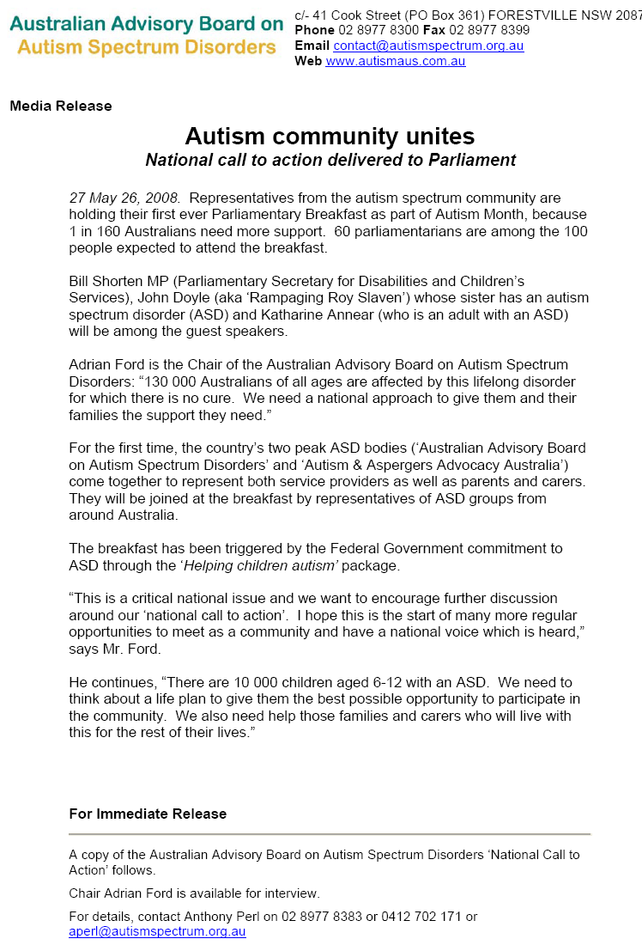

Media Release

Parliamentary breakfast about autism issues
Members of Parliament will meet members of the community about autism spectrum for Breakfast at a Parliament House in the morning (27/5). Politicians will hear about autism spectrum disorders and the life experiences of people with these conditions.
Two national bodies representing people with autism spectrum disorders and the Government have joined together to host this event.
Speakers will include Bill Shorten MP, Parliamentary Secretary for Disabilities and Children’s Services, John Doyle (aka ‘Rampaging Roy Slaven’) whose sister has an autism spectrum disorder (ASD) and Katharine Annear, an adult with an ASD.
Autism Aspergers Advocacy Australia, known as A4, is a nation grassroots organisation representing people with ASD, their families and carers. “A4 is an internet-based organisation with members from all over the country. A4 helps the growing number of people with ASD and their families get their message to government” said Bob Buckley, Convenor of A4.
The Australian Advisory Boards on Autism Spectrum Disorders (AABASD) is a peak body for most of the state-level autism/ASD organisations. AABASD published a report showing there were 10,114 children aged 6-12 years in 2004 and 11,814 in 2005. Autism was once considered a relatively rare disorder but by 2005 in Australia, 1 child in 160 aged 6 to 12 years had been diagnosed with an autism spectrum disorder.
Work to develop the Government’s Helping Children with Autism package brought these groups into closer contact, leading to the idea to hold this Breakfast during May, Australia’s Autism Awareness Month. The Budget also describes six new autism specific childcare centres.
“These valuable services are the federal government’s first steps towards ensuring people with autism get their chance to be productive members of our Australian community” Mr Buckley said. “Many people with autism need help through much of their lives, while others just need the community to understand that they are ‘different’ from the rest of us.”
Mr Buckley says “People with ASD and families want their needs to be addressed in schools. They often need help with employment. Some people with ASD need supported accommodation specifically suited to their disability. There is still so much to do.”
“We are very pleased that so many politicians are interested in this issue”, he said.
Contact: Bob Buckley, Convenor, Autism Aspergers Advocacy Australia

A Report on the Parliamentary Breakfast for ASD
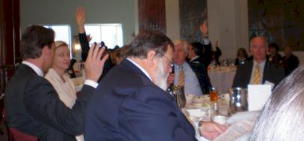
The breakfast went very well. The final number were 96 people turned up ...over 50 politicians. We should regard this as a major success.
Congratulations go to all the A4 members who contacted their politicians and got them to turn up for this event. There was a strong show of hands when Bob Buckley asked which politicians A4 members had contacted (and some politicians were a bit shy).
The event ran very smoothly. Katharine spoke brilliantly: several politicians spoke to me afterwards about how Katharine moved them with her speech. These silhouettes from the Breakfast are of Bill Shorten MP, Katharine and John Doyle (aka rampaging Roy Slaven).
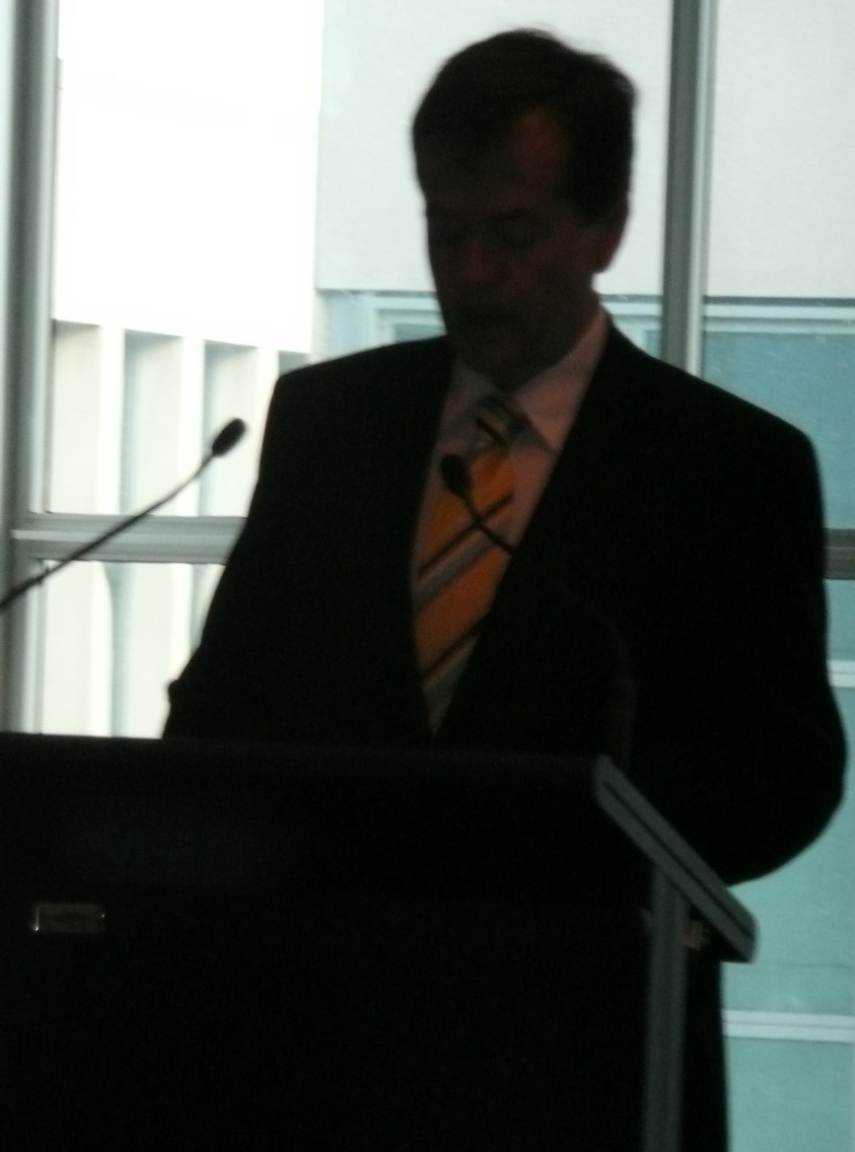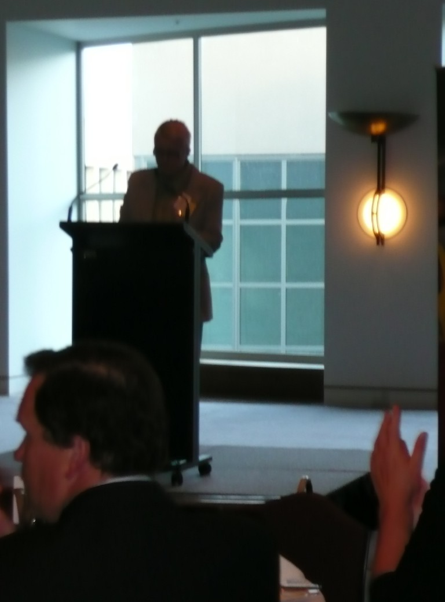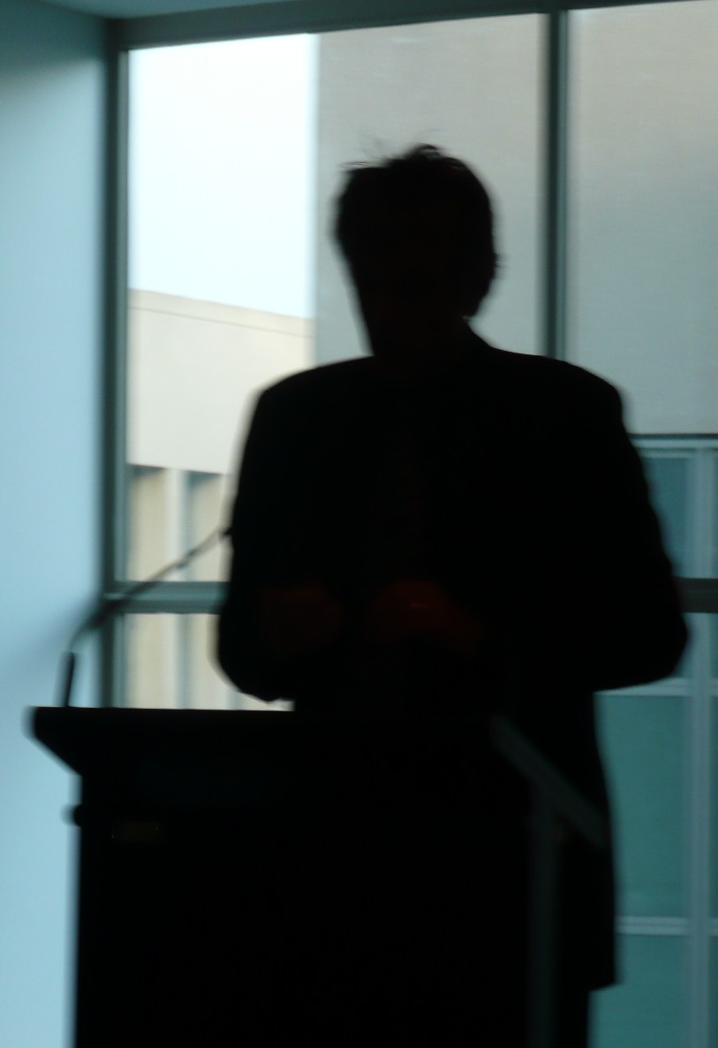
All the politicians said they found the event very informative. This is good because the purpose of the event was to increase autism awareness among our federal politicians. Several politicians, from both sides of the political spectrum, are interest in forming a Parliamentary Friends of ASD ... we will be following that up.
The people representing A4 were Katharine Annear, Bob Buckley, Peter Hill, Myrna Dominguez, Mary Gebert, Zack de Jonge and Bernardette Wilson. Thank you to the people who represented A4: it is a big effort to get there and a significant personal sacrifice. I want to express my special admiration for Zack whose severe autism meant that just being there, with all those people in an unfamiliar (and uncomfortable for him) setting, took a substantial and visible effort on his part. Well done Zack.
Here are pictures of Myrna and Katharine, and Katharine, Bob and Mary.
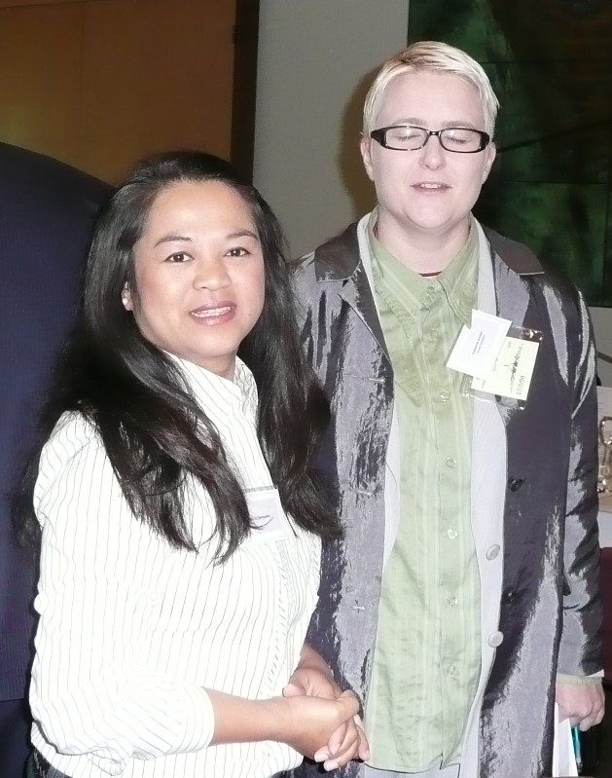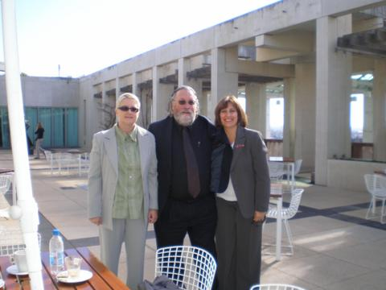
A4 organised a meeting with Bill Shorten MP to brief him personally on the issues we raised at the Breakfast.

Release: Victorian State Plan Consultation Summary
29th April 2008
Dear Parents, Parent Support Groups, Service providers Please find attached in PDF format the consultation summary made available on the autism state plan website just moments ago.
This is the link to the autism state plan website.
http://autismstateplan.dhs.vic.gov.au/consultation/summary.htm
Cheers and regards
Meredith Ward
Manager - Autism State Plan
Autism Victoria Inc.
0400 226 408
For the latest information about the Autism State Plan go to:-
http://autismstateplan.dhs.vic.gov.au
liaison@autismvictoria.org.au
PO Box 235
Ashburton Vic 3147
www.autismvictoria.org.au

call on UN - open every door for children with autism
Ivan Corea of the UK Autism Awareness Campaign calls on the United Nations on World Autism Day to open every door for children with autism. See the internet videos at
http://edition.cnn.com/video/#/video/health/2008/04/02/intv.austism.corea.cnn and http://ukautismnews.blog.co.uk/2008/04/04/un-world-autism-awareness-day-you-tube-f-3994549
Certainly we need the world to recognise the needs of people with ASD because our national and state governments refuse to adequately address the needs of people with ASD.

Households with autism likely to earn less
New research suggests that the average household with children with autism not only spends thousands of dollars toward educational, behavioral and health care expenses each year, but also suffers from a lesser-known cost that hits them up front – a sizeable chunk of missed household income, perhaps as much as $6,200 annually.
The study, published in April's edition of Pediatrics, paints a more detailed financial picture of how expensive life can become for parents of children with an autism spectrum disorder.
"To our knowledge, this is the first U.S. study that examines this front half of the 'money in, money out' equation," said economist Guillermo Montes, Ph.D., the study's lead author and a senior researcher at the Children's Institute, a not-for-profit organization affiliated with the University of Rochester, where he also serves as a faculty member in the division of General Pediatrics. "To collect data on expenses is fairly straightforward– it's a survey report. But projecting earning potential and then stacking that against actual income requires complex statistical modeling."
The fill press release is http://www.rochester.edu/news/show.php?id=3144
Other references are at
- http://google-sina.com/2008/04/02/households-with-kids-with-autism-likely-to-earn-less/
- http://www.medicalnewstoday.com/articles/102520.php

Australian ASD research a tasteless joke
The UK has its Autism Research Centre (featuring Ali G's less famous brother, Simon Baron-Cohen, see http://www.autismresearchcentre.com/arc/staff_member.asp?id=33) getting major funding from government through the Medical Research Council.
The US Government continues to expand its investment in autism/ASD research (see http://www.medicalnewstoday.com/articles/102543.php).
Where is Australia's effort? Nowhere to be seen. Australia needs to fund ASD research or we will not be training and maintaining skills in professional staff needed to treat and support people with autism in this country. The state of ASD research in Australia, primarily due to the absence of funding and leadership, is a sick and not-funny joke.
It is time for the federal Government lifted its game in autism/ASD research significantly.

Book Review: Australian Autism Handbook
The essential resource guide for autism spectrum disorders
Benison O’Reilly and Seana Smith
Jane Curry Publishing 2008

This excellent resource fills a much needed gap for Australian families who have just received a diagnosis of Autism Spectrum Disorder. At long last parents can access an easy to read, comprehensive and supportive local guide to help them through the early months of the maze that is autism.
The diagnosis and assessment process is demystified as the reasons for various tests are explained as are the roles of the various allied health professionals.
The early intervention section briefly discusses many different approaches to autism, e.g. Applied Behaviour Analysis; Floortime; Relationship Development Intervention©, TEACCH and the SCERTS Method. Another chapter looks at other interventions including Social Stories©, Video Modelling and Auditory Integration Training. Yet another section explores complementary treatments like the Biomedical Approach.
Throughout the book O’Reilly and Smith put forward a balanced commonsense approach, encouraging the reader while at the same time stressing the need to engage the newly diagnosed child in an intensive, individualized early intervention program
At least a third of this book consists of a wonderful resource guide of financial entitlements and service providers. It will be a boon to newly diagnosed families and a source of ongoing reference for service families and others who have to move from one part of Australia to another. The reader should also refer to the website www.autismhandbook.com.au which will maintain the relevance of the resource section by adding new services and amending where relevant existing ones.
The numerous comments from parents scattered throughout this book make the book come alive. They will resonate with many readers and hopefully offer support and encouragement on both good days and the not so good.
Reviewed by Gay von Ess

Press Release: Rotary autism research grant
Local Rotary Club partners with Australian Rotary Health Research Fund to fund a $30,000.00 national Autism research grant.
The Rotary Club of Dapto has joined forces with the Australian Rotary Health Research Fund to jointly fund a national Autism research grant.
It has been estimated in a recent economic report by Synergies Economic Consulting that Autism cost the Australian economy between $4.2 billion to $7.5 billion per year. This combined with the human toll on both individuals and families prompted members of The Rotary Club of Dapto to fund this important research grant.
At this years annual change over dinner on the 24th of June the Club will hand over a $20,000 cheque to the Australian Rotary Health Research Fund as its contribution to the Autism research grant. The Australian Rotary Health Research Fund will then match the cheque with a further $10,000. Nominations for funding should be forwarded to the Australian Rotary Health Research Fund.
For further information please contact Peter Hill
Phone: 4221 3888 BH 4262 1888 AH Mobile: 0408 125 752 Email: peterh@uow.edu.au

Investigating the Gender Profile of Autism
My name is Victoria Miller and I am inviting parents and teachers to participate in my investigation on the profile of autism by gender. I am conducting this study with my supervisor, Associate Professor Mark Stokes, for the thesis component of my Doctorate of Clinical Psychology at Deakin University in Melbourne.
The purpose of my research is to investigate the possibility that some girls and boys with High Functioning Autism or Asperger’s Syndrome are not being diagnosed because they appear differently - these girls and boys just seem ‘different’ in some way but people don’t properly understand why.
Being able to better understand high functioning autism (HFA) and Asperger’s Syndrome (AS) may allow more girls and boys with HFA and AS to be referred and diagnosed during early childhood rather than later in adolescence and therefore access services such as early intervention programs.. This may prevent some of the later difficulties that can develop for these groups such as mood disorders like anxiety and depression, educational problems and an increase in social and relationship difficulties during high school.
For my research I am seeking parents and teachers of adolescent males and females with HFA or AS to fill out a 20 minute paper-and-pencil questionnaire about their child or student in order to better understand the ways in which males and females with HFA are similar and different in areas such as appearance, communication, peer relationships and behaviour at home and school.
This might help us to make important gains in beginning to understand the role of gender in HFA and AS.
If you would like to participate in this research, or would simply like some more information we would love to hear from you. Please feel free to contact myself by email (vcm@deakin.edu.au), or my supervisor Associate Professor Mark Stokes by email (mark.stokes@deakin.edu.au) or phone (03 9244 6865).
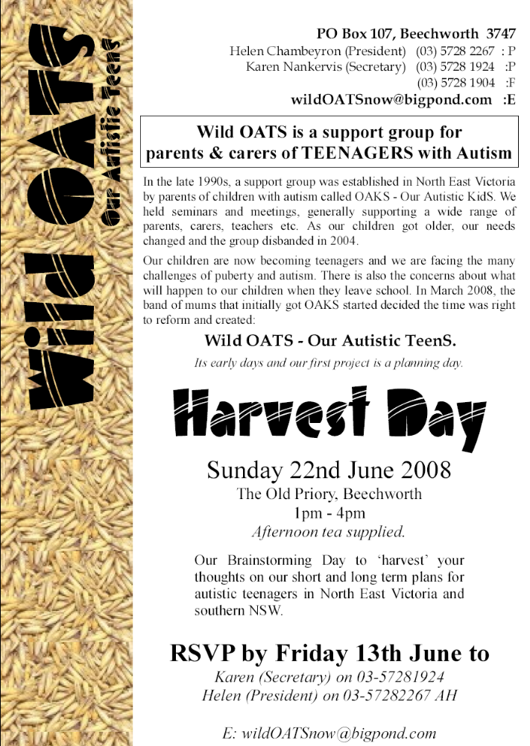

Autism in federal politics
The term "autism" is increasingly part of the political agenda in Australia, especially for Parliamentary Secretary the Hon. Bill Shorten MP. The following are links to some of his recent relevant releases ...
- http://www.billshorten.fahcsia.gov.au/internet/billshorten.nsf/content/disabilities30may08.htm
- http://www.billshorten.fahcsia.gov.au/internet/billshorten.nsf/content/autism_awareness_bkfast_28may08.htm
- http://www.billshorten.fahcsia.gov.au/internet/billshorten.nsf/content/autism_10may08.htm
- http://www.billshorten.fahcsia.gov.au/internet/billshorten.nsf/content/autism_2may08.htm
- http://www.billshorten.fahcsia.gov.au/internet/billshorten.nsf/content/world_autism_02apr08.htm

employment of people with a disability
The federal government is looking at issues affecting the employment of people with a disability. A government press release can be found at http://mediacentre.dewr.gov.au/mediacentre/oconnor/releases/disabilityemploymentstrategyconsultsinhobart.htm
There is a discussion paper that can be downloaded from http://www.deewr.gov.au/employmentstrategy. Towards the end it asks people to make submissions.
Alternatively, you can send your comments and stories to cnvnr@a4.org.au before June 10 and I will combine them into a submission from A4 about people with ASD and their associates.

2020 Summit
I went to the 2020 Summit website (see www.australia2020.gov.au) and searched for 'autism', 'autistic' and 'asperger'. There were two results: a PDF and MS Word version of the 2020 Summit Initial Report.
Page 25 of the Initial Report tells us, under Pre-Summit Submissions, that ...
A number of people highlighted the difficulties faced by carers, usually related to caring for a family member with a disability. Among the possible solutions canvassed were:
- Additional funding to cover increased costs of caring (e.g. medical, housing and transport costs);
- Additional services (e.g. training for parents of autistic children, recreational services for disabled young people and supported accommodation); and
- A national disability insurance scheme, perhaps targeted at those who are catastrophically injured.
In relation to 'disability', the idea of a national disability insurance scheme seems to have attracted some attention. The summit reiterates that 15.1% of Australians have a disability, 6.3% have severe or profound disability.

Bookkeeper jailed
The Age (Melbourne), 24/05/2008, Page 11
BOOKKEEPER Gayle Marylin Rowe was yesterday jailed for three years and six months for stealing almost $200,000 from the Irabina Childhood Autism Services charity in Bayswater between 2002-04. She had pleaded guilty in the County Court to 15 charges including obtaining financial advantage by deception and theft.
Her barrister, Tim Bourke, said Rowe used the money to send her son to private school. Rowe must serve a minimum non-parole period of 24 months. -- SARAH-JANE COLLINS
As if it isn't already hard enough getting effective early intervention for kids with ASD. ... Bob Buckley

The question has not been answered
Former National Institutes of Health (NIH) Director, Dr. Bernadine Healy, in the US has gone on television and said emphatically, that when it comes to a possible link between autism and vaccines and/or mercury, "the question has not been answered". Her position on autism is the same as views some prominent A4 members expressed from the outset.
Her comments bring into question the conduct of US government agencies responsible for public health. You can view the video at http://www.cbsnews.com/stories/2008/05/12/cbsnews_investigates/main4086809.shtml .

Movie: Ben X
The Sydney Film Festival website (http://www.sydneyfilmfestival.org/film_details.asp?id=10&fID=528) says …
As the title suggests, at the centre of Nic Balthazar's debut feature is Ben - a withdrawn teen who rarely speaks. He's been diagnosed with Asperger's syndrome, a variant of autism, although his mother isn't particularly convinced that this lengthy phrase has any meaning at all. She just knows he's uncommunicative and exhausting. Ben retreats into a fantasy computer game, derived from the actual game 'Overlord', in which he plays a heroic knight with a heroine sidekick. When he's the victim of a particularly nasty prank at school, he withdraws further into this fantasy world - with surprising effects. Winner of three awards at the Montreal Film Festival, including the Grand Prix, Balthazar's film as well as being an entertaining ride, looks at life for an autistic teen from an entirely new angle. JN

Senate Inquiry into Special Disability Trusts
On 21/5, a Senate Committee wrote to A4 …
The Senate has referred to the Committee matters relating to Special Disability Trusts for inquiry and report by 18 September 2008. The terms of reference for the inquiry are attached and are also accessible on the Committee's website at www.aph.gov.au/senate_ca as well as Part 3.18A of the Social Security Act 1991 referred to in the terms of reference.
The Committee invites you to provide a written submission addressing any or all of the issues that may be of relevance to you. The submission should be lodged with the Committee Secretary by 13 June 2008.
A4 wrote back, saying …
Thank your for inviting (21/5/2008) Autism Aspergers Advocacy Australia (A4) “to provide a written submission addressing any or all of the issues” relating to the Inquiry into Special Disability Trusts.
This invitation took us by surprise because we feel the answers are obvious in relation to people with an autism spectrum disorder and their families. However, we appreciate the opportunity to explain again the situation facing families of people with an autism spectrum disorder.
…
A4 took this opportunity to explain the lifetime experience of many people with ASD to a relative large and influential Committee. If you are interested in what A4 says to government about the lives of people with ASD and their families, please take a look at the entire letter/submission. You can download it from http://www.a4.org.au/documents/SpecialDisabilityTrusts.doc

Letters:

from Vern Hughes
Hi Bob
Just a quick comment on your editorial remarks in Update on ASD specific issues and generic issues.[feel free to publish this or cite it if you wish]
Over the last few years, I have opted not to pursue ASD specific campaigns. My main reason is that, with 2 ASD sons aged 19 and 17, I don't actually want ASD specific things for them now. What I want is to be able to use the resources put into generic services to get supports that are right for these 2 individuals in their lives ahead. The right supports for them from here on will not be ASD specific. What I am sure of is that the dollars put into generic schooling and generic recreation supports and generic employment support programs do not work for them. The dollars from the taxpayer spent on these kind of services have never worked for them, and aren't going to work for them in the future.
I therefore just want to be able to use those dollars, cashed out per individual, to get the right supports for them. And only they, and their parents, and a few trusted professionals chosen by us, actually know what works for them. Bureaucrats and program managers in service providers do not know, and will never know, and what's more, can never know, what is right for these 2 individuals as they pass from one life phase to another, with changing interests, changing needs, and changing life goals.
I therefore think that individualising funding arrangements is the only thing that makes sense for my kids. And it is the only thing that makes sense for all the unique configurations of disability and impairment that present in every unique individual.
For so long as every disability-specific interest group, and every behavioural/learning deficit-specific interest group, and every mental illness-specific group, and the rest, campaigns for program money for only their group, the longer will their various campaigns remain small, fragmented, and ultimately too inconsequential for governments to take seriously. Because ultimately the big priority areas for governments are funding outlays for mass not niche constituencies.
The common thing shared by every person with a disability, or a behavioural/learning deficit, or a mental illness, or aged frailty, and their families, is a desire for supports that are right for them. And which can be acquired or purchased by them, no matter how divergent and idiosyncratic their support needs might be.
Individualised funding, with an individual budget, is the common means for everyone to achieve their unique aspirations. It is the only common goal we all have.
Vern Hughes
0425 722 890

to Organisations
To all support organisations for our Autism Spectrum children,
Please feel free to forward this to anyone you feel may be interested.
Unfortunately I write this letter on the cut off day for any chance my son has of justice. Today is the last day to lodge an appeal to court to have a case heard against the education department for failing in their duty to provide him with an adequate education.
Despite numerous emails to politicians at state and Federal Level including the Premier of Western Australia and the Prime Minister of Australia, and a complaint to the Human Rights and Equal Opportunity Commission we are still being unheard and my son still has no justice.
I want to raise the awareness of the public and the government that adequate education of our children is not happening. That the system is causing our children to be placed on medication to deal with their distress and that too many are being forced out of the mainstream education setting. As you know once problems occur the families of such children have to fight impossibly hard to get their problems heard and too many of us are unable to fund the last resort of a legal challenge.
That the education of these children is not necessarily so impossible is clearly demonstrated by individual teachers and schools who have exceptional understanding, passion and commitment to our children. Their success is why I continue to dream when our situation has failed so badly.
The system is so determined to avoid having to pay out when situations go wrong that they attack the parents for attempting to negotiate on their children's behalf casting false accusations of mental illness or parents incompetence, or perhaps worse they label the child naughty and defiant to muddy the waters and prevent the truth being known.
I appreciate that our families are battling so hard that they cannot spend their time and emotional energy to front the politicians and explain their situation. So many of us avoid causing confrontation because we fear it will cause our children yet more damage.
I want to allow all in our community to participate in getting changes happen that will support and enable our children on the autism spectrum.
Will you consider standing beside me to raise awareness by participating in a virtual round the world walk/ride to raise awareness of ASD education issues?
I envisage a website where people can log on and add their steps and kilometers, perhaps add their stories if they feel like contributing.
I am hoping that we could together create such a site and contact all the autism/aspergers associations to spread the awareness around the world.
What do you think? Can you help? I need people who have expertise in media, website production and public relations to help get this campaign off the ground. Perhaps we could incorporate a fundraising for ASD education research in which case we would need someone with knowledge of such matters?
I am contacting all the organisations and individuals I can think of today, as for me it is a day of profound importance that my son looses his hope of justice. I want to change our society so no one else looses theirs.
I hope you can find some way to contribute to our push for justice for our children. They deserve better then to be deserted by the system that causes them so much pain.
In the mean time as I try to put together the resources to get such a site off the ground would you consider recording your steps so when the site is launched you can enter them in to start our journey. We have a long way to go to walk around the world but one step at a time we can help our children change the world.
Thank you.
Yours sincerely,
Donna Philp, parent to two children with Asperger's Syndrome.

learning disorders & disabilities
Hi
The article Let's define 'learning disabilities' at last (at http://www.theage.com.au/articles/2008/02/22/1203467395731.html?page=fullpage) may interest your readers. It says
THE recent finding by the Victorian Civil and Administrative Tribunal over a lack of appropriate support ... indicates the serious shortcomings in understanding and support for learning disabilities in Australia. ...
Because a shared definition of learning disabilities is not a part of Australian educational discourse, many teachers and parents are unaware of its genetic and permanent nature. In particular they are frequently unaware that learning disabilities are highly resistant even to skilled intervention.
This includes the teaching of reading by phonic methods, which relies on the ability to analyse sounds, a processing skill that is very difficult for many students who have learning disabilities. Consequently, governments and the media frequently focus on literacy problems and assume these are due to inadequate pedagogy. At least to some extent they are likely to be due to learning disabilities.
It is also possible for Australian teachers to complete their training without being informed about learning disabilities and how to cater for the needs of these students. There is instead widespread confusion among Australian teachers over the terms "learning difficulties" and "learning disabilities".
The terms are used interchangeably to refer to disparate groups of students, such as those who have intellectual disabilities, those who speak English as a second language, or those who have specific literacy skill difficulties despite their average to high ability in other areas.
Surely the federal government should act immediately to ensure staff employed in education systems across the country can meet the needs of children with learning difficulties and learning disabilities, including most children with ASD. What is the federal government doing to address this challenge?
best
Ian R

Teaching Children with Autism
The Verbal Behaviour Approach:

author & researcher:
Mary Lynch Barbera, RN, MSN, BCBA
Verbal Behaviour Workshop
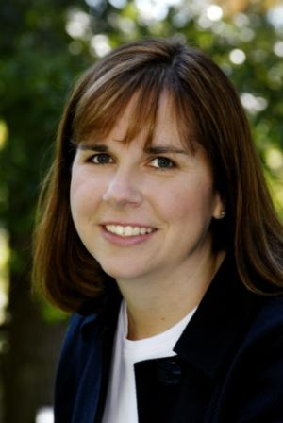
1st August Sydney
and
4th & 5th August Melbourne

Proudly Sponsored by
Australian Centre for Autism Services
www.acasn.com.au
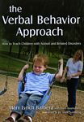

For further information contact our office on 03 9458 1333
or
www.acasn.com.au
Book included in workshop
Mary Lynch Barbera, RN, MSN, BCBA is a Board Certified Behavior Analyst and the Lead Behavior Analyst for the Pennsylvania Verbal Behavior Project, studying the outcomes of Applied Behavior Analysis/Verbal Behavior in classrooms throughout the State of Pennsylvania, USA.
Mary has extensive experience in working with schools and families with children on the Autism Spectrum. Through her private consulting practice, Mary has worked with hundreds of children with autism and is providing training to thousands of professionals and parents across the USA.
Mary is an established researcher with several peer reviewed and co-authored publications. She has presented extensively at autism research forums.
Her recent 2007 publication, The Verbal Behavior Approach: How to Teach Children with Autism and Related Disorders, has received international recognition as well as multiple endorsements and positive reviews.
Drawing on her experience as both a parent of a son with autism and as a Board Certified Behavior Analyst (BCBA), Mary Lynch Barbera will provide participants with information to help children with autism learn language and other important skills.
Mary will demonstrate strategies from her book: The Verbal Behavior Approach: How to Teach Children with Autism and Related Disorders, and provide guidance using scientifically proven strategies of Applied Behavior Analysis (ABA) specifically utilizing B.F. Skinner’s analysis of Verbal Behavior.
This workshop will enable participants to get started immediately using a Verbal Behavior Approach to teach children with autism and related disorders.

ONE DAY SEMINAR

POSITIVE BEHAVIOURAL INTERVENTIONS

FOR PEOPLE USING CHALLENGING BEHAVIOURS

TARGET GROUP
Employees from: Education Services; Disability Services & other Health & Human Services who comprise of clientele using "Challenging Behaviours"
Personal Carers inlcuding: Parents, relatives, friends and carers of people who use "challenging behaviours"

OBJECTIVES
A person who uses Challenging Behaviour(s) is likley to be responding to a situation that they do not currently have the ability to manage appropriately. Challenging Behaivours are often a perosn's only existing means to communicate a message to other people: "I don't know how to manage this situation i am finding challenging". This programme is designed to assist those who work with people using challenging behaviours to better understand the reasons why these behaviours occur and to then devleop effective interventions based on preventative strategies and skill-building based strategies. These strategies will allow a person to better manage in these same situations they previously found challenging.

TOPICS COVERED
• Understanding the reasons why challenging behaviours are used
• Identifying when to implement behavioural strategies
• Difference between reactive and preventative strategies
• Developing “Positive Behavioural Interventions” resulting in desired behavioural change

ABOUT THE PRESENTER
Tan Curtis has extensive experience working in the field of Behaviour Management and Counselling in university clinical settings and private practice with children, adolescents and adults who are displaying challenging and unwanted behaviours. Tan’s experience has included (but not limited to) supporting those who are experiencing difficulties related to: Anxiety; Aspergers Syndrome, Autism Spectrum Disorder, Intellectual Impairment, Attention Deficit Hyperactivity Disorder, Learning Disorders, Oppositional Defiance Disorder, Eating Disorders, Bipoloar, Borderline Personality Disorder, Schizphrenia and Depression.
Tan Curtis is the director of FABIC. Tan has a Master of Behaviour Management; a Master of Counselling; a Bachelor of Health Science (Behaviour Management) and an Associate Diploma of Education.

PROGRAMME DETAILS
Date: Friday, June 20, 2008
Time: 8.30am - 4.30pm
Location: Hellenic Convention Centre
Cnr Callum & Matilda Streets
Woden ACT 2602
Provided:
Morning Tea & Afternoon Tea
(Delegates provide own lunch)
Costs:
$175 per person per single booking
$148.50 per person for group bookings (2 or more people)
(All prices are inclusive of GST)
Note:
Limited places available.
Booking will be confirmed on receipt of payment (i.e. direct transfer, credit card or cheque by mail)

Contact
Amanda Fullarton (Personal Assistant)
on behalf of
Tan Curtis
Clincal Behaviour Management and Counsellor
Assoc Dip Ed (Child Care), BHlthSci (BehMgt), MBehMgmt, MCoun
Suit 34 Medical Centre
Worongary Shopping Centre
1 Mudgeeraba Rd (Exit 77 off the Pacific Highway)
Worongary Qld 4213
Phone (07) 55 305 099 or 0412 615 798
Fax (07) 55 305 079
tancurtis@fabic.com.au
www.fabic.com.au

Making Sense of Autism and Strategies that Succeed
I would like to introduce myself. My name is Kirrilly Garvey and I am the Administration Manager from the Children's Hospital Education Research Institute (CHERI), at The Children's Hospital at Westmead.
CHERI is holding a 2 day conference in September, called "Making Sense of Autism and Strategies that Succeed". This conference is being held on 4 and 5 September 2008 at Westmead Hospital. Please find below information on the conference:
Autism spectrum disorders (ASD), which includes autism and Asperger’s syndrome, are developmental disorders affecting how a person learns, communicates and makes sense of the world around them. ASD are being diagnosed at an increasing rate and the majority of students with ASD are educated in mainstream classrooms. Teaching students with ASD may present as a challenge. While there is a range of strategies that can be implemented in educational settings, no one intervention is effective for all students with ASD and not all strategies are successful.
The conference aims to help “make sense” of autism and of the strategies that succeed. Conference sessions will focus on the identification and diagnosis of ASD, associated mental health and social issues such as bullying, and dealing with adolescents’ sexuality. In addition, an emphasis is placed on identifying the needs of the student to guide the selection of appropriate interventions. Information on evidence based interventions and strategies that succeed will also be presented.
The keynote speakers will be Dr Jacqueline Roberts and Associate Professor Verity Bottroff.
Please find attached a draft program (print version).
It would be greatly appreciated if you would be willing to distribute some information on our conference. We can supply this in hard copy (please provide the number and postal address), email version, website version or newsletter version. Could you please advise which of these options suits you better. CHERI is a registered charity and this conference is a fund raising event to assist our clinics and research.
You can also visit our website www.cheri.com.au/conferences.html for further information on the conference.
If you have any conferences or activities you would like advertised on our website, we would be happy to put them on our webpage at http://www.cheri.com.au/other_events.html.
I look forward to hearing from you.
Kind regards
Kirrilly.
Kirrilly Garvey
Administration Manager
Children's Hospital Education Research Institute (CHERI)
the children's hospital at Westmead
Cnr Hawkesbury Road & Hainsworth Street
Locked Bag 4001
Westmead NSW 2145
Ph: +61 (0)2 9845 0418
Fax: +61 (0)2 9845 0421
Email: KirrillG@chw.edu.au
Web: www.cheri.com.au
"Making Sense of Autism and Strategies that Succeed" Conference on 4 and 5 September. Please visit www.cheri.com.au/conferences.html for more information.

Sydney Seminar Series 2008
Dear Community;
Mindd Foundation will be running a seminar series to promote effective treatments for allergies, ADHD, Autism, asthma, learning delay, digestive disorders and associated neuro-biological illness and auto-immune disorders. All seminars will take place in Bondi Junction and will feature experts in biomedicine, chiropractic, kinesiolgy, neuro-development, education, nutrition, psychology, cooking and more.
Please pass on the information to friends, family, GPs, educators, health care workers and anyone in a position to help effected children.
Each seminar will be followed by a "support group" meeting designed to help families in obtaining the best possible treatment outcomes. Discussion will cover everything from supplement and dietary compliance to dealing with skeptical family members. If any experienced parents wish to come along to lend a hand, please email us.
The attached flyer outlines the details. You can also register and access information here. To ensure a place ($20) we advise registering early.
The first 6 speakers in the series are as follows;
- Choosing The Right Diet, Karen Wheelright, 10 June
- Allergy Elimination, Matthew Bourke, 13 August
- Healing Foods, Cooking Demo Sandra Ramacher, 10 September
- Social Skills, Anca Ramsden, 15 October
- Biomedical Intervention, Dr. R. Cosford, 11 November
- Learning Strategies, Jim Hoosan, 10 December
If anyone would like to organise a Mindd seminar in their area please let us know.

A4 Contacts
A4 is a grassroots organisation. All A4 activity, such as publishing the Updates (newsletters), is done by volunteers. Please understand that A4 volunteers may have no training or qualifications for their various roles. They do the best they can for people with ASD, their families and associates. A4 welcomes assistance and constructive criticism.  Anti-spam: change -at- to @ in email addresses.  Update team: editor-at-a4.org.au  Editing: Bob Buckley and Vicki McKay were both involved in editing this edition …  Production: Helen Curtin (Qld) – proof-reading, Bob Buckley (ACT) – distribution. | A4 Steering Committee  Convenor: Bob Buckley (ACT)  cnvnr-at-a4.org.au  Treasurer (donations): Cathy Ryan (Vic.)  treasurer-at-a4.org.au  Members: Kelley Harris (Vic), Lionel Evans (Qld), Geraldine Robertson (Tas.), Mary Gebert (Vic), Katharine Annear (SA), Myrna Dominguez (NSW), Vicki McKay (Vic), Jasmine McDonald (WA), Peter Hill (NSW), Helen Steinhardt (Qld), Janet & Andrew McLean (WA), Leigh Michel (NSW), Raphael Murphy (SA).

