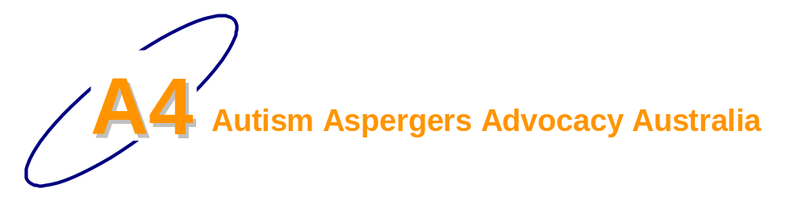
October 2007
Issue 6
UPDATE

Government allocates $190 million for autism
Ian
6/10/2007
Thanks Bob and your team for getting autism onto the Government’s agenda. I notice that the Prime Minister announced it himself. Is this because you contacted him and pressured his department?
Of course I am disappointed that it doesn’t do anything to help me. My son is 14 years old, so Mr Howard’s announcement does nothing for him. I hope families will not have to go through the same experiences as we did. I hope they get better access to diagnosis and early intervention in the future.
Thanks Bob for sharing your efforts with A4 members through the Updates. It lets me know how it all happens. I really don’t know how you do it.
Getting so much money from the federal Government specifically for autism is a major achievement. I doubt any state government has ever done anything comparable for autistic kids and their families. The cynic in me wonders if it will ever really happen.
I don’t understand what the government plans to do. I find the descriptions very confusing. Do you understand them? Can you explain them?
Inside this Issue | Disclaimer  While we have made every effort to ensure that information is free from error, A4 does not warrant the accuracy, adequacy or completeness of the information, graphics and materials in the A4 Update. A4 does not guarantee that A4 Updates will be free from viruses.  A4 is not responsible for the results of any action taken or not taken on the basis of any information in the A4 Update, nor for any error or omission in that information. A4 expressly disclaims all and any liability and responsibility in respect of anything done consequent on the whole or any part of the information in the A4 Update. A4 shall not be liable for any loss, damage, liability, expense, cost or personal injury, whether direct or indirect, consequential or incidental, which you suffer, incur or are liable for, howsoever caused (whether due to A4's negligence or otherwise), arising from or in connection with your use of A4 Updates.
Government allocates $190 million for autism 1
More messages to political candidates 2
Melbourne to Canberra walk for autism 2
Victorian Autism State Plan: consultation 4
from A4 Steering committee 5
personal from Bob Buckley 5
Convenor’s message 7
Politicians’ pre-election promises on autism 7
human rights 9
Carers Report 11
In conclusion 11
AABASD Media Release 12
Announcements put autism on the map 12
AABASD Call to Action 12
ASD in the media 12
A4 Contacts 13

I am very pleased that Mr Rudd said he will match the Liberal Party. I don’t understand Labor saying it will create 6 autism childcare centres. What is that about?

More messages to political candidates
Having got the attention of both major political parties, we should try to keep autism/ASD in their minds. Please if you can manage it, continue to send short messages to the candidates in your electorate, to your senate candidates and to the party leaders.
We should reinforce their actions to help people with autism … while the announcements may not provide the help you would like, we should not leave political candidates thinking they could never satisfy people associated with ASD. We should commend them for what is a major step forwards; and we can also remind them that there is plenty more to do. Here is a suggestion for a simple message that you could adapt and send:
Dear <candidate’s name>
I am very pleased your party announced that it will improve diagnosis and early intervention services for people with autism if elected. I am relieved that your Party now recognises the distinct needs of people with autism spectrum disorders (ASD).
I remain concerned that the plans that were announced do little to help my child who has already been diagnosed with autism/ASD/Aspergers/…. I am particularly concerned that governments need to significantly improve services for people with ASD in the areas of school support, employment, independent living, supported accommodation, respite, behavioural treatment & support, case management and advocacy. You can help our family through ensuring more of the ASD-specific services are provided for people who already have an ASD diagnosis.
If you have specific concerns or difficulties (for example: accessing a dentist with the right skills, behavioural treatment & support, toilet training or incontinence, sleep disturbance, obesity, etc.) you should mention them.
If you have ASD or if your concern is for people who are not your children, please change the message to suit.
I suggest you keep your messages simple. If you have more to say, try sending a short message every week If you want more ideas, take a look at the AABASD Call to Action (see below). It has a number if suggestions for actions; you could use these as the basis for your messages.
If the law concerns you, feel free to mention the need to protect people with autism/ASD from discrimination and to protect their human rights. Keep it simple.
If you are writing to the Labor Party, you could mention that Labor could communicate better with the community over issues relating to people with ASD including Aspergers disorder/syndrome. Labor leaders and spokespeople are especially reluctant to meet with representatives from the autism/ASD community. Clearly, Labor’s response on the issue of autism/ASD is “me too” and Labor leaders lack the knowledge and understanding needed to improve outcomes for people with ASD. Instead of just talking about it, Labor needs to actually consult if it wants to do better for people with ASD.
Please keep up the momentum. Politically, grassroots pressure has the most effect. Keep sending messages throughout the campaign. A4 will try to keep you Updated.

Melbourne to Canberra walk for autism
Esperanza is an inspiration. On Monday 8th October, Esperanza set out from her home in Melbourne to walk to Canberra. Her goal was to deliver her petition to the federal Government. She set out having collected over 1200 signatures supporting people with autism.
Just a few days before the walk, Esperanza’s friend, Ronit, contacted me for any support I could provide. I was not able to help much. My involvement was all done in a bit of a rush. I had not even spoken to Esperanza before she set off.
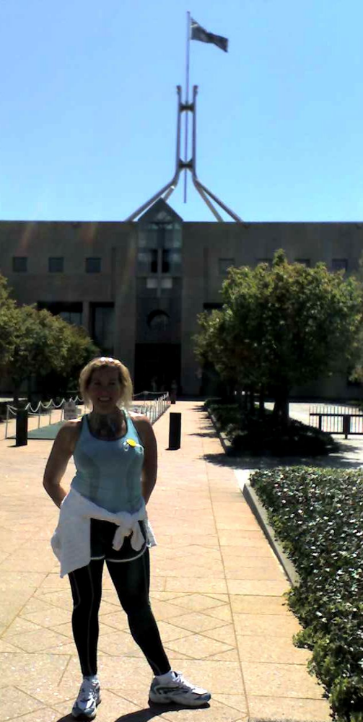Esperanza arrived in Canberra on 14th October and called me from Parliament House. I met with her as the Prime Minister set off to the Governor General’s residence to start the election process. He waved to us as he drove past. Calling the election meant the Senator who was planning to receive the petition did not come to Canberra.
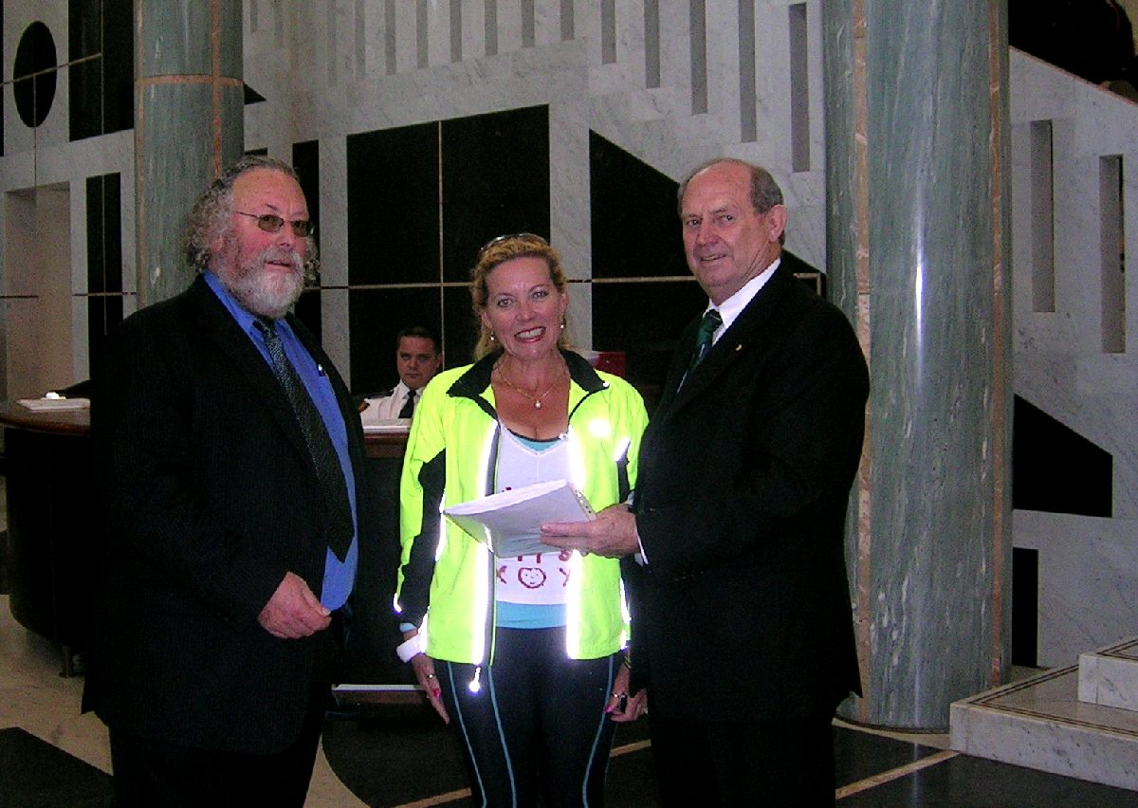
We were not sure what to do with the petition. Eventually, we organised to hand the petition to Mr Ian Harris, the Clerk of the House of Representatives. He agreed to meet us on Monday 15th October at very short notice. He explained about the election and how he would hold the petition and give it to the incoming Government after the election. Ian Harris is one of the most helpful people I have ever met.

As it turns out, people can add to the petition up until the election. You can download the petition sheet from the A4 website and print it (the URL is www.a4.org.au/documents/EsperanzaPetition.doc). Just get as many people to sign it as you can — print as many copies as you need, sign them, then send the original signed pages to me before Parliament sits next (after 24 November):
Autism Petition
c/- Bob Buckley
27 Fairbridge Cres
Ainslie ACT 2602
I will deliver them to Mr Harris and they will be included when the petition is handed over.
After Esperanza handed over the petition, we sat down for a coffee and debrief. Esperanza is interested in having an annual walk for autism. I think this is an excellent idea. I hope in future we could get more people involved, and organise more publicity.
While we were talking, an advisor from Mal Brough’s office came to see us. The Senator contacted them to see if they could receive the petition as the Senator could not be there. We explained that we had already given the petition to Mr Harris. Then Esperanza had a long chat about autism with the Minister’s advisor. Esperanza really is an inspiration.
Esperanza does not have a direct connection with ASD. She has friends who are affected and has seen it in her nursing work. She is passionate about helping.
Congratulations Esperanza. What a great effort! Thanks also to the very quiet Sebastian, her son, who drove the support car.

Victorian Autism State Plan: consultation
Dear Bob & A4 Members,
Work has now commended on developing Victoria’s Autism State Plan. It’s imperative that the autism community has their say via the consultation process.
Please find attached a flyer which we ask you to circulate among your family, friends, colleagues and anyone you think might be interested.

A special note about the discussion paper:-
The discussion paper describes the current service system and some of the issues. The discussion paper is not a plan for the future nor a draft plan. Its purpose is to provoke the reader to consider what the issues are for them personally. It would be helpful to read the discussion paper before attending a forum — but not essential.
Organisations like Autism Victoria and A4 exist to make life better for the autism community and have successfully raised the profile of the autism community’s issues amongst our MP’s both Victorian State and Federal.
As an encouragement to all to keep on keeping on, this is how the state plan came into being …
In the lead up to the November 2006 Victorian State Election, Autism Victoria lobbied for 9 areas of priority in a letter to the Premier in Sept 2006. Below is an extract from that letter about one of the nine areas of priority being the development of an autism state plan :-
1. Development of an ASD State Plan
Prevalence of Autism Spectrum Disorders in the community is now 1:166 (60 per 10,000) a rise of about 1,100% from 1 in every 2,000 (5 per 10,000) about a decade ago placing considerable strain upon, diagnostic, intervention, educational and support services across all life cycle phases.
In addition, a move over the past decade from exclusive settings to inclusive models within early childhood, childhood and adulthood means there is an increased need for Specialist knowledge in mainstream generic settings such as kindergarten, childcare, primary, secondary and tertiary education facilities as well as continued specialist support to specialist settings. There is also a need for greater understanding and awareness amongst allied and acute health professionals.
Because babies with an ASD grow into adults with an ASD, the services they require traverse the Bureaucratic silos. Hence, the need for a coordinated statewide response is now urgent especially when you consider that the inclusive “social” model is beginning to mature and the “pioneer” children with an ASD are beginning to enter Secondary and Tertiary Educational facilities.
Autism Victoria Inc. is well placed to work collaboratively with Government to develop a statewide co-ordinated response to the increased demand on services across the life cycle. An ASD state plan would include evaluation of the current situation, identifying the strengths and weaknesses of various sectors, service gaps, and consider the findings of the ACT NOW project about the ASD specialist knowledge, skill and expertise needs of professionals across all sectors.
Action required:
New One Off funding of $50,000.00 p.a. for 3 years. (Total Investment $150,000.00)
Development of an “ASD State Plan” by Autism Victoria through a collaborative statewide Whole of Government approach in response to increased demand for ASD specialised services within mainstream generic and special settings.
In its 2006 pre-election policy Addressing Disadvantage, the Government made a commitment that it:
… will develop an Autism State Plan in partnership with Autism Victoria, to build new and better approaches across government for meeting the growing and complex needs of people with autism and Autism Spectrum Disorders (ASD).
Since this announcement, Autism Victoria have been working with its Government partners to take this work forward. Key activities include:
looking at current demand on services
evaluating the findings of the Autism Secondary Consultation and Training Strategy
identifying gaps in services
developing strategies to make the service system more effective.
The Autism State Plan will consider the needs of people with an ASD of all ages and life stages – children, adolescents and adults.
Meredith Ward
Government and Public Relations Liaison
Autism Victoria Inc.

from A4 Steering committee
The Victorian Government is consulting the community about an autism state plan (see http://autismstateplan.dhs.vic.gov.au/). A4’s Steering Committee applauds the Victorian Government’s intention to develop an Autism State Plan. We welcome the Government’s implicit recognition that autism spectrum disorders are a distinct and significant disability type that requires specific attention.
Please participate in the consultation. If you possibly can, write a submission explaining what the state government can do to improve outcomes for your family and people with ASD. If you want, you can explain how the government could improve the services you encountered to improve outcomes for the people coming through the system behind you.
We understand that the Victorian Government does not intend to publish submissions. If you would like to share your submission with A4 members … send (email) an electronic copy of your submission to cnvnr@a4.org.au and we will put it on the A4 website. If you want to share your submission anonymously, please make that clear when you send it.
Links to the submissions that people send us will be on the A4 in the webpage: www.a4.org.au/vicplan.htm

personal from Bob Buckley
I am glad to see the Victorian Government develop a state plan for autism/ASD and consulting the community about it (see http://autismstateplan.dhs.vic.gov.au/).
Please … I urge all Victorians with ASD and/or their families to participate in the consultation; please say how you feel about the current lack of appropriate services (you may not agree … feel free to say that too) and tell your story if you possibly can. Please find out when the forums are on, then please go along and tell your story. Even if you cannot attend, write and tell the Victorian Government what you need or what your child needs from the Government … or what families who will be diagnosed in future need to ensure people with ASD can live as independently as possible, or (even better) to get a job and participate in their community.
If you live in Victoria, please make an effort to tell your Government what you need.
Following is my personal perspective on the consultation paper and the associated process: many A4 members will feel differently.
Unfortunately, the Victorian Government’s Autism State Plan Consultation Paper disappoints me. It shows clearly that Victorian government officials who are involved do not understand the lives and experiences people with ASD and their families endure. It shows that the government officials reject and ignore information that is currently available … they reject information they do not want to hear/see. The paper left me humming this song http://www.youtube.com/watch?v=LLiX8sgfgQU.
I detailed some of my concerns in my submission. If you are interested you can download my submission from the A4 website (see www.a4.org.au/vicplan.htm).
I urge people to think about the aims they expect of a state ASD plan. Please do not just accept the principles given in the Consultation Paper.
My experience with consultation processes such as this (and I have been very close to them) is that officials need to tick off that they consulted the community, but are extremely reluctant to allow the consultation to influence the outcome. People with ASD and their families need to keep confronting government officials with reality to overcome their state of delusion … where they think everything is going fine and a few minor adjustments will fix it all. Be very clear that you need significant change.
The consultation paper has serious flaws. I expect the officials have been advised repeatedly about these, but that they chose to reject or ignore the advice. I have not asked the people involved and I doubt they could or would tell me if I asked … but I know some of the people involved and I am confident I know their views well.
From the outset, people need complete and factual information; for example, some information can be found in the federal’s Government’s brochure Early Intervention For Children With Autism Spectrum Disorders: A Guide For Parents (download from http://www.health.gov.au/internet/wcms/publishing.nsf/Content/D9F44B55D7698467CA257280007A98BD/$File/autbro.pdf). Families need to know that for best outcomes most children with ASD need a minimum of 20 hours per week of intensive ASD-specific early intervention for two or three years. People should be deeply suspicious of a consultation paper that ignores such key information.
The consultation paper shows the currently existing so-called pathways diverging on the basis of intellectual disability (ID). This shows a prejudice that somehow autism/ASD is a “secondary diagnosis”, also expressed in the paper.
Victorian officials have the idea that people with ASD who do not have ID therefore do not deserve or need treatment, therapy, support and services. This idea and its consequent service model is profoundly detrimental and discriminatory.
Please use this chance to inform Victorian officials about the needs of people with ASD, their families and carers. Think beyond the Autism State Plan Consultation Paper. Leave the Victorian officials without any excuse for their ignorance and prejudice. Please tell them what you need and how you feel.
In conclusion, I want to be clear that I am pleased Victoria is developing an Autism State Plan. I am disappointed government officials still have such a poor understanding of ASD in our community and what needs to be done to get much better outcomes. I am quite cynical about this process, but at the same time I am optimistic that it will help.
Bob Buckley

Convenor’s message
Dear A4 member
I am sorry. I am unable to keep up with writing about events at present. Please forgive me. I will try to catch up … but I have to give the lobbying activity priority. It would help a lot if a few other people could write up some of what is happening at present. If you can help, please email me at cnvnr@a4.org.au … no prior experience is required.
The week of the 3rd October left me a bit dazed and confused.
On the evening of 1st October, I had a call from Adrian Ford asking me if I knew what was going on. I did not know what was happening. When I got off the phone, there was a message asking me to call Minister Mal Brough’s office in Queensland. I called and was asked whether I could be in Eagleby, south of Brisbane on Wednesday morning for an important announcement.
Around a month ago, I heard reports from the field that Labor was interested in autism because the government was considering making a statement.
About a week before the announcement, a local ASD support group told me they were meeting local politicians (with a possibility that Mal Brough would turn up) and asked whether A4 could help them with some background. But none of us had any idea what was developing.
Fortunately, I was able to drop everything and fly to Queensland for the Government’s announcement. I thank my family and employer for their flexibility and support.
The following is what I understand happened.

Politicians’ pre-election promises on autism
I let the A4 Steering Committee know that I was invited to Queensland and would attend. Over the next 24 hours I found out that most of the State autism associations were also coming. None of us knew what to expect … everyone was guessing.
On the way to the venue, I got a call from Melbourne telling me that the ALP has announced it would create six autism centres, and that the Government was expected to make a major autism/ASD announcement.
When we arrived at the Community Centre in Eagleby we were given an informal preliminary briefing. But until Mr Howard arrived and spelled out the package, the size of the Government’s initiative did not really sink in.
I am still trying to understand what it all means.
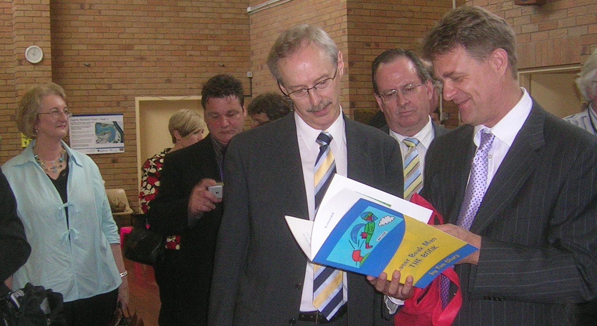
Waiting … Adrian Ford and Dr James Morton study Laser Beak Man
The Government’s initiative on autism is the first concrete admission from any government in Australia that people with autism spectrum disorders do not get the services they need. Mr Howard's announcement is welcome and significant.
Mr Howard himself announced the Government's autism policy. This policy came from his office: it covers several portfolios, and none of the other Ministers or their departments was able to develop such a policy. This announcement demonstrates the type of leadership needed to tackle the challenge that ASD poses for government with coordinated initiatives in multiple departments.
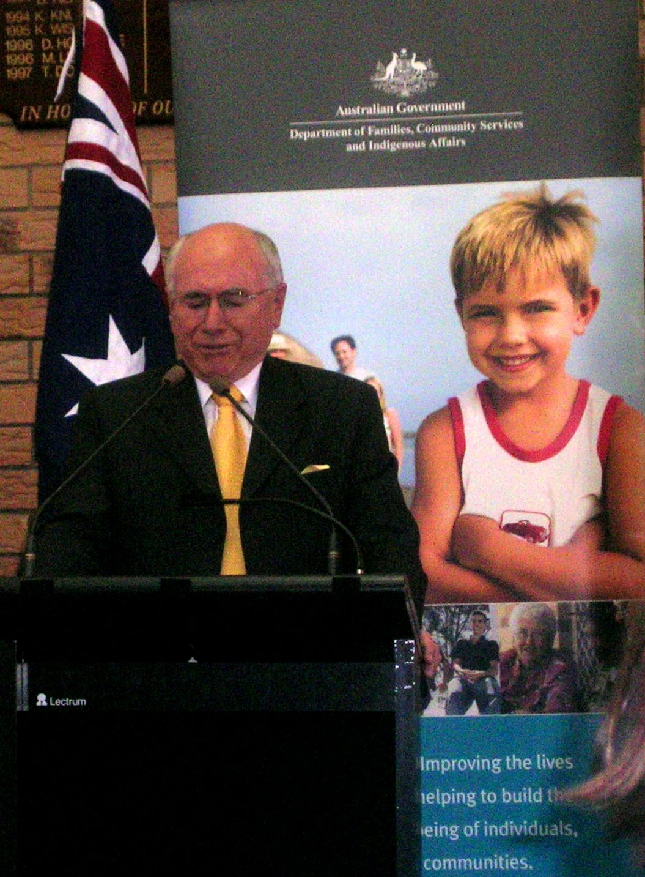
Mr Howard announcing $190m autism policy
The Government’s specific initiatives are described in Factsheets …
- New Medicare items for diagnosis and early intervention treatment for children with autism spectrum disorders - RTF 107KB | PDF 31KB
- Support for school students with autism spectrum disorders – professional development for teachers - RTF 93KB | PDF 93KB
- Increased access to early intervention programmes for children with autism spectrum disorders - RTF 114KB | PDF 33KB
- Support for school students with autism spectrum disorders – parent workshops and information sessions - RTF 100KB | PDF 30KB
- Education and support for families and carers of children aged 0 to 6 with autism spectrum disorders - RTF 97 | PDF 30KB
You can also see a copy of the Prime Minister’s speech … http://www.pm.gov.au/media/Speech/2007/Speech24601.cfm
Hopefully, few families in future will experience difficulties like most A4 members had accessing diagnostic and appropriate early intervention services for children with ASD. Provided the government is able to deliver best practice early intervention for people as they are diagnosed, research indicates the Government will get the most benefit for the dollars it spends. From a community perspective, this is “the right thing to do”.
The Government’s autism policy has not been designed to attract votes. The policy mostly helps people who do not yet know they will need services for ASD.
The Government's initiative has relatively little direct effect for the 35,000-40,000 people who already have an ASD diagnosis. Understandably, people have expressed disappointment that the Government has not addressed their needs. Unfortunately, few of these people received “best practice early intervention” in a timely fashion for their ASD so many of them have major needs that existing services do not meet.
Mr Howard says this initiative is just the start. The detail still has to be worked out. For example, many families need respite. Do they want their child in some type of intervention program while they get their respite? Some families want therapy. What types of therapies are best for these people and how do they feel about it? Do they agree?
I am optimistic that the federal Government will help, either deliberately or inadvertently, to obtain better services for people with ASD from the states. The states should have a significant role providing services and a new CSTDA is needed immediately.
At this stage, I am unsure what the Government’s announcement means in detail. There seems to be some flexibility ... perhaps because it was developed in such secrecy (with very limited initial consultation).
Labor’s announcement (see http://www.kevin07.com.au/news/health/specialised-early-childhood-centres-for-children-with-autism.html) is about “specialised child care and early intervention centres”. It says “Federal Labor’s new autism specific centres would follow similar developmental methods to the AEIOU program that currently operates in Brisbane, and the Lizard Centre in Sydney”.
Mr Rudd said (see http://alp.org.au/media/1007/dsihealoo030.php)
“Can I say autism is above and beyond party politics and I think it’s very important that Mr Howard’s initiative is combined with ours to provide a total national response to the challenge of autism right across our country.”
I am keen to see some detail of Mr Rudd’s proposal. What services will each centre provide and how much will it cost?
Labor has a “blog” on autism at http://www.kevin07.com.au/blog/myblog/guest-blog-not-just-more-underwear-from-kmart-up-close-and-personal-with-autism.html

human rights
Previously, I mentioned discussions with staff in the Department of Prime Minister and Cabinet (PM&C) and the Attorney General’s Department about human rights and people with ASD. (see here and http://www.a4.org.au/documents/PMC070906HRpublic.doc in Update 5, 2007 ). I asked Prof Hilary Charlesworth, an eminent authority on international law and human rights, to review the letters. She responded ...
I found the correspondence of interest - and concern. The official view that education is the best way to promote human rights seems to abdicate governmental responsibility to enforce rights. Using a discrimination lense to react to disability also limits the government response, and as you point out, the exemptions in any event make the protection from discrimination nugatory.
I can add little to your response of 18/9, which makes all the points I could make.
Recently, I met with the Attorney General, Mr Phillip Ruddock MP to discuss my concern that people with ASD have little or no human rights protection in Australia, especially given the DDA Section 45 and the High Court’s Purvis decision. The Purvis decision is a legal precedent that lets any service provider deny service to people with a disability whose behaviour they will not tolerate. So a school can expel a student with autistic behaviour and there is no legal protection or safety net for the student.
Mr Ruddock MP is concerned that children with ASD, if placed in mainstream classrooms, could disrupt other children’s education or could endanger staff and other students. He indicated students with ASD would be better off in special schools (I felt it was not worth trying to explain that few special schools have staff who are adequately trained and/or the resources needed to educate students with ASD appropriately).
He seemed aware that special schools are contrary to current government policy and that the number of places in special schools had decreased over time.
I could not interest him in protecting the right of a child with ASD to education services that are effective for the individual child. Nor could I interest him in ensuring protection for other human rights that are essential for people with ASD.
The Government planned to revise the Disability Discrimination Act this spring due to comment from the Productivity Commission ... but their plan did not eventuate. Mr Ruddock got his Department to commit to consulting A4 once the legislation is drafted.
In relation to ensuring protection of human rights for people with ASD, Mr Ruddock MP just does not get it.
In the meantime, I received a very disappointing letter from PM&C (see http://www.a4.org.au/documents/AG071015.doc). It says:
On the broad question of how far legislation is or should be used to enhance the circumstances of particular groups, it is likely that there will continue to be different views.
This response avoids the issues. Clearly, the UN seeks to ensure the rights of people with disabilities are protected. This response does not explain why the Australian Government refuses to ensure people with disabilities, and children with ASD in particular, have the right (recognised in UN Conventions)
- to receive treatment, therapy, education, services and support for their ASD;
- to protection from discrimination of all types;
- to access fair and effective legal processes;
- etc..
The Government also says:
... on advice from experts, eligibility for this item is not extended to ASD because it is not regarded as an intellectual disability.
Originally, the Government said the Medicare items referred to in my letter were for people with communication and sensory difficulties. This should include people with ASD. People with ASD certainly need longer to communicate their health needs. But the Government subsequently changed its description of the target group to people with an intellectual disability.
There is no evidence that the government consulted experts on ASD, despite our having raised concerns right from the start. The Secretary for Health told us the Health Department consulted the AMA. These are people who spent their entire career in not treating people with ASD so they have little knowledge and no experience relevant to ASD. It would be unprofessional for anyone in their position to give advice that could affect people with ASD. So what advice relevant to people with ASD did the Government get, and from whom?
The new Medicare items due in July 2008 are irrelevant to people over 12 years of age who already have an ASD diagnosis.
I appreciate the Government’s recent announcement will provide $190 million over five years. But I am concerned that the basic services this will provide should be a child’s right: they should not dependent on the coincidence of a particular political leader’s generosity and “the efforts of people like yourself, who have drawn these issues to the government’s attention”.

Carers Report
The Report, ‘The Wellbeing of Australians—Carer Health and Wellbeing’ looks important. Click here to download a copy. I will try to read it and comment for the next A4 Update.

In conclusion
Thanks Ian (see the lead article) and all the others who wrote such complementary emails/letters. We did not do it alone; we would not be able to influence government without our members doing their bit.
I am sorry that I cannot answer Ian’s questions. The Government’s announcement is unclear to me, too. And I have even less idea of what Labor intends to do for people with ASD if it wins government. There is some talk that Labor’s six childcare and early intervention centres may mean six “centres for excellence for autism”. Mr Howard’s 4000 or 8000 places over five years will require many more than six centres just to deliver the early intervention component.
I will try to get clarification from both sides before the coming election.
I know the Government’s announcement will mostly benefit people who are not yet aware their child needs help. I hope there will be spin offs for people who already have a diagnosis. I hope state governments will recognise autism is a distinct type of disability and that ASD-specific services are essential. Hopefully, having the federal government recognise ASD specifically will help improve services at the state level.
I am still waiting for a response as promised from DEWR.
This is just the start. A4 works at the federal level. We need people to lobby at the state level as well.
So please get excited … lobby your state government and get results. It can be done.
Regards
Bob Buckley

AABASD Media Release

Announcements put autism on the map
3 October 3, 2007. The Australian Advisory Board on Autism Spectrum Disorders welcomes today’s announcements by both the Federal Government and the Opposition.
Advisory Board Chair, Adrian Ford says, “Today’s announcements by both parties are welcomed and put autism spectrum disorders firmly on the map. The Australian Advisory Board on Autism Spectrum Disorders has been in consultation with the Federal Government in particular for several years, so this announcement represents a huge step forward.”
The Australian Advisory Board on Autism Spectrum Disorders has a ‘National Call to Action’ which clearly outlines the issues facing people with an autism spectrum disorder, their families and the consequent impact on the community at large.
“The Medicare rebate announced by the Government will give a huge boost to multidisciplinary early diagnosis,” says Adrian.
Adrian continues, “We know that early intervention followed particularly by specialised school programs can have a major impact on the ability of children to transition into work environments. But we can not forget that there will also always be adults with an autism spectrum disorder with special needs.”
Young children with an autism spectrum disorder and their families will benefit most out of today’s announcements. Families who struggle to find autism specific placements for their children will be excited by the much needed injection of funding and specialised programs.
Adrian says, “The Governments plan to offer 450 teachers and other skilled staff specialist training is going to have a major impact on the many children in the school system that have not been able to receive the specific care they need.”

AABASD Call to Action
The AABASD has revised its Call to Action. Download it from:
http://www.autismaus.com.au/aca/pdfs/Autism_NationalCalltoAction_Oct07.pdf
The A4 Steering Committee agrees with the AABASD Call to Action.

ASD in the media
Bob Buckley
According to Kate Benison Medical Reporter in Kids need plenty more fish in the tea (SMH, 19/9/2007 http://www.smh.com.au/news/national/kids-need-plenty-more-fish-in-the-tea/2007/09/18/1189881513693.html )
Omega-3 fatty acids, which are found in seafood, eggs and some meats and plants, play a role in brain and nervous system development, behaviour, learning and mood. Low levels have been linked to depression, Asperger's syndrome, attention deficit hyperactivity disorder and dyslexia.
A story, mostly about carers, Howard pledges more for disabled in The Age 25/9/07 briefly mentioned an autistic son (see http://www.theage.com.au/news/national/howard-pledges-more-for-disabled/2007/09/25/1190486307147.html)
… and then on 3rd October, it all went mad! (A4 sent out a special email soon after). Then it all went quiet again. Since then there has been a trickle of comment.
The Age published A decision that affects the lives of real people, Anna Clark
October 8, 2007 see http://www.theage.com.au/news/opinion/a-decision-that-affects-the-lives-of-real-people/2007/10/07/1191695736091.html?page=fullpage and was followed with this letter (see http://www.theage.com.au/news/letters/this-labor-idea-is-foolish-and-weak/2007/10/09/1191695907112.html?page=fullpage) …

From inside autism
ANNA Clark's article (Opinion, 8/10) is a timely reminder from someone with an insider's perspective that children with autism spectrum disorders do grow older and their needs go beyond early intervention and respite care. Recent policy announcements from the Government and Opposition are a welcome refocusing of attention, and a good start — but the escalating prevalence of ASDs needs more.
Early intervention is a wonderful thing if you can get it — but it is not a cure, and most autistic kids will need specialist assistance throughout their schooling. Many will need help to find their way into adult life, achieve independence, and the rest that parents wish they could take for granted. Many, like Sol, may never find independence. To leave this burden on parents and relatives is unforgivable.
Mark Websdale, treasurer, Autism Alliance Association, Laverton

A4 Contacts
A4 is a grassroots organisation. All A4 activity, such as publishing the Updates (newsletters), is done by volunteers. Please understand that A4 volunteers may have no training or qualifications for their various roles. They do the best they can for people with ASD, their families and associates. A4 welcomes assistance and constructive criticism.  Update team: editor-at-a4.org.au  Editing: normally Juanita and Vicki … but  Bob Buckley did this one.  Reporting: vacancies in all states.  Production: Helen Curtin – proof-reading (Qld), Bob Buckley – distribution (ACT). | Steering Committee  A4 Convenor: Bob Buckley (ACT)  cnvnr-at-a4.org.au  Treasurer (donations): Cathy Ryan (Vic.)  treasurer-at-a4.org.au  Members: Kelley Harris (Vic), Lionel Evans (Qld), Geraldine Robertson (Tas.), Wendy Kiefel (Vic), Mary Gebert (Vic), Katharine Annear (SA), Myrna Dominguez (NSW), Vicki McKay (Vic), Jasmine McDonald (WA)

The Commonwealth State and Territory Disability Agreement (CSTDA) funds many services for people with a disability.
the disability standards for education (see http://www.ag.gov.au/www/agd/agd.nsf/Page/Humanrightsandanti-discrimination_DisabilityStandardsforEducation) do not offer students with ASD any legal protection. The AG’s website says “The Standards are intended to give students with disability the same rights as other students” ... but you do not need Standards for this. Student with ASD need ASD-specific services and support ... called “reasonable adjustments” in legal terms. We are also told a reasonable adjustment “... is a measure or action taken to assist a student with disability to participate in education and training on the same basis as other students”. As many students with ASD cannot participate “on the same basis as other students” the disability standards for education do not help.

