February 2010 - Volume 8, Number 2
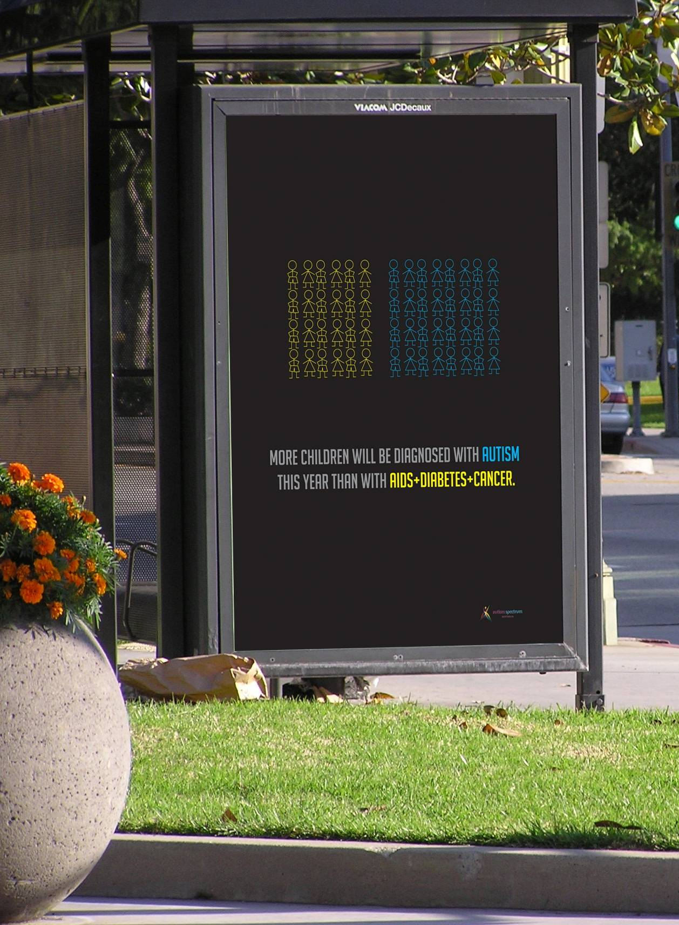
Sam’s “issues poster” that won him second place in a Competition across 5 campuses – voted by his peers (see below)

Warning over growing ASD numbers
Data from Centrelink show more than 1% of Australian school-age children have a confirmed diagnosis of Autistic Disorder or Asperger’s Disorder. These data, presented at the APAC’09 conference in Sydney, show the number of children diagnosed with autism spectrum disorders (ASD) more than doubled over the preceding 5 years. Similar diagnosis levels have been confirmed in the USA.
Back in 2004, a peer reviewed paper published data that the Australian Bureau of Statistic (ABS) collected for its Survey of Disability, Ageing and Carers (SDAC) showing the number of Australians with ASD more than doubled in the 5 years from 1998 to 2003. The number of Australians estimated to have ASD on the basis of the ABS SDAC rose from 13,000 in 1998 to 30,000 in 2003. We await the results of the latest data collection in the SDAC data series. Other data collections show prevalence of ASD is growing rapidly.
The diagnosis rate for ASD has doubled every 5 years over a 20 year period. In the early 1990s, the prevalence of ASD was said to be 1 per 1,000. The prevalence of ASD now exceeds 1 in 100, so ASD diagnoses increased 10 fold over 15–20 years.
The following table shows how the percentage of children with ASD will increase over time if this pattern continues.
ASD affect adults and children: ASD are said to be life-long. Many people diagnosed with ASD experience severe or profound disability through their life; they need life-long 24/7 support and supervision.
Year | children
Year | male | female | total
2009 | 1.6% | 0.4% | 1%
2014, +5 yrs | 3.2% | 0.8% | 2%
2019, +10 yrs | 6.4% | 1.6% | 4%
2024, +15 yrs | 12.8% | 3.2% | 8%
2029, +20 yrs | 25.6% | 6.4% | 16%
2034, +25 yrs | 51.2% | 12.8% | 32%
2039, +30 yrs | 102.4% | 25.6% | 64%
Analysis of the ABS SDAC 2003 data shows 87% of people with autism spectrum disorders have severe or profound disability. Many people who are diagnosed with ASD need substantial levels of support.
If diagnosis rates continue to double every 5 years, in 20 years the effect on the community and the Australian workforce will be substantial. In 25 years, supporting such a high level of disability in the community would be challenging and the situation for males in 30 years is inconceivable.
If this growth of ASD diagnoses continues, if outcomes for people with ASD remain particularly poor and governments continue doing very little, the effects of ASD on our nation and our community could soon be greater than either our ageing population or global warming.
At the very least, Government should immediately fund research into why diagnoses of ASD are increasing. We should know the nature of the challenge due to ASD and how best to tackle it. Surely we need to know, right now, what happens for children when they become adults with ASD, how rates of ASD diagnoses for Australian children could slow down, whether severe/profound disability persists with increasing prevalence of ASD, and what policy and actions are needed.
Notice that with 1% if children diagnosed, almost 2% of parents are affected by ASD. In many cases, this could influence extended families and friends. Even if ASD issues do not impact on imminent state and federal elections, the influence of the issue should grow over the next decade.
This timely warning is due to Esther Woodbury, President of the Community Living Project in Canberra, pressing for projections of the number of people with disabilities/ASD who will need specialised accommodation and support in the foreseeable future.

Contents
Warning over growing ASD numbers 2
Contents 3
Convenor’s message 3
National autism group applauds Tasmanian policy 6
Tasmanian Libs make ASD an election issue 7
Autism becomes an election issue 8
Adelaide: Libs announce ASD specific school, supported mainstream, special schools 9
Special Education Inquiries and more … 9
Allied Health Professional’s autism website 10
School suspension in the ACT 11
Inquiry into a National Long Term Care and Support Scheme for people with a disability and their families 12
Proposed DSM-5 13
New Research Project - Females with Disabilities 14
Letters 14

Invitation to comment 14
“Breaking Point” -- Four Corners 15
NSW closing more schools 15
Issues Poster 17
NSW Carer’s Petition 18
interesting and helpful publication 18
Events and Notices 19
Thanks to Melissa Christie … 21
A4 Contacts 21
Bob Buckley
A4 Convenor
24/2/2010

Convenor’s message
Dear A4 member
If you think the lead article (above) is important, please pass it on (email or letter) to your federal politicians. And please feel free to share it with state politicians, too.
In two coming state elections, Liberal oppositions have made commitments to sections of the ASD community in their states. These election promises could become government policy in those states. ASD now has sufficient numbers to matter to politicians, so A4 encourages members in all states to push hard for what you want. Use these examples as leverage.
A4 is not politically aligned. A4 will comment critically on ASD-related policy … and the lack of policies. The Liberals and Greens in Tasmania have policies of interest to many A4 members. The Liberals in South Australia also made an election promise that will interest many. I feel A4 has a responsibility to let members know about these policies. A4’s political interests relate only to ASD.
Many of you saw the ABC’s Four Corners “Breaking Point” story; a powerful story raising a number of issues. Clearly, some families need residential respite facilities and prefer that such a service is integrated with special education settings.
A residential school for people with severe disability addresses both education and respite needs; responsibilities of different government silos. Few governments have the ability to address such needs (bureaucrats call them complex, though journalists could describe them pretty clearly within 30 minutes of 4 Corners); it takes creative energetic families and sympathetic not-for-profit organisations to provide the services needed.
Governments say their service models are ‘person focussed’, yet their services fail persistently to meet even simple examples of “complex” needs.
Government economist and bureaucrats invent ways to measure the economic efficiency of services that are unrelated to economic activity. Based on these invented and untested measures, Governments cut funding until services cannot function. Then they cut the service as an allegedly cost-cutting exercise.
The cost to families and the community of cutting these services is substantial but hard to quantify accurately, especially if you want to quantify it in dollar terms. Economics practice just ignores things that are too hard to measure. So Governments ignore the economic cost to the community when they close “complex” disability services.
The Breaking Point story raised the issue of community for people with severe disability. At all levels, Governments regard social groups for people with disabilities as contrary to their social inclusion policies. Clearly, Inclusion ideology and policies do not respect the needs and preferences of some of our most vulnerable citizens.
Social Inclusion advocates are like economists. They simply ignore things contrary to their personal beliefs or challenges that they do not know how to address. We see this in their submissions to the various special education inquiries.
Inclusion idealists and bureaucrats who promote social inclusion policy ignore well-known difficulties in their decisions to close special schools and force students with special needs in mainstream settings. Inclusionists routinely ignore well-known problems including:
- lack of appropriate pedagogy and curriculum;
- chronic under-resourcing and missing essential services;
- bullying; and
- lack of access to essential clinical services.
Governments need to solve these problems before they close any more special schools.
Returning to the subjects of respite and economists, A4 is preparing to write to the Productivity Commission’s “inquiry into a long-term care and support scheme for people with a disability in Australia” (see http://www.pc.gov.au/projects/inquiry/disability-support).
I thought I should start out seeing what they say about similar things. I started to look at their recent report on Contribution of the Not-for-Profit Sector (see http://www.pc.gov.au/__data/assets/pdf_file/0003/94548/not-for-profit-report.pdf).
Frankly, I think the Productivity Commission just don’t get it. It makes no sense to me to look for efficiencies in a sector that largely exists outside economic consideration. Consider some (hastily chosen) examples:
- Clean Up Australia exists due to the absence of rubbish and pollution from financial considerations and economic processes.
- Organisations like Camp Quality, Make a Wish, Guide Dogs and companion pet groups provide services that governments consider unessential … therefore, the associated activities and organisations are by definition uneconomic and inefficient.
- The Variety Australia’s bash events certainly are not just about efficient extraction of money/donations from the community.
It makes some sense to look at not-for-profit organisations (NFPs) that provide essential services, and to compare these to for-profit organisations providing comparable services or competing with Government services … for example, in areas such as childcare. But I am not convinced their report makes a useful contribution.
Table 1 shows a classification scheme for “Activities usually included within the not-for-profit sector” (page XXVII). I found absence of ‘disability’ from Table 1 especially challenging. The report says “In some human service sectors, such as disability, … NFPs make up a high share of providers” (page XXXII) yet disability is not included in the categorisation. It was not clear to me where a not-for-profit that provided services for people with a disability would fit into the categorisation scheme used in this report.
I don’t think the Productivity Commission has a lot that is useful to say about the operation of the ASD-related groups that take up my time. It does not recognise that groups trying to offer essential services such as treatment & rehabilitation (primary health care), support in education, respite, employment support and accommodation for people with ASD need to but cannot compete effectively for limited charity dollars with large professional fundraisers.
My (realistic?) wishes are that people with ASD get to live as independently as they can; and choose and achieve their personal goals and aspirations. I wish people with Autism Spectrum Disorders, their families and carers could receive, in a timely manner, the treatment, services, support, protections and opportunities that they need (see A4’s vision). These outcomes depend on Governments ensuring essential needs of people with ASD (such as treatment, appropriate education, employment, accommodation, etc.) are actually met. Their access to essential services should not depend on the efforts of volunteer organisations for people with a disability. That is just not productive, efficient, appropriate … or just.
I have neither the time nor the inclination to offer a comprehensive critique of the full report on not-for-profit organisations. Previously, I was underwhelmed with the Productivity Commission’s Inquiry report - Review of the Disability Discrimination Act 1992. Until the Productivity Commission properly appreciates the significance of large but unquantified elements of the challenge, its contribution and influence on policy will not be beneficial. I am pessimistic about the Productivity Commission reviewing “care and support scheme for people with a disability”.
Regards
Bob Buckley
A4 Convenor
Media Release

National autism group applauds Tasmanian policy
The Tasmanian Liberal Party’s autism policy has been praised by the peak body, Autism Aspergers Advocacy Australia.
“The Liberal Party in Tasmania is the first political party in Australia with a policy to deliver ‘best practice’ for young children with autism spectrum disorders (ASD). The Liberal’s policy could meet the Commonwealth Government’s 2006 ‘guidelines for best practice’ for children with autism” according to Bob Buckley, Convenor of Autism Aspergers Advocacy Australia (A4), the national grassroots advocacy group for people with autism spectrum disorders.
The policy says a Liberal Government in Tasmania will introduce:
- screening for better and earlier detection of autism spectrum disorders;
- enhanced diagnostic services; and
- treatment centres for autism spectrum disorders.
This policy extends plans of Tasmania’s Liberals to improve services and support for school students with autism spectrum disorders.
Mr Buckley suggests “Politicians and bureaucrats in Australia have struggled to develop policies that promote ‘best practice’ for people with autism spectrum disorders. Currently Australia does not have enough trained specialist clinicians and allied health professionals with the experience needed to provide clients with appropriate ASD-specific treatment, rehabilitation, services and support using cost effective programs.
The Commonwealth Government advises that children with autism spectrum disorders need at least 20 hours per week or 1000 hours per year for several years of intensive, ASD-specific early intervention. The cost of 1000 hours of early intervention under the Commonwealth Government’s Helping Children with Autism model exceeds $120,000 per child per year, of which the Commonwealth Government contributes $6,000 per year for two years.
According to Mr Buckley “best practice early intervention for children with autism spectrum disorders can be provided for around $50K-$60K per child per year. Australian Governments should create centres that offer ‘best practice’ early intervention that families can afford, and fund training of specialised clinical staff in sufficient numbers. Savings for governments and the community from effective early intervention are enormous. Benefits for the families involved are invaluable.”
The policy of the Tasmania’s Liberals addresses these issues. This important step adds to existing Liberal policy supporting A-Teams in education (see http://tasliberal.com.au/policy/supporting-students-with-autism).
The number of people diagnosed with autism spectrum disorders has grown enormously. 1-in-25,000 children were diagnosed with autism spectrum disorders in 1980. Today that rate has grown to 1-in-91: over 1% of children are now diagnosed with autism spectrum disorders. As a result, the US government has dramatically increased research funding to better understand autism spectrum disorders.
References: http://www.atac.asn.au/2010elections.html
http://www.atac.asn.au/libpol.pdf

Tasmanian Libs make ASD an election issue
There is an election soon in Tasmania, and the ASD community made ASD enough of an issue that it is getting serious interest from politicians and some media attention. In December 2009, the Tasmanian Greens launched their “Retaining the A-Team” policy (see . http://mps.tas.greens.org.au/wp-content/uploads/2009/12/RetainingTheA-Team_Booth_Dec09.pdf). On Valentine’s Day, the Tasmanian Greens proposed $¾million funding for Autism Tasmania (see http://mps.tas.greens.org.au/wp-content/uploads/2010/02/Feb14_Autism-Tasmania-Funding-Commitment_C-OConnor_MR.pdf). At best, the Greens will have to let a major party water-down these proposals to get anything implemented.
Most of the Tasmanian community is disappointed that Tasmanian Labor has said little (nothing really) about the future for people with ASD under Labor were it to retain Government. Labor’s conspicuous silence worries the ASD community.
On the other hand, the Tasmanian Liberals provided a much clearer policy on Valentine’s Day. The ABC in Tasmania reports that …
The Opposition also announced $4.5 million to deliver autism services to children.
"We can provide them with 20 or 30 hours per week of very, very serious intervention strategies," said Liberal health spokesman, Brett Whiteley.
from: http://www.abc.net.au/news/stories/2010/02/14/2819118.htm
The Tasmanian Liberal Party says they will introduce “World Best Autism Services for Tasmania”. Their commitments are available on the web:

What the Tasmanian Liberals will do: http://tasliberal.com.au/policy/world-best-autism-services-for-tasmania

Supporting students with Autism: http://tasliberal.com.au/policy/support ing-students-with-autism
The Liberal’s policy is significant because it is the first political party in Australia to commit to a policy that would deliver services that resembles best practice early intervention for children with ASD.
There is no doubt that feelings are strong on this issue. Indications are that ASD policy is loosening the attachment of some formerly “rusted on” lefties from their past voting practices. With 1% of children diagnosed with ASD, around 2% of voting parents have an interest in these matters. The issue could influence extended family and friends. It is enough to make a difference in a modern tight election.
Cover of ASD policies in the election is on the ATAC website: see http://www.atac.asn.au/2010elections.html

MEDIA RELEASE

Autism becomes an Election Issue
At a highly emotional and at times volatile forum at Glenorchy yesterday afternoon, families with children with autism made it clear that they were not going to put up any longer with the treatment that they and their families have been subjected to.
Angry families revealed the terrible stress they live under, the impossibility of getting meaningful services for their children, and how government agencies simply did not understand their needs.
'The forum was held at Glenorchy Football Club in the Labour Government's heartland, in the state electorate of Denison,' Roger Law, Secretary of Action For Tasmanian Autistic Children [ATAC] said, 'which is also the greenest electorate in Australia. It also holds one of the largest concentrations of families with autism in the State.'
Mr Law said that many of these families, who live under intense pressure and whose needs are so high, have been Labour heartland voters all their lives. Yesterday that changed.
With a well researched and detailed policy announcement that would make Tasmania the leading Australian State in the provision of care for children with autism, Liberal Health Shadow Minister for Health, Brett Whiteley, gave hope to these families, and showed the commitment of his party which had thoroughly researched the issue, had consulted widely with the autism community and which has been actively helping autism advocates to obtain services for children affected by autism.
The Greens and Labour representatives who followed Mr Whiteley could offer no policy initiatives in the area of services to children with autism, though Greens' leader, Nick McKim, did announce that his party would be releasing further policies for families with autism later in the campaign.
In the hour of questions from the audience, families dealing with the issues of autism revealed their anger that the Labour party was not represented by a member of the Government, but instead sent a candidate for Denison, Madeleine Ogilvie, who battled valiantly to try to get some credit for her party.
Mr Law said that the families were clearly angry at the inaction of Labour in the provision of meaningful services over twelve long years of government. They expressed a strong feeling that they had been let down by Labour, who were pouring millions of dollars to big business and horse-racing but had forgotten their roots, by ignoring the people who had put them into government.
At the close of the meeting, Labour staffer Terry McCarthy sat with a serious expression on his face texting for many minutes.
Mr Law said that in many Tasmanian electorates, families dealing with autism, as well as their extended families, would comprise three to four percent of the vote.
'Labour and the Greens need to develop policies to match those announced by Brett Whiteley,' he said. 'If the feelings in the rest of the disability sector are as strong as those expressed at yesterday's meeting, then Labour is in deep trouble.'

Adelaide: Libs announce ASD specific school, supported mainstream, special schools
Today we were honoured to be invited to a press conference held by the liberal party where Isobel Redmond announced their policy for ASD educational reform. The liberal party have taken the time to listen to us, read our stories and to take our proposal seriously.
We have called on the labour party to contact us and to come up with a solution that will address the educational crisis facing our children in the current system.
The liberal party have committed to
- establish an ASD specific school to provide more autism spectrum educational services and increase the range of alternative options available to parents
- set up a steering committee, including parents and other stake- holders, to for the framework for and oversee the establishment of the ASD specific school
- develop a state-wide plan to deliver ASD focused education services across SA including supported mainstream classes, special classes and units in mainstream schools, and special schools.
"SA children will receive a quality education that meets their individual personality, learning style and support needs under a Redmond Liberal government"
Well done everyone who has spent time writing your stories, signing the petition and talking with the pollys to raise and highlight the issues our kids face in schools.
All the news cameras were there and they just showed the story on 10 so I would expect nine, and seven to follow suit.
Visit http://asdschool.com/ for more info and congrats to our community!!!
Congratulations to ASD campaigners in SA ... see http://asdschool.com/?page_id=131 and http://www.asdschool.com/documents/20100129%20Quality%20education%20for%20children%20with%20ASD.pdf

Special Education Inquiries and more …
Committees in the parliaments of both NSW and ACT are currently inquiring into Special Education.
A4 responded to the NSW Inquiry into The provision of education to students with a disability or special needs. The website for the NSW Inquiry is http://www.parliament.nsw.gov.au/Prod/parlment/committee.nsf/0/47F51A782AEABBABCA25767A000FABEC
Submissions published so far are at http://www.parliament.nsw.gov.au/Prod/parlment/committee.nsf/V3ListSubmissions?open&ParentUNID=47F51A782AEABBABCA25767A000FABEC. The link to Aspect’s submission is http://www.parliament.nsw.gov.au/Prod/parlment/committee.nsf/0/A7C08F3E1527BBE3CA2576D40018B84A
Hopefully, A4’s submission will appear in the list of submissions.
In December, the ACT Government released the Shaddock Review of Special Education in the ACT. You can download it from http://www.det.act.gov.au/__data/assets/pdf_file/0014/105341/Review_of_S...
The ACT Legislative Assembly Standing Committee on Education, Training and Youth Affairs has a website for its Special Education Inquiry (see http://www.parliament.act.gov.au/committees/index1.asp?committee=117&inquiry=821). There have been 13 submissions. Two submissions that relate specifically to students with ASD are:
- 08. Mr Bob Buckley (67KB)
- 09. Autism Asperger ACT (52KB)
You may be interested in the ACT Government Standing Committee Inquiry report release 10 years ago ... see http://www.parliament.act.gov.au/downloads/reports/E03studentswithadisab...
The same committee has just completed its Inquiry into … reform of the ACT education system. It has a simultaneous Inquiry into the educational achievement gap in the ACT.
The ACT Legislative Assembly Standing Committee on Health, Community and Social Services is conducting an inquiry into respite care services in the ACT and would like to hear from anyone with an interest in this inquiry, particularly users of respite care services and carers.
The ACT government also asked for a budget submission at very short notice. The ACT Government does not provide Autism Asperger ACT with any financial assistance that would help it respond to this barrage of inquiries and submissions.

Allied Health Professional’s autism website
Allied Health Professionals Australia created yet another autism/ASD website at http://www.autism.ahpa.com.au/ with sections for consumers and health professions.
The consumer section says …
The term ‘autism spectrum disorder’ (ASD) is now commonly used to describe autism, Asperger’s syndrome, and Pervasive Developmental Disorder – Not Otherwise Specified (PDD-NOS) which is also known as atypical autism.
… About 75 percent of children with ASD have below normal intelligence. However, around 10 percent demonstrate high intelligence, …
Perhaps they mean “Autistic Disorder” when they say “autism”. PDD-NOS is not “also known as atypical autism”; rather “atypical autism” is an ICD-10 term that falls within the DSM-IV PDD-NOS category. The ICD-10 also has a PDD-NOS category. More information is available on the A4 website (see http://a4.org.au/a4/asd and particularly http://a4.org.au/a4/PDDformal).
Currently, 1/3 of Australian children diagnosed with ASD has Asperger’s Disorder. Normal or above intelligence is part of the criteria for Asperger’s disorder, so the number of children with ASD and below normal intelligence is under 66%. Many commentators suggest 10–50% of children with Autistic Disorder have an intellectual disability. So the overall proportion is probably 20% (max. 33%) of children with ASD have below normal intelligence.
Families should be aware that Australian allied health professionals get very little training in treatment and support of children with autism spectrum disorders. Typically, training for a degree in an allied health profession includes at most one lecture on autism. Only a small number of graduates choose to specialize in treatment and services for children with ASD, and most of those who have specialist knowledge are well known in the ASD community. And some of our “respected authorities on ASD” are from outside the allied health professions.
Allied health professionals who do not have specialist knowledge of ASD may be able to help families access diagnostic services and point them towards some basic information, but in many instances families will quickly exhaust an allied health professional’s knowledge and expertise in ASD.
The existing level of ASD expertise among Australian allied health professionals is disappointing. In particular, the number of Australian allied health professionals who have knowledge and experience in supervising a best practice early intervention program for a child with ASD is miniscule.
Families who have lived with a child who was diagnosed 6–12 months previously, who have read on the subject, explored the internet and attended a relevant workshop or conference will usually have greater knowledge of relevant treatment and services provision than an allied health professional who does not have specialist knowledge and experience of ASD. With this knowledge, most families know they do not know enough, and they know it will be difficult or impossible to get the expert help they need.
ASD in Australia presents a massive workforce challenge. Government, Universities and the allied health professional bodies need to recognise the challenge and start to address it.
Then the allied health professional groups might find members who can provide correct information about ASD for their website.

School suspension in the ACT
ACT Labor and Liberals legislated to let schools suspend students for up to three weeks. Minister Barr says that this will not affect 99% of students. He says schools need 3–week suspensions to organise support for the student prior to re-entry. But students with autism spectrum disorders (ASD) in the ACT simply do not get the behavioural support they need. Suspending students with ASD will not help; it will exacerbate the situation and frequently result in an even bigger crises. If the ACT Government is serious then it will improve in-school support for students with ASD and provide specialist behavioural support to both prevent and address challenging behaviour.
Apparently, this legislation will affect 1% of students. It happens that 1% of students are now diagnosed with ASD. It is likely that these two 1% groups overlap significantly.
Under this legislation, students with ASD are now at risk of longer suspensions. Politicians, bureaucrats and educators need to understand that many of the 1% they intend to suspend for longer periods will regard suspension from school as a reward, a get-out-of-jail card for escaping unbearable and extremely confusing situations. Suspension reinforces challenging behaviour.
For example, an ACT high school frustrated a student with autism (and little communication). The situation escalated quickly and the student damaged school property. After lots of yelling, the student heard “blah blah blah … Mum is taking you home” and sure enough, his mother arrived soon after and took him home. He preferred the safety of being at home to the chaos at school which he was powerless to address. Although this student had difficulty learning, this lesson was stark and particularly effective: he learned that he is rewarded for breaking stuff in stressful situations (and he is able to escape intolerable situations). His behaviour at school deteriorated dramatically and severely. Since his first suspension, stress situations have been more challenging for his family. Failure to provide a safe and accessible environment for him led to severe anxiety and “challenging behaviour” which has spilled over into all aspects of his life, even breaking the sanctity of his home as his refuge.
The Liberals say this measure is about tackling bullying. Apparently, they expect suspension will reduce students’ inappropriate behaviours. Behaviourists advise that aversive stimuli are risky at best. Aversives usually escalate when they do not work … which is exactly what is happening with plans to extend school suspension in the ACT.
Bullies are reinforced through the attention they get in the suspension process and their perceptions of increased peer respect (hero status) from their suspension.
Recent research reports students with ASD experience four times more bullying than other students. Too often bullies are rewarded when schools blame students with ASD over bullying. Students with ASD cannot communicate their side of the story and the school punishes the victim.
For families already in difficulty, suspending students and forcing parents/carers out of employment is very likely to make bad situations worse. Autism Asperger ACT is aware of schools suspending young students with ASD and exhausting the family’s leave entitlement.
An experienced school primary school principal told me of an experience she had with a student with Asperger’s Disorder. The deputy principal suspended the student following an occasion of major frustration. The student’s behaviour at school was immediately more challenging … but improved quickly when the principal told the student that he would not be suspended again in any circumstance.
Where is the evidence that suspending students with ASD improves their behaviour? Could this proposed law discriminate against students with disability due to their ASD? Is suspension from school an appropriate way to address problem behaviour?
Students with ASD need a professional approach to behavioural challenges. A populist knee-jerk reaction, giving schools a longer suspension period, will have worse outcomes for students with ASD.
ACT politicians, bureaucrats and educators should discuss plans for longer suspensions with Autism Asperger ACT, the local autism association, and find better alternatives.

Inquiry into a National Long Term Care and Support Scheme for people with a disability and their families
The Australian Government is committed to developing a National Disability Strategy to enhance the quality of life and increase economic and social participation for people with disability and their carers. The Commission will begin the inquiry in April 2010. That is, Next month!
Be sure you register your interest in the Productivity Commission inquiry into a National Long Term Care and Support Scheme for people with a disability and their families.
Last week the Productivity Commission received their terms of reference for the inquiry you can view the terms at: www.pc.gov.au/projects/inquiry/disability-support/terms-of-reference.
The terms of reference are deliberately broad and wide ranging to allow a thorough exploration of the many complex issues which would be thrown up by the introduction and implementation of a National Care and Support Scheme.
The Productivity Commission will hold public consultations as part of its inquiry. It is absolutely vital that the Commission hear from people with a disability, their families and carers, as well as the organisations that support them. If the system is truly to be reformed it must take account of the experiences and needs of people with a disability and their families. It is only with these experiences as a base that real transformative change will be achieved. The commission must hear the voices of those with real live experience of disability.
This is your chance to have your say about how you would like the system to change - do not miss this important opportunity to shape the future of people with a disability, their families and carers in this country.
Register your interest at: http://www.pc.gov.au/projects/inquiry/disability-support/register That way you will know when the consultations begin and how you can participate.
Thank you again for your support.
The NDIS Team
LISA Comment: Like the Victorian Parliamentary Inquiry into Supported Accommodation, we all need to give this our full support. "Tell 'em how it really is!" ...... "Let us leave no stone unturned!"
Tony & Heather Tregale
LIFESTYLE IN SUPPORTED ACCOMMODATION (LISA) INC.
Tel: 03-9434-3810: Email: vk3qq@optusnet.com.au
Web: www.lisainc.com.au : www.lisa-aus.blogspot.com
NOTE: We are always interested in feedback, and information; general, specific, good or bad. If you wish anonymously: Our mail address is 73 Nepean Street, Watsonia, 3087

Proposed DSM-5
The American Psychiatric Association (APA) is revising its Diagnostic and Statistical Manual for Mental Disorders. The current edition is known as the DSM-IV or more precisely the DSM-IV-TR.
Anyone interested in how the APA proposes to change their diagnostics criteria for Autism Spectrum Disorders can take a look at their website: dsm5.org. The proposed changes for autism related diagnosis are at http://www.dsm5.org/ProposedRevisions/Pages/proposedrevision.aspx?rid=94
If you have a serious interest in this area, it may be worth looking more broadly at their section on "Disorders Usually First Diagnosed in Infancy, Childhood, or Adolescence" (see http://www.dsm5.org/ProposedRevisions/Pages/InfancyChildhoodAdolescence.aspx ).
Of course, there are some strong feelings about this issue. Expect lots of commentary on the internet, for example ...
- http://www.apa.org/news/psycport/PsycPORTArticle.aspx?id=ap_2010_02_11_ap.online.all_D9DQ25C80_news_ap_org.anpa.xml
- http://news.yahoo.com/s/ap/20100211/ap_on_he_me/us_med_asperger_s_diagnosis
- http://www.aspiesforfreedom.com/showthread.php?tid=18226&pid=322773#pid322773
- http://www.wrongplanet.net/postt119068.html
- http://blog.autismspeaks.org/2010/02/10/a-single-diagnostic-category-for-autism/

New Research Project - Females with Disabilities
Dear everyone,
The University has just commenced a research project to find out why females with disabilities participate, or do not participate, in sport. Attached is a flyer promoting the research. Could you please circulate the attached to relevant networks and/or clients?
If you require further information, please contact me using the details below.
Many thanks for your assistance in advance.
Kind regards,
Ryan Sherry <Ryan.Sherry@uts.edu.au>
School of Leisure, Sport & Tourism
Faculty of Business
University of Technology, Sydney
PO Box 222
Lindfield NSW 2070
Telephone: (02) 9514 5101 (Wed)

Letters

Invitation to comment
Hello everyone
We would like your comments on this draft policy on a universal parent and carer living allowance.
http://www.civilsociety.org.au/PandC/Policy02.htm
It is intended to cover parents caring for young children, or sons and daughters with a disability or a mental or chronic illness, or frail elderly family members. Everyone in this situation knows that their role in society is not valued as much as that of a person in the paid workforce.
Our policy would abolish tax concessions in housing and superannuation which favour high income earners and property developers, saving $53 billion and $24 billion respectively for annual redirection into a Parent and Carer Living Allowance set at the minimum wage figure of $544 per week.
This policy is a potential cornerstone for a political movement of parents and families, with the federal election coming up this year and state elections in most states.
http://www.civilsociety.org.au/PandC/Policy02.htm
Let me know what you think.
Best wishes
Lena Bailey
for the Convening Group
info@civilsociety.org.au

“Breaking Point” -- Four Corners
To whoever sits behind the screen and receives this, Thankyou for sending me this information, I only recently signed up with you.
As a mother raising 3 children with extra needs, one with a developmental disorder, one with a physical disorder and Aspergers syndrome and one severely autistic son I can feel so disconnected, alone and out of the loop. Thankyou for allowing me to feel involved and empowered through your site.
Kylie Mcclelland
Thank God, at last this was presented to “mainstream” Australia. It is not the actions of a civilized country to expect parents/siblings and families of severely disabled children to provide full time care for their offspring. It ruins the family and everyone becomes severely affected by the constant strain and worry of caring for the extremely dependent family member. Everyone in the family ages prematurely, some develop psychological disorders yet many survive as best they can, due to constant wear and tear beyond belief and understanding of the general public.
I have a son with moderate autism and moderate intellectual disability and two other children and it is constantly a struggle, the effects on our lives touches everything we do.
My heart goes out to those who have to make these heart wrenching decisions. When the government in its misguided policy threw out the residential institutions it sacrificed our most vulnerable in the society and the successive governments have their blood on their hands as we have seen in some horrific cases when parents have taken their children’s’ lives sometimes along with their own.
Anne, Camberwell, Victoria

NSW closing more schools
Dear Mr Buckley,
My name is Julie Lewis and I am the foster mum of two young boys who have special needs. I am writing to you to voice my concern at the proposed closing of Lakeside Special School at Gateshead, on Lake Macquarie & The Newcastle School in NSW. My eldest foster son, X, attends Lakeside school. X is 8 years old and has global developmental delay, severe autism, dyspraxia, ADHD and epilepsy. As you can imagine he is a very challenging child to care for and requires around the clock support.
We were so very lucky when we successfully enrolled X in Lakeside school back in 2005. The school is relatively small with only around 34 students, ranging in age from 5 years to 18 years. The staff have become like extended family to X (and to us) and no problem has ever been too big or too small to address. As X has extreme difficulty adapting to new people and environments the school, being a kinder to year 12 school, suited him perfectly. This was the main reason we chose this school. Changing schools every few years, as has been proposed by the Department of Education in the new Combined Schools program, would be disastrous for X. The new model would have 3 campuses, a Junior school in one location, a middle school in another location & a senior school in yet another location. Now, for X, even small changes have a profound effect on him. For example X had the same teacher, teacher’s aide and classroom for 3 years running. 4 out of the 6 children in his class had also remained the same during that time. But last year X had a new teacher and a new teacher’s aide. The classroom and children in his class remained the same, however X sunk into a deep depression. He had stopped eating, was sad, clingy, wasn't sleeping and had become very aggressive. X is completely non-verbal and could not tell us what was upsetting him. We knew there would be a settling in period but we had no idea that this change in teachers would affect him so badly. It took 6 months of the year and a process of elimination to work it all out. The school was fabulous, changing teachers and aides, carefully taking into consideration other children in the school, creating a little time-out area in the classroom for X to retreat to if need be, following through with programs such as the brushing program that the occupational therapist had suggested to relax X and being extremely supportive to our family. Thankfully X is doing much better now but it has been a joint effort between X's doctors, therapists, school and us. It has been an experience I hope to never go through again. Can you imagine what changing, not just teachers but a completely different school would do to him?
The parents at Lakeside School are trying our best to keep our school open as an option to the Combined Schools model. This model is a first nationally & there is no proof that it will work. Firstly you have children of different developmental age being grouped together in chronological age. The 3 schools will be much bigger as they will take in students from the 2 schools that will be closed down. We have been told by the Dept of Education that schools could be as big as 108 students with moderate to severe disabilities. There will be constant change each year as a new influx of students start, as well as students being moved on to another school every 4 years. There will be an absence of older role models, something that my child benefits from at Lakeside. We have been told that we should embrace the change ... change is good ... our children have to learn to cope with change. Part of my son’s disability is the inability to accept change. I was told I could send X to a mainstream school as an option. This is completely out of the question. I fear my only choice will be to home school.
There is a small handful of parents willing to fight the Dept. of Ed. on this matter. Others would if they could but time & energy are so very precious when you have kids like ours as I'm sure you know.
How do we get our message across? Mathew Morris, the local member, has been very supportive, as has the teaching staff at the school, various doctors & therapists, but I fear it is already too late. WE NEED OPTIONS! We need to keep our school open. We have been assured by the Dept of Ed that is not a money saving exercise, rather it is in the children's best interest. I would be extremely interested in any advice or opinions you may have.
Mind you, I do realise how fortunate we are having so many special schools in our area. That is why many of us came to live here, because of the wonderful services. We just don't want to lose them.
Regards
Julie Lewis
Hi Julie
The first thing I can do is to share your story via the A4 Update ... it goes to politicians so they see A4 is interested. However, I am not sure how much of X's personal information you/we should share. Could you think about that and get back to me quickly ... I am working on the next Update now.
Second, I suggest you and others write to the NSW Parliamentary Inquiry into special education ... and put your case strongly. A4 made a submission. There will be information in the next A4 Update and in our submission that might help you.
Let me know if you want people to contact you to get together about this.
I also suggest you organise several groups of parents to see your local members, the NSW Education and Disability Ministers and the Shadow ministers. And write to all these politicians several times. Make suggestions about what they can do ... but also explain how their decisions/actions (and the bureaucrats' decisions) cause problems.
Say what you mean ... and don't spend too much time refining words. It is much more important that you send a message than get perfect words.
I hope this helps ...
Regards
Bob Buckley
Dear Bob,
Thank you for replying to my email. You are quite right in suggesting privacy in regards to X's details. X is also in our foster care and although I have DOC's permission to use his Christian name only, I do need to be careful. I would love the proposed closure to be included in the A4 Update … maybe using a different name?
We have covered most of your suggestions although we have yet to contact the Shadow Minister or the Disability Minister (who would that be?). We had a meeting with the DET last week. Apparently each of the Special Schools are having one of these meetings. At first we were told that ONLY parents of current students could attend, but we found out that the principal cannot close a meeting like that so we invited the teachers, friends, family, local members and a psychologist. We took minutes of this meeting and I can forward them to you if you like. I believe the DET is trying to keep parents of each school isolated from each other as when a group forum was suggested it was very quickly stomped on. We have since found out that information that was given to us was significantly changed at The Hunter Orthopaedic School meeting.
Matthew Morris, our local member, is now in the process of setting up a meeting for us with Verity Firth, Minister for Education and Training.
Thank you for you advice and support. I truly appreciate it. We have been told that the only way to persuade The Minister that Lakeside should remain open is to build up our numbers which have been slowly falling (currently only 33 students). This is extremely difficult when parents are told that our school is ear marked for closure in the near future. Parents enrolling students are reluctant to choose our school as a stable environment for their child ... so our numbers are falling. Catch 22.
We are already in the process of putting together a submission into the Parliamentary Inquiry. It should be ready to submit on Monday.
Thanks again ... we have a long fight on our hands. Apparently a firm decision won't be made till next year.
Regards
Julie

Issues Poster
I just wanted to let you know how proud we are of our son Sam, who recently graduated from a Graphic Design course with Distinctions.
Attached is an “issues poster” that won him second place in a Competition across 5 campuses – Brisbane, Sydney, Melbourne, London & Manchester – voted by his peers.
What a long way we’ve travelled on our journey!
Cheers,
P.S. Please remember that Sam has the copyright on this image. He is looking for work in the Graphic Design field in Brisbane, if anyone has any contacts or is interested in his work.
Nelle Frances
AUTHOR OF THE BEN AND HIS HELMET SERIES OF BOOKS
aspergerchild.com ~ putting the pieces together
www.aspergerchild.com
(: 61 + 0422 621 749, nelle@aspergerchild.com
Editor: The Poster is on the front page of this issue.

NSW Carer’s Petition
http://caring4carers.com.au/
Please send the above link out through your network asking friends and family to sign the petition to ensure that the NSW parliament passes the oppositions Carers Recognition Bill 1010.
The bill recognises that carers exist (sad but true, there is no legislation in NSW or Victoria recognising we exist).
The bill entitles carers to an assessment.
It will legislate a Ministerial Carers Advisory Council comprising more than half representation from primary carers.
We need to make the numbers too big for NSW Labor to not pass the bill.
This is the year leading up to a state election early next year, the perfect time to ensure the passage of this bill.
The Herald article from yesterday is attached.
Warm Regards
Nell

interesting and helpful publication
I work at a mainstream high school that is the only Big Picture school in WA. I currently work with 2 (diagnosed) Asperger's Syndrome students and a few others who unfortunately did not fit the criteria for diagnosis. The Big Picture school is just perfect for ASD students and the staff have become very focussed on autism, thanks to your A4 Update. They eagerly await my copy of your A4 and have gained valuable information from the various articles and letters. The school has also purchased quite a few of the DVDs that you recommend.
Thank you so much for producing such an interesting and helpful publication.
Regards
Denise Crouch

Events and Notices
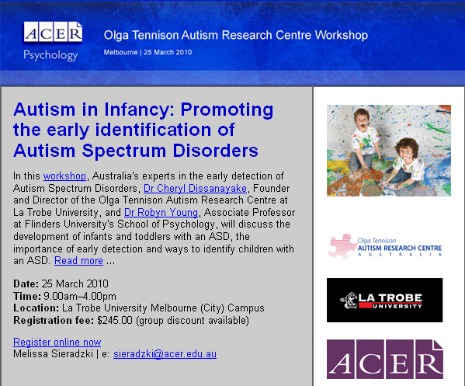
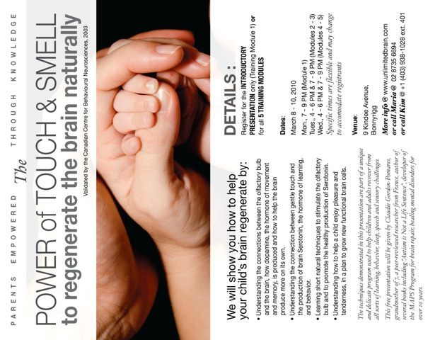
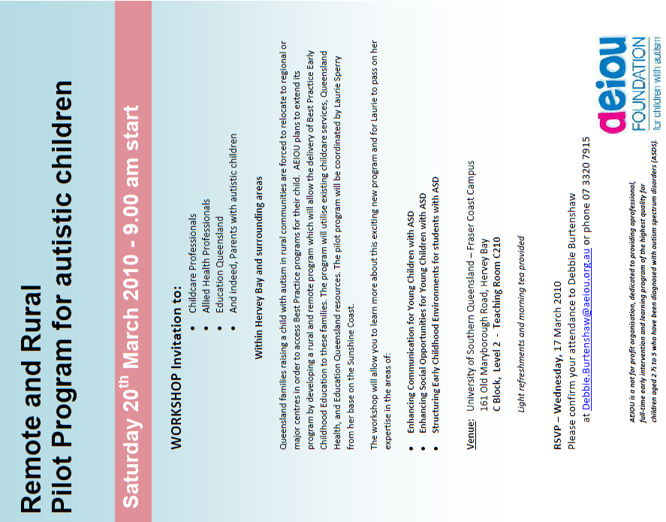

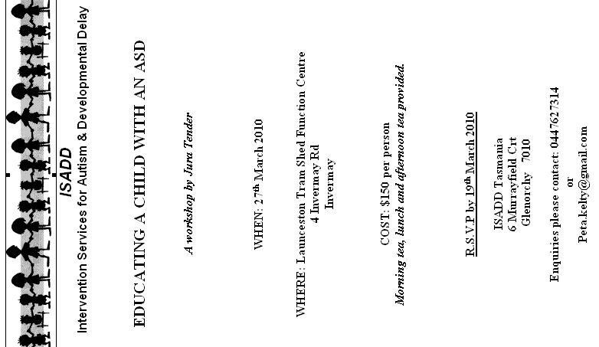

Thanks to Melissa Christie …
Disclaimer
While we have made every effort to ensure that information is free from error, A4 does not warrant the accuracy, adequacy or completeness of the information, graphics and materials in the A4 Update. A4 does not guarantee that A4 Updates will be free from viruses.
A4 is not responsible for the results of any action taken or not taken on the basis of any information in the A4 Update, nor for any error or omission in that information. A4 expressly disclaims all and any liability and responsibility in respect of anything done consequent on the whole or any part of the information in the A4 Update. A4 shall not be liable for any loss, damage, liability, expense, cost or personal injury, whether direct or indirect, consequential or incidental, which you suffer, incur or are liable for, howsoever caused (whether due to A4's negligence or otherwise), arising from or in connection with your use of A4 Updates.
A4 Contacts
A4 is a grassroots organisation. All A4 activity, such as publishing the Updates (newsletters), is done by volunteers. Please understand that A4 volunteers may have no training or qualifications for their various roles. They do the best they can for people with ASD, their families and associates. A4 welcomes assistance and constructive criticism.
Anti-spam: change -at- to @ in email addresses.
Update team: editor-at-a4.org.au
Editing: Bob Buckley edited this edition
Production: Helen Curtin (Qld) – proof-reading, Bob Buckley (ACT) – distribution.A4 Management
Convenor: Bob Buckley (ACT)
cnvnr-at-a4.org.au
Committee: Peter Hill (NSW), Mary Gebert (Vic), Myrna Dominguez (NSW), Helen Steinhardt (Qld), Mauraid Clayton (Vic), Colleen DeVeyrac (Qld).
Treasurer (donations): Cathy Ryan (Vic.)
treasurer-at-a4.org.au
for her contribution as A4 Update editor through the latter part of 2009 and the start of 2010. Her contribution is valued by all.

The survey was due in 2008 but the ABS deferred data collection until the end of 2009.
The ICD-10 is set of diagnostic criteria different from the DSM-IV which is often used in Australia.
described by the Health Department as 20+ hours per week of intensive ASD-specific intervention for two or more years.

