Dear Prime Minister
Since June 2016 I have been unable to access my son’s myPlace webpage via the myGov website.
I have raised this several times. Yesterday, I spent about 2 hours mostly on hold with the NDIA and the myGov helpline.
The NDIA said their system is working perfectly and that the problem is with the myGov website. The myGov help people check out their system and said the problem is the NDIA’s myPlace system.
I believe that the problem is that the myGov website has incorrect (possibly corrupted) data/information in its dataset about my myPlace account. The incorrect data should be either deleted or corrected.
Both myGov and myPlace staff refuse to take responsibility for checking this data. Neither will ensure that the transition from the myGov to myPlace actually works for me.
I am writing to you so that you know that even the simplest of Government computer systems just don’t work. And that I am very disappointed that my taxes pay for such a grossly inadequate service.

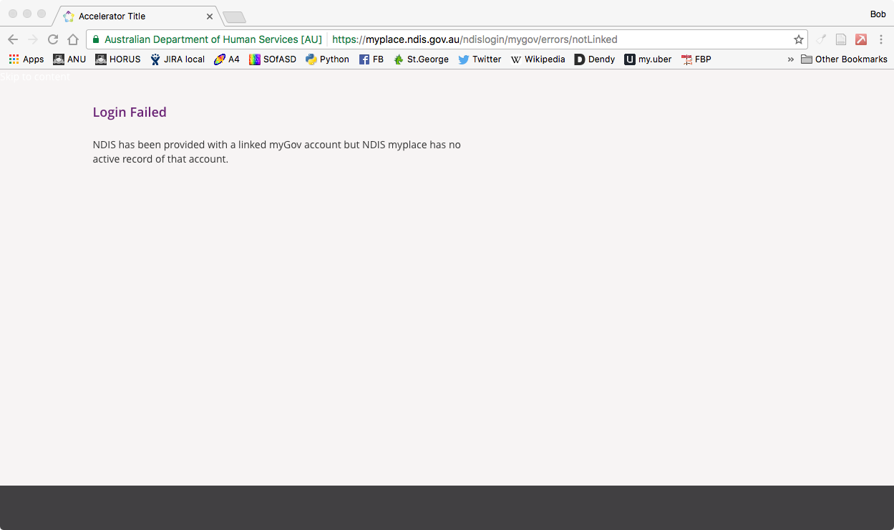
I can be reached by email – bob@buckley.id.au - or mobile 0418677288

yours sincerely
Bob Buckley
2/2/2017

